1. **Assumption**

A team with four member is going to develop a clone web site for a university. There are mainly seven features in the website of which one feature that must as same as original one with full functionality along with database system. According to chosen website I have to assume and build diagrams like user stories, use case, work flow, class diagram and erd. We have chosen SharePoint CMS platform to build the system. I have to gather out all the relevant resources that required to build the system and team members with enough skills in their respective field.

1. **User story**

|  |  |  |  |
| --- | --- | --- | --- |
| **Serial No** | **Actor**  **The person wanted to find something from web** | **Activity**  **That actor want to do** | **And the outcome** |
|  | As a student  I want to see available **courses offered** by the university  So that I can enroll to my desire one. | | |
|  | As a visitor  I want to visit **research** option  So that I can study something that can enrich my knowledge. | | |
|  | As a visitor  I want to see available **News** posted in the web page  So that I can update myself new changes or availability about the university. | | |
|  | As a student  I want to see **success stories of previous students** studied at the university  So that I can choose the university without any sort of hesitation. | | |
|  | As a student  I want to provide the **success stories to school/college**  So they can influence and could be a part of the university in future or like a potential one. | | |
|  | As a staff  I want to **provide contact details** to those students who are seeking for  So that they can reach to the university administration to discuss. | | |
|  | As a staff  I want to **deal with enquiries** to those who are seeking  So that they can have their desire question answer. | | |
|  | As a stuff  I want to manage **news** and **updates** session  So students and visitors can update with new enquires. | | |

1. **Use case diagram**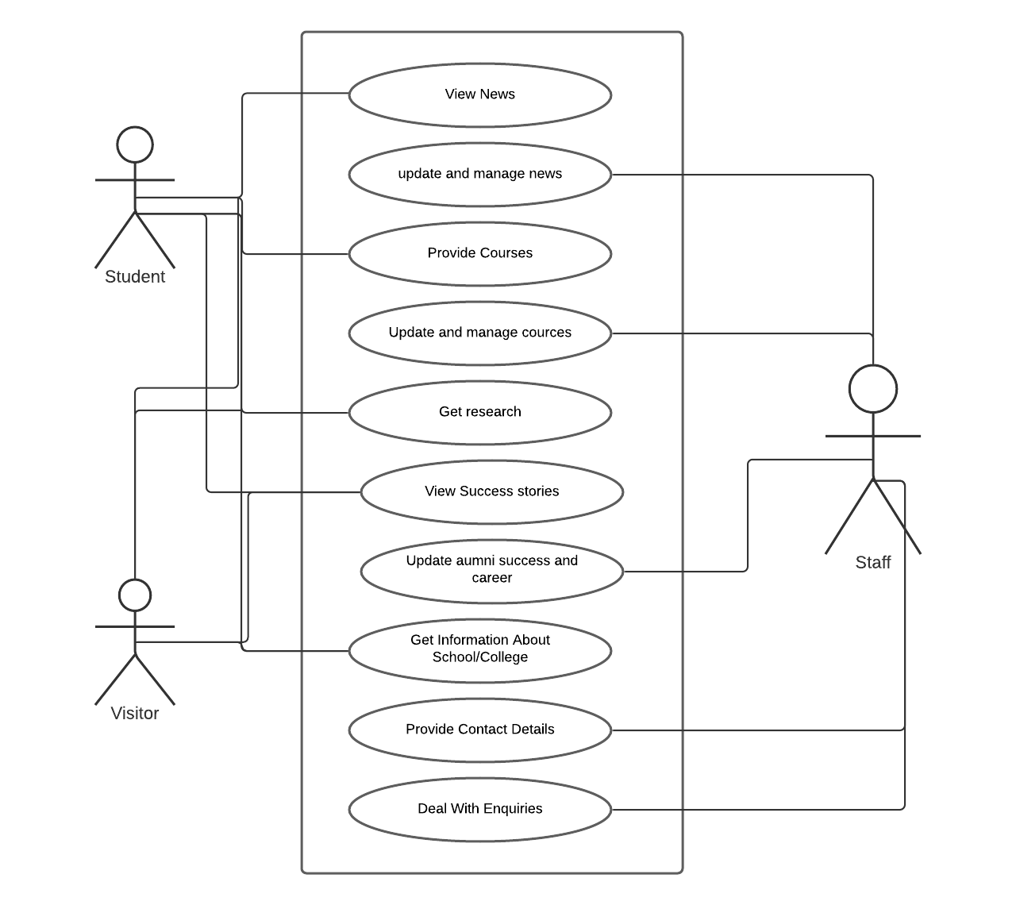
2. **Workflow**

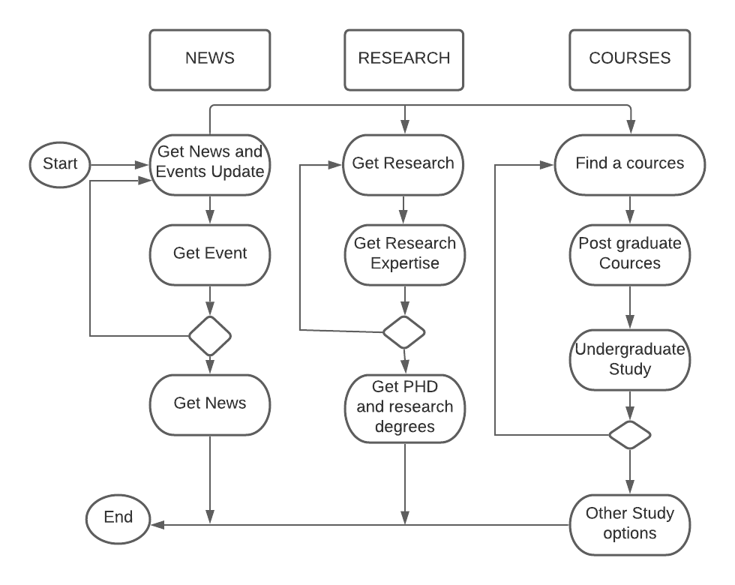

1. **Initial class diagram**

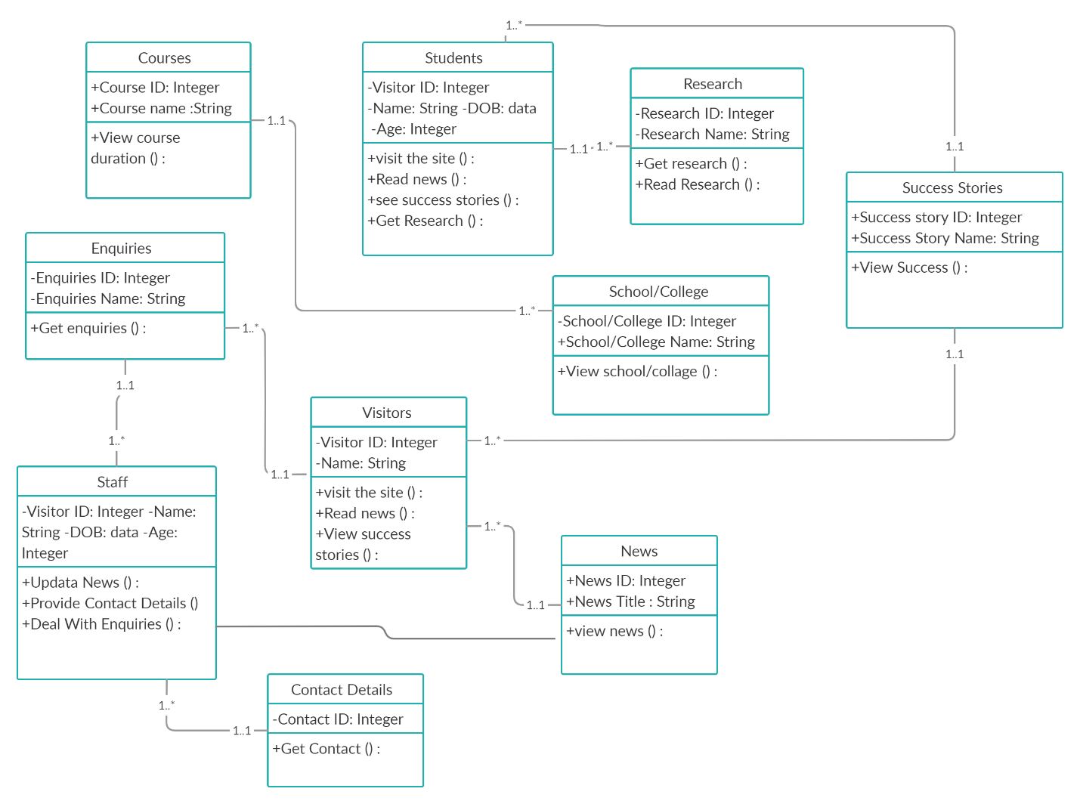

1. **ERD**

