**Test Case**

1. **Functional Testing:**

A form of software testing that validates functional requirements / specifications against the software function is Functional testing. The aim of the Functional Testing is to test each software feature by providing appropriate input and checking the performance against the functional specifications.

Our developed website Functional testing given below:

|  |  |  |  |  |  |
| --- | --- | --- | --- | --- | --- |
| **Test Case ID** | **Title of Test** | **Process of Test** | **Taken Action** | **Expected Result** | **Actual Result** |
| 1.1 | Functional Testing | Student will submit Contact us form of future undergraduate student and data will store to database | Visited Contact us page. Submit contact form with required field. | User will fill up required text box. After successful submission they will see confirmation message in mail. And data will be store on database. | Contact us form and confirmation message is working. Data also storing in database. |
| 1.1 | Functional Testing | Search Course Offer | Clicked on Search Box | All search related Courses will appear in search box | Search Box Is Not working |

1.1 Test Result:

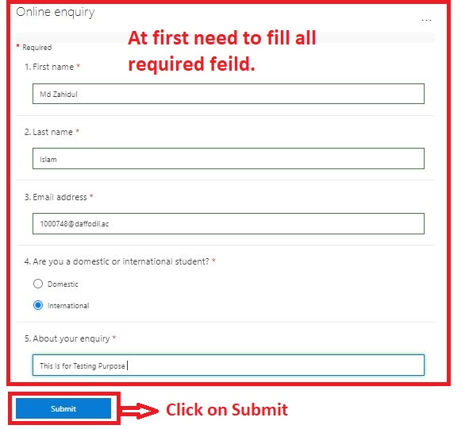

Figure: Function test of contact us

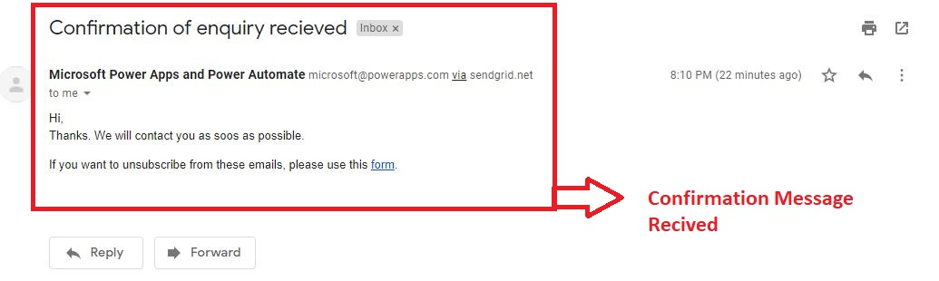

Figure: Function test of contact us

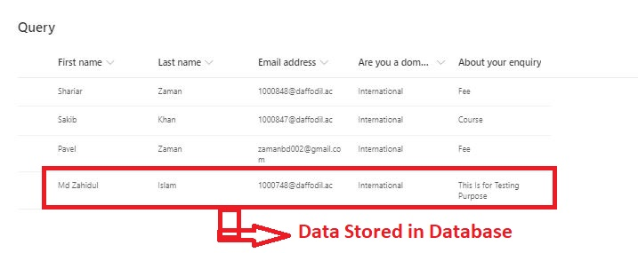

Figure: Function test of contact us

1.2 Test Result:

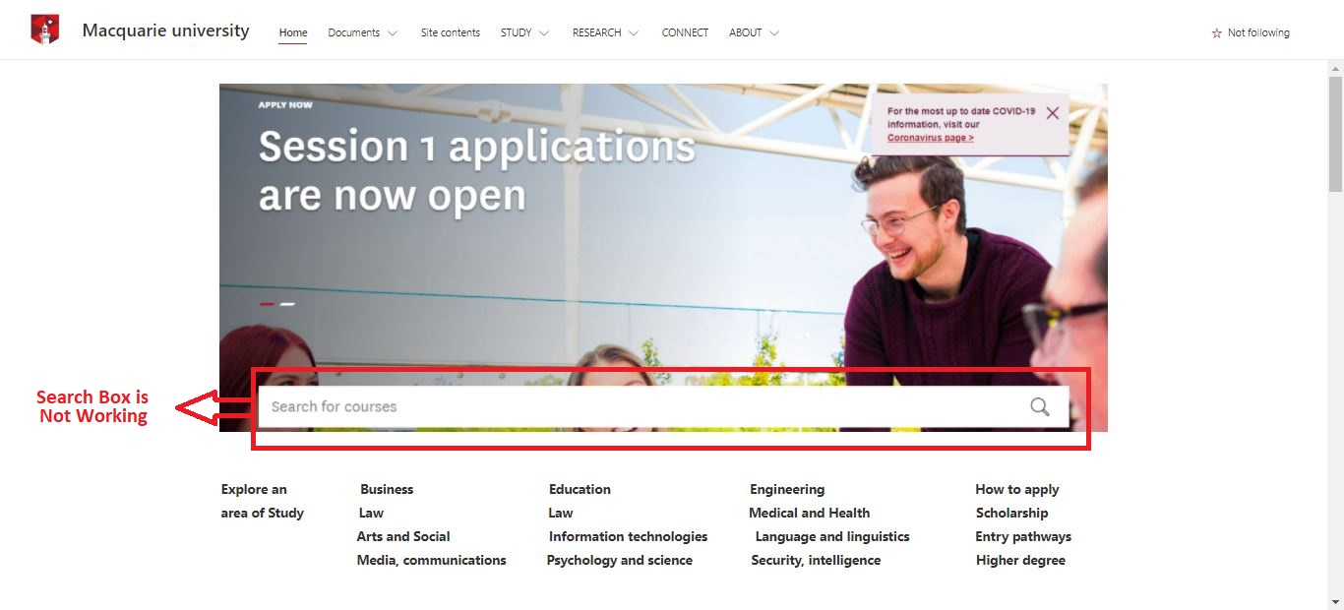

Figure: Function test of search Course

1. **Integration Testing:**

Integration testing is performed to measure the components/modules when combined to check that they function as expected. In example to test the components/Module which is running well separately do not have problems when integrated.

Our developed website Integration testing is given below:

|  |  |  |  |  |  |
| --- | --- | --- | --- | --- | --- |
| **Test Case ID** | **Title of Test** | **Process of Test** | **Taken Action** | **Expected Result** | **Actual Result** |
| 2.1 | Integration Testing | User Click on “Find a Course ”  Link | Opened “Information of high school” page and clicked on “Find a Courses” Link | The system will redirect to “Courses” page. | The Homepage has successfully redirected to “Courses” page |
| 2.2 | Integration Testing | User Click on “Success Stories and Newsletter” | Opened “Courses” page and clicked on “Success Stories and Newsletter” link | The system will redirect to “Success Stories and Newsletter” page | The Homepage has successfully redirected to “Success Stories and Newsletter“ page |
| 2.3 | Integration Testing | User Click on “Contact us” | Opened “Success Stories and Newsletter” page and clicked on “Contact us” Link | The system will redirect to “Contact us” page | The Homepage has successfully redirected to “Contact us” page |

2.1 Test Result:

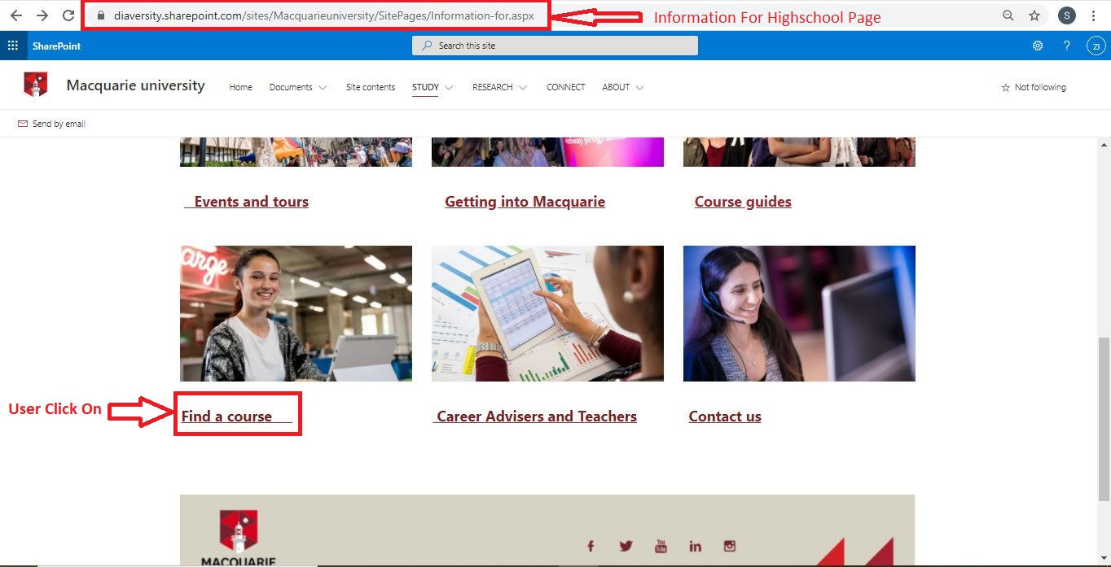

Figure: Integration Testing Between Two Pages

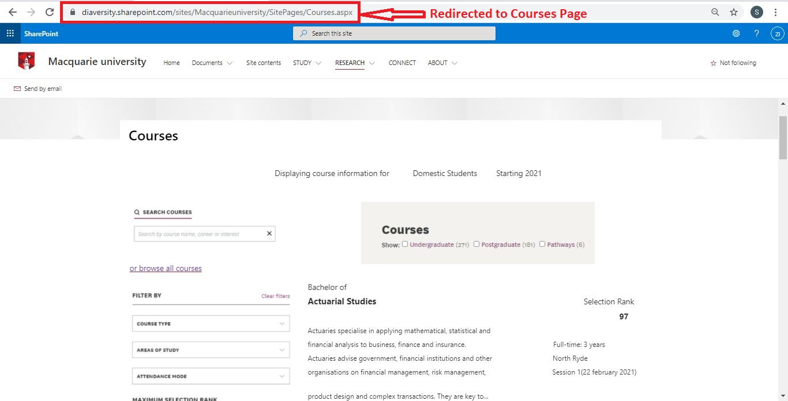

Figure: Integration Testing Between Two Pages

2.2 Test Result:

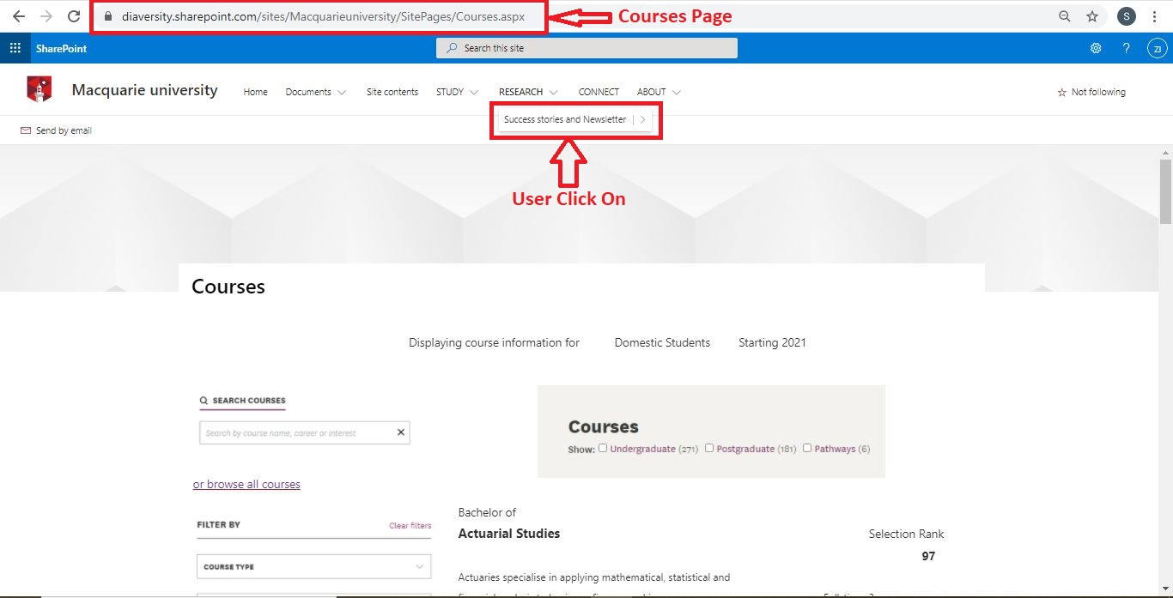

Figure: Integration Testing Between Two Pages

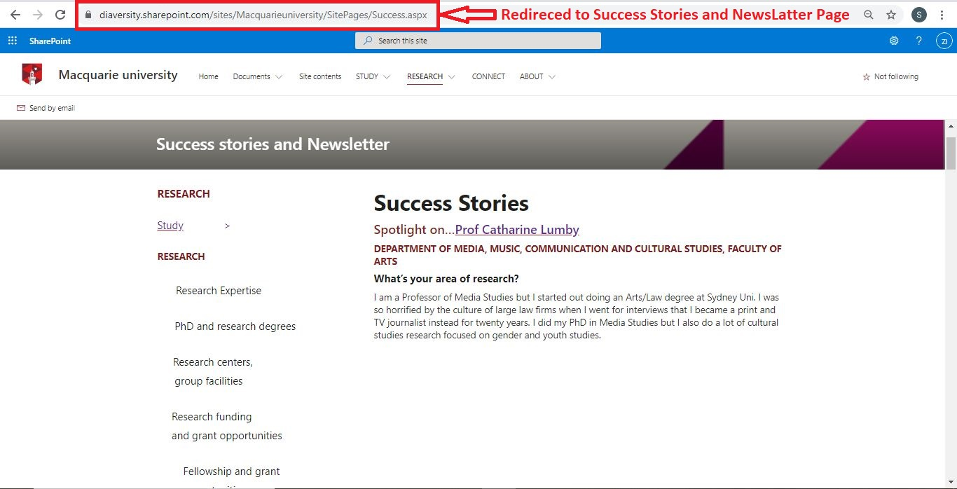

Figure: Integration Testing Between Two Pages

2.3 Test Result:

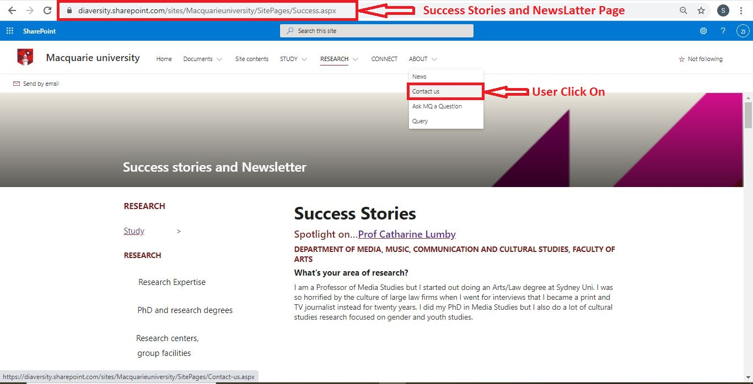

Figure: Integration Testing Between Two Pages

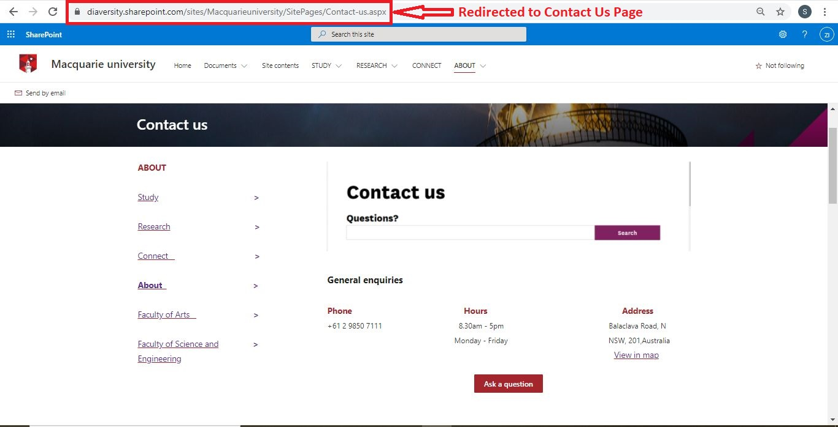

Figure: Integration Testing Between Two Pages

1. **Browser Compatibility Testing:**

Browser Testing is a multi-browser process for testing web applications. Browser testing means checking the application’s compatibility across various web browsers and ensuring that your web application runs properly across different web browsers.

Our developed website browser compatibility testing given below:

|  |  |  |  |  |  |
| --- | --- | --- | --- | --- | --- |
| **Test Case ID** | **Title of Test** | **Process of Test** | **Taken Action** | **Expected Result** | **Actual Result** |
| 3.1 | Browser Compatibility Testing | Browsing the website on “Google Chrome” | Opened Google Chrome and browsed the website | The Website will run perfectly | Without any problem website has run perfectly |
| 3.2 | Browser Compatibility Testing | Browsing the website on “Opera Browser” | Opened UC Browser and browsed the website | The Website will run perfectly | Without any problem website has run perfectly |
| 3.3 | Browser Compatibility Testing | Browsing the website on “Microsoft Edge” | Opened Microsoft Edge and browsed the website | The Website will run perfectly | Without any problem website has run perfectly |

3.1 Test Result:

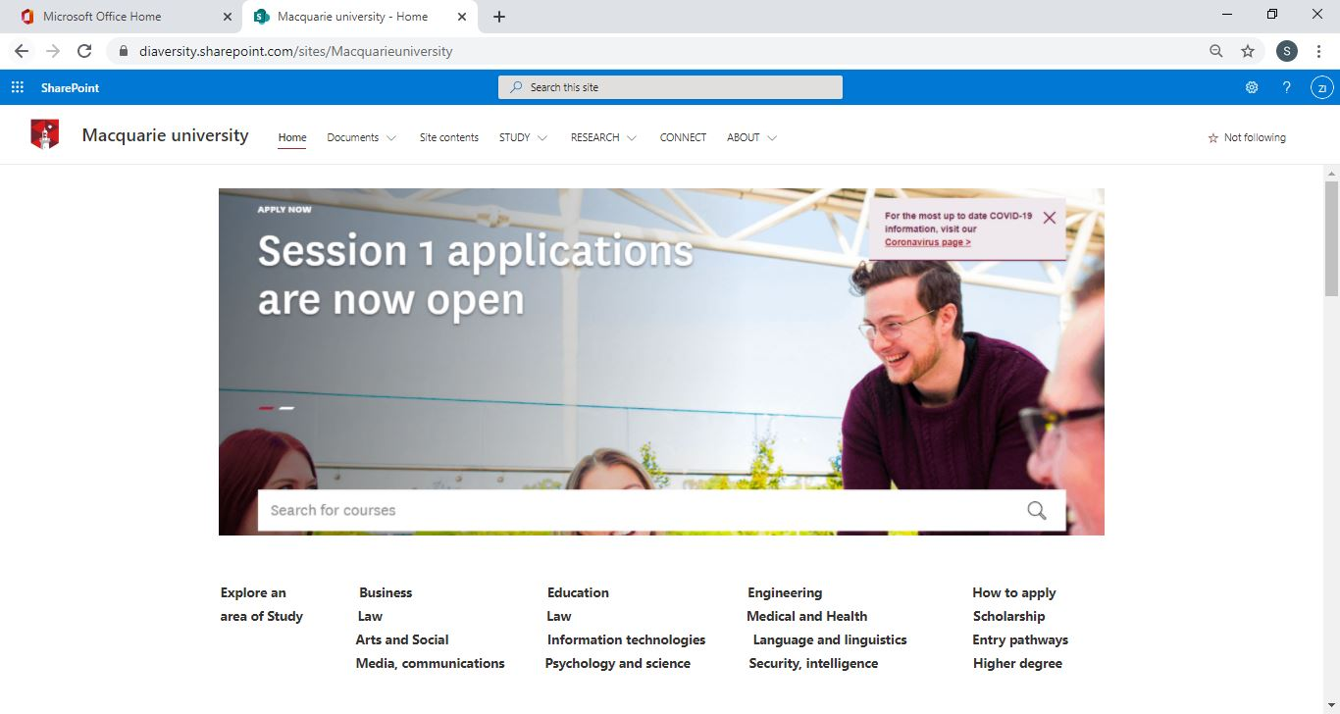

Figure: Google Chrome Browser Compatibility Testing

3.2 Test Result:

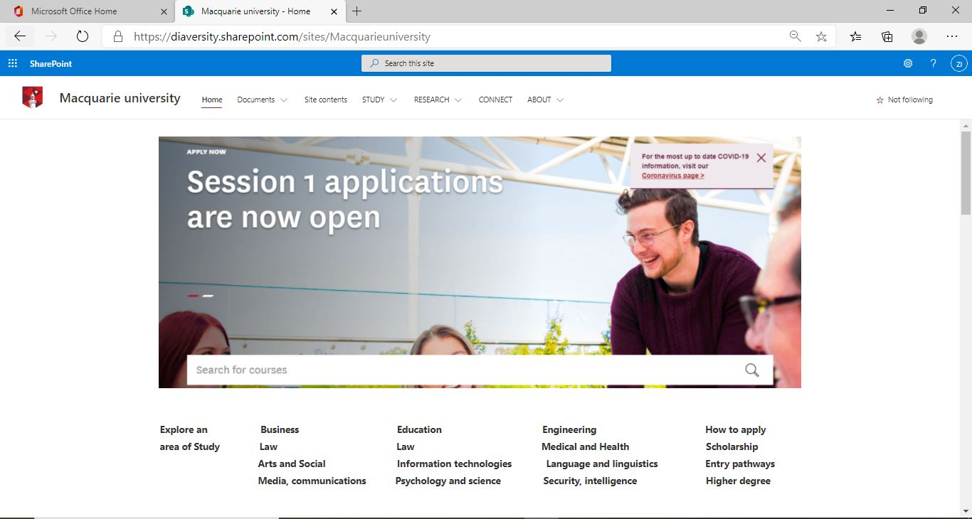

Figure: Microsoft Edge Browser Compatibility Testing

3.3 Test Result:

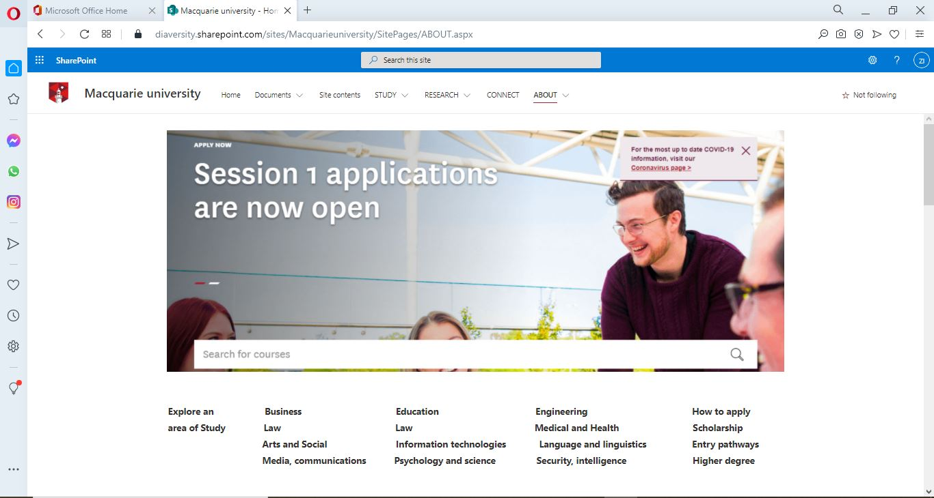

Figure: Opera Browser Compatibility Testing

1. **Responsiveness Testing:**

Without compromising performance and user experience, Responsive design enables websites to adapt to various screen sizes. Depending on the viewport, UI elements, text, and images will rescale and resize. Our developed website is tested on different device like Mobile, Tab and Notebook.

Our developed website Responsiveness testing given below:

|  |  |  |  |  |  |
| --- | --- | --- | --- | --- | --- |
| **Test Case ID** | **Title of Test** | **Process of Test** | **Taken Action** | **Expected Result** | **Actual Result** |
| 4.1 | Responsiveness Testing  (Mobile) | Browsing the website on Mobile Screen | Running The Website in (360 ⨯ 640 ) PX Screen | Mobile view screen will show the system perfectly. | Web Content and Dropdown Menu is not responsive. |
| 4.2 | Responsiveness Testing  (Tab) | Browsing the website on Tab Screen | Running The Website in (768 ⨯ 1024 ) PX Screen | Tab view screen will show the system perfectly. | Web Content and Dropdown Menu is not responsive. |
| 4.3 | Responsiveness Testing  (Notebook) | Browsing the website on Notebook Screen | Running The Website in (768 ⨯ 1024 ) PX Screen | Notebook view screen will show the system perfectly. | Notebook View Screen is responsive. |

4.1 Test Result:

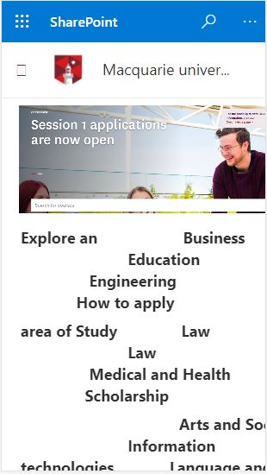

Figure: Mobile Responsiveness Testing (1)

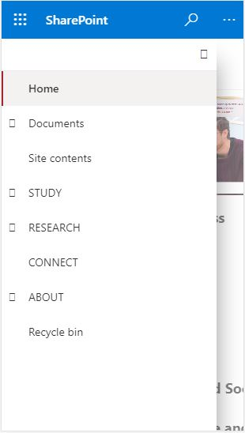

Figure: Mobile Responsiveness Testing (2)

4.2 Test Result:

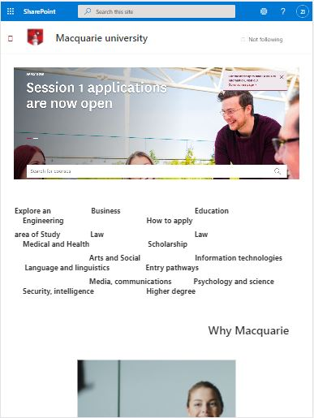

Figure: Tab Responsiveness Testing (1)

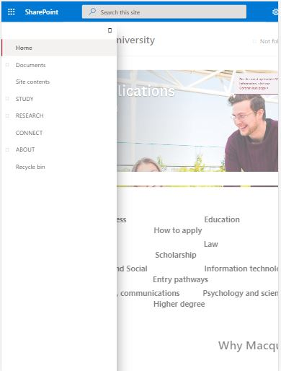

Figure: Tab Responsiveness Testing (2)

4.3 Test Result:

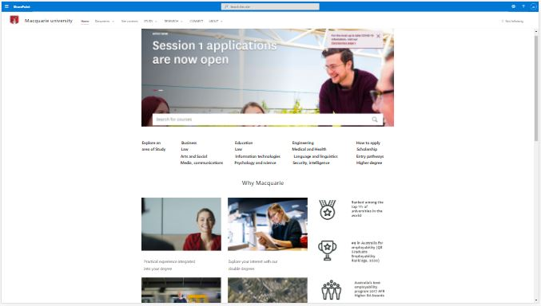

Figure: Notebook Responsiveness Testing (1)

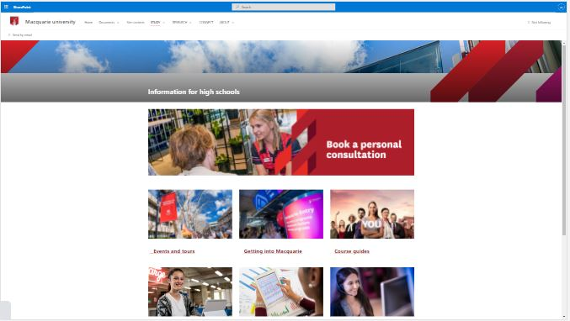

Figure: Notebook Responsiveness Testing (1)

1. **Usability Testing:**

Usability Testing is a testing tool for evaluating how simple software is and how user-friendly it is. Usability testing focuses specifically on the ease of use of the program by the user, application flexibility to manage controls and application capability to achieve the targets.

Our developed website Usability testing given below:

|  |  |  |  |  |  |
| --- | --- | --- | --- | --- | --- |
| **Test Case ID** | **Title of Test** | **Process of Test** | **Taken Action** | **Expected Result** | **Actual Result** |
| 5.1 | Usability Testing | View News Page and see it’s usability | Moved the mouse on Research page and clicked News Link | User will be able to see news title , description and date | News title description and date showing successfully |
| 5.2 | Usability Testing | View Contact us page and see usability | Opened the site and clicked on contact us | Phone Number, Working Hours and address will show. | Everything is showing clearly. |
| 5.3 | Usability Testing | User will see menu dropdown system. | Moved the mouse courser to contact us menu | User will be able to see dropdown menu | Dropdown menu is successfully showing |

5.1 Test Result:

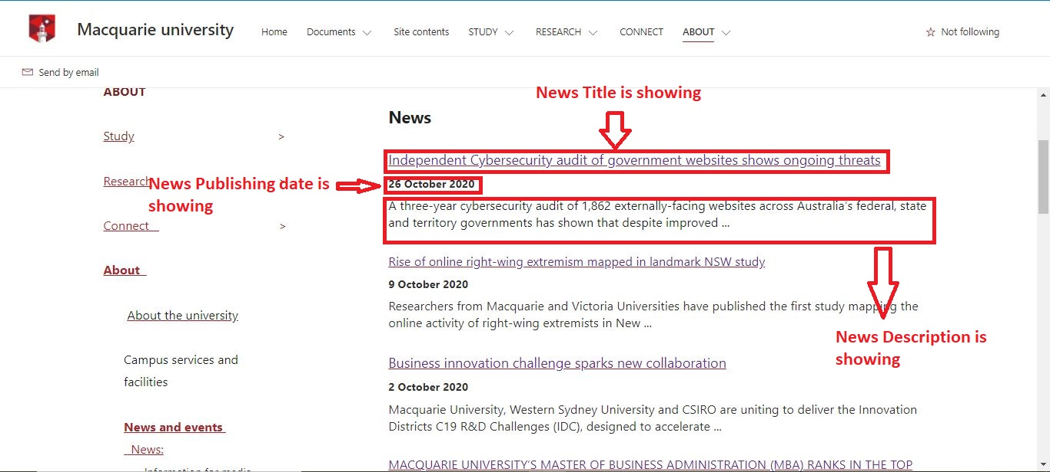

Figure: Usability of the system

5.2 Test Result:

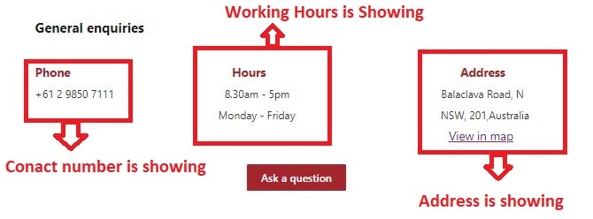

Figure: Usability of the system

5.3 Test Result:

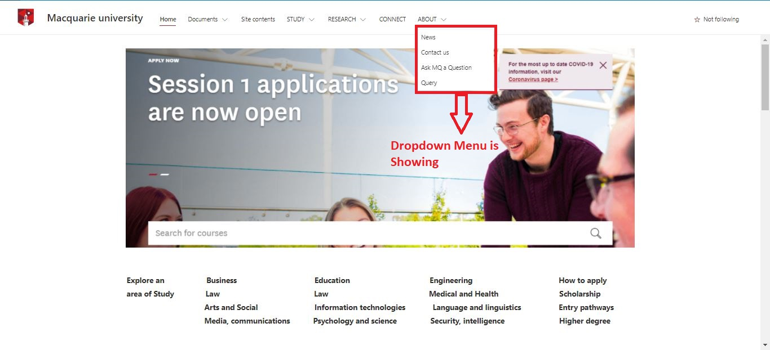

Figure: Usability of the system

1. **Security Testing:**

Security testing is a form of software testing which uncovers software program bugs, risks, dangers and protects malicious attacks from attacker. The aim of Security Checks is to find any potential software system vulnerabilities and weaknesses that might lead to a loss of information, profit, and reputation at the hands of the Organization's workers or outsiders.

Our developed website Security testing’s given below:

|  |  |  |  |  |  |
| --- | --- | --- | --- | --- | --- |
| **Test Case ID** | **Title of Test** | **Process of Test** | **Taken Action** | **Expected Result** | **Actual Result** |
| 6.1 | (SQL Injection) security testing | Query SQL Injection testing | Checked SQL security. Microsoft provides well SQL security with their Code. | Query will protected from SQL Injection test | Website Database is well Protected |
| 6.2 | (Brute Force Attack) security testing | Password Strangeness Checking | None | Website will be protected from unauthorized access | Website Database is well Protected from unauthorized login. |

6.1 Test Result:

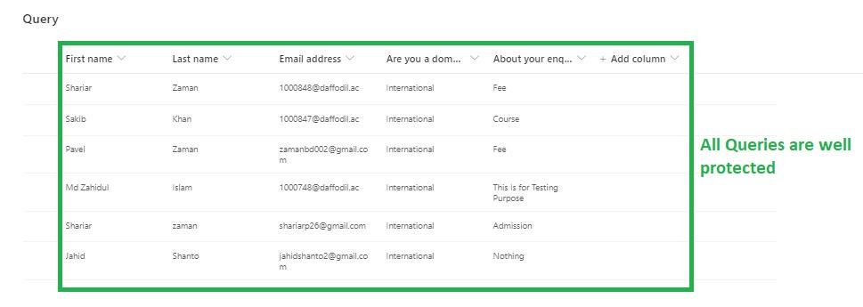

1. **Unit Testing:**

Unit testing is a kind of software testing in which software’s particular units or components are evaluated. The aim is to verify that the software code performs as planned in each unit. Unit Checks separate and validate the correctness of a code segment. An individual function, system, procedure, module, or entity can be a unit.

Our developed website Unit testing are given below:

|  |  |  |  |  |  |
| --- | --- | --- | --- | --- | --- |
| **Test Case ID** | **Title of Test** | **Process of Test** | **Taken Action** | **Expected Result** | **Actual Result** |
| 7.1 | Unit Testing | Information about high school unit testing | Visited Information about high school and tested that unit. | Unit Functionalities will work successfully | Unit Functionalities is working properly. |
| 7.2 | Unit Testing | Find a course unit testing | Visited Find a course page and tested that unit. | Unit Functionalities will work successfully | No Unit Functionalities is working. |

7.1 Test Result:

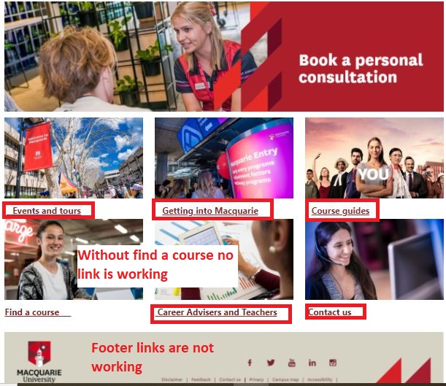

Figure: Unit testing of the feature.

7.2 Test Result:

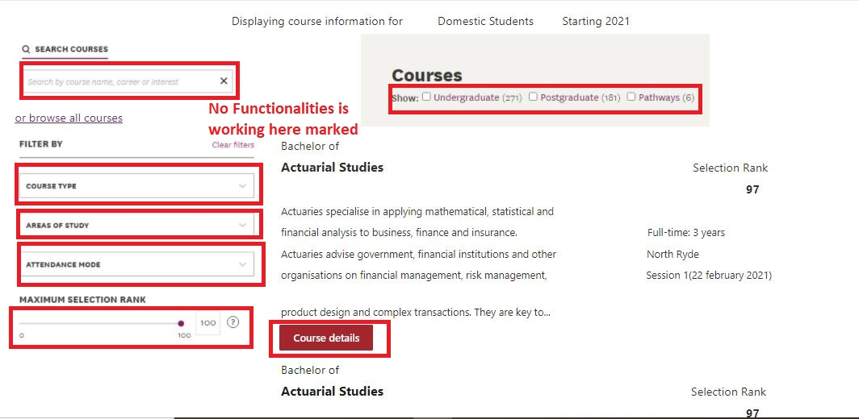

Figure: Unit testing of the feature.