Assignment 08-1: Iterating on an Algorithm

Sharie Rhea
Southern New Hampshire University
CS 680: Advanced Algorithms
Dr. Maureen Kinkela
August 30, 2026

For this project, the goal was to develop an application that efficiently determines whether a specific data entry exists within a dataset, adhering to the requirement that the data be stored in a heap and searched using depth-first search (DFS). To test and validate the system, I utilized five sample datasets provided in a pipe-delimited, comma-separated value (CSV) format containing two distinct fields: "sequence" and "data." The specific application requirements are as follows:
- The application shall be able to read a data set from a file where the format is consistent with the provided data record format.
- The application shall be able to retrieve a record or records from the file based on provided search criteria.
- When displaying a record, only the data field shall be displayed.
- When displaying a record, the data field shall be labeled.
- The application shall be able to accept a word to search for within the data set.
- When searching, if the word is not found, the application shall indicate that the value was not located within the data set.
- The application shall provide an indication of how many records were searched.
- The application shall be optimized to minimize the time necessary to perform the search function.
I utilized a test-driven development (TDD) approach to build the application, progressing through several iterations of the classic "red, green, refactor" cycle (GeeksForGeeks, 2025). The following section details my initial iteration in full, followed by summaries of subsequent cycles. To begin, I designed a comprehensive suite of test cases using Python’s unittest framework to validate each core requirement (Python, n.d.). These test cases target five primary areas: data loading, heap construction, search functionality, output formatting, and runtime performance. To allow the test suite to execute without syntax or import errors, I created a base App.py file containing all required method signatures. I initially stubbed out each method using Python’s pass keyword or set methods to return None when necessary. Running this suite produced expected failures across all tests—as I had not yet implemented any functional application logic—successfully completing the "red" phase of the first iteration.
Next, I implemented the core application functionality in my first pass. Throughout this process, I ran the test suite repeatedly to monitor progress, identify logical errors, and catch overlooked edge cases. For instance, although I had designed a test case to verify how the system handles multi-word search queries, I overlooked the implementation of this specific error handling until it was one of the few remaining failing test cases. Additionally, I refined several tests to invoke updated methods or account for non-deterministic behavior in the application. This continuous refinement of both the application logic and the test suite reflects the core principles of TDD and iterative development (Allan, 2019). The complete execution log for each test run is documented in the test_output.txt file. Once all test cases executed successfully, I completed the "green" phase of the first iteration.
The final phase of this cycle focused on refactoring. During this stage, I concentrated on enhancing the accuracy and specificity of the test suite. Diagnostic feedback from the test execution revealed two key issues: the application failed to handle duplicate values within the datasets, and the initial heapify operation proved non-deterministic. To address duplicates, I updated the logic to utilize a set structure. However, this modification broke several data-loading tests that relied on original entry counts, requiring further adjustments to the test parameters. I also refined the output formatting during this phase. Once the codebase and test suite were fully reconciled and all tests returned green again, I completed the “refactor” stage of the first iteration.
For the second iteration, I updated my test suite to accommodate the application's revised behavior. To handle the non-deterministic structure of the heap, I modified the assertion logic. Rather than expecting specific array indices for the first five elements, I verified element presence by popping the top five values, which guaranteed consistent, deterministic results. I then refactored the codebase to improve modularity by extracting key logical steps into dedicated helper functions, such as prompt_search, display_greeting, and get_input.
My third iteration focused entirely on optimizing the runtime performance of the search functionality. Initially, a recursive depth-first search (DFS) implementation satisfied my original 100ms runtime boundary, averaging approximately 35ms for valid searches and 50ms for invalid searches. To push performance further, I lowered the target threshold to 50ms and refactored the search into an iterative approach. This iterative implementation successfully met the stricter timing constraint. The test output logs for the recursive and iterative passes are illustrated in Figure 1 and Figure 2, respectively.
Figure 1
Test Execution Results for Recursive DFS Approach
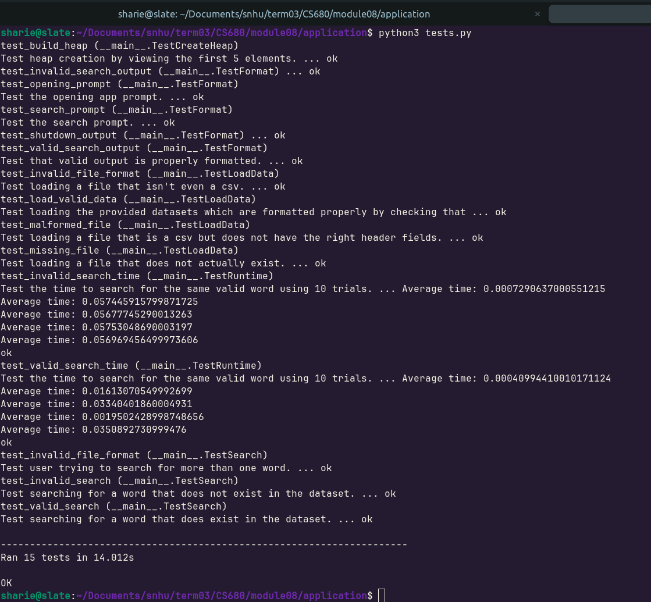Figure 2
Test Execution Results for Iterative DFS Approach
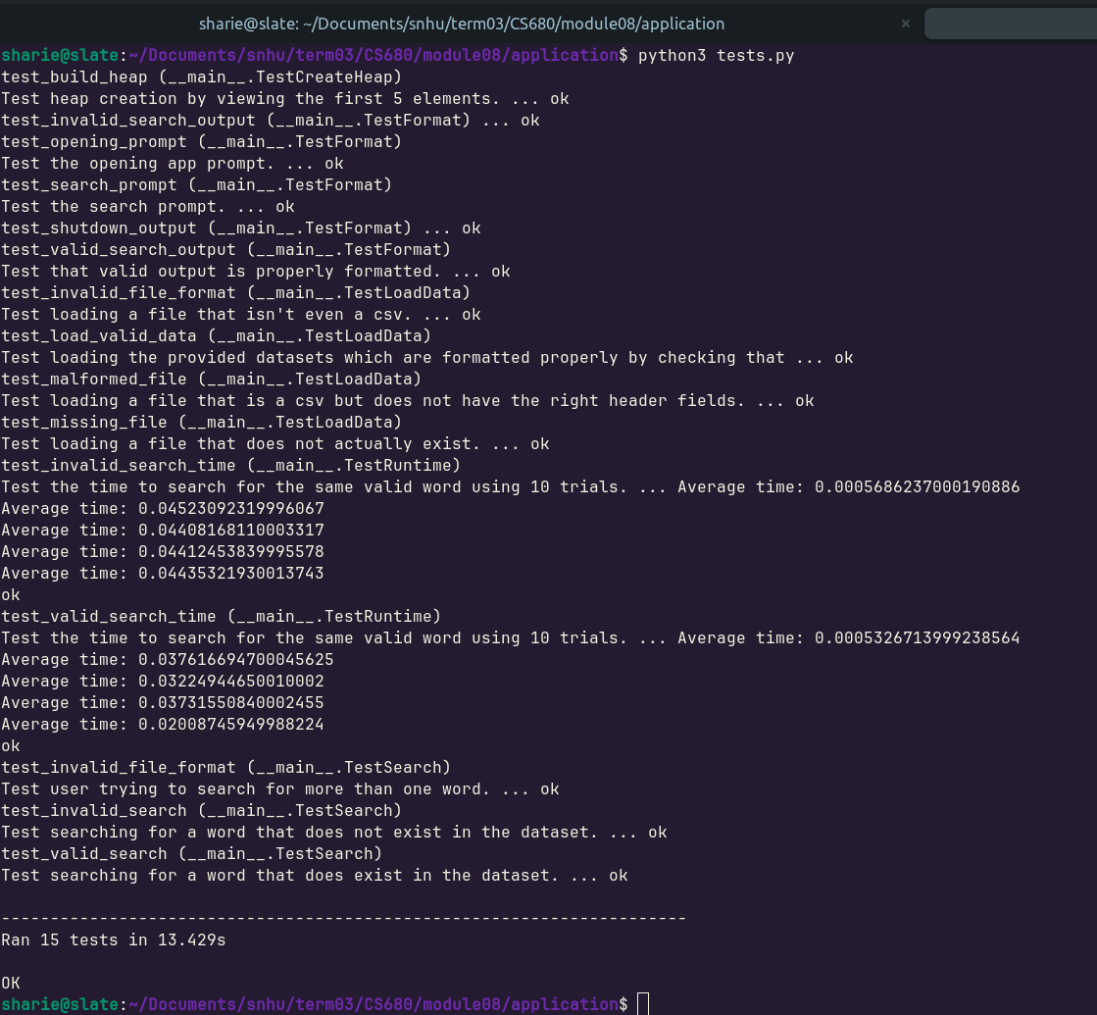 In the fourth iteration, I targeted further performance gains by tightening the runtime thresholds to 30ms for valid searches and 40ms for invalid ones. To achieve these targets, I implemented two small but key optimizations within the search routine. I created a local variable reference to the heap within the method—reducing the overhead of repeated instance attribute lookups—and I added boundary checks prior to pushing child nodes onto the stack, preventing redundant push and pop operations during execution. These changes allowed the code to comfortably pass the revised performance benchmarks. When I pushed the target even further to 20ms for valid searches, the optimized iterative DFS continued to pass consistently. Figure 3 illustrates the timing results for this final implementation.
Figure 3
Test Execution Results for Optimized Iterative DFS Approach
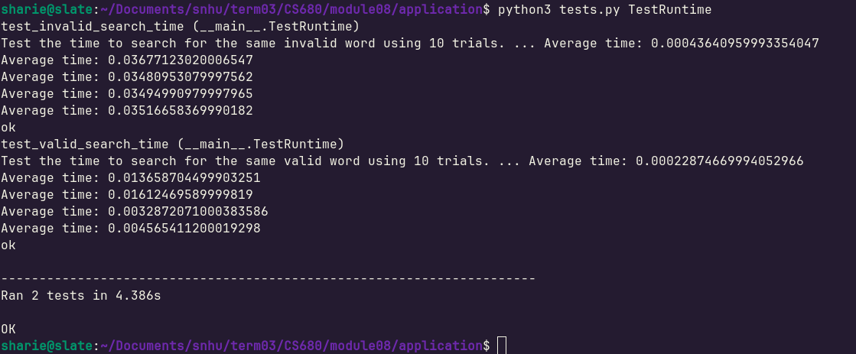
Timing results may vary on different machines. Most tests were run on a personal laptop, but these thresholds also passed on the course Codio virtual environment. Figure 4 shows this execution run.
Figure 4
Codio Test Execution
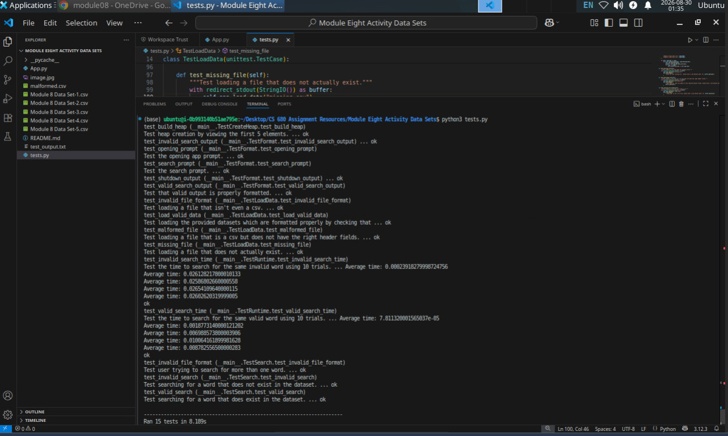
At this point, I decided to conclude the iterative development process. The performance gains were becoming marginal, and I concluded that further significant optimizations were unachievable given the required constraints of using a heap and depth-first search (DFS). A heap is an efficient data structure for value storage—particularly when backed by an array—as it requires no auxiliary space beyond the elements themselves. The heapify operation runs in O(n) time with O(1) auxiliary space complexity (Cormen et al., 2022). However, a heap is poorly suited for DFS. DFS is designed primarily for traversing graph structures to discover paths between nodes, rather than evaluating value existence across an array-backed structure (Cormen et al., 2022). Consequently, optimizing search performance within these constraints proved challenging, and the algorithm scales poorly with larger datasets. In the worst-case scenario, DFS must inspect every element in the heap, yielding a time complexity of O(n). Therefore, this approach is ultimately ill-suited for applications prioritizing search efficiency.
A far superior combination of data structure and algorithm would be a binary search tree (BST) combined with binary search, or a pre-sorted array. A balanced BST or sorted array can also be backed efficiently, requiring no additional structural overhead beyond the dataset itself. While constructing a sorted array or BST takes O(n log n) time—slightly more costly than building a heap in O(n) time—this preprocessing cost is incurred only once during data ingestion (Cormen et al., 2022). The primary advantage is that binary search yields a search time complexity of O(log n), compared to DFS's O(n) (Cormen et al., 2022). Given that the system does not require heap-specific operations like priority extraction or constant-time minimum access, a heap offers no architectural benefit over a search-optimized structure.
An even more effective solution exists for this specific use case: a hash set. Because the core requirement is strictly to determine value existence, a hash set can store unique elements directly without the overhead of tree pointers or traversal logic (GeeksForGeeks, 2026)). In terms of space complexity, storing n elements in a hash set requires O(n) space, but its memory footprint is often much smaller in practice due to the elimination of structural metadata and the removal of duplicate entries (GeeksForGeeks, 2026). Most importantly, membership queries run in average O(1) time due to the efficiency of hashing (Cormen et al., 2022). I strongly recommend replacing the current heap and DFS design with a hash set approach, which would dramatically optimize search performance.

References
Allan, M. (2019, October 25). What is Iterative Development? - An Easy Guide for the Beginners. GoodCore Blog. https://www.goodcore.co.uk/blog/iterative-development/
Cormen, T. H., Leiserson, C. E., Rivest, R. L., & Stein, C. (2022). Introduction to algorithms. The MIT Press.
GeeksforGeeks. (2025, July 12). What is Test Driven Development (TDD)? GeeksforGeeks. https://www.geeksforgeeks.org/software-engineering/test-driven-development-tdd/
GeeksforGeeks. (2026, April 24). Java HashSet. GeeksforGeeks. https://www.geeksforgeeks.org/java/hashset-in-java/
Python. (n.d.). unittest — Unit testing framework — Python 3.8.2 documentation. Docs.Python.Org. Retrieved August 25, 2026, from https://docs.python.org/3/library/unittest.html

