

**UNIVERSITY OF JUBA**

**School Of Computer Science and Information Technology**

**Department Of Information Technology (It)**

**Undergraduate Program**

**Fifth Year, Semester Nine**

**Academic Year 2023/2024**

**Course: Knowledge Base System**

**Submitted to: Dr. Fakheraldin Y. O. Abdalla**

**Lecturer, Department of Information Technology**

**Submission Date: Dec 6th 2025**

**Student name: Abdalshrif Omer Hussen**

**Index: 22-CIT-296**

1. **Question:** Name and briefly explain the four main approaches to defining AI.

**1. Thinking Humanly:**

AI systems attempt to replicate the human thought process by mimicking how humans reason, learn, and solve problems.

**2. Acting Humanly:**

AI focuses on creating systems that behave like humans (e.g., Turing Test).

**3. Thinking Rationally:**

AI uses formal logic to mimic rational decision-making processes.

**4. Acting Rationally:**

AI systems are designed to act rationally, ensuring actions maximize performance goals (rational agents).

2. **Question:** Explain how an agent interacts with its environment using a schematic diagram.

**Components:**

a. **Sensors:** Receive input from the environment.

b. **Agent Program:** Processes input and decides on an action.

c. **Actuators:** Execute actions to influence the environment.

Environment → Sensors → [Agent (Perception + Decision)] → Actuators → Environment.

**Diagram:**

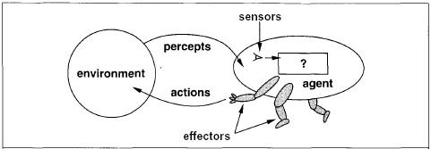

3. **Question**: Provide a partial tabulation of a simple agent function for the vacuum-cleaner world.

|  |  |
| --- | --- |
| Percept Sequence | Action |
| [A, Clean] | Right |
| [A, Dirty] | Suck |
| [B, Clean] | Left |
| [B, Dirty] | Suck |

4. **Question A:** Describe the PEAS framework for an automated taxi driver.

**Performance Measure:**

Safe driving, fast, comfortable trip, maximize profits.

**Environment:**

Roads, traffic, pedestrians, weather customers.

**Actuators:**

Steering wheel, accelerator, brakes, signal, horn.

**Sensors:**

GPS, cameras, speedometer, proximity, engine sensors, keyboard .

5. **Question B:** Discuss the different types of environments.

1. Fully Observable vs. Partially Observable.

2. Deterministic vs. Stochastic.

3. Static vs. Dynamic.

4. Discrete vs. Continuous.

5. Single Agent vs. Multi-Agent.

6. Episodic vs. sequential.

6. **Question A:** Explain the structure of a simple reflex agent with a schematic diagram.

1. Sensors observe the environment.

2. A condition-action rule dictates a response.

3. Actuators execute the response.

Environment → Sensors → Condition-Action Rule → Actuators → Environment.

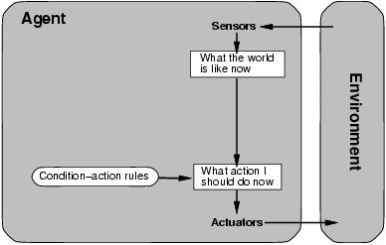

7. **Question B:** Write pseudocode for the function of the vacuum-cleaner world (REFLEXY-VACUUM-AGENT).

function REFLEXY-VACUUM-AGENT ([location, status]) return an action:

if status == Dirty then return Suck

else if location == A then return Right

else if location == B then return Left

8. **Question A:** Explain the structure of a model-based reflex agent.

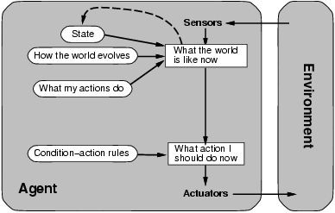

* Know how world evolves
* Overtaking car gets closer from behind
* How agent actions affect the world
* Wheel turned clockwise takes you right
* Model base agents update their state

9. **Question B:** Write pseudocode for a model-based reflex agent.

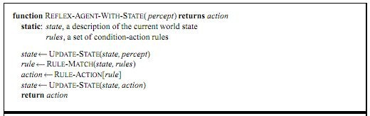

10.**The Question:** what is knowledge?

Knowledge is the sort of information that people use to solve problems.

11. **The Question:** How can we use rules as a knowledge representation technique?

Rules are if-then statements (e.g., IF condition THEN action). They encode logical reasoning and guide decision-making.

12. **The Question:** Explain the production system model using a schematic diagram.

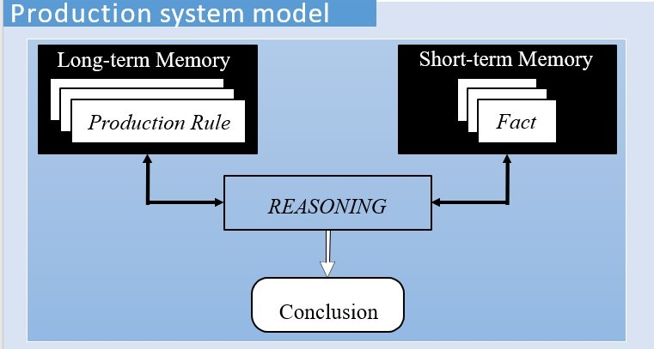

In the early seventies, Newell and Simon from Carnegie-Mellon University proposed a production system model, the foundation of the modern rule-based expert systems.

The production model is based on the idea that humans solve problems by applying their knowledge (expressed as production rules) to a given problem represented by problem-specific information.

The production rules are stored in the long-term memory and the problem-specific information or facts in the short-term memory.

13. **Question:** Explain what is basic structure of rule-based expert systems.

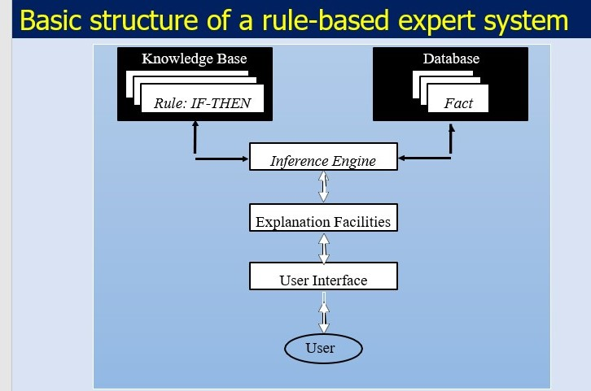

The knowledge base contains the domain knowledge useful for problem solving. In a rule-based expert system, the knowledge is represented as a set of rules. Each rule specifies a relation, recommendation, directive, strategy or heuristic and has the IF (condition) THEN (action) structure. When the condition part of a rule is satisfied, the rule is said to *fire* and the action part is executed.

The database includes a set of facts used to match against the IF (condition) parts of rules stored in the knowledge base.

The inference engine carries out the reasoning whereby the expert system reaches a solution. It links the rules given in the knowledge base with the facts provided in the database.

The explanation facilities enable the user to ask the expert system *how* a particular conclusion is reached and *why* a specific fact is needed. An expert system must be able to explain its reasoning and justify its advice, analysis or conclusion.

The user interface is the means of communication between a user seeking a solution to the problem and an expert system.

14. **Question:** by using simple drawing (Schematic diagram), explain what is complete structure of a rule-based expert system

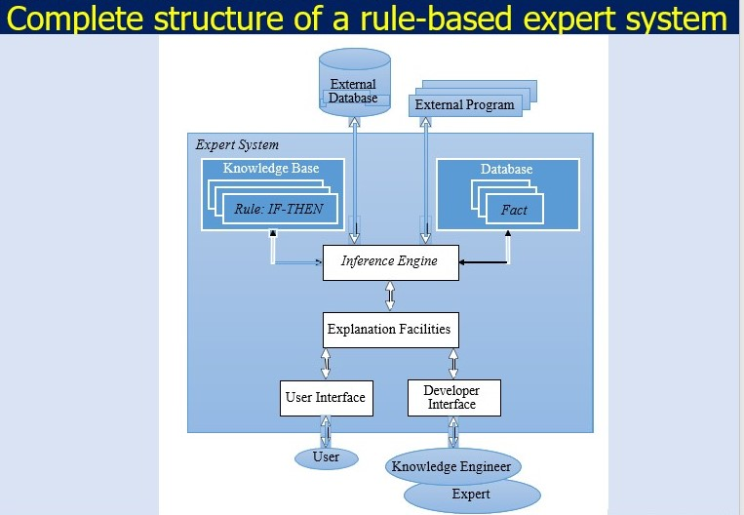

**Basic Structure:** Rule base, inference engine, Explanation Facilities, user interface, User, Developer Interface,

Knowledge Engineer, Expert.

**Complete Structure:** Adds explanation module, knowledge acquisition module, and database.

15. **Question:** Complete the following figure for forward chaining.

16. **Question A:** the random variables in this scenario.

A: Whether the alarm is going (A) or not going (-A).

G: Whether Mrs. Gibbon is calling (G) or not calling (-G).

W: Whether Dr. Watson is calling (W) or not calling (-W).

17. **Question B:** How many probabilities are there in the joint probability distribution?

The joint probability distribution involves three binary random variables: A, G, and W. Each can take two values (e.g., A or -A). The total number of probabilities is 23 = 8 probabilities.

18. **Question**: What is probability that the alarm is NOT going and Dr. Watson is Calling? **(B) 0.2 < p ≤ 0.4**

19. **Question**: What is probability that the alarm is going and Mrs. Gibbon is NOT calling? **(A) 0 ≤ p ≤ 0.2**

20. **Question**: What is probability that the alarm is NOT going?

**(E) 0.8 < p ≤ 1**