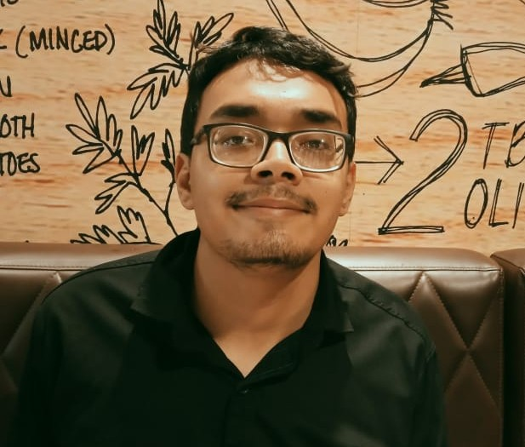

**Syed Md. Sharif Bin Alam**

Detail-oriented professional skilled in Web Research, IT Support, and Open Source Intelligence (OSINT). Proven ability to gather critical insights, troubleshoot complex IT issues, and enhance user satisfaction. Proficient in analyzing open-source data to inform strategic decisions.



**LANGUAGES**

Linkedin.url/profile

01985596864

**PROFESSIONAL EXPERIENCE**

Agrabad,Chittagong

* Office Suite
* Wireshark

**CONTACT**

**SOFTWARE**

**JBC Systems (2022 – 2024)**

**Industrial Training ( 3 Months)**

**Chittagong Technical School & College**

* Web Research
* OSINT
* IT Support
* Fast Typing
* Smart Office

**SKILLS**

**Certification**

1. **PSC**
2. **JSC**
3. **SSC**
4. **British Council**

* Bangla
* English
* Hindi

**EDUCATION**

**SSC Vocational (2020-2022)**

**Diploma (2023 - )**

**Operating Sytem**

* Windows
* Linux

©IUS - My-resume-templates.com