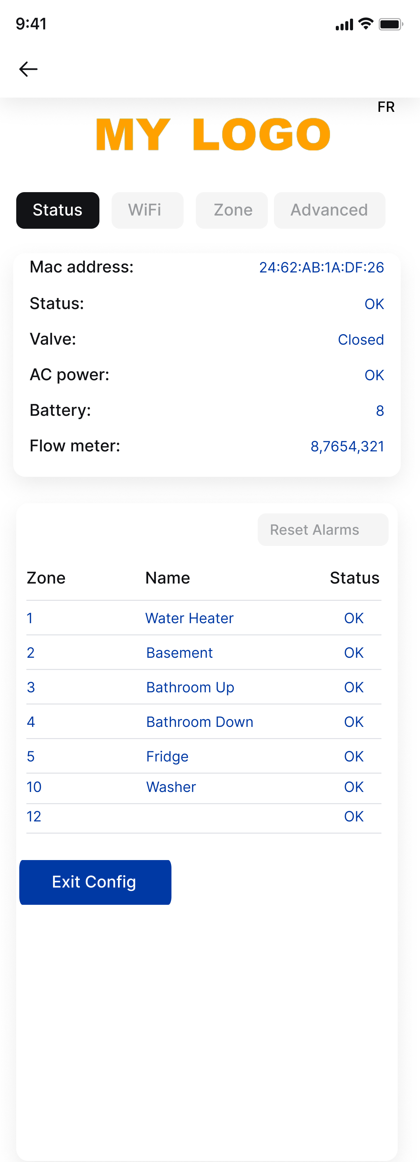

Added a FR as we’ll need to have 2nd language on the pages. Will supply French translation. As FR is clicked, it’ll become EN for English

My Logo, you can add image of 191x86 pixels, and we can replace by png.

Status: OK or ALARM

Valve: Open or Closed

AC power: OK or Not Detected

Display Zones and their Status. Status can have one of the following values. We’ll replace Text by icons that will be supplied

Codes:

1 OK  
2 Low Temp  
3 Comm failure  
4 Tilt  
5 Low Bat  
6 Low Bat & Tilt  
7 Comm failure & Low Bat  
9 Alarm  
A Alarm & Low temp  
B Alarm & Comm failure  
D Alarm & Low Bat  
F Alarm & Low Bat & Comm failure

EXIT Config will make it exit AP mode.

WiFi Config as per the current library. Selecting an SSID will copy the name on the field and require password.

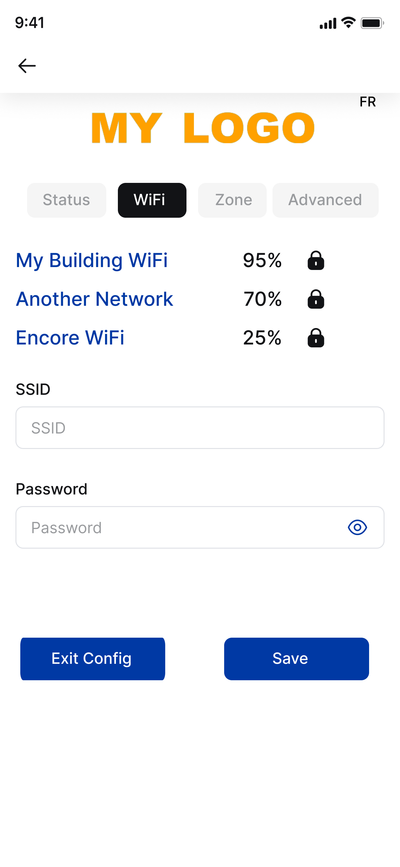

When saving, it will not associate to that SSID, but save it for when Exit Config is selected

This Page will only show up when Advanced page LoRa Toogle is OFF and LoRa tab will disappear

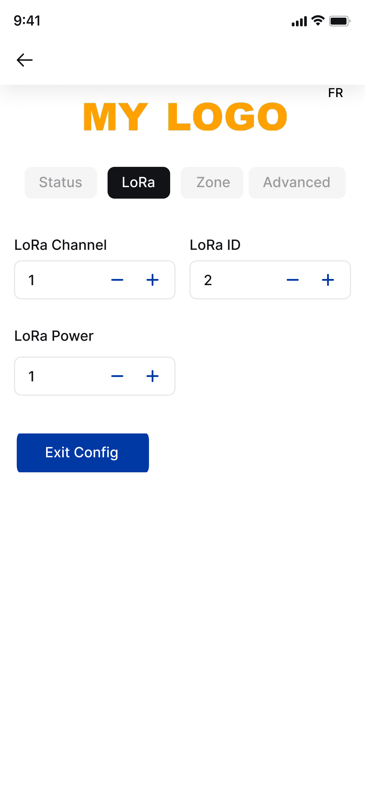

This Page will only show up when Advanced page LoRa Toogle is ON and WiFi tab will disappear

Values:

LoRa Channel : 0-12

ID : 2-99

Power: 1, 2 or 3

This Page has the main functionality. It allows user to pair a zone.

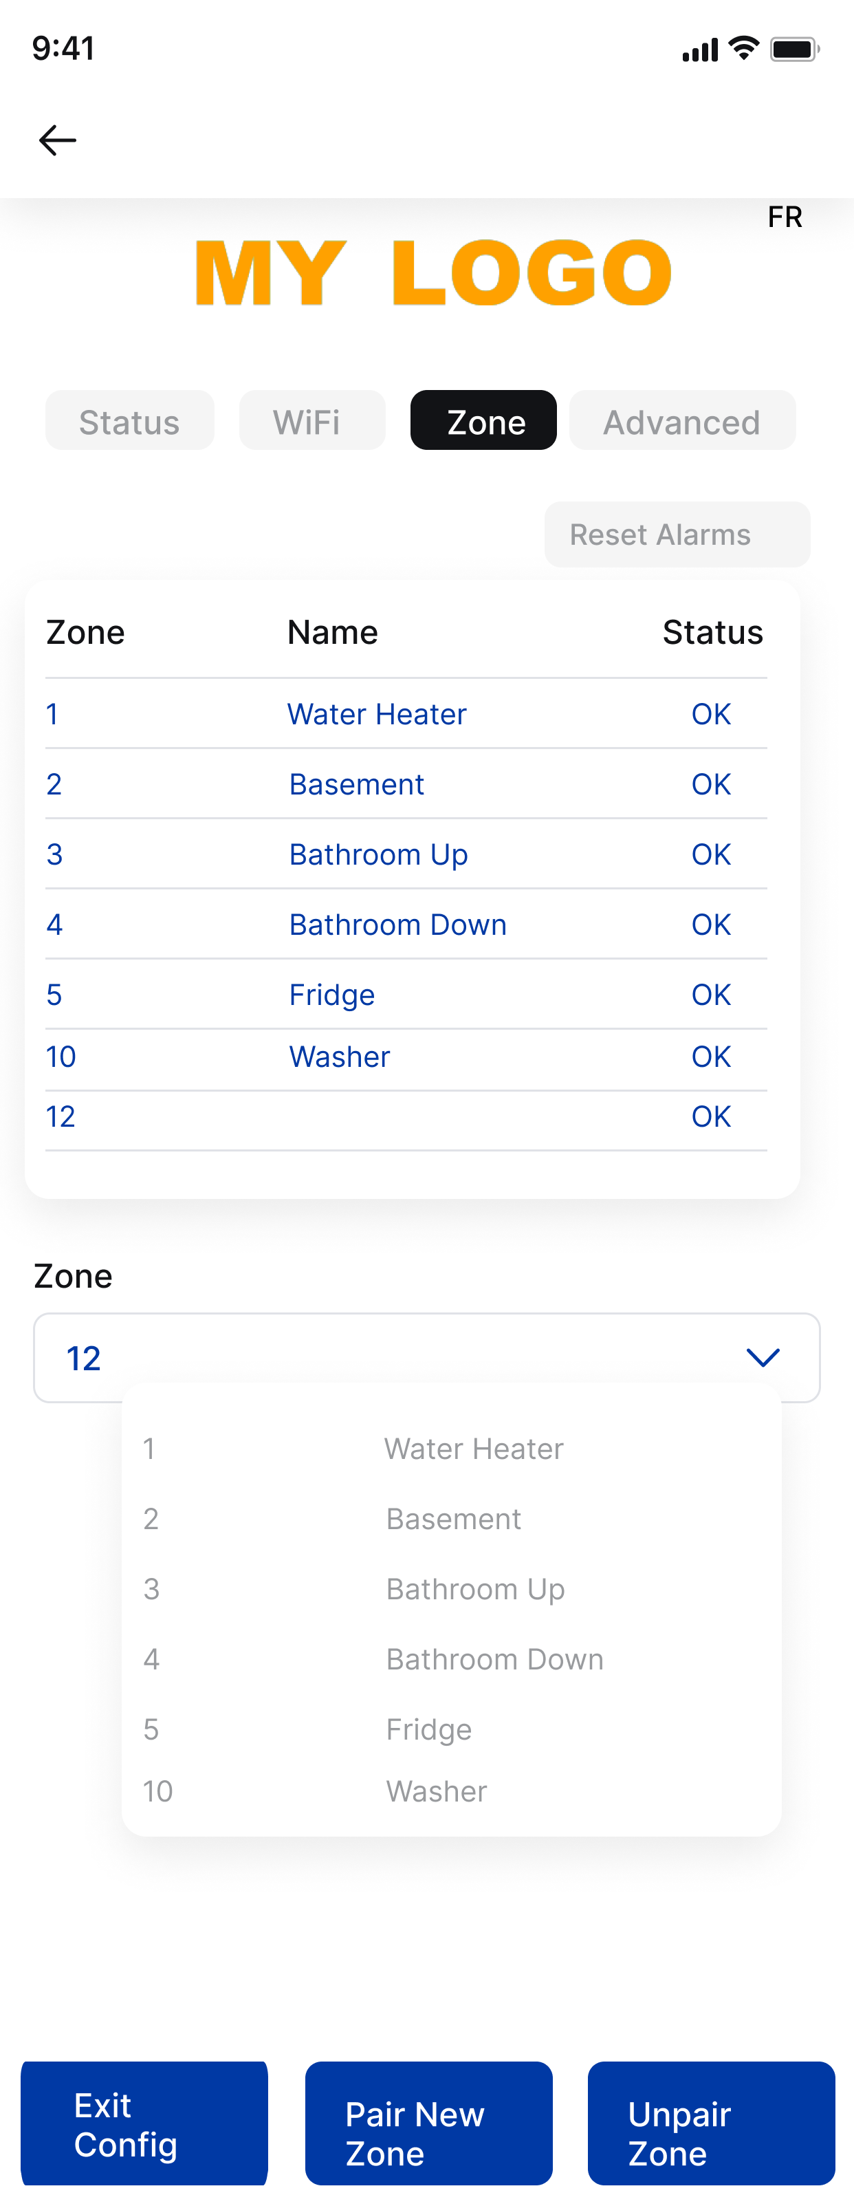

So he selects the Zone and description from the dropdown. Issue is dropdown can be very long with dozens of entries.

This will put microcontroller in pairing mode and zone will pair.

When the pairing happens, we want the listing to show automatically above without needing to refresh page. If we can javascript a beep, it would be great to.

A zone can just have a number, or a number and description

Unpair will unpair the zone.

Will update look on buttons and provide logos for the Status.

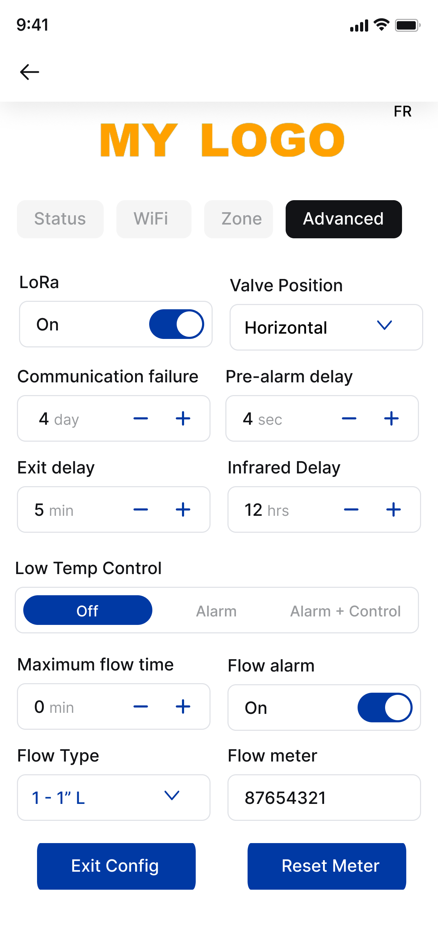

Values:

Valve Position: Horizontal or Vertical

Communication failure: 0-60

Pre-Alarm Delay 1-30

Exit Delay 0-30

Infrared Delay 0-60

Low Temp Control: 2 Off, 1 alarm only 0 enable

Max Flow Time: 0-99

Flow type:

0 – 3/4” L

1 – 1” L

3 – 3/4” G

4 – 1” G