Name: Sharif Ahmad

Reg. No.: 139743

Section: BESE 6B

Screenshots:

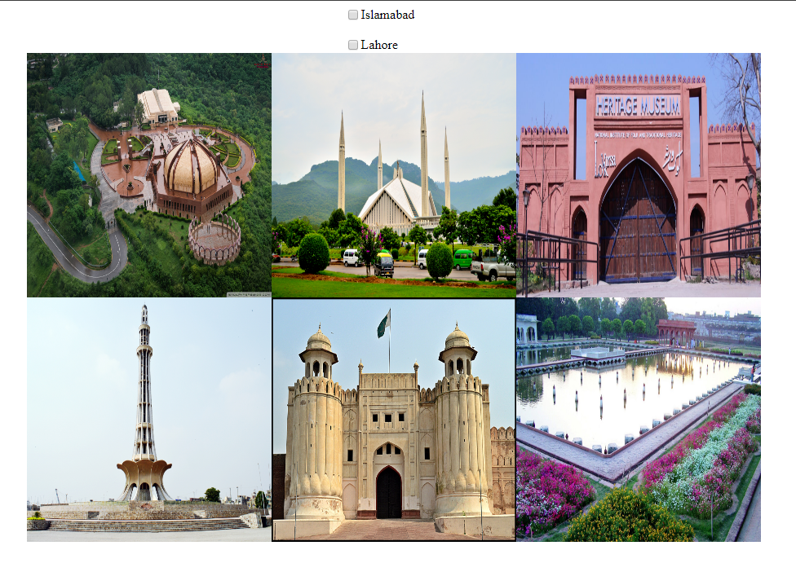

Code:

<!DOCTYPE html>

<html lang="en">

<head>

<meta charset="UTF-8">

<meta name="viewport" content="width=device-width, initial-scale=1.0">

<meta http-equiv="X-UA-Compatible" content="ie=edge">

<script src="https://cdnjs.cloudflare.com/ajax/libs/jquery/3.2.1/jquery.min.js"></script>

<script src="script.js"></script>

<link rel="stylesheet" href="style.css">

<title>lab 09</title>

</head>

<body>

<section id="chk1">

<input type="checkbox" id="Isd">

<label for="Islamabad">Islamabad</label>

</section><br>

<section id="chk2">

<input type="checkbox" id="Lhr">

<label for="Lahore">Lahore</label>

</section>

<section id="cards">

<div>

<img src="pak_monument.jpg" id="first" name="Islamabad">

*<!-- <p>Lorem ipsum dolor sit ametkd</p> -->*

</div>

<div>

<img src="faisal_mosque.jpg" id="second" name="Islamabad">

*<!-- <p>Lorem ipsum dolor sit ametkd</p> -->*

</div>

<div>

<img src="lok_virsa.jpg" id="third" name="Islamabad">

*<!-- <p>Lorem ipsum dolor sit ametkd</p> -->*

</div>

<div>

<img src="minar_e_pakistan.jpg" id="fourth" name="Lahore">

*<!-- <p>Lorem ipsum dolor sit ametkd</p> -->*

</div>

<div>

<img src="lahore_fort.jpg" id="fifth" name="Lahore">

*<!-- <p>Lorem ipsum dolor sit ametkd</p> -->*

</div>

<div>

<img src="shalimar_garden.jpg" id="sixth" name="Lahore">

*<!-- <p>Lorem ipsum dolor sit ametkd</p> -->*

</div>

</section>

</body>

</html>

body{

display: flex;

justify-content: center;

align-items: center;

flex-flow: column;

}

*/* p{*

*font-size : 2em;*

*} */*

#chk1,#chk2{

display: grid;

grid-template-columns: 20px 100px;

}

section#cards{

display: grid;

grid-template-columns : repeat(3, 300px);

grid-template-rows : repeat(3, 300px);

}

div{

display: flex;

}

img{

max-width: 100%;

height: auto;

}

$(document).ready(**function**(){

$("#Isd").change(**function**(){

$("#cards > div").show();

if($(this).prop("checked") == true){

$(" img[name |= 'Lahore'] ").hide();

}else{

$(" img[name |= 'Lahore'] ").show();

}

});

$("#Lhr").change(**function**(){

$("#cards > div").show();

if($(this).prop("checked") == true){

$(" img[name |= 'Islamabad'] ").hide();

}else{

$(" img[name |= 'Islamabad'] ").show();

}

});

$("div").click(**function**(){

$(this).toggle("slow");

});

}); */*----ready function------*/*