## Sharifa Isaako

## Interaction Design

## Assignment 1

## 91030913

## Project: Whanau (Family) Calendar

## Section 1

## Defining the problem

Provide a clear overview of Interaction Design which provides context to the project and report.

People use calendars frequently. An extensive large percentage use them every day more than once. Human-computer interaction (HCI) focuses on the design of computer technology and in particular the interaction between humans the users and computers. Calendars can help you organize your daily routines and keep a track of your to do lists, plus it’s a great tool to manage your time. Interaction design (IxD) explores how a user might interact with it. Products that provide great user experience is one that meets a particular user’s needs in the specific context where he or she uses the product. The user experience (UX) is a person’s emotions and attitudes about using a particular product. We are targeting the app is simple, easy and smooth to use. I proceeded with an heuristic analysis to determine which of the features that stood out the most. Because of time constraints I may be compelled to leave out features that could be impressive, but I could implement in the future. For example, to track a woman’s period. We have considered the user interface (UI) the visual look, feel and considered the user experience, the overall experience of the user while using the product. A clear and clean look, with easy buttons and functions on the screen. For example, to add a new event a button could be placed at the bottom right-hand corner. A user interface has three main outcomes: It should be easy for the user to become familiar with and competent in using during the first contact with the product. It should be easy for users to achieve their objective through using the product. It should be easy to recall the user interface and how to use it on subsequent uses. We will work creatively and improve the product while keeping the business goals in mind.

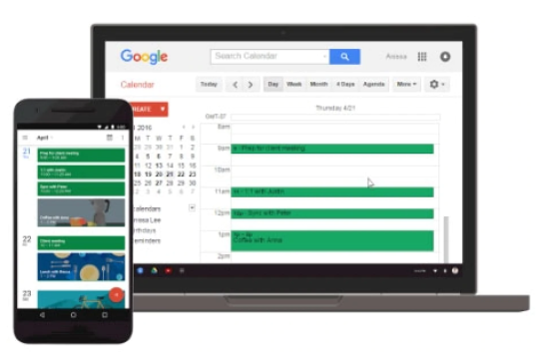

Problem Statement

Our problem statement is that we don’t have a family calendar app to help collaborate all family members commitments collectively. If it’s not in the calendar it doesn’t exist. Household management is vitally essential to help support survive our overloaded lifestyles. Including children alongside parents will generate a combined effort to further reduce additional weight to remember each other’s commitments.

Family members can set reminders, trainings, load sports, school related activities, play dates, assign tasks, pick up times, travel arrangements, sleepovers, chores, projects, due dates, meetings, meals, even shopping lists. Color coded so you can quickly see who needs to be where and when.

Bearing in mind, not everyone has the skills to interact and remember every detail already, this is why the development of this app will help develop the skills that many may lack already, this will help to train yourself and make life a lot more efficient.

Presently parents and children use their own calendars to plan and manage their commitments. As your children get older teach them it is their responsibility to get their events and deadlines on the family calendar as well. In that respect there is no characteristically designed application available for this purpose. Advertising and offering a family app would be beneficial to our daily lives not just to the parents but as well as the children remarkably. It is accessible for the whole family and the calendar has a very standard design so everyone can easily follow it.

Comparison of three applications

**Cozi**, Best for families

This app can keep all families in the loop. Its features allow you to coordinate everyone’s schedule in one place. Color coding features helps you keep track of each members appointments, assignments and task through the respective colors assigned to them. Reviews suggest limited features and lots of adds without paying premium which is expensive. Does not have the ability to create events that only I can see but other users will see it too.

**TimeTree**, Best for planning with friends

With this app you can share plans with people who are close to your heart. Plan and coordinate events together with your family by creating your schedule on just a single calendar. Also has a chat feature. Every member can give their opinions and offer suggestions in the collaborative calendar. A review has suggested not user friendly at times. But overall easy to use.

**OurHome**, Tailored to families

This app helps you monitor if your kids are doing their assigned tasks. You can mange family task assignments and organize the day to day activities of your household. Schedule tasks and allocate them to the members of the family. This app has a goal setting feature so kids can see, who and what goals they are aiming for. No adds, no subscriptions a truly free app. It has a few bugs and could do with a few more features but overall a great app been reviewed.

Identify any five-design principles and explain how they will be used within the design of this application with examples

**User experience**

Match user experience and expectations. The app needs to be centered on improving user experience with the product. We will be the voice of the user and advocate for the users’ needs while balancing the business goals. By speaking directly to their personas and helping users find relevant content immediately is a good understanding of the makeup of good and bad user experiences. For example, the calendar must be desirable, branded and design elements are used to engage in emotion and appreciation.

**Consistent design**

By maintaining consistency, you are helping users learn more quickly and they can reapply their prior experiences from one part of an application to another. For example, design a sample notification and color code it for different situations. Visual consistency is essential that the overall system should look unified, right from the fonts to body of the text.

**Engagement**

Design interactively such a way that it keeps the user engaged. Engagement is the measure of the extent to which the user has a positive experience with the product. The user should always feel like they are in control of the experience. We should allow users to concentrate on their work and not on the interface. The save button is an example telling the user once your happy with the data entered you click, and an event will be created. Now the user and members can view the new event in the calendar.

**User control**

Trust inspires confidence and with confidence the user is free to explore further. The user should have ultimate control. Allowing the user to control, trust and explore. If users feel in control of the process, they will feel comfortable and trust the system and believe the app is advantageous to their workload. For example, a common design pattern for increasing user control is undo.

**Learnability**

Bottom line is making sure the user interactions are easy to learn and remember. The goal is to encourage more user interaction. App retention is how many users kept your app after downloading and launching it in a certain time frame. This can have a huge impact on the ultimate success of the app. Learnability is one of the most important usability characteristics it will influence how many people abandon your product or stick with it. The simple, clear and easy design of the calendar is focusing on this important principle.

Provides a clear justification of the importance of using design principles for effective interaction design.

Interaction designers succeed at creating great design that are clear, minimal and to the point. You can only achieve this by adhering to the design principles. The interface parameters combined with the design principles should guide the creation of an effective interface. The principles of design are made up of various mixes of the elements of design all put together in one picture making the picture look better. This will amaze people and get good publicly and hopefully benefit the artist who made them.

## Section 2

## Project concept

A brief overview

If it’s not in the calendar it doesn’t exist! The family (whanau) calendar is a great collaborative family calendar that lets you and members share and create content together. It not only helps keep a track of your personal appointments but also other members schedules. Your entire family working together to get things done and you will always know what’s going on. Push notifications call be changed in the settings.

Identifies and describes the primary users

The primary user is in direct contact with the system interface and is usually most affect by it. The calendar app will be used most frequently by parents.

A board range of secondary users of the system identified

The secondary users are children or other members with are lighter daily schedule. These users may create much less events as to a primary user. Secondary users maybe more dependent on the primary user’s interaction.

Explains the importance of identifying a board range user

Involving users early in web projects results in better products for users, more efficient development and other benefits to stakeholders. When you understand how people use your product you can make informed decisions and avoid wasting time guessing. It also avoids making compromises later. All these benefit the developers, project manager and stakeholders.

Identifies and explains three techniques used in UCD process per phase and describes how each technique is adopted within the UCD process

Research

Understand and specify the user context. Personas, asking users questions through surveys can gather some useful information too. It’s useful when customers just tell you their expectations. Survey monkey is a great tool for surveys. Another important phase is to perform interviews with stakeholders and colleagues on the project, all this is really for is that you are meeting all the business requirements, and everyone feels like they are part of the design process.

Concept

Specify user requirements. Once we have a deeper understanding of the problems, we are facing we can get going on the ideation phase of the project. Now we are going to look holistically at the entire journey and it’s essential to understand how everything fits together. It’s important to understand the whole machine before designing an individual piece. Stories are a great way to tell your users. We are going to use a process called customer journey mapping this is a technique where we illustrate the entire process from beginning to end. The bigger the better!

Design

Produce design solutions to meet user requirements. Information architecture (IA) is the page structure of your website. A tree test is a great tool, it’s an examination of the structure of your website. You can test you most important pages if they do not perform well the tool tells you where the users think the pages should be, this is simple to change in the structure. A card sort will help you define your information architecture. If your starting from scratch a card sorting workshop is the way to go. Participants are asked to organize physical cards with page names on them into groups and give them category labels. This can be tested with more users than a tree test. After a few you will see a pattern emerge. Your job as a designer is to be a facilitator and gather users’ expectations and deliver on what they expect.

Lightning talk video

See attached teams link to watch and view.

## Section 3

## Implementation considerations

Explain iteration, evaluation and prototyping within the User-centred design (UCD) process and how this ensures the development of a usable interactive product.

Iteration

The earlier the interaction design iteration begins, the better. A product is not designed in one go, it takes many iterations to get the product improved, receive feedback and then fine-tune for an overall great design. This is used as a form of research and encourages user feedback which will benefit and mitigate any lessons learned. Speedy and productive iterations are the key to a successful design process. This doubles as evidence if required by the stakeholder. Some typical steps of iterative design: present the design to several test users, note any problems had by the test user, refine and or fix problems, repeat until problems are resolved. These processes are intended to improve the quality and functionality of a design.

Evaluation

Evaluating design using a set of heuristics principles which can help identify and deal with any identifiable usability issues. This is done to help inform the design of a product and evaluate existing products. This method uses shortcuts to produce good enough solutions in each time frame or deadline. Designing consistency, flexibility and efficient use will support and improve the usability, utility, and desirability of your designs. There are 10 rules of thumb and 8 golden rules which are used as inspiration which we will make sure to combine them all with the design guidelines.

Prototyping

We can use interaction design prototypes to experiment and implement ideas on paper or digital format to avoid costly mistakes. The most important advantage of a prototype it stimulates the real and future product. Simple tools can be used to create a prototype and therefore an important and is a valuable stage in the UCD design process. Low fidelity prototypes such as sketches are used in the early stages of development and higher fidelity prototypes such as mock-ups are used later in the design process. The key benefits of low fidelity prototypes are that they are fast and easy to develop and the user can provide feedback. A sketch, wireframe or mock is included in this document.

Sketch example:

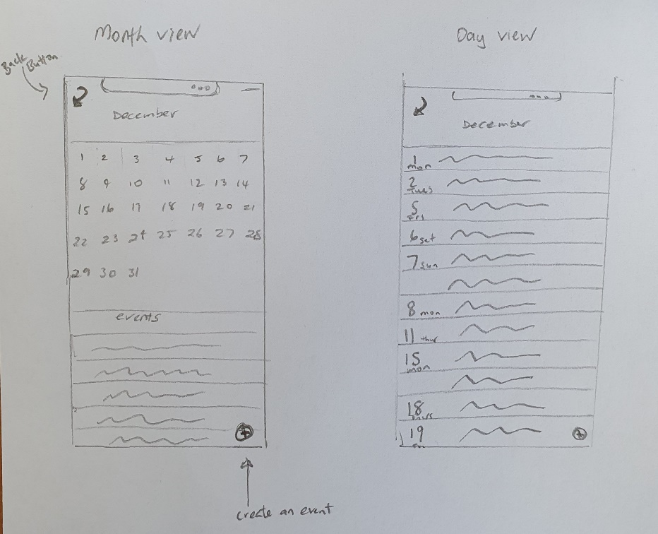

Mock-up example:

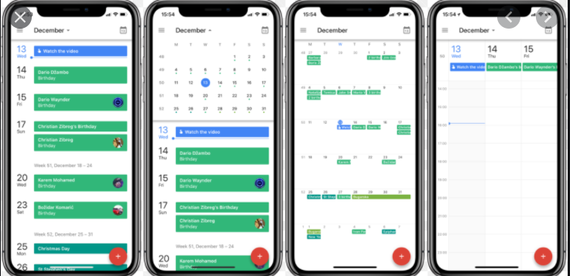

References:

Lindberg, O. (2019, October 17). Creating Interactions: An overview of UI. Retrieved from <https://xd.adobe.com/ideas/process/ui-design/overview-of-ui-user-interfaces/>

Mitra, M. (2016, April 13). 10 Most important interaction design principles. Retrieved from <https://www.mantralabsglobal.com/blog/10-basic-principles-of-interaction-design/>

Collaboration Tools:

Trello: <https://trello.com/b/7hVfUt4b/business-case>

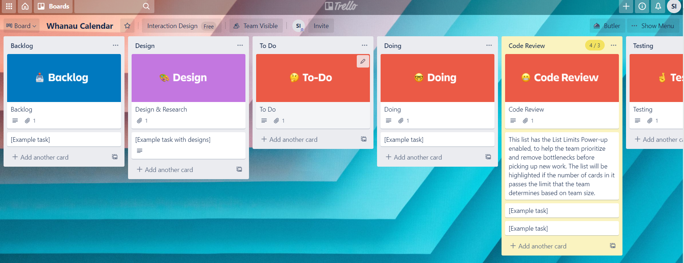

Github: <https://github.com/sharifaisaako/Interaction-Design>

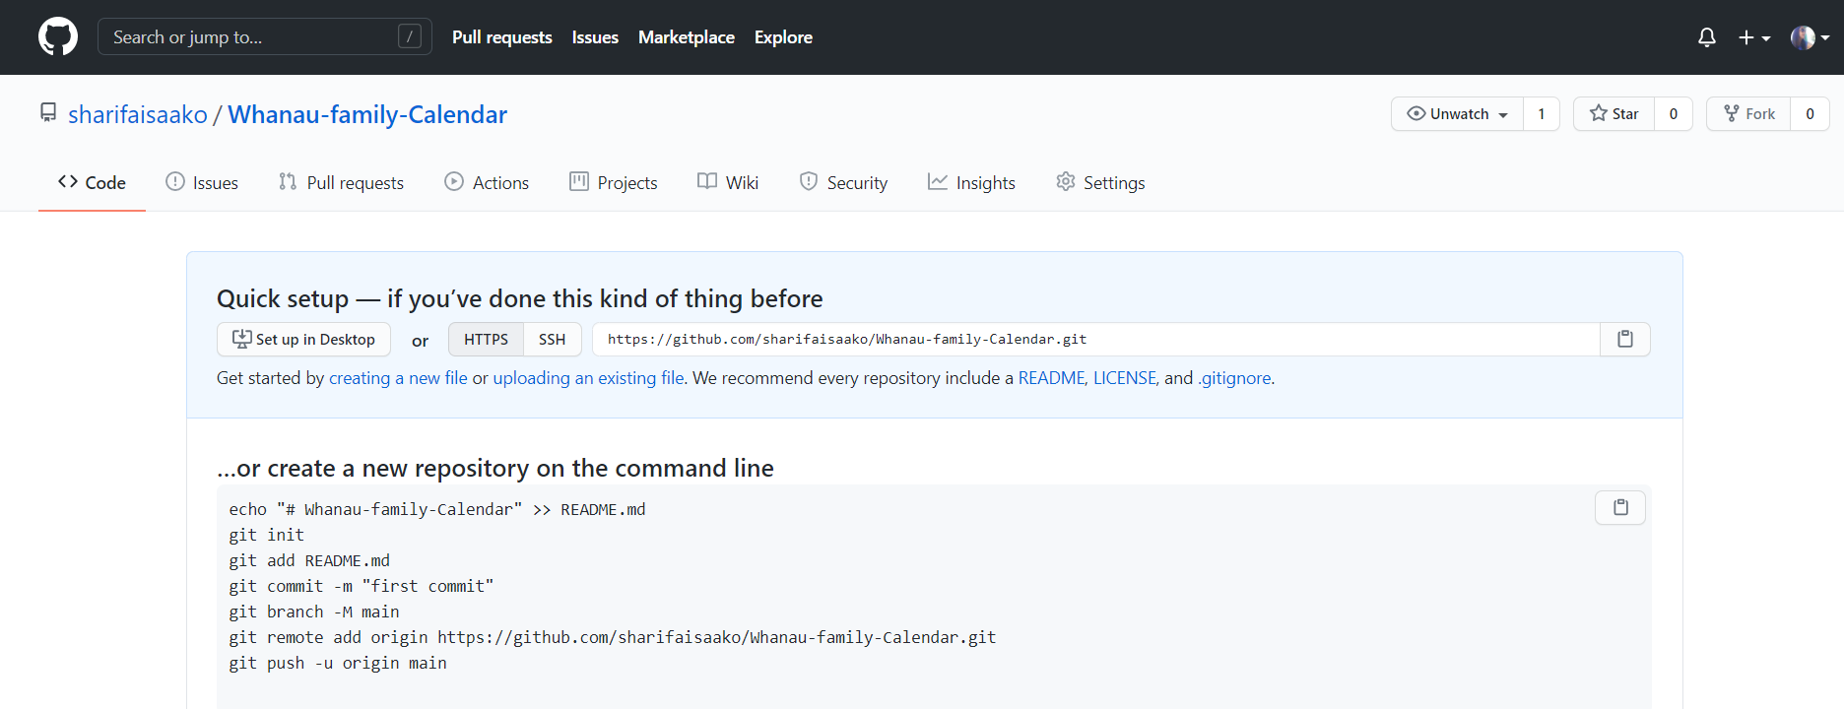

Teams: <https://teams.microsoft.com/l/team/19%3ad47abd764a054811a5e375066aac2500%40thread.tacv2/conversations?groupId=4d0ee933-514d-45fa-af22-eb1cef0f52b0&tenantId=181d82a2-39a4-4a67-ac77-14f37724e23b>

