Sharifa Isaako

Interaction Design

Assignment 2

91030913

Project: Whanau (Family) Calendar

Task 1

Overview of concept

If it’s not in the calendar it doesn’t exist! The family (whanau) calendar is a great collaborative family calendar that lets you and members share and create content together. It not only helps keep a track of your personal appointments but also other members schedules. Your entire family working together to get things done and you will always know what’s going on. Household management is vitally essential to help support survive our overloaded lifestyles. Including children alongside parents will generate a combined effort to further reduce additional weight to remember each other’s commitments. People use calendars frequently. An extensive large percentage use them every day more than once. Human-computer interaction (HCI) focuses on the design of computer technology and in particular the interaction between humans the users and computers. Calendars can help you organize your daily routines and keep a track of your to do lists, plus it’s a great tool to manage your time. Family members can set reminders, trainings, load sports, school related activities, play dates, assign tasks, pick up times, travel arrangements, sleepovers, chores, projects, due dates, meetings, meals, even shopping lists. Color coded so you can quickly see who needs to be where and when.

Presently parents and children use their own calendars to plan and manage their commitments. As your children get older teach them it is their responsibility to get their events and deadlines on the family calendar as well. In that respect there is no characteristically designed application available for this purpose. Advertising and offering a family app would be beneficial to our daily lives not just to the parents but as well as the children remarkably. It is accessible for the whole family and the calendar has a very standard design so everyone can easily follow it.

Interaction design (IxD) explores how a user might interact with it. Products that provide great user experience is one that meets a particular user’s needs in the specific context where he or she uses the product. The user experience (UX) is a person’s emotions and attitudes about using a particular product. We are targeting the app is simple, easy and smooth to use. I proceeded with an heuristic analysis to determine which of the features that stood out the most.

We have considered the user interface (UI) the visual look, feel and considered the user experience, the overall experience of the user while using the product. A clear and clean look, with easy buttons and functions on the screen. For example, to add a new event a button could be placed at the bottom right-hand corner. A user interface has three main outcomes: It should be easy for the user to become familiar with and competent in using during the first contact with the product. It should be easy for users to achieve their objective through using the product. It should be easy to recall the user interface and how to use it on subsequent uses. We will work creatively and improve the product while keeping the business goals in mind.

The aim of this report to cover the user centred design process (UCD). It is important to understand the whole machine before designing an individual piece. Customer journey mapping is a great way to get people involved, the bigger the better. A customer journey map shows your whole process from beginning to end. Creating brilliant content and you want your users to find it unfortunately this does not always happen, getting a solid navigation structure and information architecture is the best return for your investment you can get on a website. Information architecture (IA) is the page structure of your website. A tree test is an examination of your information architecture. A persona is a representation of a type of user.

A mental model is what we form when interacting with a product and is formed based on our beliefs about the system and how the system works. This model is constructed primarily on the person’s past experiences and what they think they know about the system. These beliefs we consider how we design to their mental model. Respecting people’s mental model is really the foundation of designing usable, user-centred systems. It is important to conduct research and find out what our users’ mental models are to make sure we design the system to match those expectations.

Task 2

User analysis

Summary of interviews.

Interview one; female Student studying at college prefers to use a paper calendar vs an app. The purpose of the interview is to gain further insight in relation to the whanau calendar. Her experiences relate to google calendar and or her operating system calendar. Google calendar is easy to use and there is no lack of design. She is feeling there could be an improvement done in when you schedule for all the weeks could be changed into a different format. An experience when she wanted to schedule a meeting not everyone ended up receiving an invite, it did not go through. Some requirement suggestions she would look for in a new calendar would be a chat feature, a feature to invite people and a view daily, weekly, monthly view. Some other topics she raised a restriction mode, more colourful, to do list, important list.

Interview two; female Student studying at college prefers to use a paper calendar vs an app. The purpose of the interview is to gain further insight in relation to the whanau calendar. Her experiences relate to Apple calendar. Apple calendar is easy to use, useful if I have a lot going on. She suggested some changes in her current calendar the design could look better and maybe the layout could be improved. The only experiences she could think of and share is the alerts are helpful. She did mention that she enjoys and what she likes about the Apple calendar that it is colour coded. She also likes that the calendars can be set up e.g., school, sport, work etc. Some requirements she mentioned be able to change the theme, interactive design, simple design, be able to customize the colour and night mode option.

Task 3

Evaluating existing products

My evaluators are college students, university students, young adults, and matured adults.

Evaluation of three products in the form of heuristic evaluation.

Cozi, Best for families

This app can keep all families in the loop. Its features allow you to coordinate everyone’s schedule in one place. Color coding features helps you keep track of each members appointments, assignments and task through the respective colors assigned to them. Reviews suggest limited features and lots of adds without paying premium which is expensive. Does not have the ability to create events that only I can see but other users will see it too.

Feedback from evaluators

Do not like the design at all. Too complex instead of simple. Simple squares. All the good stuff needs to be paid for. Ugly don’t like it. Adds! Big no no. Too repetitive.

TimeTree, Best for planning with friends

With this app you can share plans with people who are close to your heart. Plan and coordinate events together with your family by creating your schedule on just a single calendar. Also has a chat feature. Every member can give their opinions and offer suggestions in the collaborative calendar. A review has suggested not user friendly at times. But overall easy to use.

Feedback from evaluators

Just like a standard calendar that you hang up on the wall. Easy. I like this better than Cozi, you can see everything. There is a weekly, monthly but no daily view. Overall ok. Able to change color scheme and add photos to events.

OurHome, Tailored to families

This app helps you monitor if your kids are doing their assigned tasks. You can manage family task assignments and organize the day-to-day activities of your household. Schedule tasks and allocate them to the members of the family. This app has a goal setting feature so kids can see, who and what goals they are aiming for. No adds, no subscriptions a truly free app. It has a few bugs and could do with a few more features but overall a great app been reviewed.

Feedback from evaluators

Slow app, maybe a bug and the loading time no good. More fit for families yes. Interesting. Like how it has a reward system. Could be more colourful. Could not find a dark mode or colour settings anywhere. Calendar is ugly looks very squashed. Features are good. Simple and easy to use, font is readable.

Summary

A heuristic evaluation also known as expert review is an assessment of a digital experience to identify usability issues, which conflict with know best practices and which highlights the good and bad design aspects within a current design. But it can also include putting using context with the competition. We do this to help us identify problem areas and potential opportunities. Heuristics help us answer two important questions. How do we stack up and where do we sit? Its typically a rule of thumb used to help work through or understand how to improve the design of things.

Always make sure that the system has a simple and efficient emergency exit to fix user error. Like a back button? The best designs do not only have great error recovery but prevent users from making those errors. Flexibility and efficiency of use, it does not matter if you are an expert or a newbie. Design needs to be minimal and therefore as efficient as possible. Make sure your system has good error recovery and messages are in plain language. Even though the system can be used without documentation it may be necessary to provide it to help the user. Competitor audit compares existing features to identify positives and negatives within the design, which can be used when developing the product. The family (whanau) calendar is a great collaborative family calendar that lets you and members share and create content together. It not only helps keep a track of your personal appointments but also other members schedules. Your entire family working together to get things done and you will always know what’s going on. Push notifications call be changed in the settings. Color, night mode and theme have been top recommendations. The views have been mentioned constantly. Requirement a daily, weekly and monthly options. Possibly a chat feature. A free app without adds is highly recommended.

Task 4

Functional and non-functional requirements

Functional requirements

Functional requirements state what the system should do. They are the functions that the developer must build into a product to enable users to accomplish their tasks, therefore, satisfying the user and business requirements.

Users being able to insert meetings, schedule meetings and invite people.

User be able to assign tasks and monitor your kids doing their assigned tasks.

You can manage family commitments and organize the day-to-day activities.

Be able to colour code the calendar and change to a night mode.

A feature to do list and important list.

Viewing calendars in a variety of ways, daily, weekly, monthly, or yearly.

Login/sign up page, verification email is sent to user whenever the user registers for the first time.

Authentication of a user when they try to log into the calendar.

The site should load within 3 seconds or less? Or even 2 second or less?

Non-functional requirements

Non-functional requirements describe how a system must behave also known as the systems’ quality attributes.

Efficiency of use the average time it takes the accomplish the user’s goals.

How simple it is to understand the interface, buttons, headings etc.

How many attempts are needed by users to accomplish a particular task.

Security requirements ensure that the software is protected from unauthorised access to the system and its stored data.

The database update process must roll back all related updates.

Performance that describes the responsiveness of the system. Poor performance leads to negative user experience.

Scheduled maintenance how the impact can be minimized.

Task 5

Users and personas

## Persona 1

## Tamara Jenkins



Age: 20

Occupation: University student

Education: Studying Bachelor of Medicine and Bachelor of Surgery.

Location: Otago

Disability: None

“I need to be able to study and live my best life at medical school”.

About Tamara:

Tamara is a full-time student who is currently studying in Otago University. She wants to join the Health sector once she finishes her PhD. It is not easy to balance her study and social life, it can be challenging at times. She plays netball and volley for her varsity teams.

Key Goals:

To complete all study tasks in reasonable timeframes and still have time for self-love as well as spend time with my friends.

Pain Points: We must:

Is missing her family and siblings back home. Encourage only special home visits.

She needs to talk to them daily. Allow only mutual time for family.

Finding it hard living a student life on a budget. Possibly advise a part time job.

## Persona 2

## Pretti Singh



Age: 23

Occupation: Project coordinator

Education: Graduated from Victoria Uni, Degree in Political Science, and International Relations.

Location: Wellington

Disability: None

“There are no limits to what you can accomplish, except the limits you place on your own thinking”.

About Pretti:

Pretti is a project coordinator for a government organization. Once she graduated, she landed this role. She lives a very busy complex lifestyle. She offers her time in multiple volunteer organizations as well. She has a political passion and strong female empowerment.

Key Goals:

Empower and motivate others to achieve their full potential and promote woman in workforce. I also have a passion for climate change.

Pain Points: We must:

She goes out with friends too frequently. Limit and identify important events.

Need to implement a time management system. Make it simple and easy.

Spending too much money on food. Start cooking at home.

## Persona 3

## Chloe Edwards



Age: 40

Occupation: Full-time mum studying and part time property work.

Education: Studying for a Bachelor of Applied IT

Location: Wellington

Disability: None

“Just trying to build and better myself alongside raising my children.”

About Chloe:

Chloe is a full-time student who is currently studying in Wellington. She is seeking a new career change once she finishes her bachelor’s degree. She finds study harder due to her age and her commitments with her children and her family needs.

Keep Goals:

To complete and finish her degree and find a role that she will enjoy.

Pain Points: We must:

Hard to keep up with everyone’s commitments. Create a simple collaborative system.

To stay out of the kitchen. Implement all family members to help.

To stay focused while studying. Improve her study techniques.

A persona is a fictional profile that represents a particular group of users based on research. Rather than having many personas you would create only three or four key character ones. You can give each of your persona’s life by creating scenarios that feature them in the role of a user. Scenarios describe the stories and context behind why a specific user or user group. Most importantly personas help make the design less complex, they will guide and map your ideation process, and lastly, they will help you to achieve the goal of creating a good user experience for your target user group. Personas also create buy-ins in a team as well as empathy, helps members get into the shoes of different customer groups. Personas are also used in the UCD process when developing the prototype. Personas need to be detailed enough to become real users as we do need to recruit users for testing iteration.

Task 6

Task flows and low-resolution wireframe

Feature list for the Whanau calendar app:

* Insert meetings.
* Manage family commitments.
* Organize the day-to-day activities.
* Schedule meetings and invite people.
* Schedule meetings and invite people.
* Assign tasks.
* Colour code the calendar
* Monitor kids doing their assigned tasks.
* Change to a night mode.
* To do list
* Important list.
* Theme options
* View calendars daily, weekly, monthly, or yearly.
* Login/sign up page.
* Verification email
* Authentication of user
* 2-3 seconds loading or less.
* Set reminders.
* Push notifications
* Shopping lists
* Simple easy to use.

The scenario

The individual user from the persona Chloe her needs describe that she requires a calendar where she can manage family commitments, her daily needs and mange her time so she can study and work to balance her life. She requires her family to help around the home with chores and cooking. With this app she can assign tasks to all family members. There could be a reward system set up which will give members an incentive to take on more duties. Colour, themes, and night modes are features that will be comprised requirement from the research feedback. We will focus on one platform the mobile app and develop the prototype typically focusing on a minimal viable product (MVP).

Chloe is studying at home and her daughter has training after school. But due to the coach been away her daughter can open the app and change the scheduled pick-up time. Chloe (mum) will receive a push notification that an event has been changed and is now required to go pick up her daughter from college. Chloe can also acknowledge she has read and received the changed event, so her daughter knows that mum is on her way. This helpful feature will be a source of security and safety for Chloe and her daughter. Also, dad and other members can see their siblings training has been cancelled and will be home earlier than expect. Now the family can all go out for dinner as they were hoping to find time one night this week.

Flow Diagram

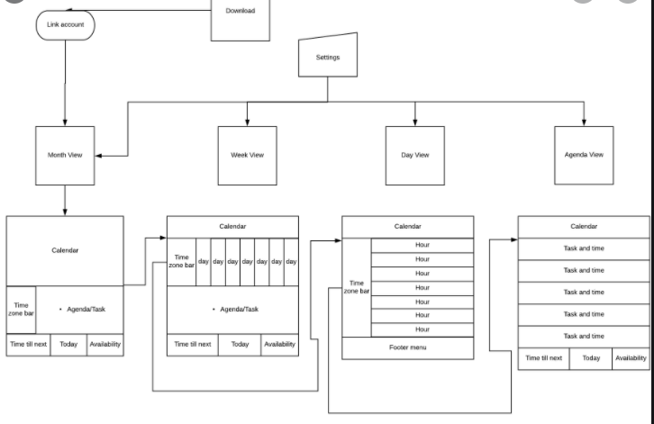

Wireframes

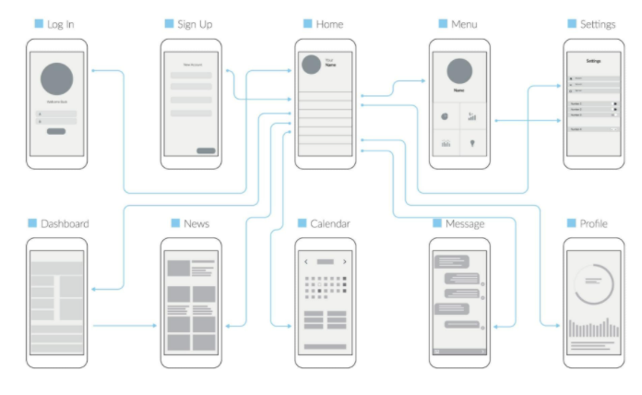

Example of different Views

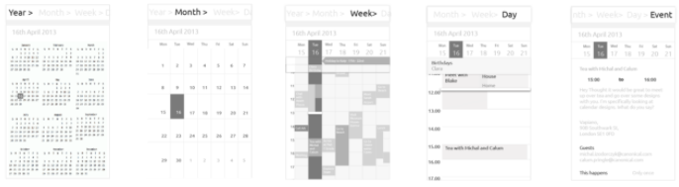

Collaboration Tools:

Trello: <https://trello.com/b/7hVfUt4b/business-case>

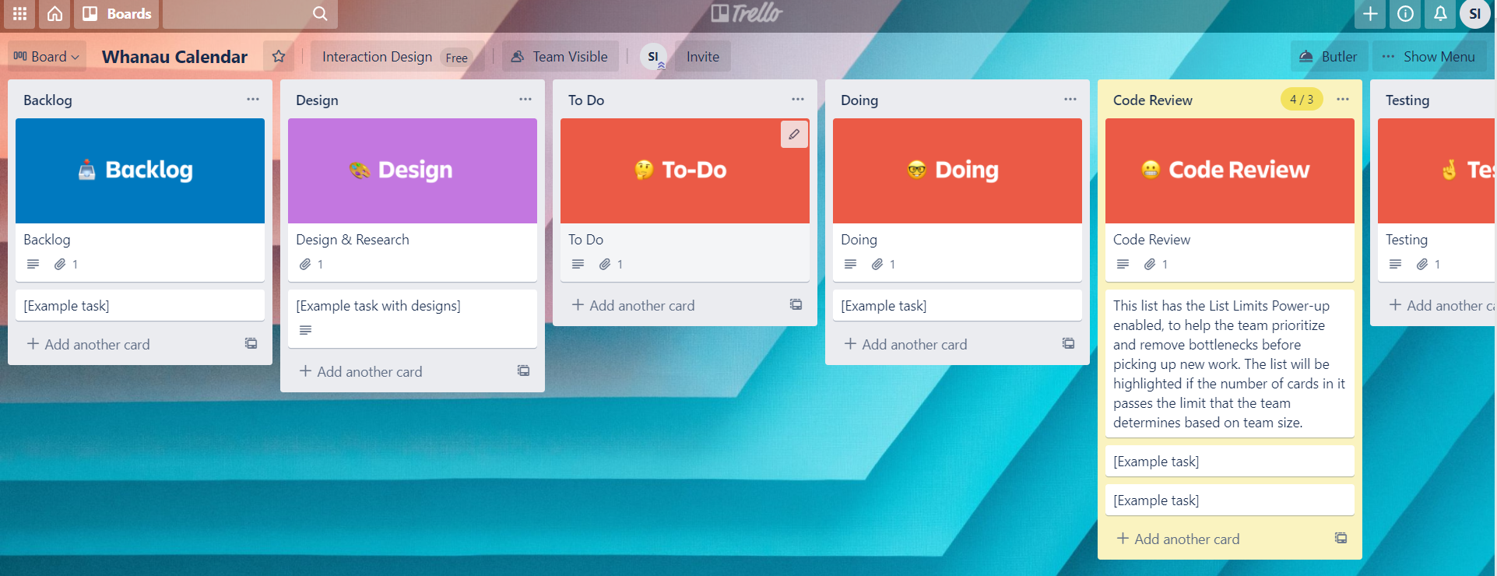

Github: https://github.com/sharifaisaako/Whanau-family-Calendar

