**Resume of** 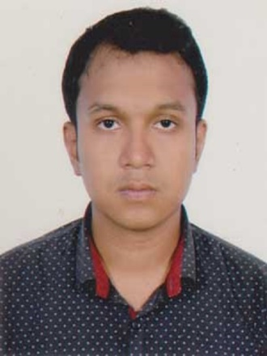

**Sharif Ashik Ishtiak**

o/4,NurjahanRoad,Mohammadpur,Dhaka

Dhaka-1207

Cell: 01944896737

E-mail:shrifashik591@gmail.com

● **Employment Objective**

To pursue a work by which I can serve by using my vision, positive attitude, interpersonal relationship, communication skill to take the challenges that will also ensure me the opportunity to grow by learning skills and knowledge ass will as develop your institution.

● **Academic Qualifications**

Bachelor of Science **(BSc)**

Institute : Daffodil International University

Subject : Computing Information System (CIS)

Passing year : Running 3rd year

**HIGHER SECONDARY CERTIFICATE (HSC)**

Institute : Lohagara Govt. Ideal College

Group : Science

Result : GPA-4.50 (Out of 5)

Passing Year : 2016

Board : Jessore

**SECONDARY SCHOOL CERTIFICATE (SSC)**

Institute : Lohagara Pilot High School

Group : Science

Result : GPA-5.00 (Out of 5)

Passing Year : 2014

Board : Jessore

● **Language Proficiency**

Excellent communication capabilities both verbal and writing in:

English : Reading, Writing, Listening & Speaking Fluent

Bangla : Reading, Writing, Listening & Speaking

● **Computer Literacy**

* MS Office XP (MS Word, Excel, Power Point)
* Internet Browsing
* Web Design
* Graphic Design
* Data analysis

● **Other Interest**

* Traveling
* Community Involvement
* Creative Thinking
* Reading

●  **Skills**

* Ability to work independently and in group
* Ability to work under pressure
* Natural ability to communicative with effectively and persuasively
* Voluntary Work
* Communication
* Critical thinking

Programming Language

* C
* Python

● **Personal Information**

Name : Sharif Ashik Ishtiak

Father`s Name : Sharif Mamunur Rasheed

Mother`s Name : Reshma Khanam

Permanent Address : Vill-Lohagora, P.O- Lohagora,

P.S –Lohagara, Dist – Narail.

Death of Birth : 30/11/1998

Marital Status : Single

Nationality : Bangladeshi (by birth)

Religion : Islam (Sunni)

Sex : Male

Height : 5’-6’’

Blood Group : B+

● **Declaration**

I am Sharif Ashik Ishtiak certify that to the best of my knowledge and belief, these data correctly describe my qualification.

Sharif Ashik Ishtiak

Date:04-06-2020