regN:22RP04321

Report

1)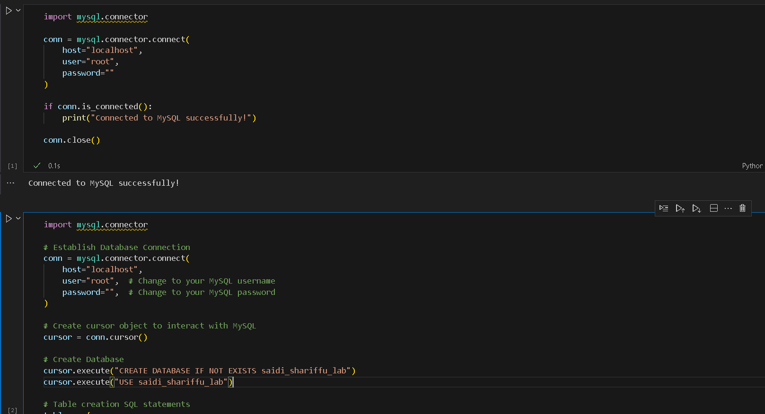

To connected is mysql are successfully

2)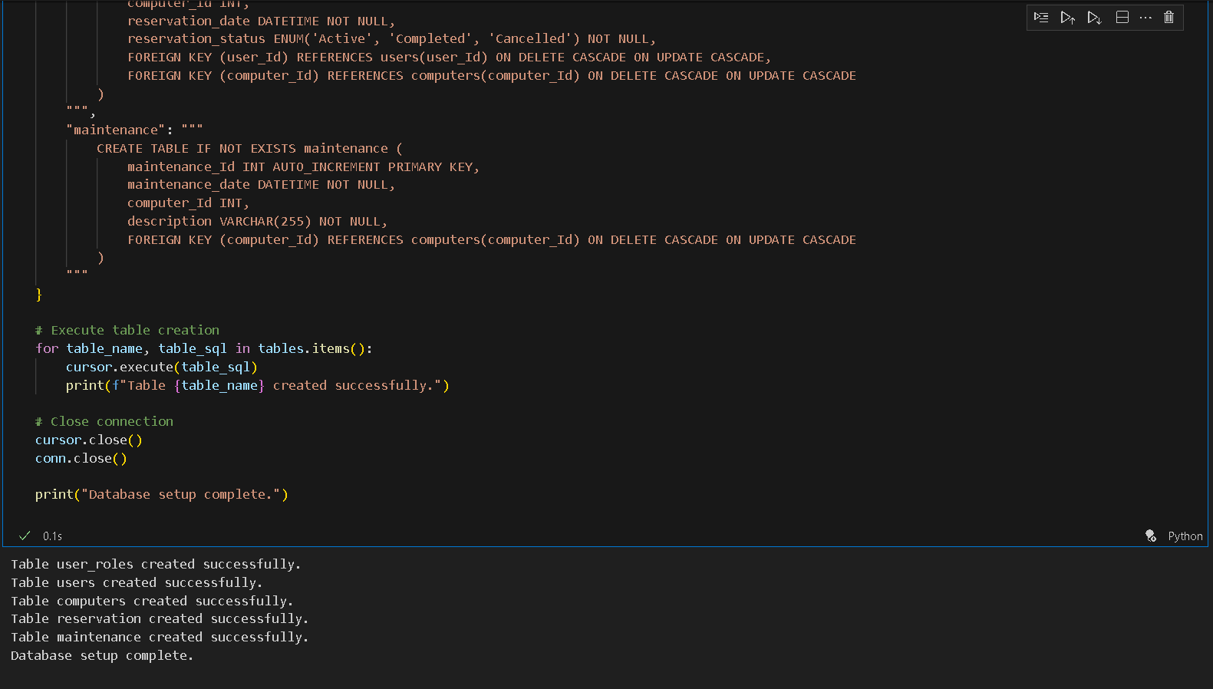

The all tables are be created and this out put of all tables.

3)

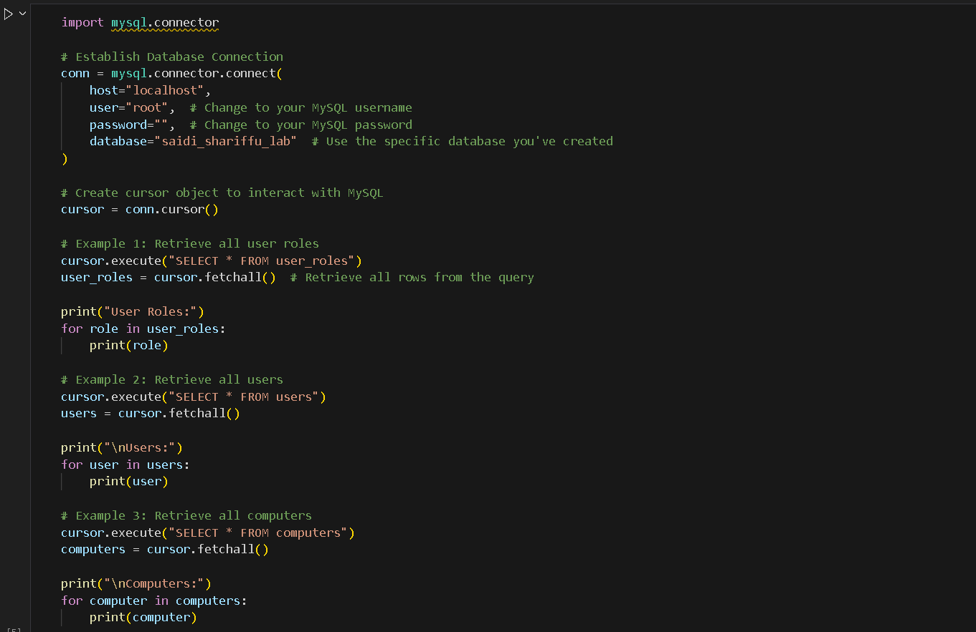

To Retrieve table that can have

4)

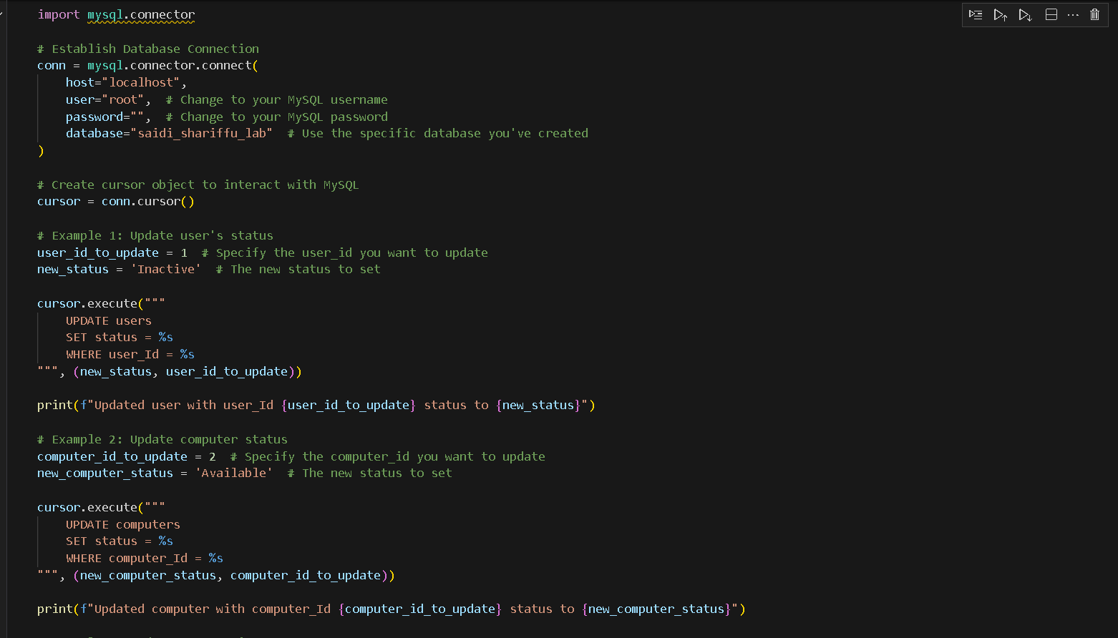

The update are be done for table

5)

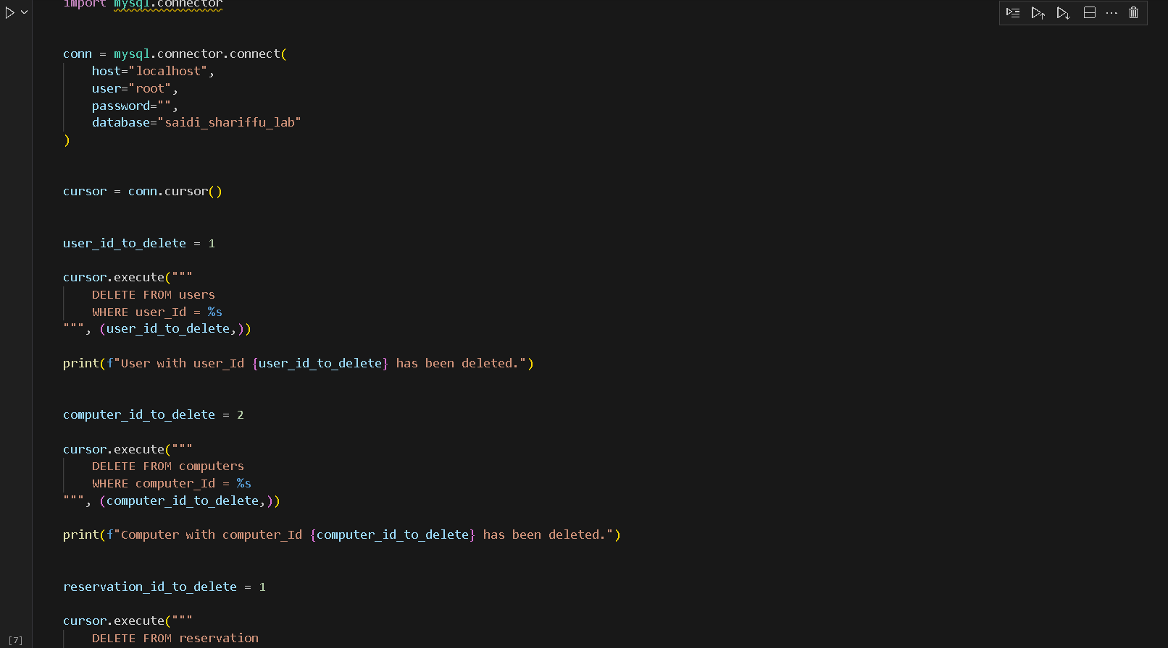

All table are deleted