FINAL CAPSTONE PROJECT
RAG-POWERED SEARCH ENGINE
**Q&A with Retrieval-Augmented Generation**

INDEX:

Table of Contents
Cover 1
INDEX: 2
1. Abstract 4
2. Introduction 4
3. Objective of the Project 4
4. Use of Dummy Company PDFs 5
5. System Architecture 5
6. Choice of Local ChromaDB 6
7. Model & Parameter Selection Rationale 6
8. Implementation Details 6
9. Execution Flow 7
10. How to Run the Project 7
Notebook Version 7
Streamlit Version 8
Output Screenshots: 8
11. Output of the System 9
12. Basic Evaluation 9
14. Conclusion 9
15. Files uploaded to GitHub (As informed to us by management) 9

Retrieval-Augmented Generation (RAG) based HR Policy Assistant
Final Project Report – Advanced Certification in GenAI (by E&ICT Academy, IIT Ghty), Batch1
Name: Mohammad Sharif Islam
Email: sharifislam.workmail@gmail.com
Mobile: 9886431461
Location: Bangalore / Guwahati
LinkedIn ID - https://www.linkedin.com/in/mohammad-sharif-islam-b6218714/

1. Abstract
This project presents a Retrieval-Augmented Generation (RAG) based system designed to answer user queries from company policy documents. The system combines document embeddings, vector similarity search using ChromaDB, and a Large Language Model (LLM) to generate accurate and context-grounded responses. The objective is to reduce hallucination and improve factual correctness compared to a standalone LLM.

2. Introduction
Large organizations either maintain multiple policy documents or a huge document that employees frequently need to reference. Searching manually through PDF(s) is time-consuming and inefficient. Traditional keyword search systems do not understand semantic meaning. This project implements a RAG pipeline to allow natural language question answering over policy documents.

3. Objective of the Project
The main objectives of this project are:
- Build a working RAG pipeline from scratch.
- Enable natural language question answering over PDF documents.
- Reduce hallucination by grounding answers in retrieved context.
- Maintain modular and reproducible implementation.

4. Use of Dummy Company PDFs
For academic and submission purposes, a “dummy company” policy document was created and used instead of real enterprise documents. This ensures data privacy and avoids sharing confidential information publicly on GitHub. The system architecture remains identical to what would be used in a real enterprise setting.

5. System Architecture
The system follows a standard RAG pipeline consisting of the following steps:
- User enters a question through Streamlit interface.
- The query is converted into embeddings using OpenAI embedding model.
- ChromaDB performs similarity search to retrieve top-k relevant document chunks.
- Retrieved chunks are inserted into a structured prompt.
- The LLM generates a final answer grounded in retrieved context.

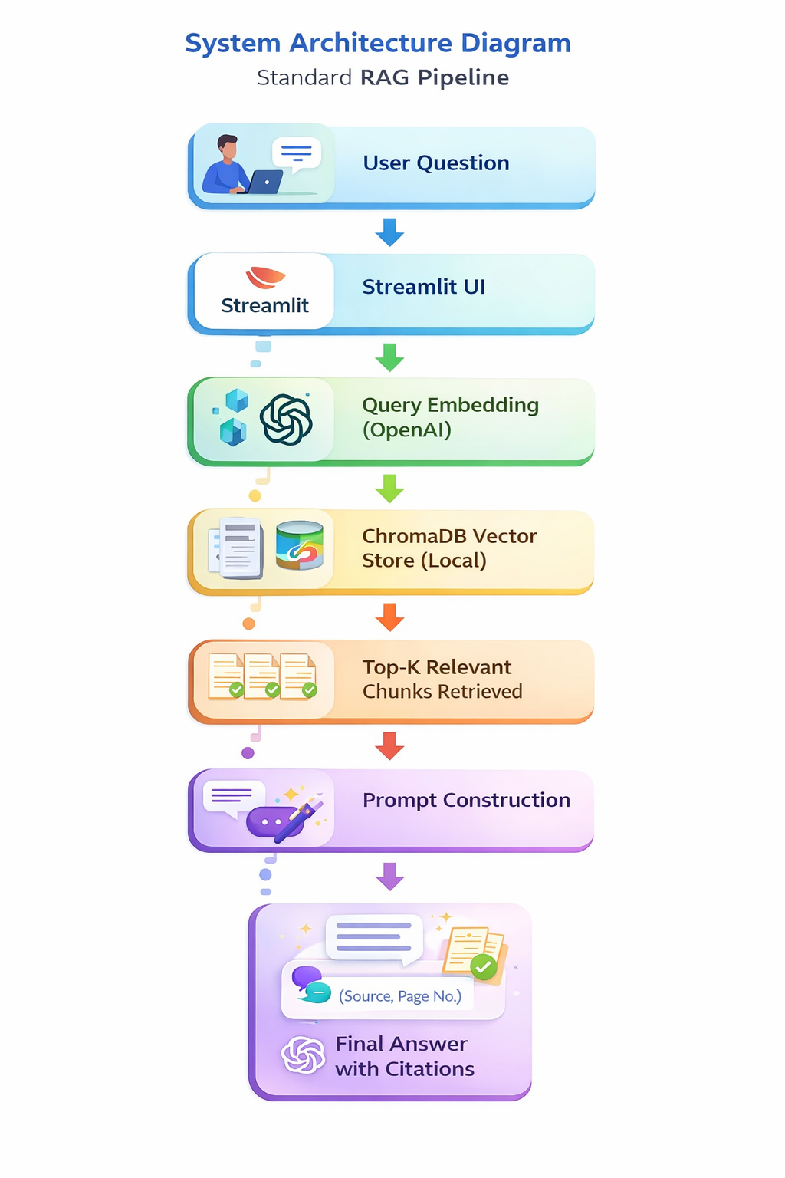

6. Choice of Local ChromaDB
ChromaDB is lightweight, easy to integrate, and suitable for local academic deployment. It was selected as the vector database because it is lightweight, easy to integrate, and suitable for local academic projects. A local vector store allows offline indexing and avoids external cloud costs. For enterprise-scale deployment, this could be replaced with managed vector databases such as Pinecone or FAISS.

7. Model & Parameter Selection Rationale
OpenAI models were used for both embeddings and text generation. The embedding model was chosen for its strong semantic representation capability. For text generation, a GPT-based model was selected because of its reliability, strong reasoning ability, and ease of API integration. The temperature was kept low to reduce hallucination and improve factual consistency.
- Embedding Model: text-embedding-3-small – cost-effective and strong semantic representation.
- Chat Model: gpt-4o-mini – efficient, reliable reasoning with lower cost.
- Chunk Tokens: 700 – balanced context without excessive token usage.
- Chunk Overlap: 120 – preserves context across chunk boundaries.
- Top-K: 5 – retrieves optimal context without excessive prompt size.

8. Implementation Details
Technology stack used:
- Python 3.x
- Streamlit (UI)
ChromaDB (Vector Store) - local
- OpenAI API (Embeddings and LLM)
- Jupyter Notebook + app.py structure (Development and Testing)
Such a design choice was chosen because it provides a transparent, modular, cost-efficient, and academically suitable implementation of a complete RAG pipeline without unnecessary abstraction layers. This is suitable for a demo purpose

9. Execution Flow
The system runs in two phases: ingestion phase and query phase.
Ingestion Phase:
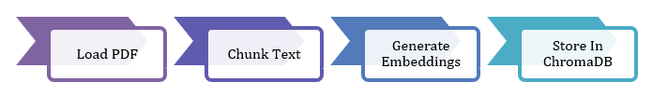
Query Phase:
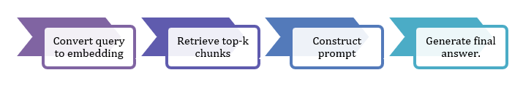

10. How to Run the Project

Notebook Version
- Ensure Main notebook (Final_Project_Sharif_Islam_RAG_SearchEngine.ipynb), PDF , requirements.txt and .env file are in the same project folder.
- Place PDFs inside folder “Policy documents” under project folder
- Ensure you place a .env file in same folder containing your OPENAI_API_KEY (sk-xxxx)
- Activate Anaconda environment.
- Open Jupyter Notebook and run cells sequentially.
- Ask questions via interactive loop or modify query cell.

Output Screenshots- Expected Output: Answer with source and page citations.

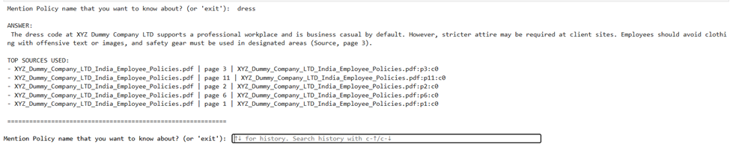
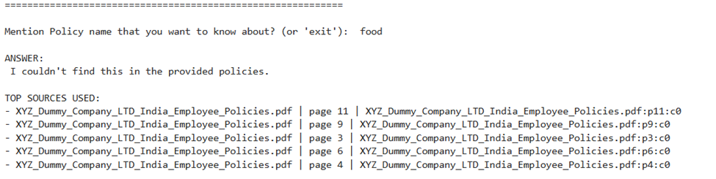

Streamlit Version
- Ensure app.py, PDFs, Requirements.txt and .env file are in the same project folder.
- Place PDF inside folder “Policy documents” under project folder
- Ensure you place a .env file in same folder containing your OPENAI_API_KEY (sk-xxxx)
- Open Anaconda Prompt in project directory. Run command: Streamlit run app.py
- Open http://localhost:8501 in browser.
- Enter question and click Search to receive grounded response.

Output Screenshots:
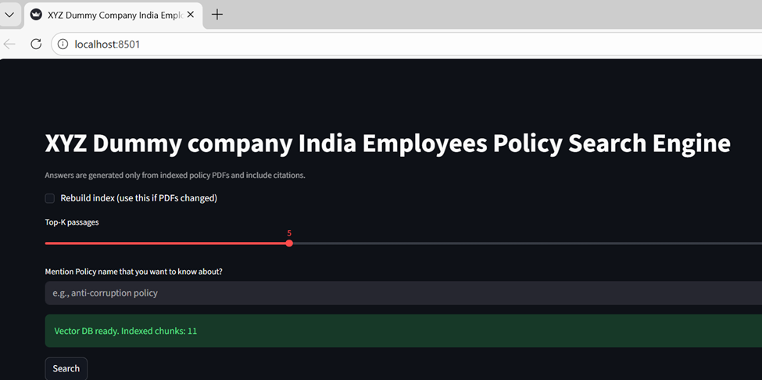
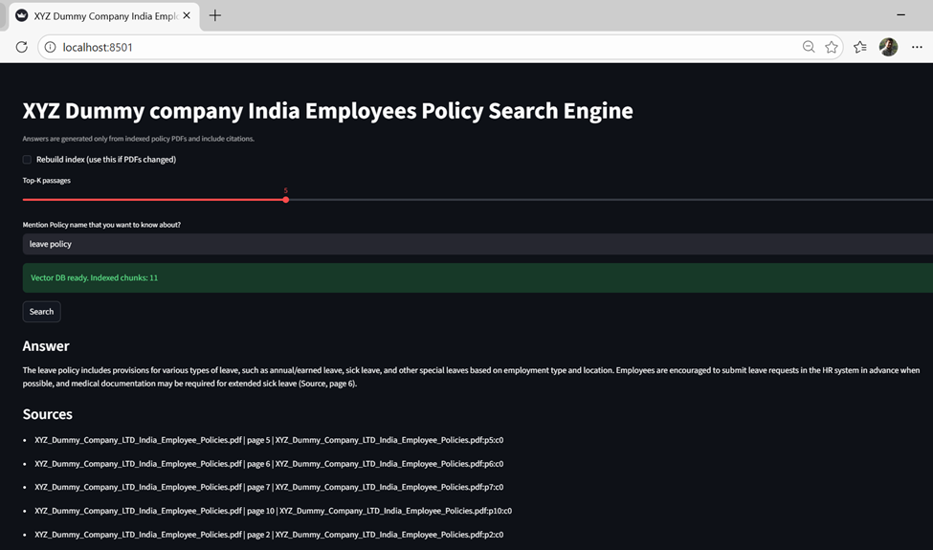
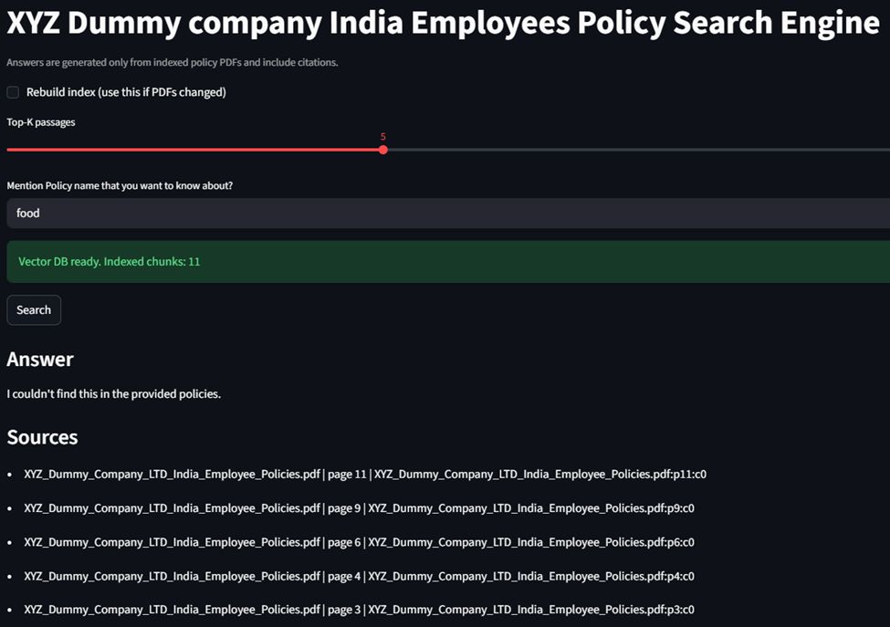

11. Output of the System
The final output consists of a natural language answer along with optional citation references indicating source document and page number. This improves transparency and trust.

12. Basic Evaluation
Manual testing showed that the RAG system produced more contextually accurate answers compared to a baseline LLM without retrieval. The trade-off observed was slightly higher latency due to vector search.

14. Conclusion
This project successfully demonstrates the design and implementation of a Retrieval-Augmented Generation system for policy document question answering. The architecture improves factual grounding and reduces hallucination. The system is modular, reproducible, and can be extended for enterprise deployment.

15. Files uploaded to GitHub (As informed to us by management)
- Main Jupyter Notebook (Final_Project_Sharif_Islam_RAG_SearchEngine.ipynb)
- app.py (Streamlit UI file) - This is the deployable UI version.
- 1 Policy PDFs (Dummy Company data only, under folder “Policy documents”
- Requirements.txt
- Project Report (RAG_Search_Engine_Project_Report.docx)

