**LAB TASK_10**

**SUBMITTED BY: SHARIFULLAH**

**SUBMITTED TO: MR. BASIT ALI**

1. Create a table emp_copy same as employee table

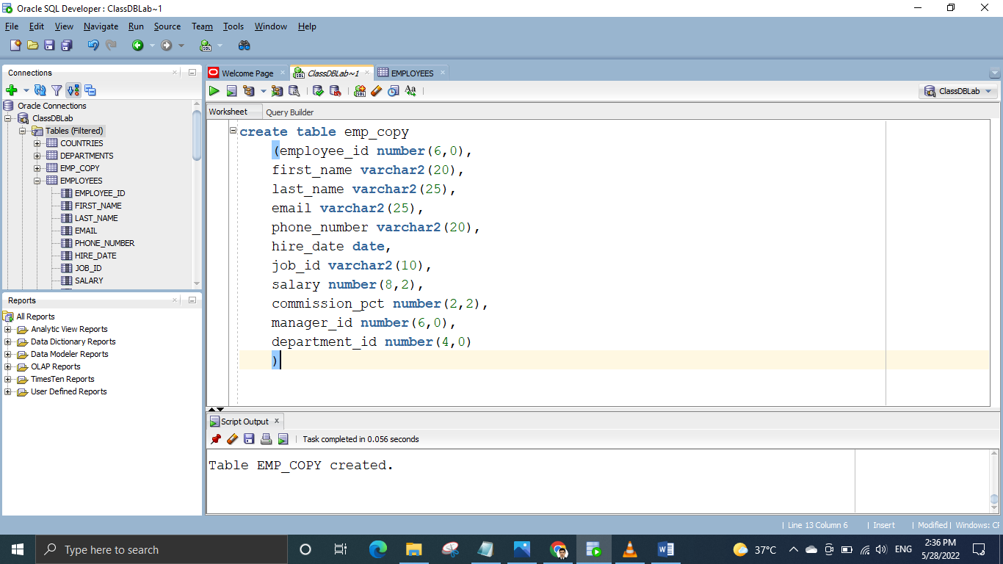

1. Add the data of employee table to emp_copy using subquery.

