**REACT FRONTEND**

Create a single page app that displays a list of starships from the Star Wars movies.

Data source:

Collect the starships from SWAPI.

<https://swapi.co/api/starships/>

Criteria:

- The list should be paginated, following the SWAPI pagination.

- Every element in the list (starship) should contain the following data:

- Name: Name of the starship

- API attribute: “name”

- Display: Text

- Criteria: First letter should be always capitalized

- Crew: Number of crew members

- API attribute: “crew”

- Display: Number

- Criteria: In case the value is 0 (zero), display the word “None”

- Passengers: Number of Passengers

- API attribute: “passengers”

- Display: Number

- Criteria: In case the value is 0 (zero) , display the word “None”

- Hyperdrive Class: Index that represents the hyperdrive class of starship.

- API attribute: “hyperdrive_rating”

- Display: Progress bar. Scale 0 to 6 where 6 is 100% of the progress bar.

- Criteria: In case the value is “unknown”, progress bar should at zero and be grey (disabled colors)

Deliverable:

- Source code

- Deployment instructions

- In case you had any doubt regarding the requirements and made an assumption, just describe what was the doubt and your thinking process.

How to deliver:

Publish your code in a repository of your choice or send a compressed file via email (job@altagram.com).

Curiosity / Reference:

What is hyperdrive?

https://starwars.fandom.com/wiki/Hyperdrive

Mockup: 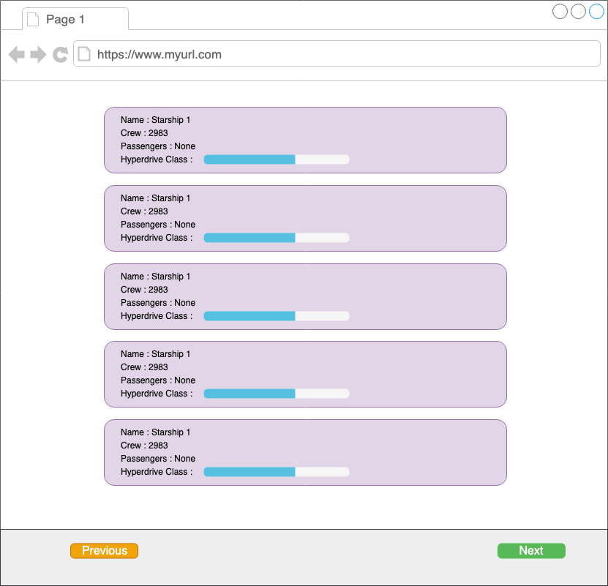

Feel free to be creative with the layout. The mockup is just a visual representation of the requirements, as an example.