# mage result for yazaki logo

|  |
| --- |
| IEIC System Project Report |

# System Requirements Specification (SRS)



**Customer: YAZAKI**

**Authors:**

Pedro Antonio Gámez Hernández | A00369538

Sharif Nasser Kadamani | A00820367

**Professors:**

Dr. Alfonso Ávila

Dr. Graciano Dieck

Mtra. Jackeline Marcos

Dr. Eleazar Reyes

Dr. Raúl Peña

Mtro. Artemio Aguilar

**Revision Chart**

|  |  |  |  |
| --- | --- | --- | --- |
| **Version** | **Primary Author(s)** | **Description of Version** | **Date Completed** |
| V1.0 | Sharif Nasser Kadamani &  Pedro Antonio Gámez Hernández | This is the first version created of the SRS, which will be rechecked and reworked throughout the semester. | 17/08/2018 |
| V2.0 | Pedro Antonio Gámez Hernández  &  Sharif Nasser Kadamani | This is the second version created of the SRS, which will be rechecked and reworked throughout the semester, specifically concentrating on the activity and UML case diagrams as well as functions | 01/09/2018 |
| V3.0 | Pedro Antonio Gámez Hernández  &  Sharif Nasser Kadamani | This is the third version created of the SRS, which will be rechecked and reworked specifically in the functional details and some and regarding the Specific requirements. | 23/11/2018 |

|  |  |  |  |
| --- | --- | --- | --- |
| V4.0 | Pedro Antonio Gámez Hernández  &  Sharif Nasser Kadamani | This is the fourth version created of the SRS, which will be rechecked and reworked to polish and finish the whole system report. | 29/11/2018 |

**Contents**

1

Software Requirements Specification (SRS) 1

1 Introduction 7

1.1 Purpose 7

1.2 Scope 7

1.3 Definitions, acronyms, and abbreviations 7

1.4 Organization 9

2 Overall Description 9

2.1 Current Process & Its Limitations 10

2.2 Proposed Solution & Its Benefits 10

2.3 Product Perspective 11

2.4 Product Functions 11

2.5 User Characteristics 12

2.6 Constraints 12

2.7 Assumptions and dependencies 12

3 Specific Requirements 13

3.1 Functional Requirements (FR) 13

3.2 Non-functional Requirements (NFR) 16

4 Modeling Requirements 17

4.1 Use Case Diagram and Documentation 17

4.2 Activity Diagrams 21

5 References 23

6 Appendix 23

**List of Figures**

Figure 3 – System Environment 10

Figure 4 - Use Cases…………………………………………………...……………………………………18

# Introduction

This document outlines the software and hardware requirements for the creation of the automobile cluster in all its properties and functions. It covers the overall description of the system, including user interface, hardware function, hardware components and connection between them as well as software function, language programming and the overall project communication form between components, and the design. This document is intended to be a proposal to explain the function of the project as a whole, developing a prototype the assembly and function of hardware, software in between as ones set, for its approval and a reference for developing the first version of the ACT for the development team.

## Purpose

## This document is intended to inform the function, specification, requirements, purpose and design of the software and hardware in the development of the vehicle cluster. It should be useful to receive useful data from the vehicle, translating information to the user through graphics displayed in a TFT device, data such as Speed, RPM, Brakes, Fuel Level, Oil Level, Battery Level and Gear position among others.

## Scope

This document outlines the specification requirements for the IEIC system, it contains an overall description, the acronyms and abbreviation used, the product perspective, the product functions along with the constraints and specific requirements and modeling requirements. It also includes the case diagrams and activity diagrams and finally the references used.

It does not include some non functional specifications, such as cluster color, cluster overall size and price.

## Definitions, acronyms, and abbreviations

|  |  |
| --- | --- |
| **Term** | **Definition** |
| CAN bus | **Controller Area Network**: Is a vehicle bus standard designed to allow devices and microcontrollers to communicate with each other in apps with a host computer. |
| SPI | **Serial Peripheral Interface**: Is a serial communication interface specification used for short distance communication, primarily in embedded systems. |
| I2C | **Inter-Integrated Circuit:** Is a synchronous, multi-master, multi-slave, packet switched, single-ended, serial computer bus. It is widely used for attaching lower-speed peripheral [ICs](https://en.wikipedia.org/wiki/Integrated_circuit) to processors and [microcontrollers](https://en.wikipedia.org/wiki/Microcontroller) in short-distance, intra-board communication. |
| VPU | **Vehicle Processing Unit** |
| GPU | **Graphics Processing Unit** |
| V&V | **Validation and Verification:** are independent procedures that are used together for checking that a product, service, or system meets requirements and specifications and that it fulfills its intended purpose. |
| SAMA | The SAMA5D2 series is a high-performance, ultra-low-power ARM Cortex-A5 processor based MPU. Microchip Linux distribution. |
| TFT | Thin Film Transistor-Liquid Crystal Display |
| LCD | Liquid Crystal Display |
| BSP | Board support package |
| SDR | Software Defined Radio |
| SIR | Surface Insulation Resistance |
| Backlight | luminosity in the LCD display |
| Cluster | A group of servers that acts like a single system |
| PCB | Printed circuit board |
| RGB | Red, green, blue |
| Bus CAN | is a communication protocol |
| Datapool | an array of the CAN messages and the data that they contain |

## Organization

This document is organized in the introduction, overall description, specific requirements, modeling requirements, references and the appendix sections with subsections focusing on more specific matters in each section like the purpose, the scope, definitions, proposed solutions, product functions, functional requirements and use case diagrams as well as activity diagrams.

# Overall Description

## This section will give an overview of the whole system. It will be explained how the basic process works, what are the software and hardware limitations as well as our proposed solutions and our benefits and solutions

## Current Process & Its Limitations

The actual cluster project consists of 5 specific hardware components which are, TFT display, Arduino Zero, Pican 2 Duo, SAMA, and the PCB which has the LED driver installed and the communication between all these components. The limitations of our project are the very little information available for the process , the led driver, which has various forms of programmable forms and states. Another problem with this project is that the SAMA and TFT have different numbers of pins, so we need to design an adapter in the PCB. The final limitation is found in the TFT driver. The LP8860 Q1 is a totally new led driver that just went out in the market and is extremely complex.

## Proposed Solution & Its Benefits

The solutions proposed is to keep reading the LP8860 Q1 datasheet and gather as much information as possible about the led driver, for this we must keep reading all we can and decipher what we need to do to get all the right connections and outputs. To communicate the devices, two communications protocols will be needed. SPI and I2C. In the first one, the Arduino Zero will be the master in an SPI connection that will receive the vehicle´s information from its slave the Pican2duo and will store the data in a data pool. And I2C will be used to transfer the information between the arduino zero and the SAMA

The benefit of this solution is to get the correct information of the datapool where it is needed, and be able to extract any signal necessary for reading and displaying off the datapool values.

## Product Perspective

We can observe the context diagram to give ourselves a perspective of how the overall system works.  
  
Figure 1: Context Diagram   
In this diagram demonstrate the interaction between the user, the tester and the environment with our product.

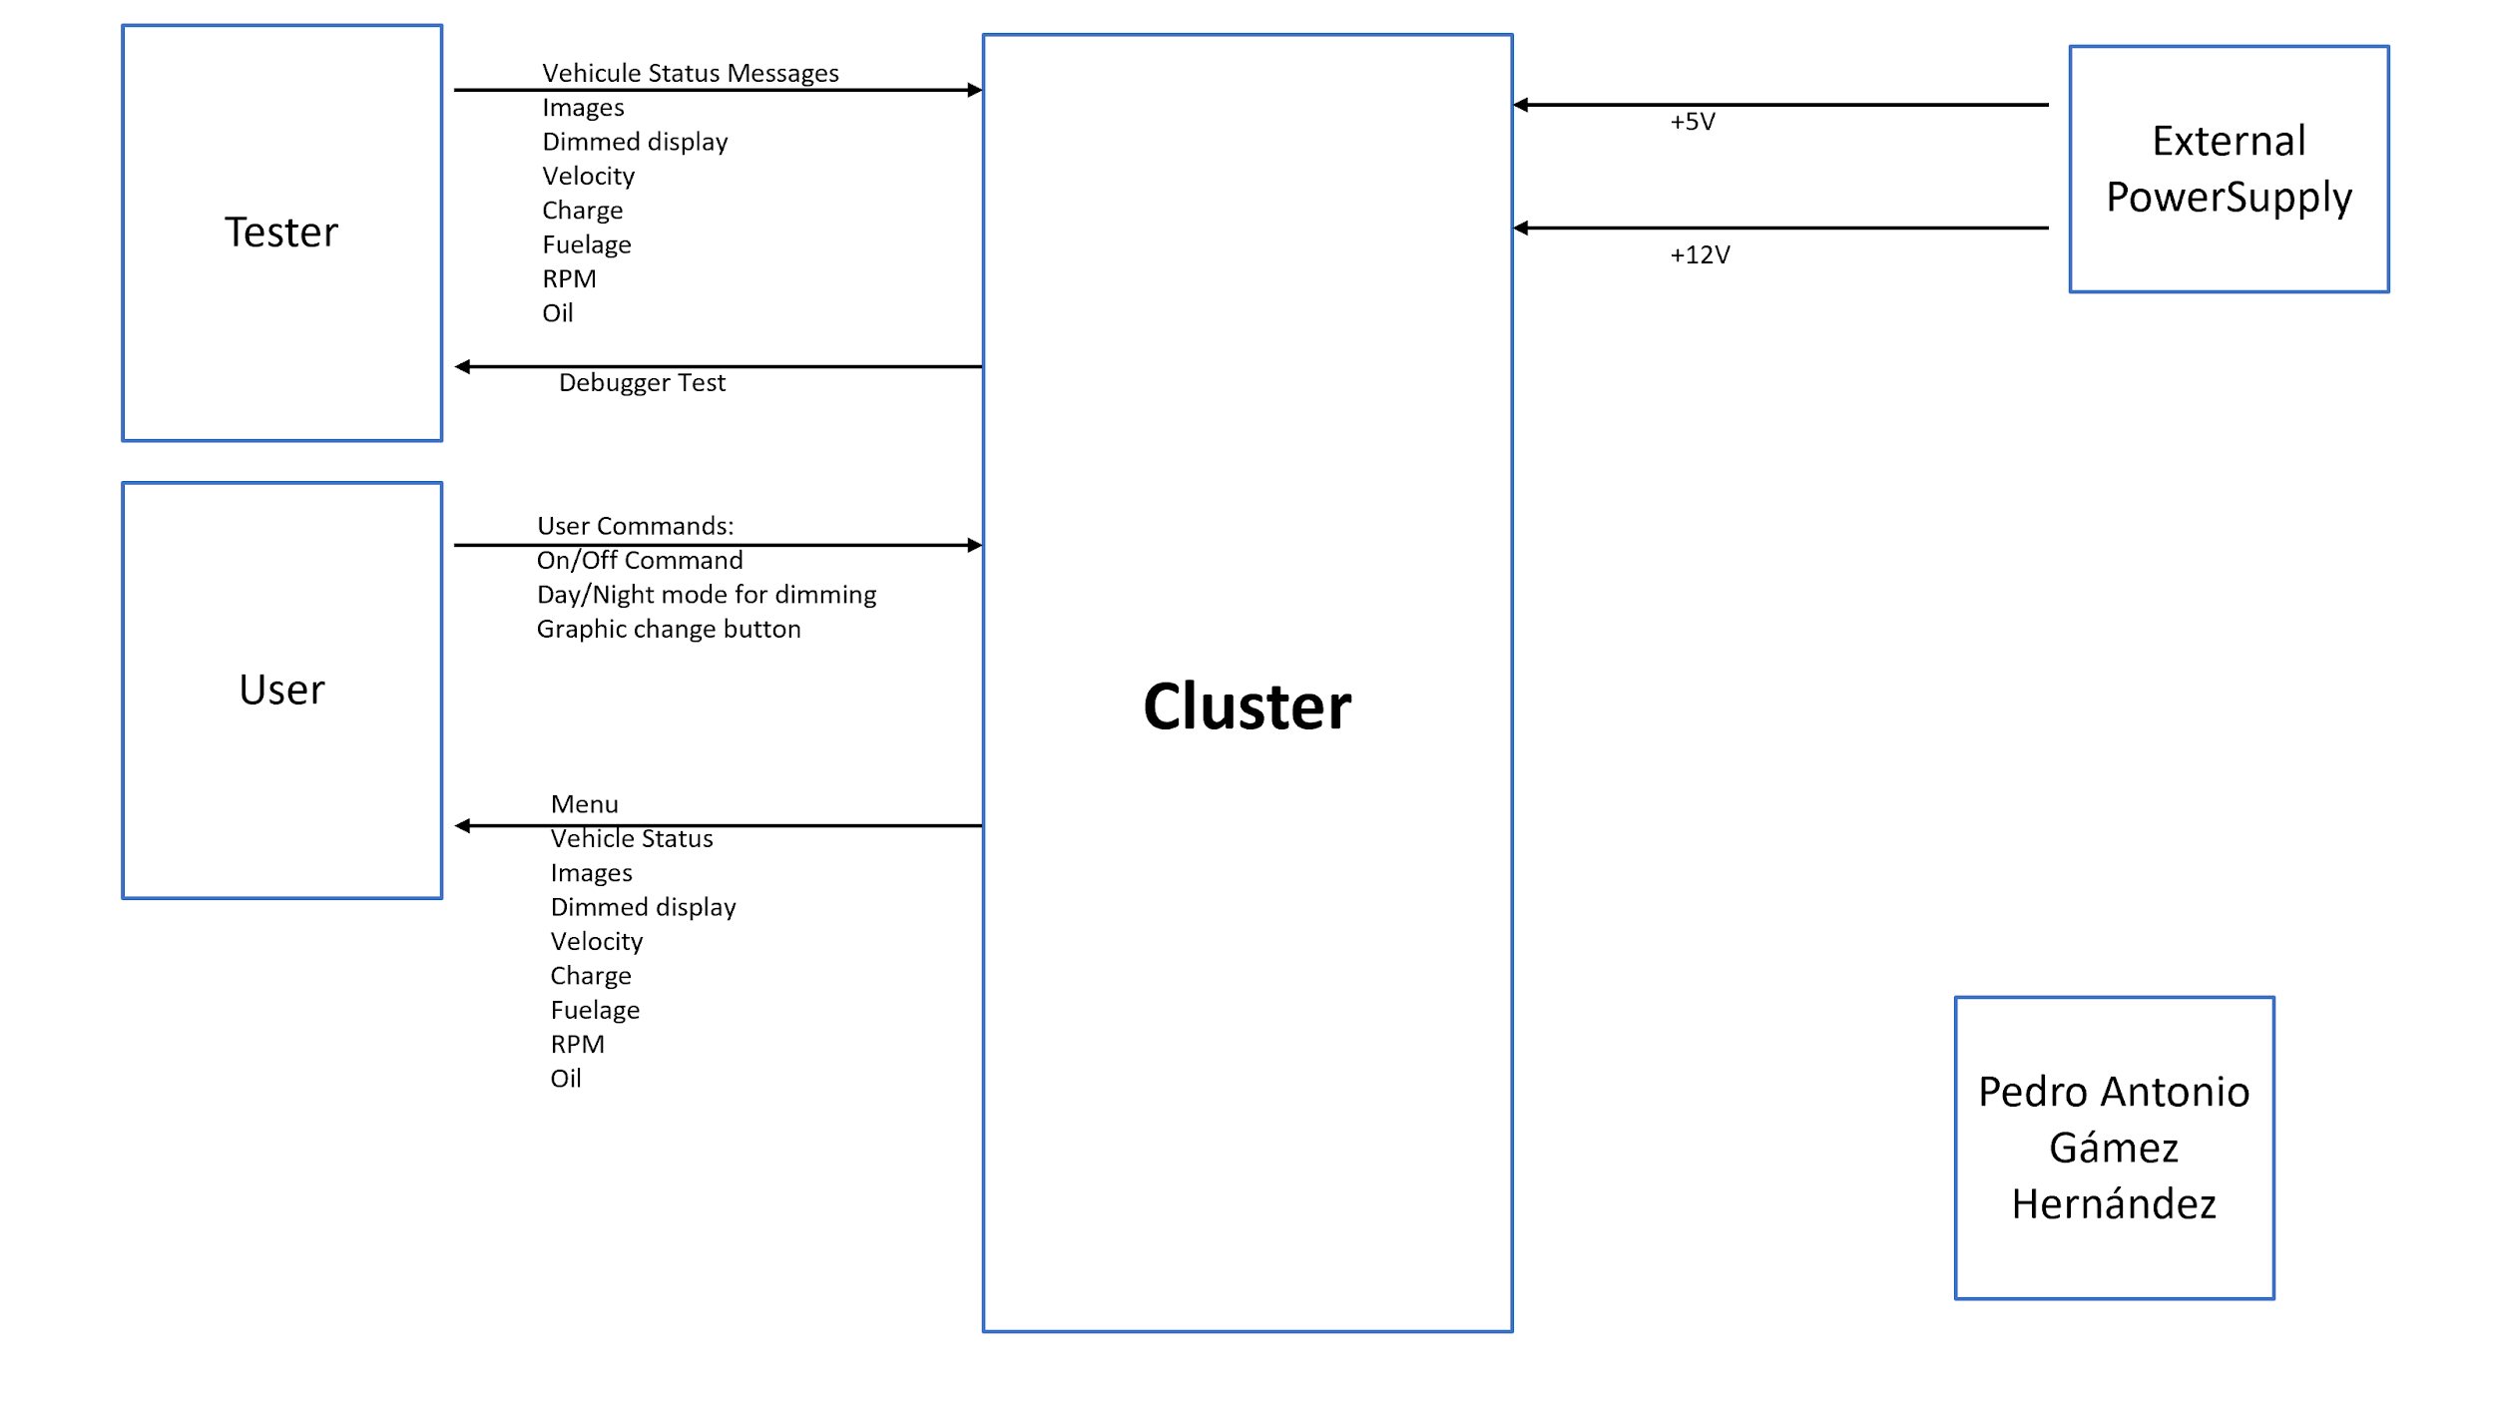  
   
The solution involves the use of distinct components and elements to achieve the overall functioning of the project, this starts with the power supply which gives power to what we want and boost the configuration to our peripherals sucha es the TFT, the GPU, and the VPU, and using the Canoe as the tester to send values and test that our cluster can display all that we want.

## 

## Product Functions

The functions that the product shall comply with providing customers with an automotive display that displays to them different information to know, such as the gas level, battery level, odometer, speedometer, RPM and other useful automotive states and functions. And you can provide a different change in dimming.

## User Characteristics

The customer has to be any type of driver that has at least the minimum age to have a driver's license (at least 18 in the majority of the countries). The user should have the standard characteristics of a driver: average sight, average reflexes and no color vision deficiency. And must not have mental problems or medical condition of any sort that inhibits the driver from not driving correctly and safely.

## Constraints

The embedded system is constrained by the limits in current and voltage, the saturation of the components and the small resolution of the TFT that limits the size of the images that can be displayed. The color resolution is also limited to 6 bits for each main color (red, green and blue) due the TFT has only 6 bits for each of these colors, although through the SAMA we could send up to 8 bits.

## Assumptions and dependencies

There are some assumptions in the software, hardware, the most risky of all being the functioning of our Led Driver which is being implemented without being simulated in any form whatsoever, and the values are just chosen on the basis of the typical application aside from having to burn the registers in the EEPROM inside. Apart from the modified registers we must have correct values in these registers and also make it function properly as well as create a perfect communication between TFT and SAMA, using the bridge connectors of 50 to 55 pins and getting all the pin to get the correct display of the graphics at the TFT. On the other side we must be able to ace on all aspects on the communication between the Pican Duo, Arduino Zero, SAMA, and TFT.

# Specific Requirements

The following is a list of requirements gathered from the board cluster that will be our project. The final project will contain tachometer, fuel, oil, and battery levels as well as speedometer, temperature, time, brake and turn indicators as well as others.

**3.1 Functional Requirements (FR)**

|  |  |
| --- | --- |
| **Function** | FR001. |
| **Description** | Change the backlight of the screen |
| **Input/output** | CAN |
| **Fail Safe** | If there is no CAN message received, the brightness shall remain the same. |
| **Electrical Characteristics** | The input comes from the CAN message |

|  |  |
| --- | --- |
| **Function** | FR002. |
| **Description** | Display Cluster Image on the screen |
| **Input/Output** | The TFT will receive the image from the SAMA through the 6 bit RGB bus and will send the information to the display. |
| **Fail Safe** | Displays an error message when no information is detected |
| **Electrical Characteristics** | The images will be send through the bridge for the 6 bit resolution of the SAMA. |

|  |  |
| --- | --- |
| **Function** | FR003. |
| **Description** | Switch between different graphics sets |
| **Input/Output** | Switch button |
| **Electrical Characteristics** | GPIO pin at Arduino Zero |

|  |  |
| --- | --- |
| **Function** | FR004. |
| **Description** | Change RPM on the display |
| **Input/Ouput** | The TFT will receive the image and the value from the SAMA through the 6 bit RGB bus and will send the information to the display. |
| **Fail Safe** | If no information is received, the pointer of the RPM will not move and remain where it last was. |
| **Electrical Characteristics** | The value will be received with a CAN message and will reach the SAMA board through i2c. |

|  |  |
| --- | --- |
| **Function** | FR005. |
| **Description** | Change Speed on the display |
| **Input/Ouput** | The TFT will receive the image and the value from the SAMA through the 6 bit RGB bus and will send the information to the display. |
| **Fail Safe** | If no information is received, the pointer of the Speed will not move and remain where it last was. |
| **Electrical Characteristics** | The value will be received with a CAN message and will reach the SAMA board through i2c. |

|  |  |
| --- | --- |
| **Function** | FR006. |
| **Description** | Change Oil Level on the display |
| **Input/Ouput** | The TFT will receive the image and the value from the SAMA through the 6 bit RGB bus and will send the information to the display. |
| **Fail Safe** | If no information is received, the Oil Level will not move and remain where it last was. |
| **Electrical Characteristics** | The value will be received with a CAN message and will reach the SAMA board through i2c. |

|  |  |
| --- | --- |
| **Function** | FR007. |
| **Description** | Change Fuel Level on the display |
| **Input/Ouput** | The TFT will receive the image and the value from the SAMA through the 6 bit RGB bus and will send the information to the display. |
| **Fail Safe** | If no information is received, the Fuel Level will not move and remain where it last was. |
| **Electrical Characteristics** | The value will be received with a CAN message and will reach the SAMA board through i2c. |

|  |  |
| --- | --- |
| **Function** | FR008. |
| **Description** | Change Indicators on the display |
| **Input/Ouput** | The TFT will receive the image and the value from the SAMA through the 6 bit RGB bus and will send the information to the display. |
| **Fail Safe** | If no information is received, the Indicators will not change and remain how it last was. |
| **Electrical Characteristics** | The value will be received with a CAN message and will reach the SAMA board through i2c. |

|  |  |
| --- | --- |
| **Function** | FR009. |
| **Description** | Change Mileage on the display |
| **Input/Ouput** | The TFT will receive the image and the value from the SAMA through the 6 bit RGB bus and will send the information to the display. |
| **Fail Safe** | If no information is received, the Mileage will not change and remain how it last was. |
| **Electrical Characteristics** | The value will be received with a CAN message and will reach the SAMA board through i2c. |

|  |  |
| --- | --- |
| **Function** | FR010. |
| **Description** | Change Break Indicator on the display |
| **Input/Ouput** | The TFT will receive the image and the value from the SAMA through the 6 bit RGB bus and will send the information to the display. |
| **Fail Safe** | If no information is received, the Break Indicator will not change and remain how it last was. |
| **Electrical Characteristics** | The value will be received with a CAN message and will reach the SAMA board through i2c. |

* 1. **Non-functional requirements (NFR)**

**NFR001**.- The boot-up time must be less than 2 seconds.

**NFR002**.- The IEIC should not cost more than $300 USD.

**NFR003**.- The information must be displayed in real time with an update rate of 0.5s.

**NFR004**.- The dimensions of the circuitry must not be greater than 500x300x150mm

**NFR005**.- The maximum weight shall be of 200g

**NFR006**.- The color resolution of RGB will be reduced to 6 bits for each color instead of 8 bits.

**NFR007**.- The IEIC will use a switching mode power supply to convert the battery´s 12V to 5V or 3.3V according to the components specifications

# Modeling Requirements

This section we add the Use case diagrams and the documentation as well as other diagrams to better explain the functioning of the final project.

## Use Case Diagram and Documentation

A use case diagram is used to model the actions between the user (conductor) and the cluster.

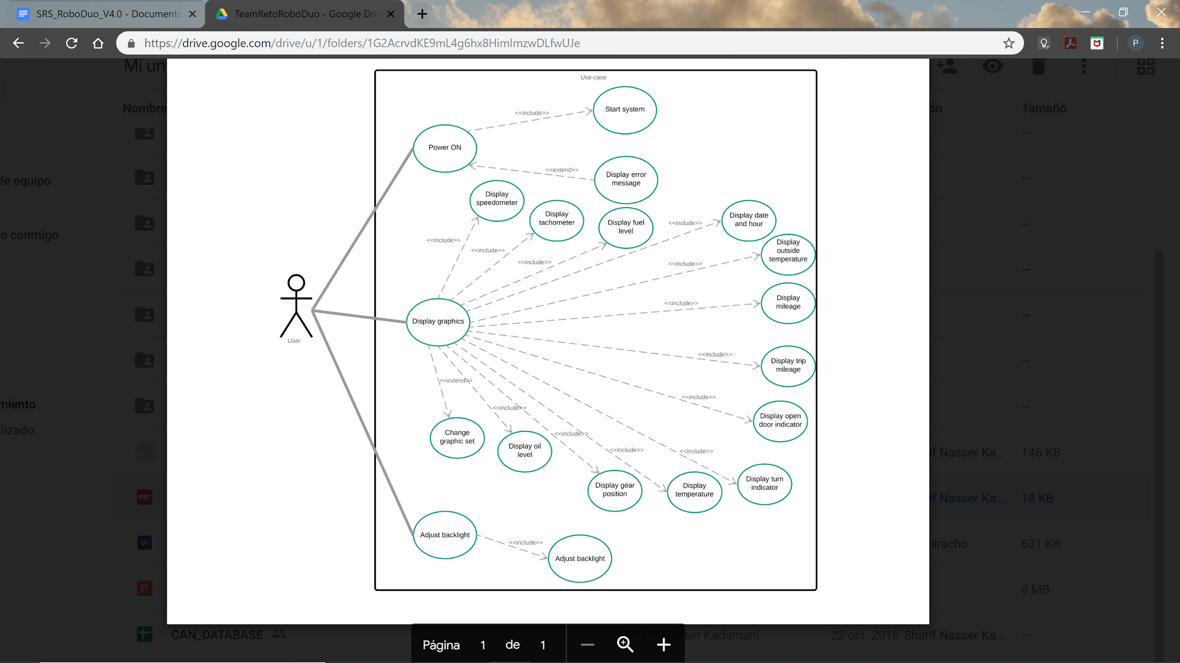

Use case diagram for Adjust backlight

|  |  |
| --- | --- |
| **Use Case:** | Adjust backlight |
| **Actors:** | Users |
| **Description:** | This use case reflects the value being sent through CAN and this will give the dimming adjustment. |
| **Type:** |  |
| **Includes:** | Different settings to adjust the brightness and maximum brightness |
| **Extends:** |  |
| **Cross-refs:** |  |

Use case diagram for Displays Graphics

|  |  |
| --- | --- |
| **Use Case:** | Displays Graphics |
| **Actors:** | User |
| **Description:** | This use case reflects the value that will be received with a CAN message thorugh the Pican and then to the Arduino from there to the SAMA board through i2c and be displayed in the TFT. |
| **Type:** |  |
| **Includes:** | Display mileage, display Tachometer, display Fuel Gauge, display Speedometer, display Temperature, display Outside Temperature, display gear position, Display RPM, Display indicators, Display breaks, Display hour. |
| **Extends:** |  |
| **Cross-refs:** |  |

## Activity Diagrams

The following activity diagrams illustrate the phases and activities that the system does in order to develop the prototype.

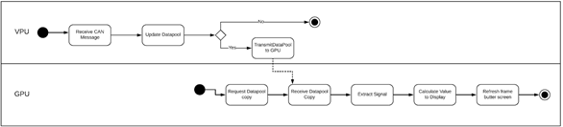

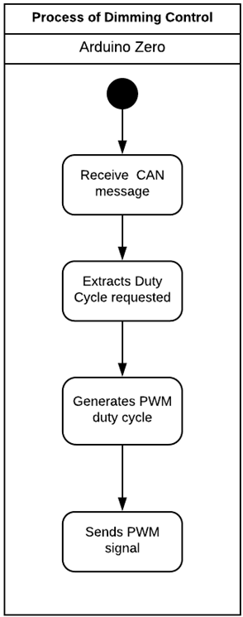

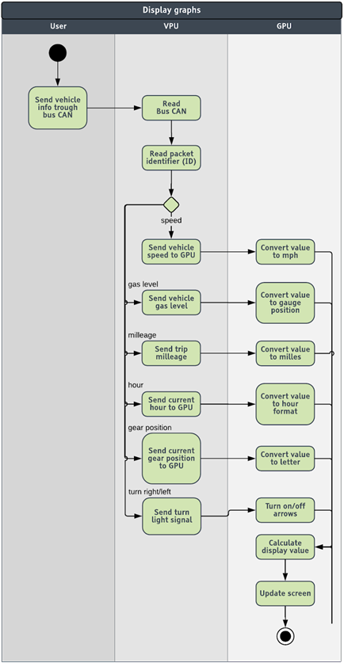

# References

(2009)IEEE Recommended Practice for Software Requirements Specification*.* United States of America: *IEEE Computer Society.*