**Programming Language Design**

Language name: **mathpy**

Orientation: **numerical calculations and arithmetic operations**

**Example**

program exampleMatrix

!Programa que lee dimensiones de dos matrices y verifica si es posible sumarlas

integer :: a, b, c, d, e(a, b), f(c, d)

do

print *, “escriba la dimensión uno de la matriz uno:”;

read *, a;

print *, “escriba la dimensión dos de la matriz uno:”;

read *, b;

print *, “escriba la dimensión uno de la matriz dos:”;

read *, c;

print *, “escriba la dimensión dos de la matriz dos:”;

read *, d;

if( a == c) then

if ( b == d) then

do a = 0, c

do b = 0, d

e(a,b) = e(a,b) + f(a,b);

print *, e(a,b);

end do;

end do;

exit

end if;

end if;

if( b == d) then

if ( a == c) then

do a = 0, c

do b = 0, d

e(a,b) = e(a,b) + f(a,b);

print *, e(a,b);

end do;

end do;

exit

end if;

end if;

end do;

end program exampleMatrix;

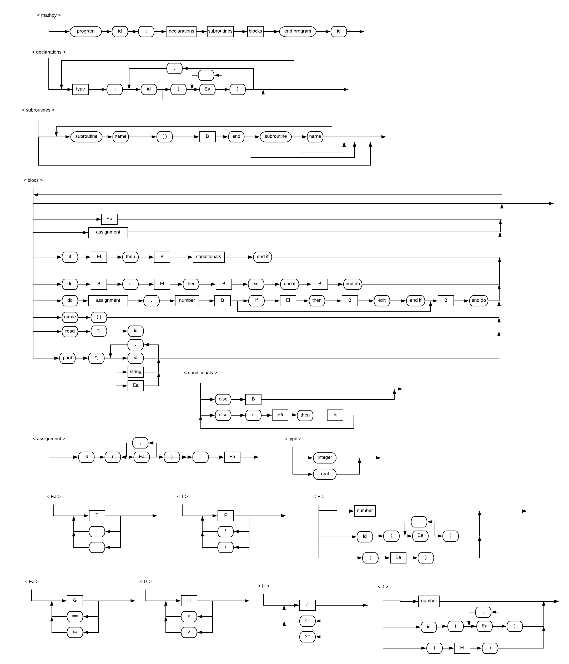**Syntax Diagrams**

**List of Tokens and Keywords**

|  |  |  |
| --- | --- | --- |
| **Symbol** | **Internal Name** | **Name** |
|  | idsym | ID |
|  | intsym | INT |
|  | floatsym | FLOAT |
| “” | stringsym | STRING |
| + | plussym | PLUS |
| - | minussym | MINUS |
| * | timessym | TIMES |
| / | dividesym | DIVIDE |
| = | assignsym | ASSIGN |
| == | eqsym | EQ |
| /= | neqsym | NEQ |
| < | ltsym | LT |
| <= | ltesym | LTE |
| > | gtsym | GT |
| >= | gtesym | GTE |
| . | dotsym | DOT |
| , | commasym | COMMA |
| : | colonsym | COLON |
| ; | semicolonsym | SEMICOLON |
| ( | lparensym | LPAREN |
| ) | rparensym | RPAREN |
| program | programsym | PROGRAM |
| end | endsym | END |
| integer | integersym | INTEGER |
| real | realsym | REAL |
| subroutine | subroutinesym | SUBROUTINE |
| if | ifsym | IF |
| then | thensym | THEN |
| else | elsesym | ELSE |
| do | dosym | DO |
| exit | exitsym | EXIT |
| read | readsym | READ |
| print | printsym | PRINT |

**Grammar**

|  |
| --- |
| language 🡪 mathpy |
| mathpy 🡪 PROGRAM ID COLON declarations subroutines blocks END  mathpy 🡪 PROGRAM ID COLON declarations subroutines blocks END PROGRAM  mathpy 🡪 PROGRAM **ID** COLON declarations subroutines blocks END PROGRAM **ID** |
| declarations 🡪 INTEGER COLON COLON variables declarations  declarations 🡪 REAL COLON COLON variables declarations  declarations 🡪 empty  variables 🡪 variables COMMA ID matrix  variables 🡪 ID matrix  matrix 🡪 LPAREN index RPAREN  matrix 🡪 empty  index 🡪 index COMMA arithmetic  index 🡪 arithmetic |
| subroutines 🡪 subroutines SUBROUTINE ID LPAREN RPAREN blocks END  subroutines 🡪 subroutines SUBROUTINE ID LPAREN RPAREN blocks END SUBROUTINE  subroutines 🡪 subroutines SUBROUTINE **ID** LPAREN RPAREN blocks END SUBROUTINE **ID**  subroutines 🡪 empty |
| blocks 🡪 blocks arithmetic  blocks 🡪 blocks assignment  blocks 🡪 blocks IF comparison THEN blocks conditionals END IF  blocks 🡪 blocks DO blocks IF comparison THEN blocks EXIT END IF blocks END DO  blocks 🡪 blocks DO assignment COMMA arithmetic blocks END DO  blocks 🡪 blocks DO assignment COMMA arithmetic blocks IF comparison THEN blocks EXIT END IF blocks END DO  blocks 🡪 blocks ID LPAREN RPAREN  blocks 🡪 blocks READ TIMES COMMA ID  blocks 🡪 blocks PRINT TIMES COMMA list  blocks 🡪 empty  conditionals 🡪 ELSE blocks  conditionals 🡪 ELSE IF comparison THEN blocks conditionals  conditionals 🡪 empty  list 🡪 list COMMA ID matrix  list 🡪 list COMMA arithmetic  list 🡪 list COMMA STRING  list 🡪 arithmetic  list 🡪 STRING  list 🡪 ID matrix |
| assignment 🡪 ID matrix ASSIGN arithmetic |
| arithmetic 🡪 arithmetic PLUS term  arithmetic 🡪 arithmetic MINUS term  arithmetic 🡪 term  term 🡪 term TIMES factor  term 🡪 term DIVIDE factor  term 🡪 factor  factor 🡪 INT  factor 🡪 FLOAT  factor 🡪 ID matrix  factor 🡪 LPAREN arithmetic RPAREN |
| comparison 🡪 comparison EQ comparisontwo  comparison 🡪 comparison NEQ comparisontwo  comparison 🡪 comparisontwo  comparisontwo 🡪 comparisontwo LT comparisonthree  comparisontwo 🡪 comparisontwo GT comparisonthree  comparisontwo 🡪 comparisonthree  comparisonthree 🡪 comparisonthree LTE comparisonfour  comparsionthree 🡪 comparisonthree GTE comparisonfour  comparisonthree 🡪 comparisonfour  comparisonfour 🡪 INT  comparisonfour 🡪 FLOAT  comparisonfour 🡪 ID matrix  comparisonfour 🡪 LPAREN arithmetic RPAREN  comparisonfour 🡪 LPAREN comparison RPAREN |