Access Virtual IP SSH(Port 22)

Open Metasploitable-3 and check the ip address:

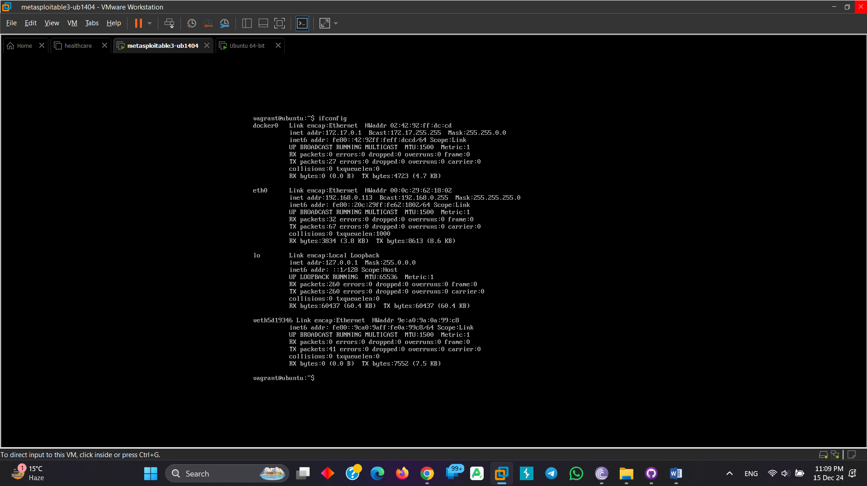

Here metasploitable ip = 192.168.0.113

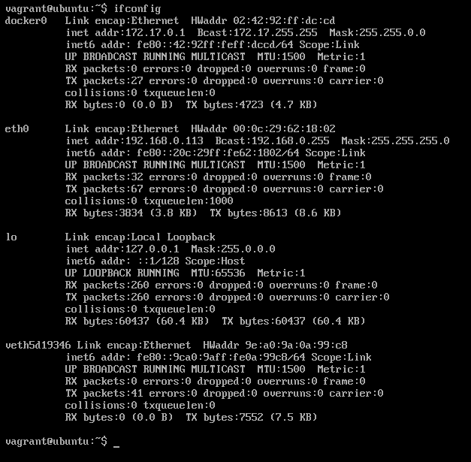

Type netdiscover in terminal for find metasploitable-3 ip address:

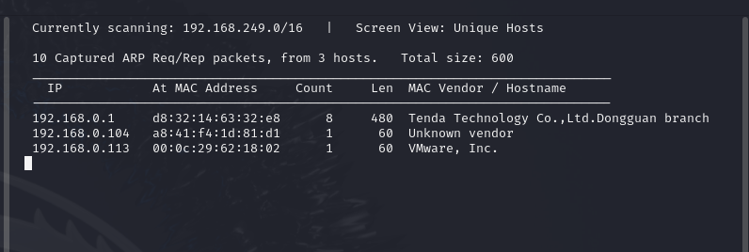

Type nmap -sV 192.168.0.113 for find open port

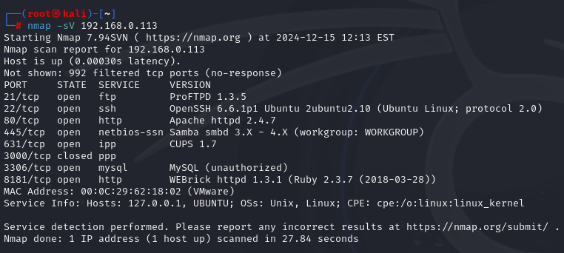

Now start metasploit frame word by typing msfconsole:

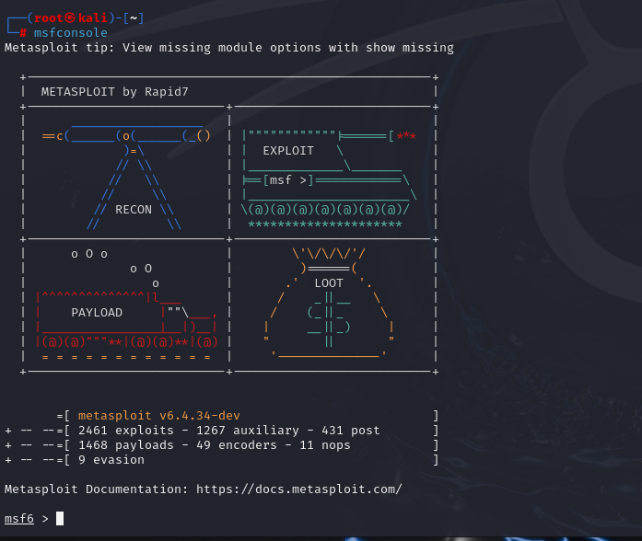

search ssh_login

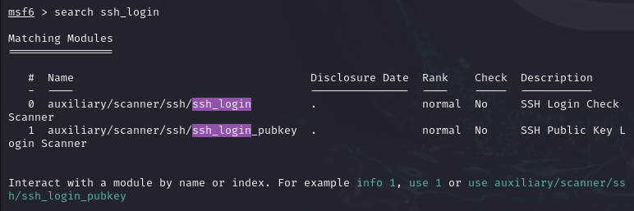

Use 0,auxiliary scanner as a search



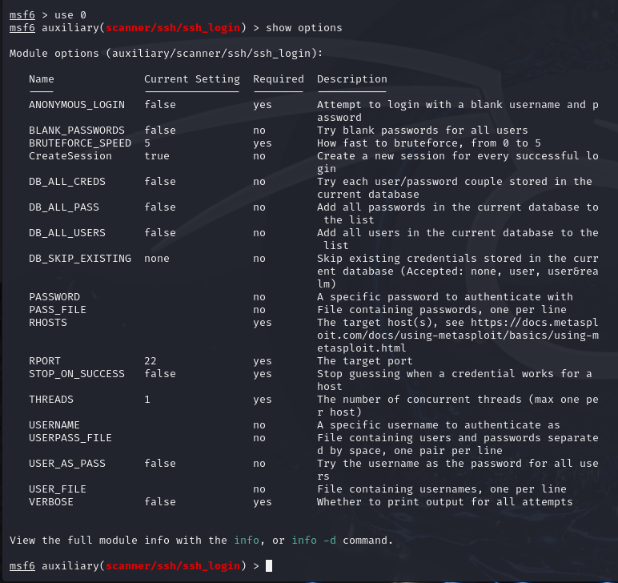

Set the RHOST(RHOST is the target host):



Set user and password txt file:

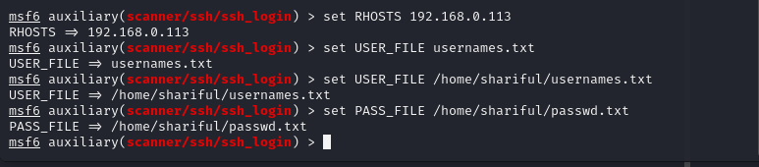

Here verbose and STOP_ON_SUCCESS are false.set them true

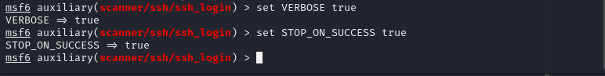

Now exploit the bruit force attack:

It’s take huge time for check username and password.after checking type sessions



Its show active sessions

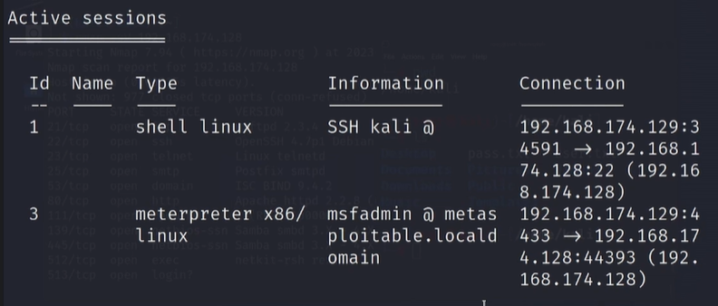

Here sessions 3 is meterpreter:

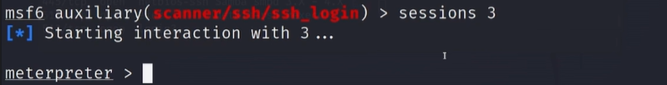

Check file in the meterpreter using ls. This is the metasploition machine. Now here we can create and delete file/folder what we need.

