Copy Website Data

This is the process to copy any website using S3 Trac Web Copier.

S3 trac allows you to download the client site component of a website including HTML CSS JavaScript Images Multimedia and many more assets.

Download and open HTTrack.

Here is the step by step procedure:

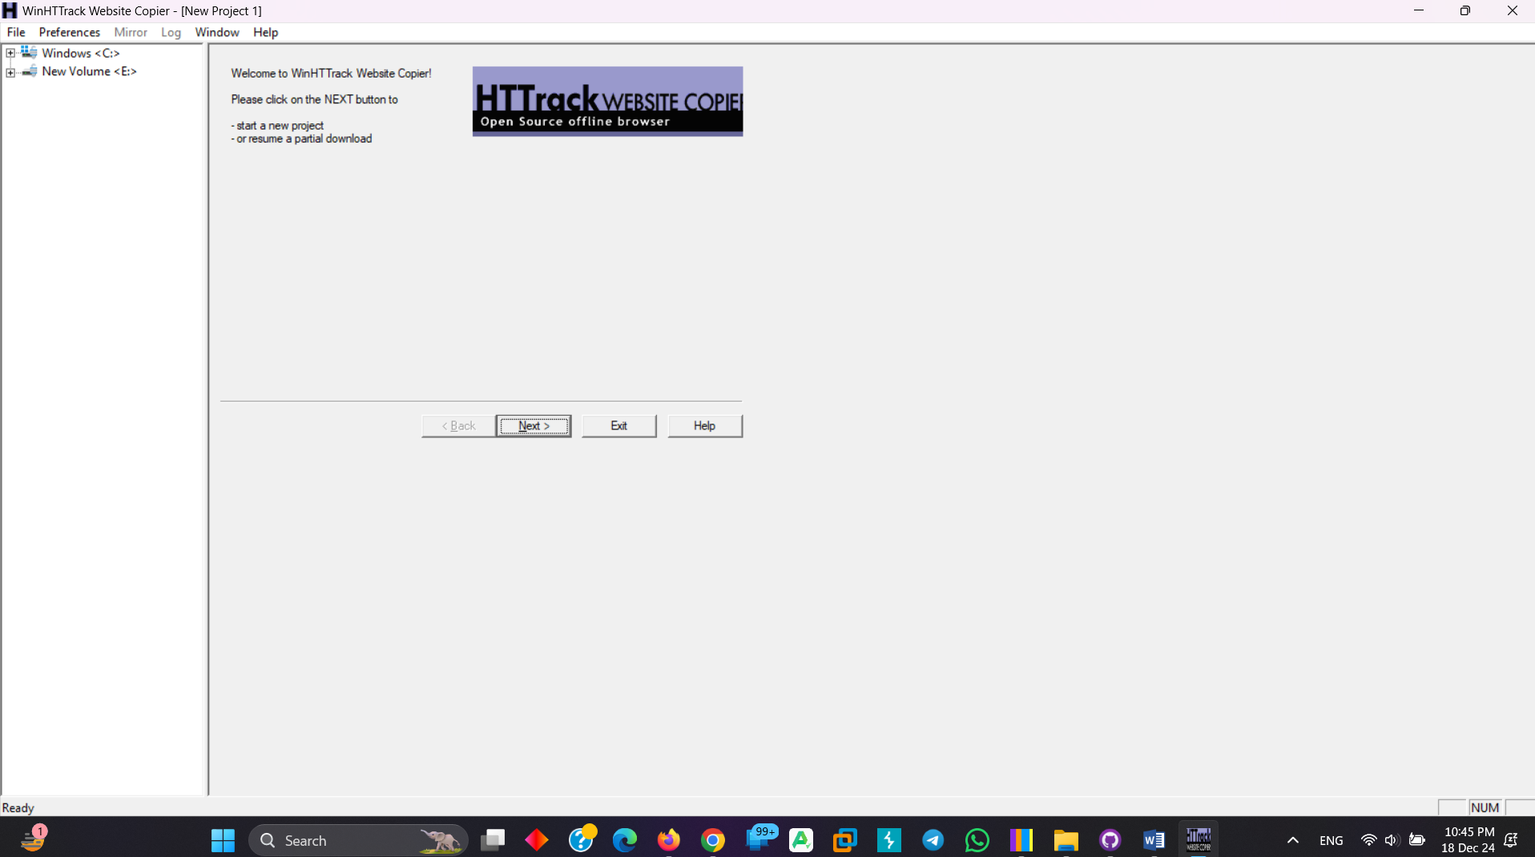

Write a project name and select the output directory:

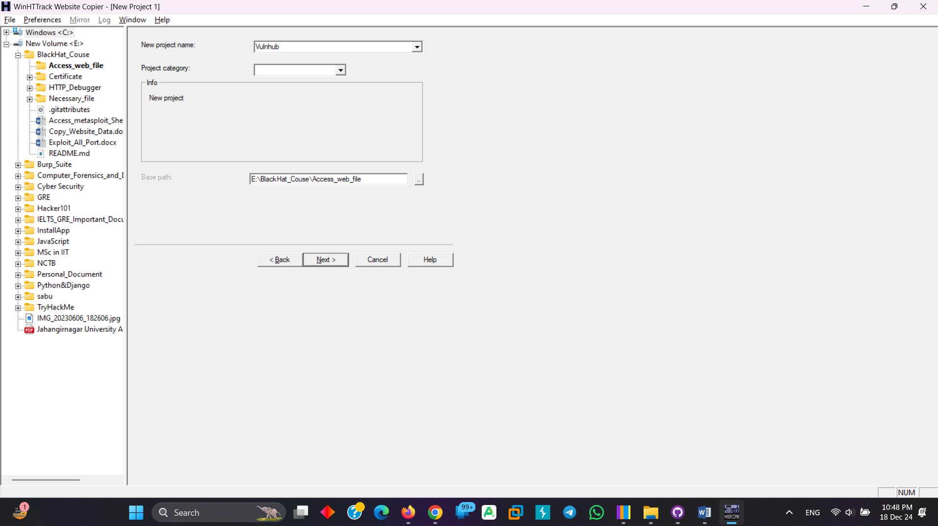

Copy any URL and paste:

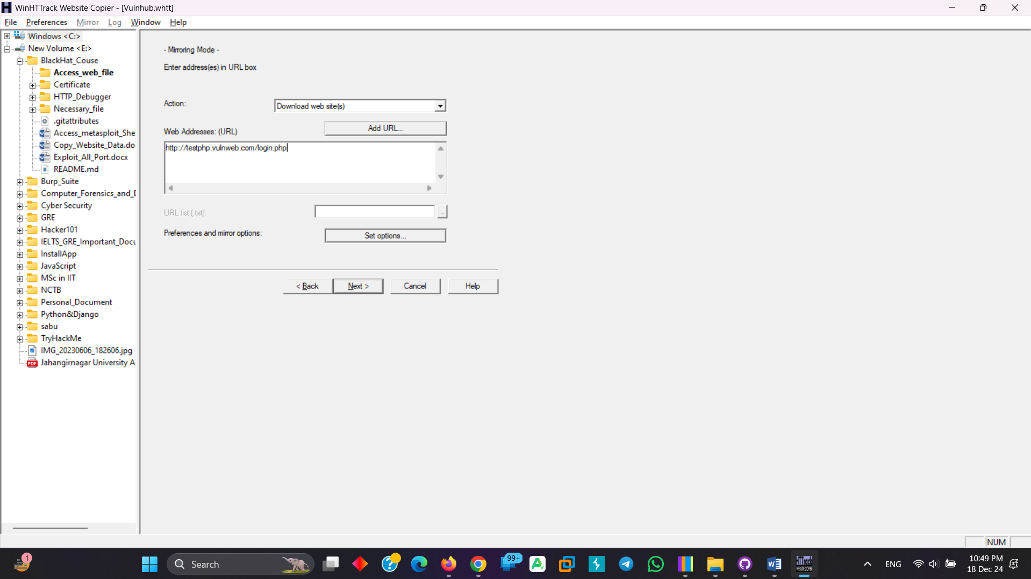

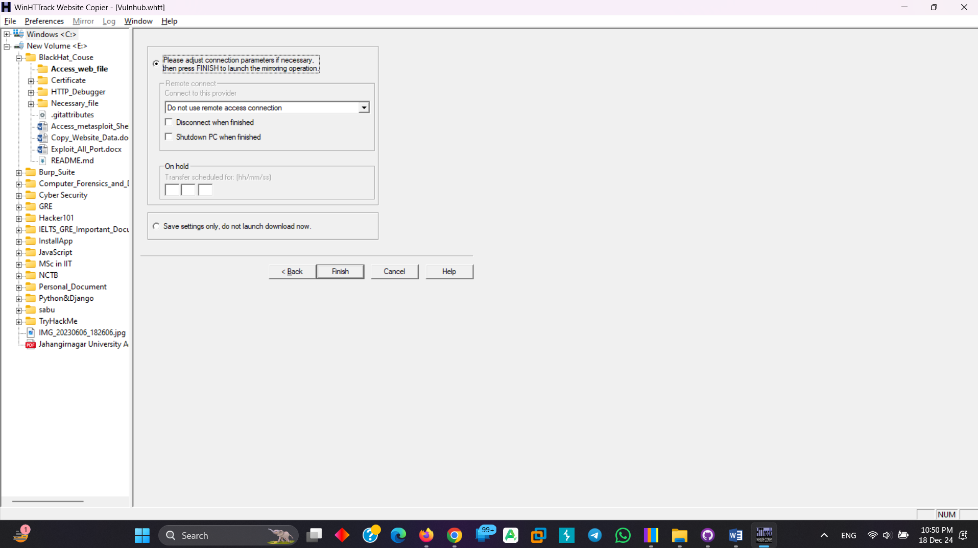

This will take some times for complete scanning:

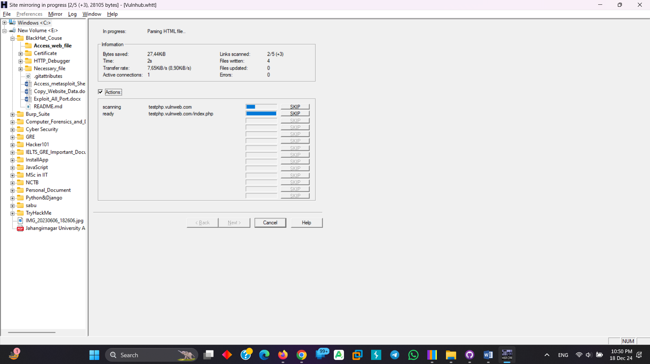

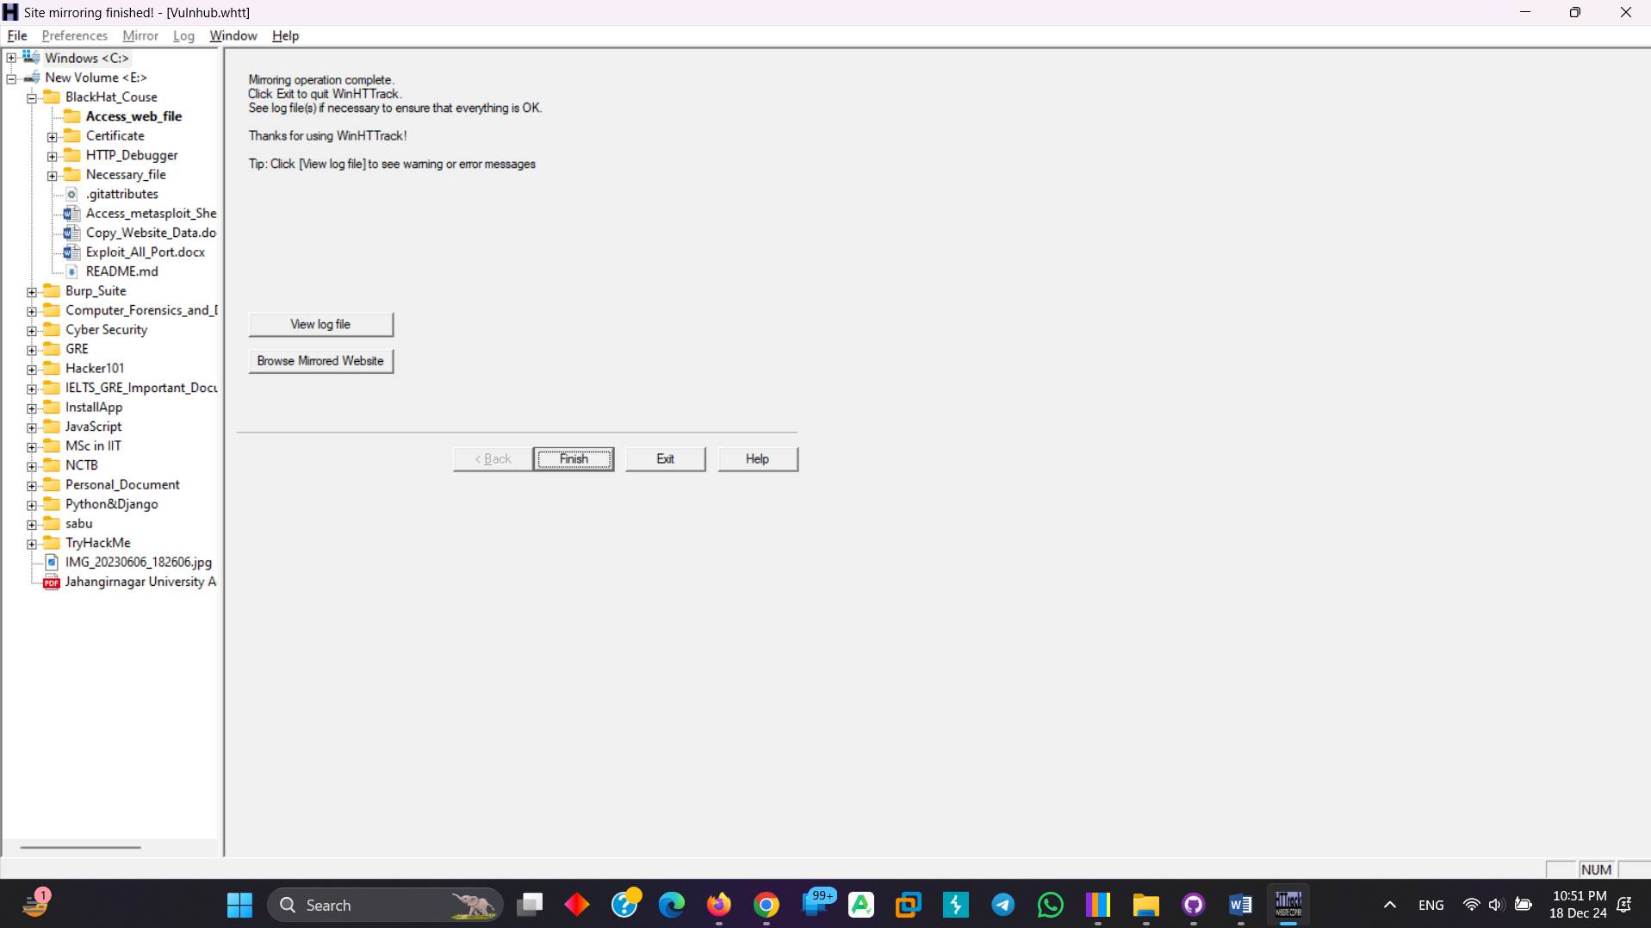

After finish, open the file location:

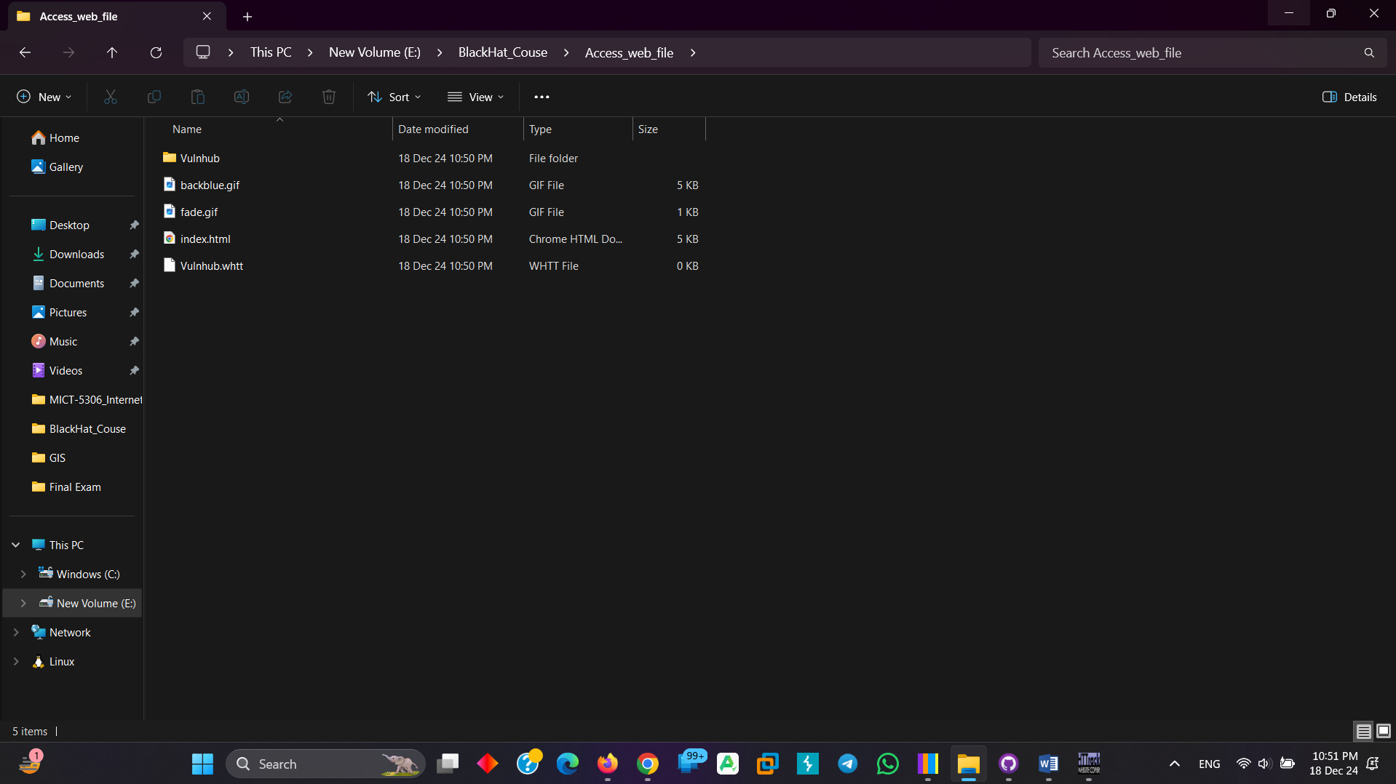

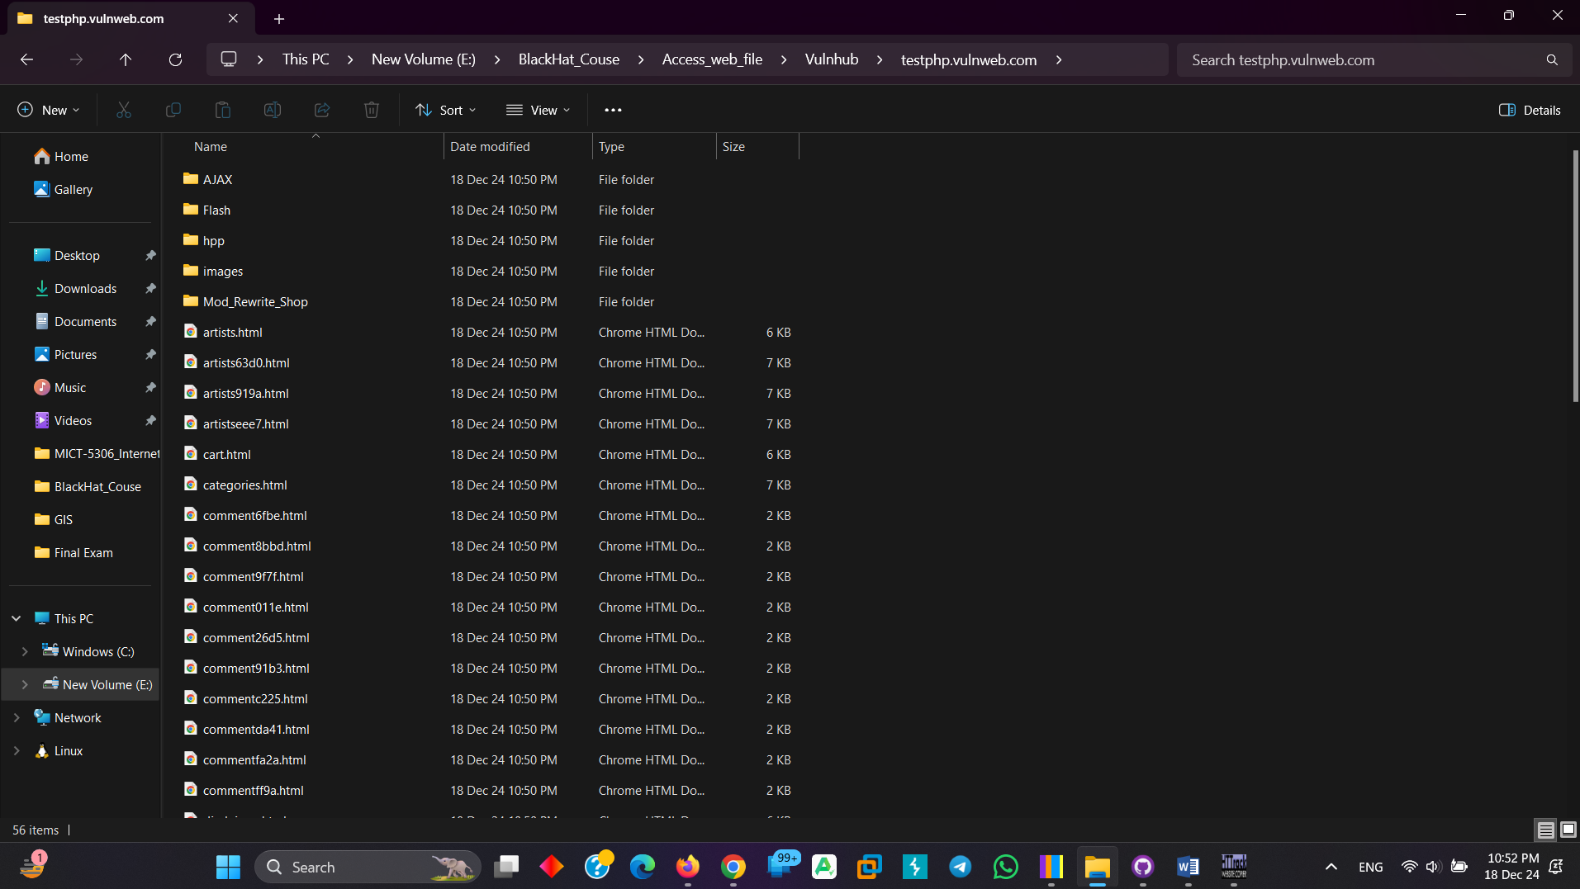

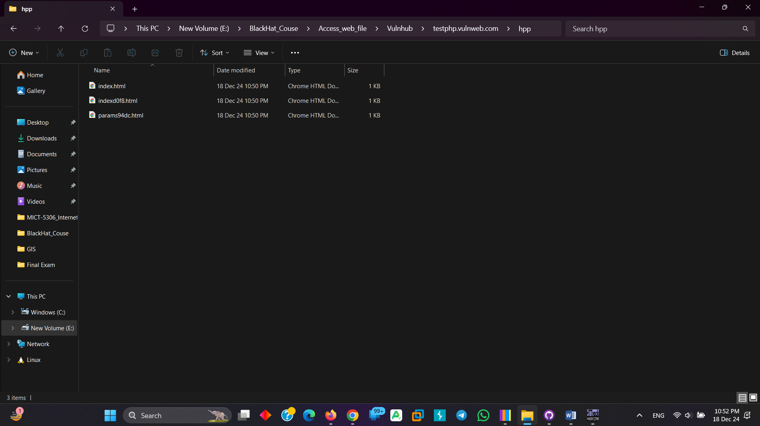

See the location, its local file now.

