Email FootPrinting

We'll learn how to gather information about an email address and can track it.

First open any mail and goto “Show original”

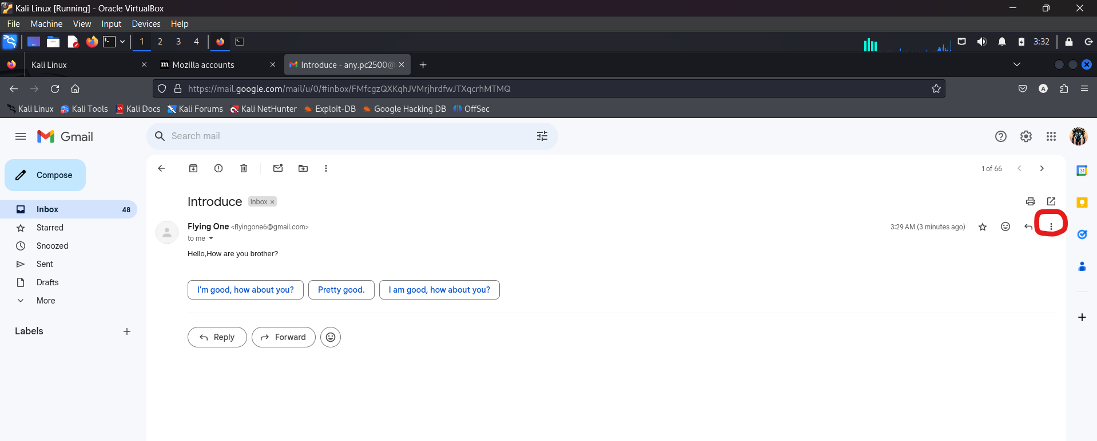

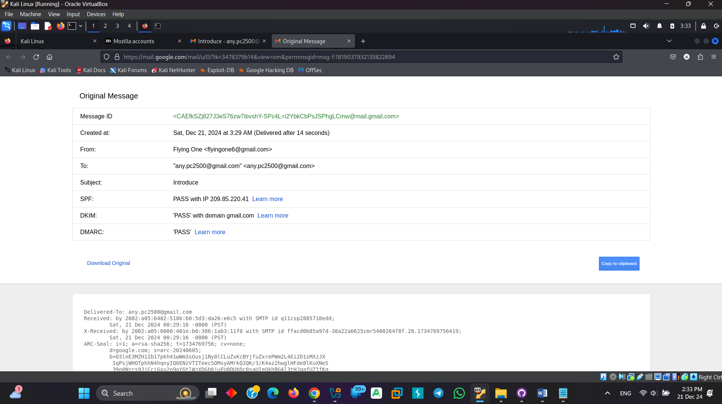

Then Copy to clipboard.

Then goto ip2location email tracer.

Link: <https://www.ip2location.com/free/email-tracer>

Paste the email header(Copy to clipboard).

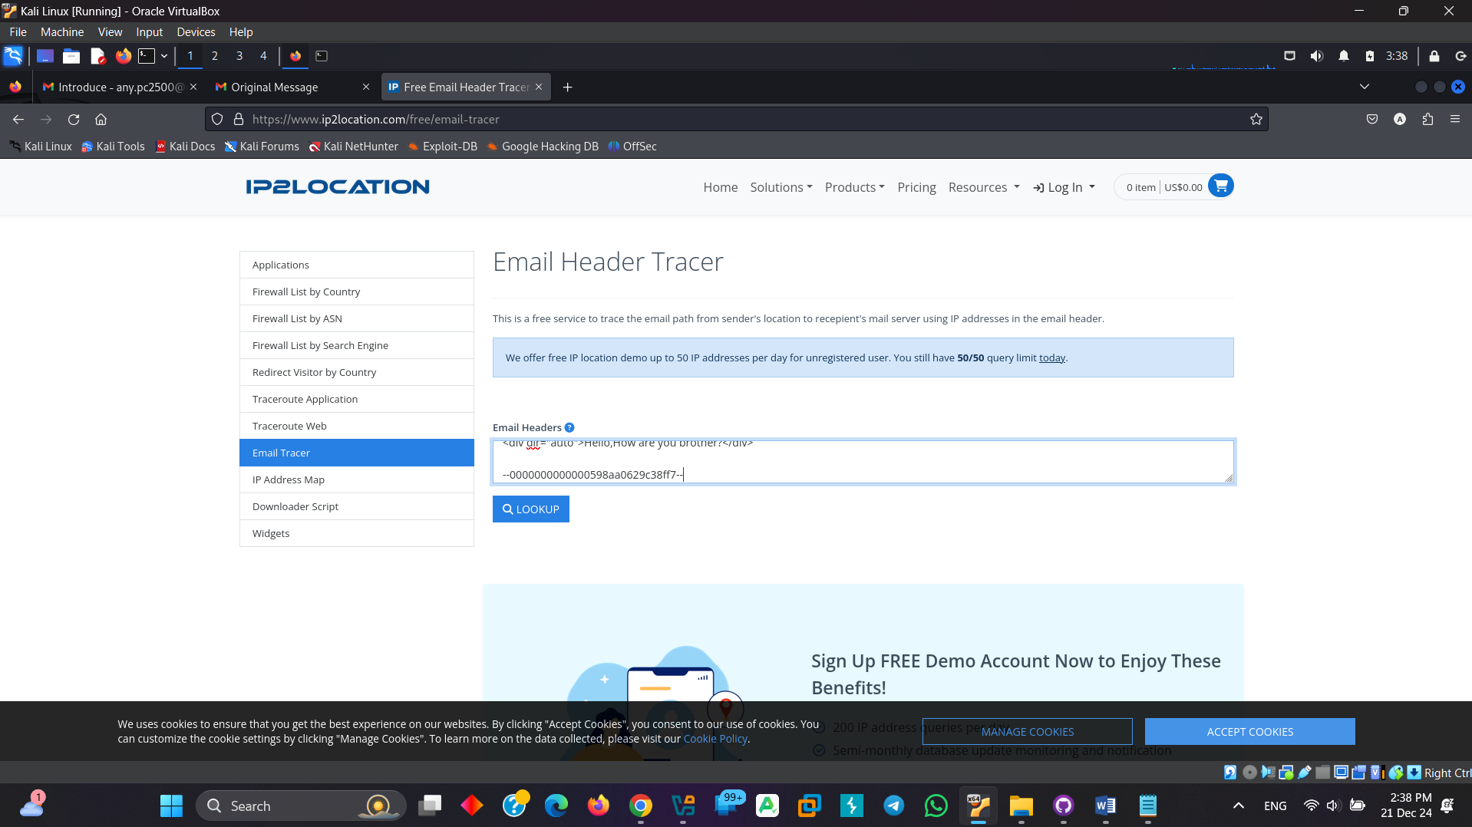

Click Lookup.

