HoneyPots

HoneyPots is the process to learn how to catch hackers. Honeypot is essentially a trap designed to attract hackers such as police use various techniques to catch cyber criminals. Cyber security experts, they employ honey pots to catch hackers. Some companies install the honeypot within the network, and when hackers try to beat the company's security, the honeypot captures the attacker IP address and geolocation data.

<https://github.com/technicaldada/pentbox>

Open the link and follow step by step procedure:

git clone <https://github.com/technicaldada/pentbox>

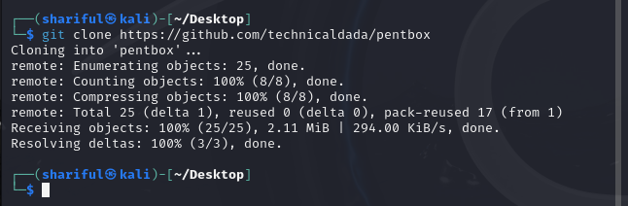

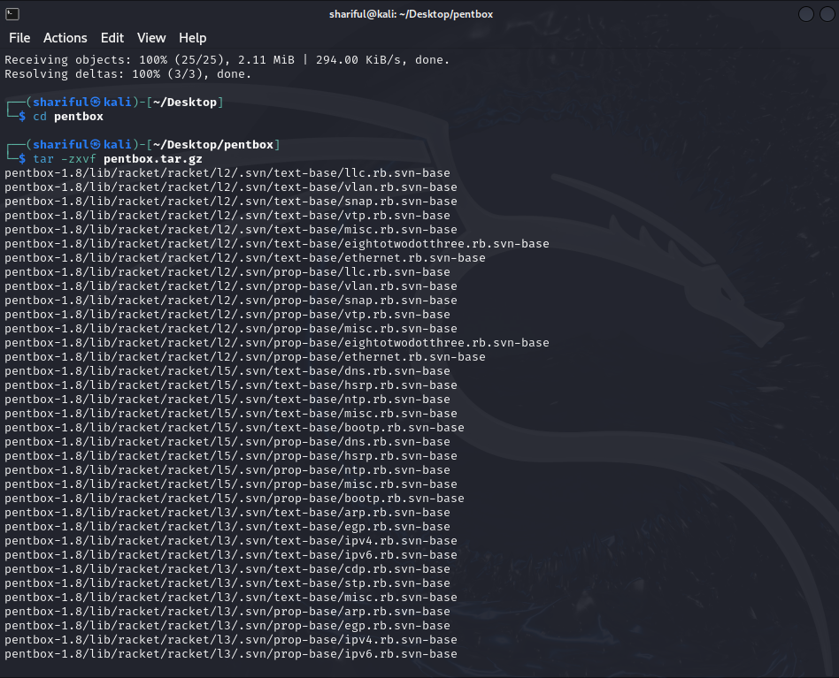

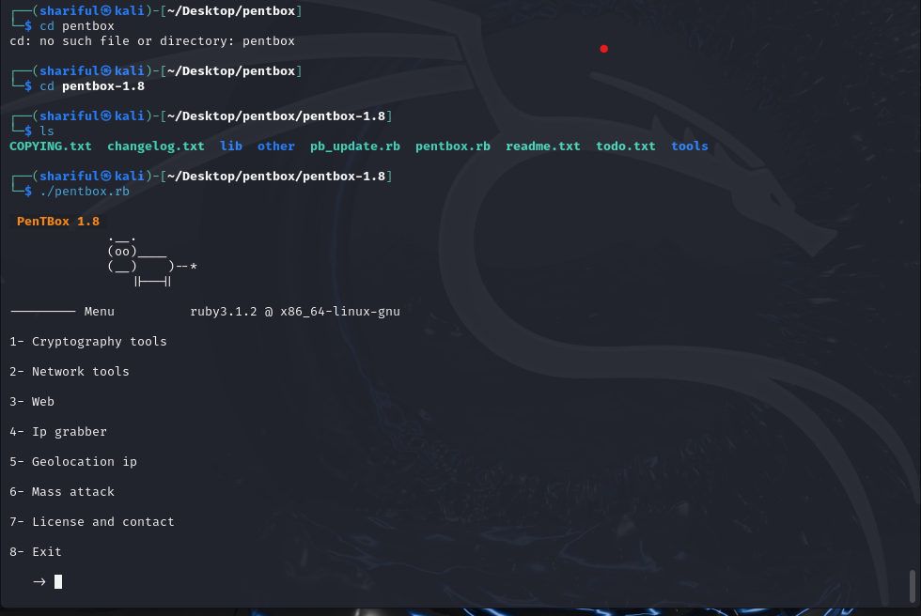

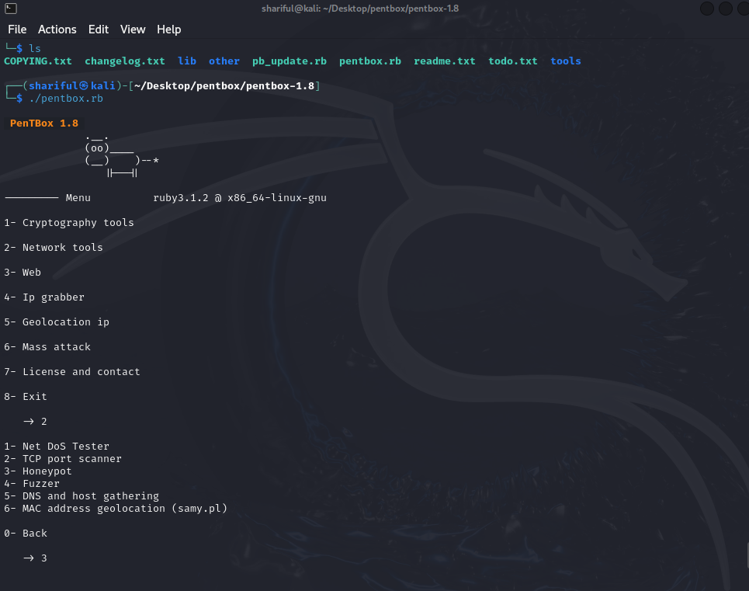

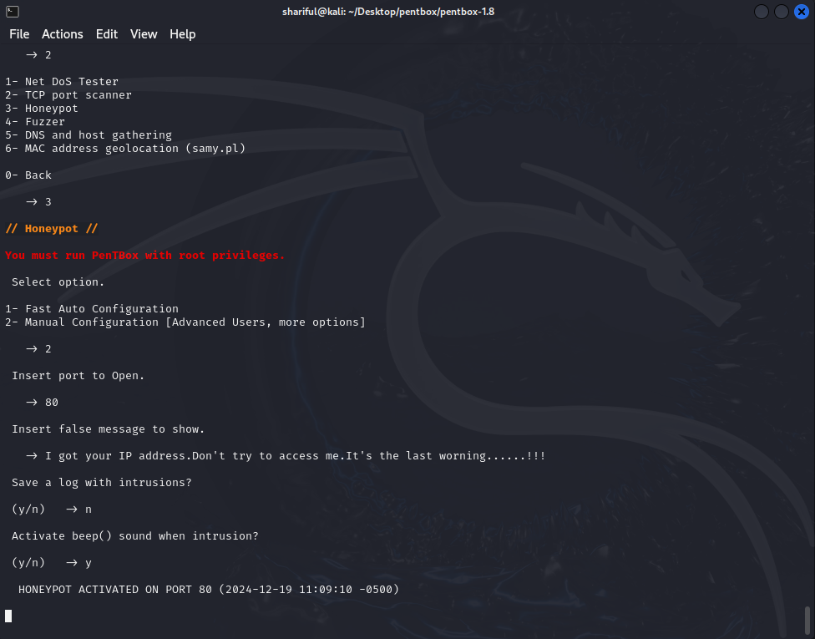

When anyone enter my IP address with port 80 there will show a message and in my terminal there will show hacker ip and location.

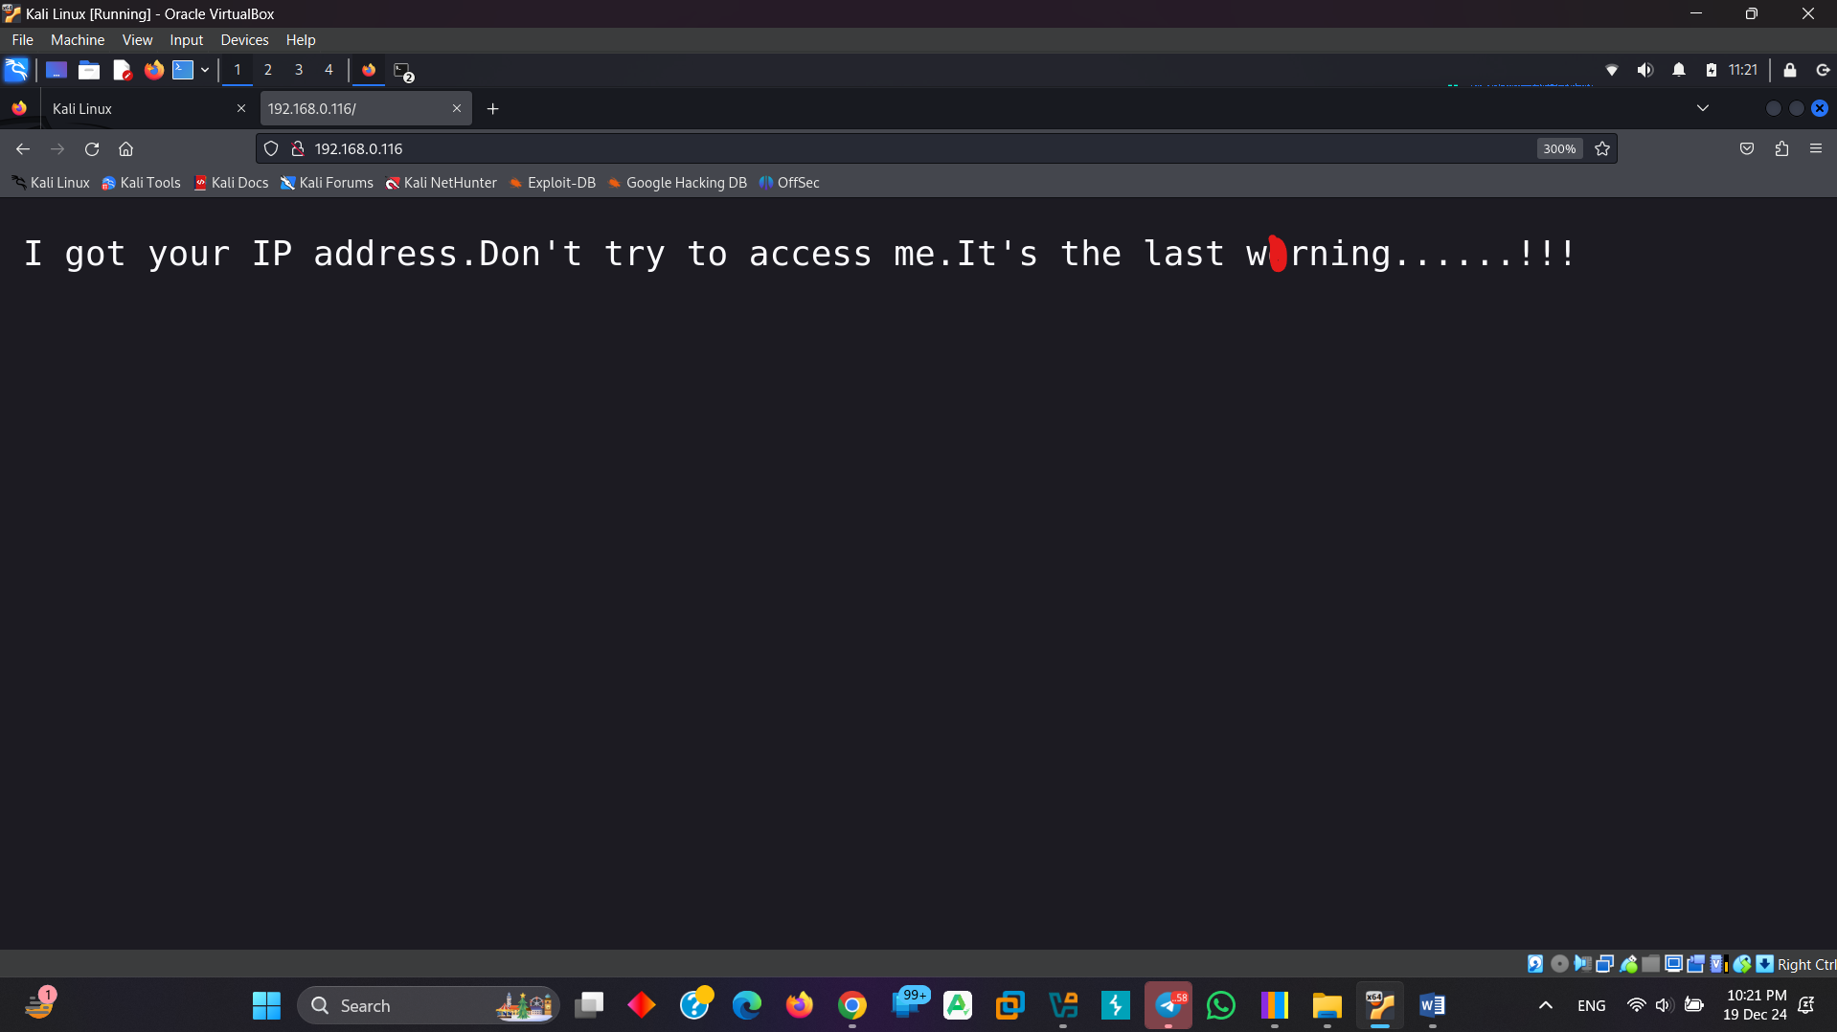

Here is the hacker details:

