KeyLogger

A keylogger is a type of surveillance software or hardware designed to record keystrokes made on a computer or mobile device. It can capture sensitive information such as passwords, usernames, and credit card details without the user's knowledge. Keyloggers can be used for legitimate purposes, such as monitoring employees or children, but they are often exploited by cybercriminals for malicious activities. They can be installed through malware, phishing, or physical access to the device. To protect against keyloggers, users should install antivirus software, update their systems regularly, and avoid downloading files from untrusted sources.

Goto the website and clone the file.

Link: <https://github.com/GiacomoLaw/Keylogger>

Goto linux directory

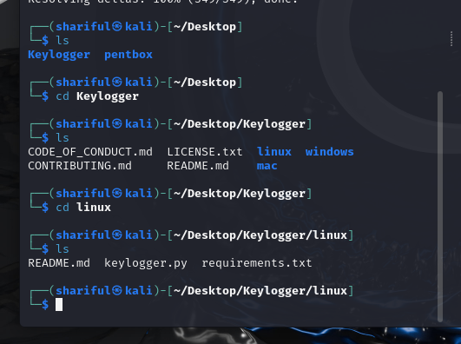

Install requirements.txt file



Run keylogger.py and browse any file.

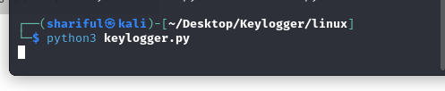

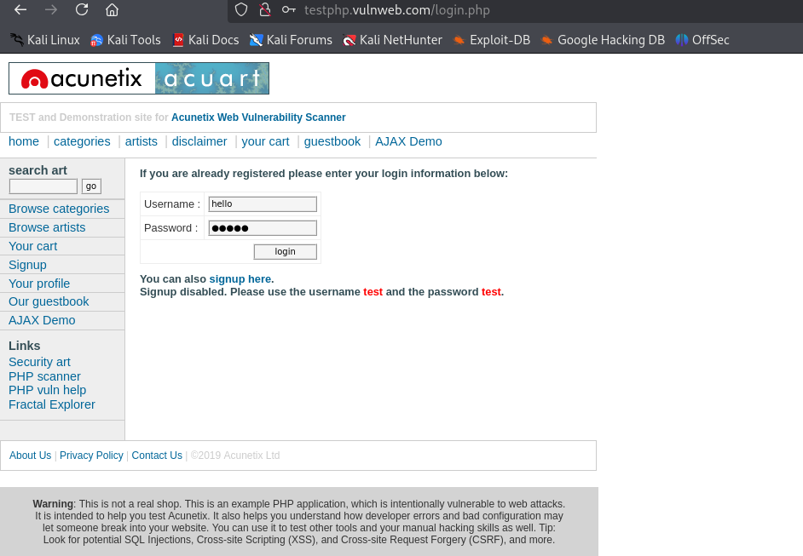

Goto the linux folder and open the log file:

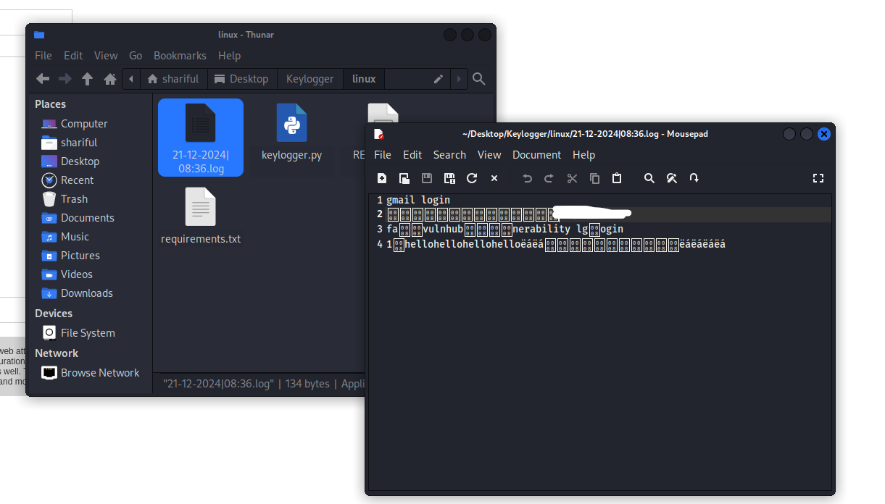

Here show the user and password hello.