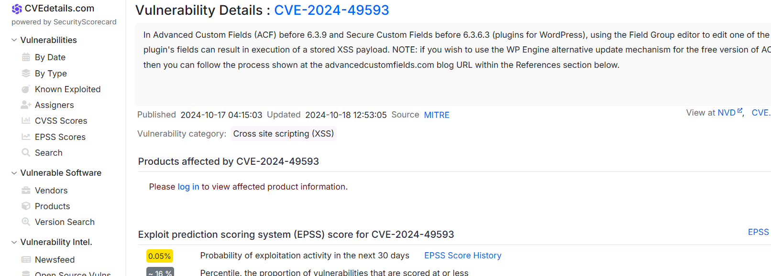

Example: Latest Microsoft Vulnerability Details

leakix.net/ 🡪

<https://threatmap.checkpoint.com/> 🡪 live attack protocal

[LeakIX - Graph](https://leakix.net/graph?) 🡪 check live vulnerability

72.249.68.156🡪 juniv.edu

<https://www.whois.com/> 🡪 domain name,identity,ip

<https://who.is/> 🡪 inp

<https://www.ipvoid.com/> 🡪 target ip details 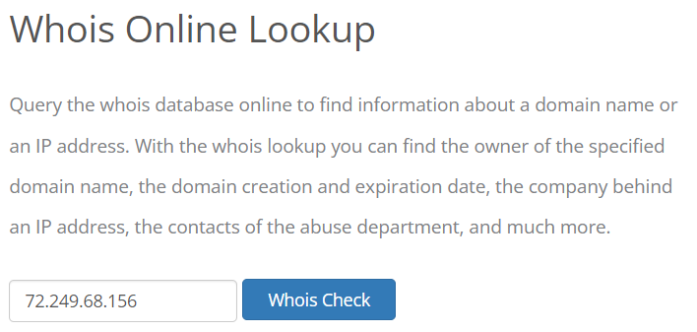



A mean ip address 🡪 it’s call A record

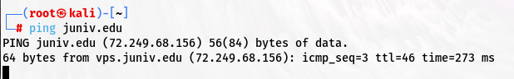

Nessus/tenable security center🡪 vulnerability scaner

Nessus installation🡪H.W 🡪 scan hoy policyr against e PN7W-Z9BP-KNM7-ZF5A-5NXP

SLA 🡪 service level argument

[Download Burp Suite Community Edition - PortSwigger](https://portswigger.net/burp/communitydownload)

<https://www.abuseipdb.com/> 🡪 to send a ip in black list

<https://any.run/>

<https://any.run/malware-reports/>

<https://app.any.run/submissions/>

<https://app.any.run/tasks/eaedffff-3e09-4c96-8bce-8f94950eaf7b>

Information gathering:

