Shariful Islam

ID: 2111252

21 Sep 2024

Assignment no 1: **Create** **Shared Folder**

1. Setting🡪 Shared Folders 🡪 add shared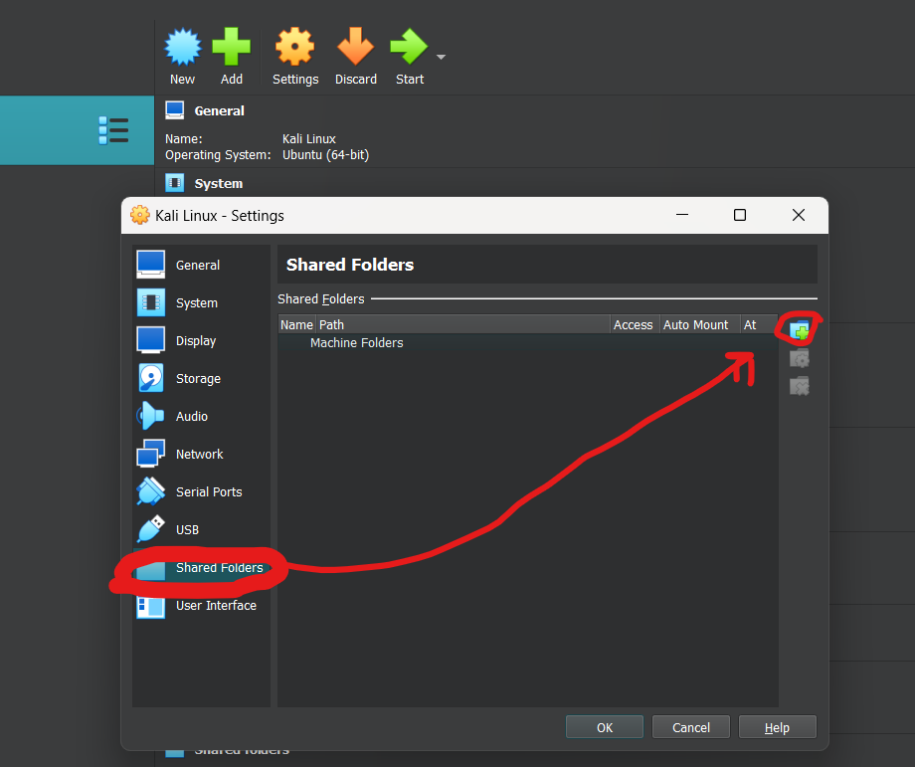
2. Folder Path 🡪 other 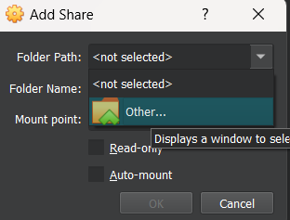
3. Select folder: 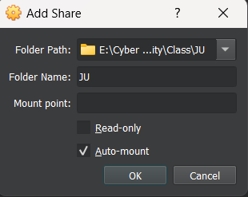
4. Check is Add Share in Terminal :
   1. sudo -i 🡪 for root folder
   2. cd /media/sf_JU 🡪 sf stand for share folder🡪JU is folder name
   3. check target file is available in Shared Folder 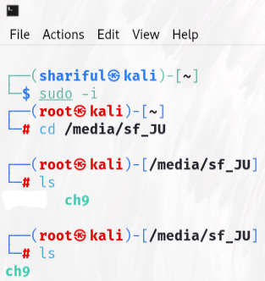
   4. Type testdisk ch9 🡪 Process 🡪Intel 🡪 Advanced 🡪Boot 🡪List 🡪Files 🡪Find red line and go to this line, then type C and again type C 🡪 deleted file will be copy in target (JU) folder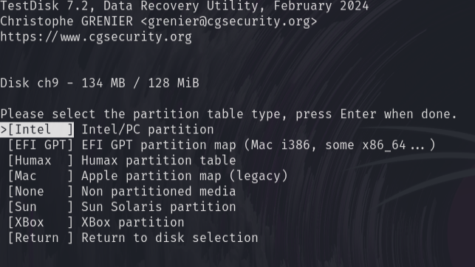 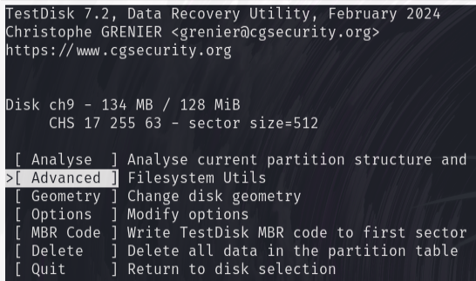 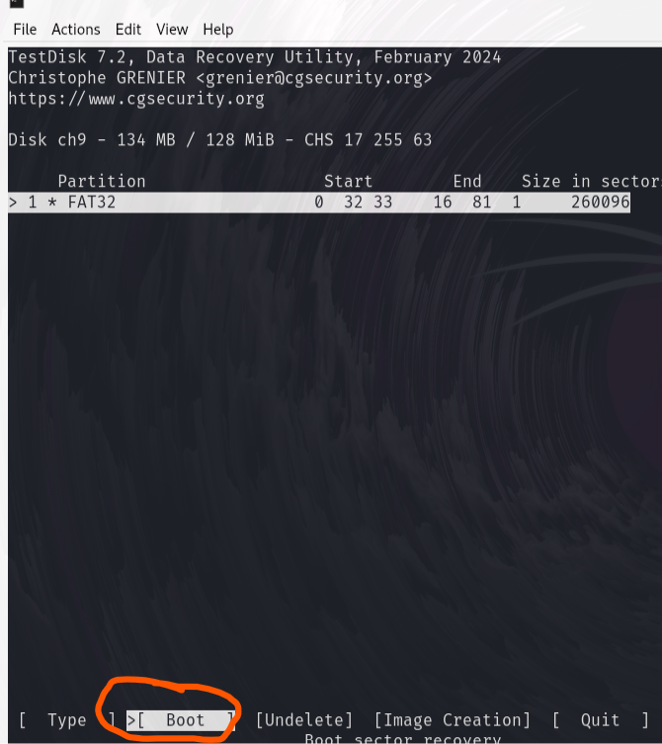 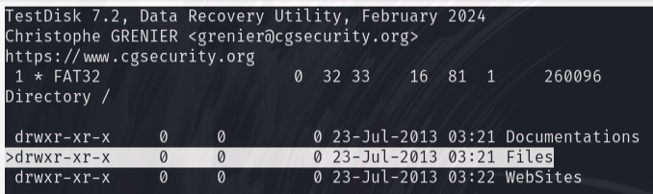 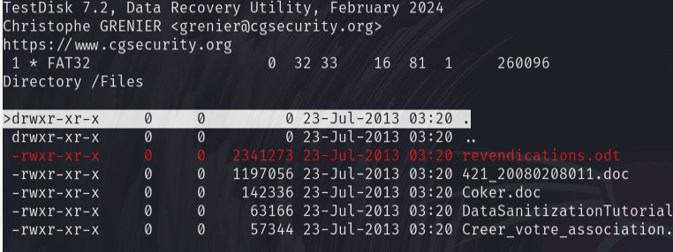 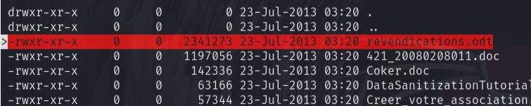
   5. Open target folder (JU)🡪a new folder “File” created 🡪 change the extension to ZIP (don’t do compress for create zip)🡪 then extract all the file
   6. Go to Picture location using cd and type exiftool picture_name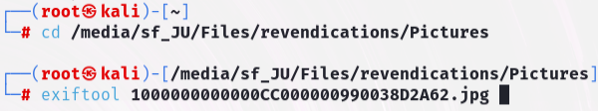
   7. Here show all details about picture: 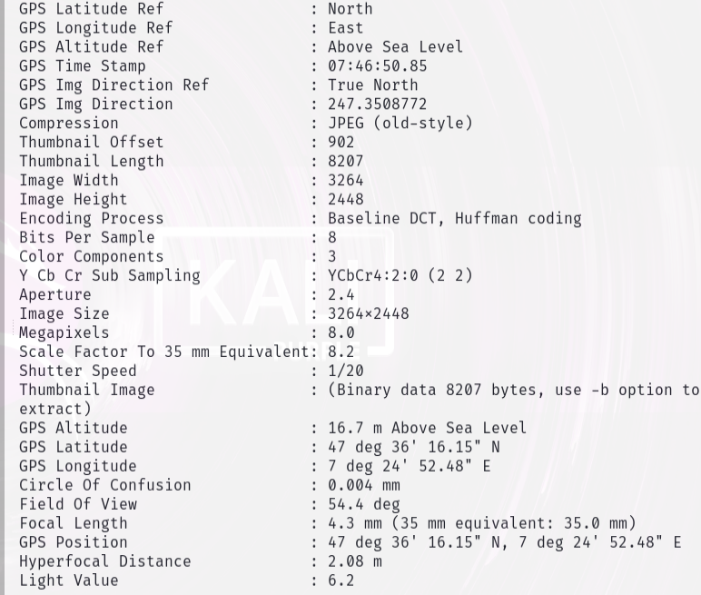
   8. For find picture location: goto: <https://www.gps-coordinates.net/> and type GPS Latitude and Longitude 