Cyber Security

Class no 16(Lab 7, Arabi Sir)

16 Nov 2024

VNC recoderter

**Router switch configuration:**

Router port 🡪 interface

┌──(root㉿kali)-[~]

└─# nipper –help

nipper --ios-router --input=ios.conf --output=report.html

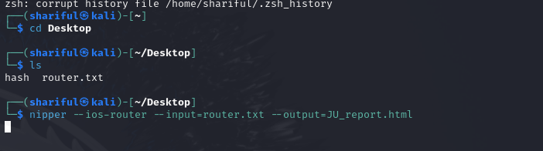

┌──(shariful㉿kali)-[~]

└─$ cd Desktop

┌──(shariful㉿kali)-[~/Desktop]

└─$ ls

hash router.txt

┌──(shariful㉿kali)-[~/Desktop]

└─$ nipper --ios-router --input=router.txt --output=JU_report.html

Then open JU_report.html file

SNMP mean ping one ip

What assessment do you find?

Observation and solution (recomandation) ta dibo just

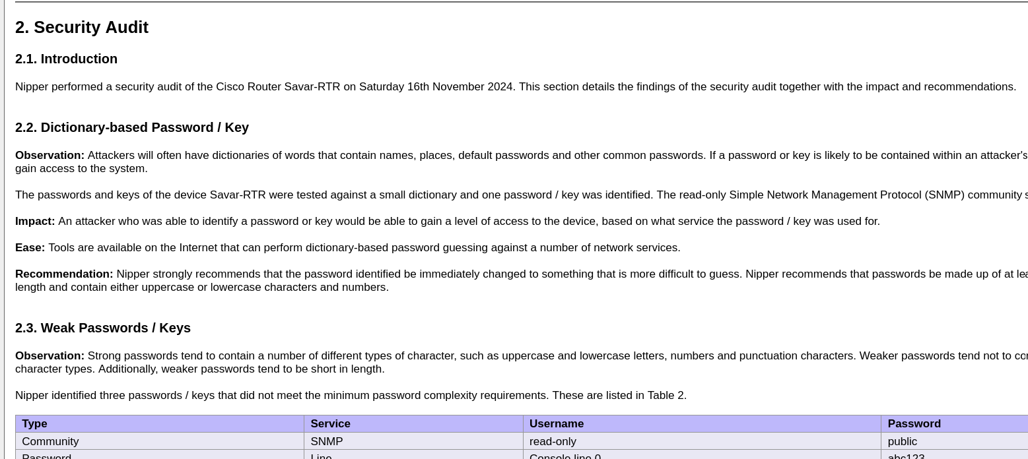

CISCCO –Juniper –Huwaei – Mikrotik 🡪from this router we can easily download configuration file

Social Engineering attack

setoolkit

