Cyber Security

Router Switch Configuration and Find Vulnerability

29 Nov 2024

nipper --help

For find all information about nipper.

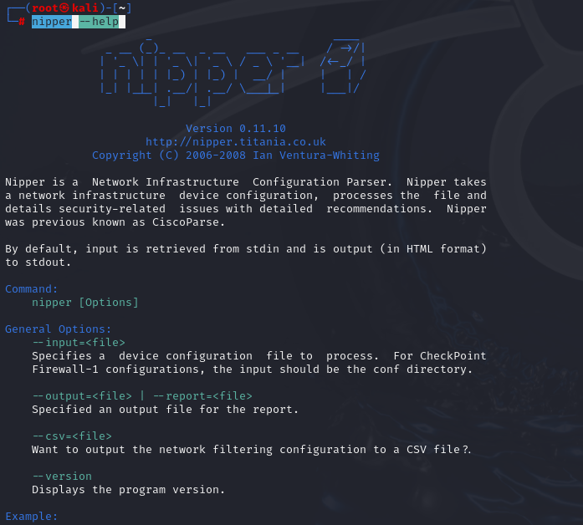

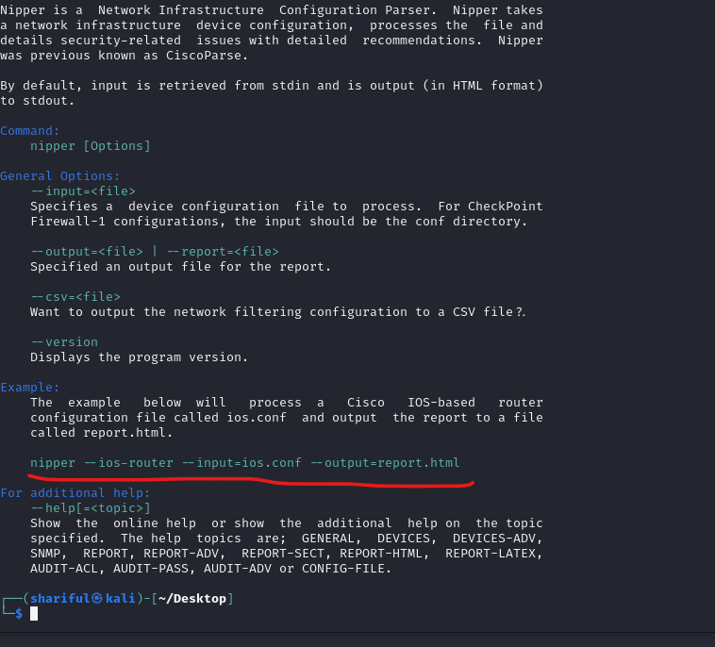

nipper --ios-router --input=router.txt --output=report.html

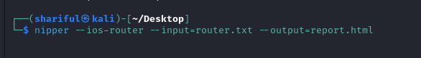

After execute this. A report.html file will be create. Just open this and find the vulnerability.

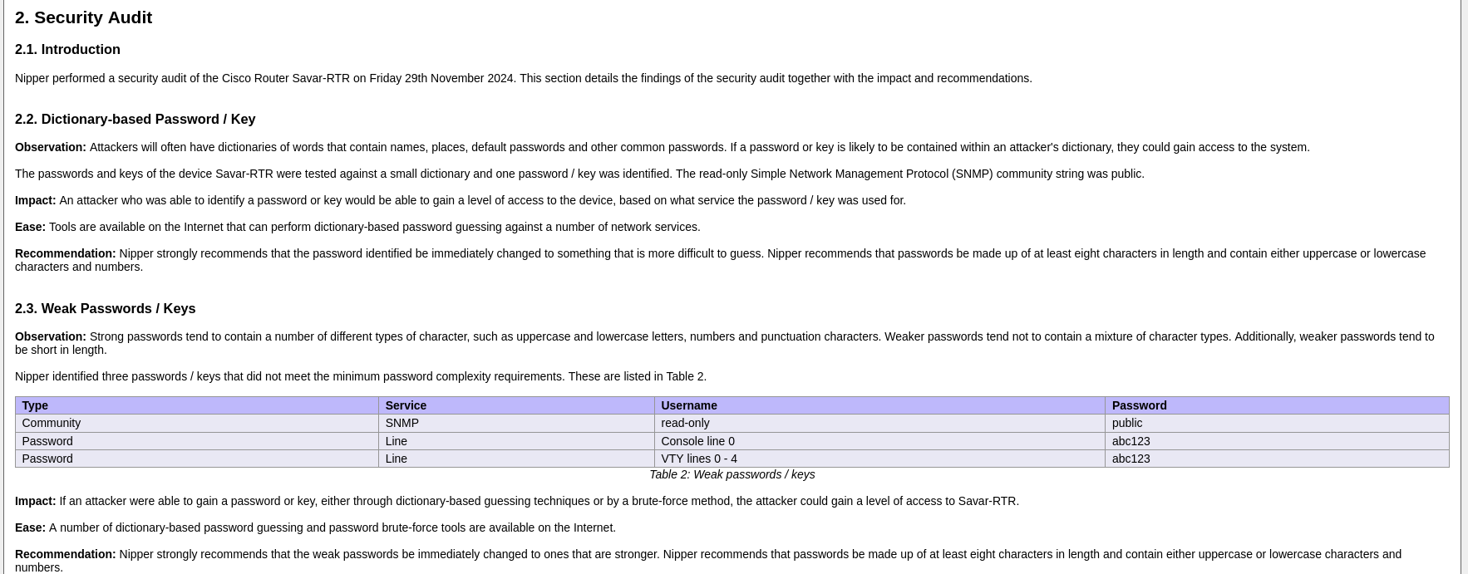

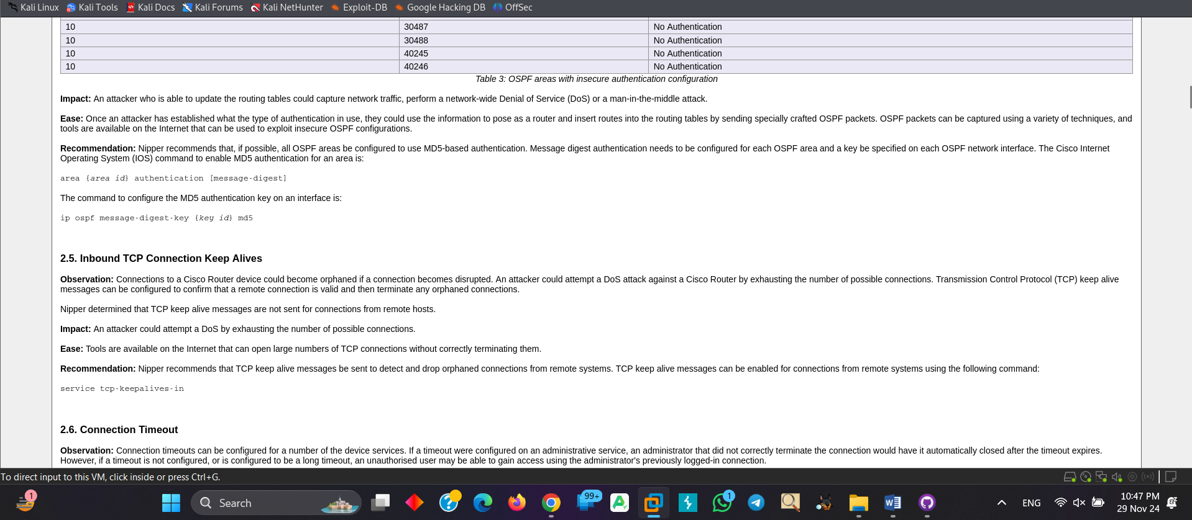

Here is the security audit’s observation and Recommendation.