**Shariful Islam**

**ID: 2111252**

**Ans to the question no Case-01**

┌──(root㉿kali)-[~]

└─# **cd /media/sf_Mid_Term**

┌──(root㉿kali)-[/media/sf_Mid_Term]

└─# **exiftool img1.jpg**

┌──(root㉿kali)-[/media/sf_Mid_Term]

└─# **exiftool img2.jpg**

1. When was the photo taken
   1. For img1
   2. For_img2
2. Who is the device manufacturer?
   1. For img1
   2. For_img2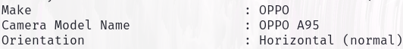
3. What encoding process is maintained?
   1. For_img1
   2. For_img2
4. What is the image height of this sample?
   1. For_img1
   2. For_img2
5. What time was the photo originally taken?
   1. For_img1
   2. For_img2

**Ans to the question no Case-02**

1. Nmap: Nmap is a popular open-source tool used for network discovery and security auditing. It helps network administrators and security professionals scan and map networks, identify open ports, detect services, and discover devices on a network.
2. **ifconfig** 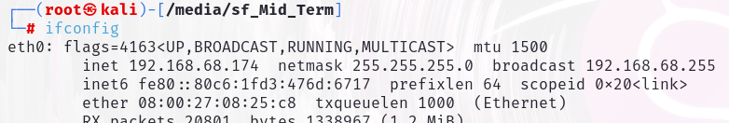
3. nmap -sS 192.168.68.216 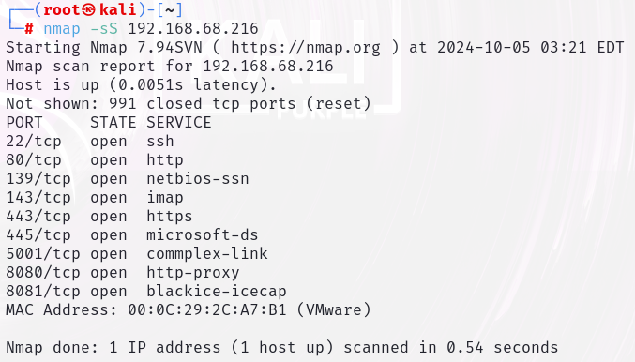
4. **nmap 192.168.68.216 -p 80 –sV**

ORT STATE SERVICE VERSION

80/tcp open http Apache httpd 2.2.14 ((Ubuntu) mod_mono/2.4.3 PHP/5.3.2-1ubuntu4.30 with Suhosin-Patch proxy_html/3.0.1 mod_python/3.3.1 Python/2.6.5 mod_ssl/2.2.14 OpenSSL...)

MAC Address: 00:0C:29:2C:A7:B1 (VMware)

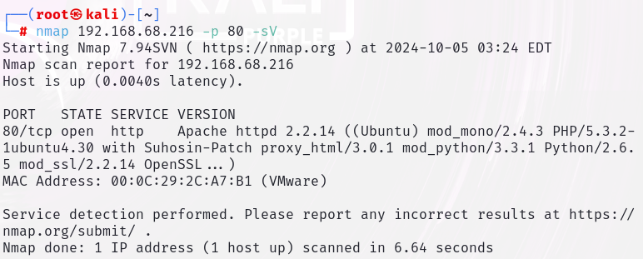

1. **nmap 192.168.68.216 -p 80 -sV –O**

Device type: general purpose

Running: Linux 2.6.X

OS CPE: cpe:/o:linux:linux_kernel:2.6

OS details: Linux 2.6.17 - 2.6.36