**Flag 0:**



Need to post something

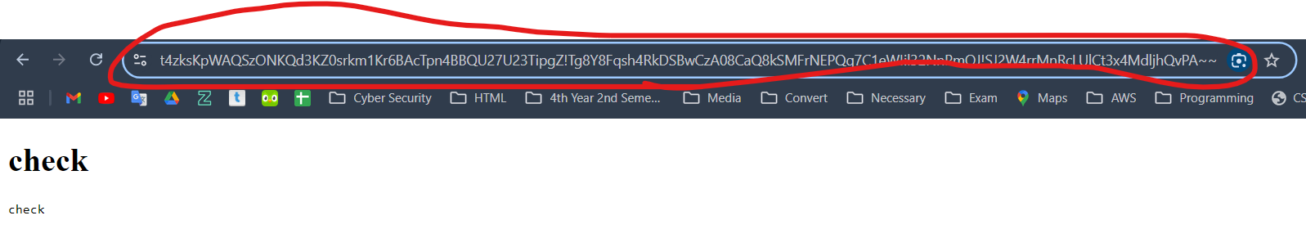

Here’s the encrypted link.

Remove ~~ from end of the link.

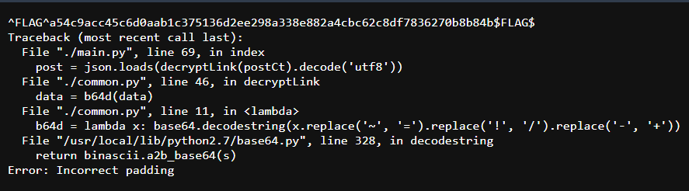

Another way to claim flag0



Flag1:

