Flag1:

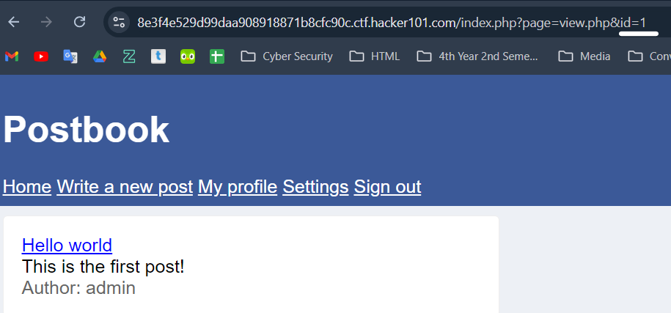

When you find id/edit/post in sequence number 1,2,3…. Then change this number one by one.

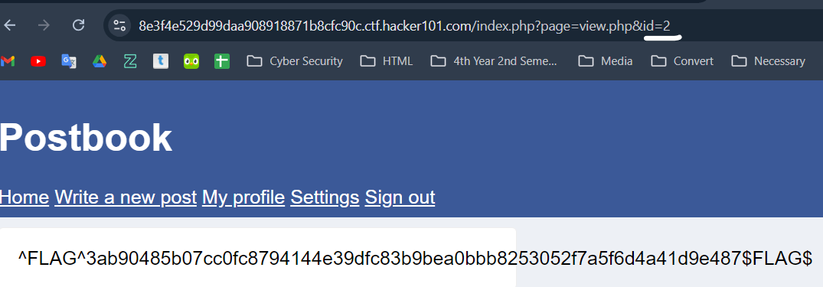

**Flag 2:**

See inspect, is there anything hide?

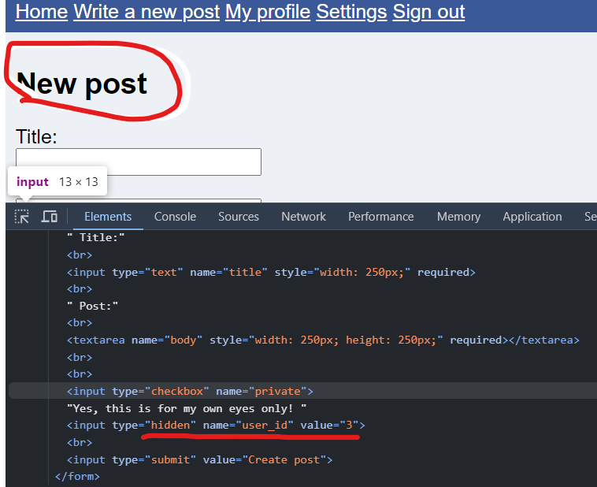

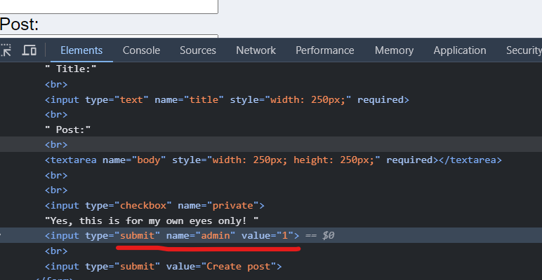

After this, post any content

