**Methodology**

One kind of Deep Learning neural network architecture that is frequently utilized in computer vision is the convolutional neural network (CNN). The branch of artificial intelligence known as "Computer Vision" gives computers the ability to comprehend and analyze images and other visual input.

**1.   Convolutional Layer**

The convolutional layer, which produces the majority of the network's computations, is the fundamental layer used to build convolutional neural networks. Keep in mind that the number of parameters does not equal the amount of calculation. Compared to a fully connected network of the same size, the convolution operation can effectively reduce the training complexity of the network model as well as the network connection and parameter weights. Standard convolution, transposed convolution, hole convolution, and depth separable convolution are examples of common convolution operations.

**2.  Activation Layer**

Artificial neural networks can be filled with an Activation Function to aid in the network's ability to recognize complex patterns in data. Rectified Linear Units (ReLU), Randomized LeakyReLUs (RReLU), Exponential Linear Units (ELU), and others are examples of common activation functions. Among the most important unsaturated activation functions is the linear rectification function (ReLU). As shown in its mathematical expression is as follows:

f(x)=max (0, x)

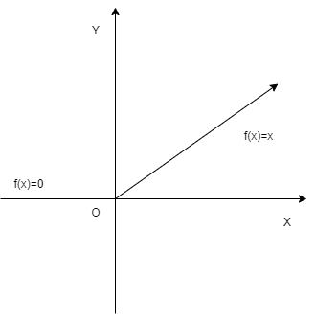

Fig: ReLU function image.

**3.  Pooling Layer**

These days, convolutional neural networks frequently use it as one of their constituent parts. In order to reduce overfitting, the amount of data and parameters are compressed by placing the pooling layer between successive convolutional layers. The pooling layer's primary job is to compress images if that's the input type.The pooling layer's primary job when the input is an image is to compress it.

By performing collective statistical operations on the special diagnosis at various positions in the local area of the image, the pooling layer can effectively reduce the size of the matrix. This reduces the parameters in the final fully connected layer, speeds up calculation speed, and lessens the excessive sensitivity of the convolutional layer to the image position.  The common operations of the pooling layer include the following: max-pooling, average pooling, Spatial Pyramid Pooling etc.

**Architecture of CNN:**

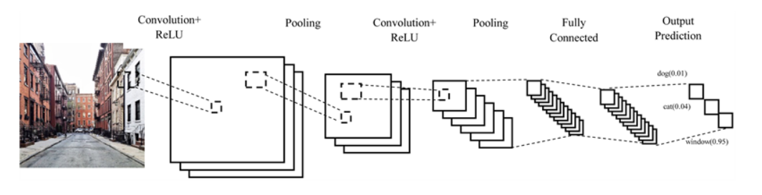

**Fig: Architecture of CNN:**

**Working procedure of CNN**

**Step:**

1. import the necessary libraries
2. set the parameter
3. define the kernel
4. Load the image and plot it.
5. Reformat the image
6. Apply convolution layer operation and plot the output image.
7. Apply activation layer operation and plot the output image.
8. Apply pooling layer operation and plot the output image.

**Flowchart:**

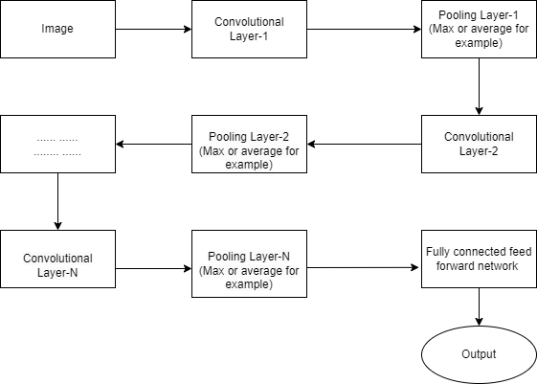

**Fig:Flow chart of CNN network**

**Here are some applications of CNNs:**

**Image Classification:**

CNNs are frequently used in image classification applications, where the network is trained to classify images into various groups. This program is widely used in many different domains, from diagnosing medical images to recognizing objects in photos.

**Object Detection:**

CNNs are useful for locating and identifying objects in pictures. CNNs are used in popular object detection frameworks such as Faster R-CNN and YOLO (You Only Look Once). Robotics, autonomous cars, and surveillance systems are a few examples of applications.

**Facial Recognition:**

Facial recognition systems use CNNs to recognize and verify people. They can be used for social media tagging, access control, and security systems.

**D2DET:**

In deep learning, an object detection model for computer vision tasks is called a deformable two-stage detector. It combines two key concepts: the two-stage architecture and deformable convolutional networks.

1.Two-stage architecture: Generally, object detection models work in two steps. They create region proposals, or possible bounding boxes that might include objects, in the first stage. To get the final object detections, these suggested zones are refined and classified in the second stage.

2.Deformable Convolutional Networks (DCN): Convolutional layers that may adaptively modify their receptive fields in response to features in an image are known as deformable convolutional networks. This makes it possible for them to record more precise and adaptable data regarding the forms of objects, particularly when such objects are hidden, incorrect or exist at different scales.

**Working procedure of D2Det algorithm:**

Certainly, here's a step-by-step procedure for the working of a deformable two-stage detector algorithm:

Step 1:Input Image

Begin with an input image that you want to perform object detection on.

Step 2:Feature Extraction

To extract feature maps, run the input image through a convolutional neural network (CNN).These feature maps extract the image's visual data.

Step 3:Region Proposal Network (RPN)

After processing the feature maps, the RPN creates a series of anchor points, or potential object bounding boxes, in different aspect ratios and sizes. There is a score assigned to each anchor box that represents the probability that it contains an object.In order to adaptively modify the receptive fields and gather more relevant data, apply deformable convolutions in the RPN.

Step 4:Anchor Scoring

Based on the probability that each anchor box contains an item, assign objectness scores to each one. The classification layer is used for this.

Step 5:Anchor Refinement

Make predictions about bounding box regressions to better align the anchor boxes with the actual positions of the objects. Regression layers are used for this.

Step 6:Anchor Selection

Choose the top-ranked anchors as suggestions for additional processing by filtering the anchor boxes according to their objectness scores. These suggestions show the areas that are most likely to have things.

Step 7:Region-of-Interest (RoI) Pooling

Utilize ROI pooling or a related method on the feature maps and extract fixed-size feature vectors for every proposal that is chosen. Regardless of their initial sizes, this phase guarantees that all proposals have uniform input sizes for additional processing.

Step 8:Deformable Convolutional Networks (DCN)

After passing the ROI features via deformable convolutional layers, the receptive fields of the layers adapt. For deformable or hidden objects in particular, deformable convolutions enable the acquisition of information from multiple locations within the ROI.

Step 9:Object Classification

Assign a class label to each ROI using a classifier network to identify the kind of object that each proposal contains.

Step 10:Bounding Box Regression

Regressor networks are used to fine-tune the bounding box coordinates that correspond to the regions of interest. The bounding boxes can be adjusted in this phase to better fit the exact locations of the objects.

Step 11:Post-processing

For the purpose of eliminating unnecessary or heavily overlapping bounding boxes, apply non-maximum suppression (NMS).This removes duplicates and guarantees that only the most reliable detections are kept.

Step 12:Output

The output of the deformable two-stage detector, provide the final collection of detected objects along with their class labels and updated bounding box coordinates.

The two-stage object detection method is combined with the advantages of deformable convolutional layers in the deformable two-stage detector algorithm to improve the accuracy of object detection and localization, particularly when objects display deformations, occlusions, or scale variations.

**SSD:**

SSD operates as a one-shot detector. It predicts the boundary boxes and the classes directly from feature maps in a single pass and does not have a gave region proposal network. SSD adds offsets to default boundary boxes and small convolutional filters to predict object classes in order to increase accuracy.

The SSD object detection composes of 2 parts:

Extract feature maps, and Apply convolution filters to detect objects.

SSD extracts feature maps using VGG16. Next, it makes use of the Conv4_3 layer to detect objects. As an example, Four object predictions are made for each cell, also known as location. To improve accuracy, SSD can be trained from beginning to end. SSD has better coverage on location, scale, and aspect ratios and makes more predictions.

**Working procedure of SSD:**

A well-liked object detection model for real-time object detection in photos and videos via deep learning is the Single Shot MultiBox Detector (SSD). SSDs are made to anticipate a set of bounding boxes and the class labels that correspond with them in order to identify objects in an image.

Here's an overview of how an SSD works in deep learning:

1. Input Image:

A neural network is used by the SSD model to extract features from an input image of any size. The backbone network is usually a convolutional neural network (CNN) that has been pre-trained, like VGG16 or ResNet. CNN uses several scales to extract features from the picture.

2. Feature Maps:

Various-sized feature maps are produced as the image is processed by CNN. Information is captured at different spatial resolutions by these feature maps. In general, higher-level features are captured by the deeper layers of the CNN, whereas lower-level features are captured by the shallower layers.

3. Multi-scale Feature Fusion:

SSD uses convolutional layers with different kernel sizes and moves to obtain feature maps at different scales. These layers are in charge of combining features from the backbone network's various layers. To identify objects of various sizes, feature maps at various scales are utilized.

4. Default Anchor Boxes:

A set of default anchor boxes, also called default bounding boxes, with various aspect ratios and scales are defined for every location in the feature maps. To begin object detection, these anchor boxes are used. In order to better fit the real objects in the picture, the SSD model predicts offsets, or deltas, for these anchor boxes.

5. Object Detection Head:

After feature extraction and anchor box definition, the SSD network splits into two parallel subnetworks:

- Localization Head: This part predicts the offsets (deltas) for each anchor box to adjust their positions and sizes to match the ground-truth objects in the image.

- Classification Head: This part predicts the class probabilities for each anchor box, indicating the likelihood that an object of a particular class is present in that box.

6. Non-Maximum Suppression (NMS):

Following the receipt of predictions from the localization and classification heads, low-confidence and redundant detections are filtered out using a post-processing technique known as non-maximum suppression. NMS makes sure that as final detections, only the most certain and non-overlapping bounding boxes are kept.

7. Output:

An array of bounding boxes with the corresponding class labels and confidence scores is the SSD model's final result. The objects that were found in the input image are represented by these bounding boxes.

Because SSD is effective at predicting class labels and bounding boxes at multiple scales in a single forward pass, it can detect objects in real time. This makes it a well-liked option for many applications, such as image recognition, autonomous driving, and surveillance. By modifying the quantity and dimensions of the default anchor boxes and fine-tuning the model on particular datasets, the SSD architecture's flexibility allows it to be tailored for a variety of object detection applications.

**YOLOv:**

YOLO is an algorithm that provides real-time object detection using neural networks. The accuracy and speed of this algorithm makes it popular.

The abbreviation YOLO stands for "You Only Look Once." This algorithm (in real-time) finds and recognizes different objects in an image. YOLO employs object detection as a regression problem, resulting in the class probabilities of the identified images. Convolutional neural networks (CNN) are used by the YOLO algorithm to detect objects in real-time. As the name implies, the algorithm can detect objects with just one forward propagation via a neural network. This indicates that a single algorithm run is used to predict the entire image. Multiple class probabilities and bounding boxes are simultaneously predicted by the CNN.

There are several variations of the YOLO algorithm. Tiny YOLO and YOLOv3 are a couple of the popular ones.

**Working procedure of yolo algorithms:**

YOLO algorithm works using the following three techniques:

1. Residual blocks
2. Bounding box regression
3. Intersection Over Union (IOU)

**Residual blocks**

First, the image is divided into various grids. Each grid has a dimension of S x S. The following image shows how an input image is divided into grids.

Bounding box regression

A bounding box is an outline that highlights an object in an image.

Every bounding box in the image consists of the following attributes:

* Width (bw)
* Height (bh)
* Class (for example, person, car, traffic light, etc.)- This is represented by the letter c.
* Bounding box center (bx,by)

**Intersection over union (IOU)**

In object detection, the phenomenon known as intersection over union (IOU) characterizes how boxes overlap. YOLO creates an output box that exactly covers the objects by using IOU. The task of predicting the bounding boxes and their confidence scores falls on each grid cell. If the expected and actual bounding boxes match, the IOU is equal to 1. Bounding boxes that are not equal to the actual box are removed by this mechanism.

**Combination of the three techniques**

The image is first split up into grid cells. B bounding boxes are predicted by each grid cell, along with their confidence scores. To determine each object's class, the cells make predictions about the class probabilities.

A car, a dog, and a bicycle are just a few examples of the at least three classes of objects that are visible. A single convolutional neural network is used to make all of the predictions at the same time.

The predicted bounding boxes and the actual boxes of the objects are guaranteed to be equal by intersection over union. The effect removes irrelevant bounding boxes that don't match the object's dimensions (height and width). The final detection will be made up of distinct bounding boxes that precisely match the objects.

For instance, the yellow bounding box surrounds the bicycle and the pink bounding box covers the car. The blue bounding box has been used to highlight the dog.

YOLO algorithm can be applied in the following fields:

Autonomous vehicles can utilize the YOLO algorithm to identify nearby objects, including people, cars, and parking signals. In forests, this algorithm is used to identify different kinds of animals. Journalists and wildlife rangers use this kind of detection to recognize animals in photos.

**Proposed System Model**

In our proposed topic we used four algorithms. Here is a flowchart of our proposed model

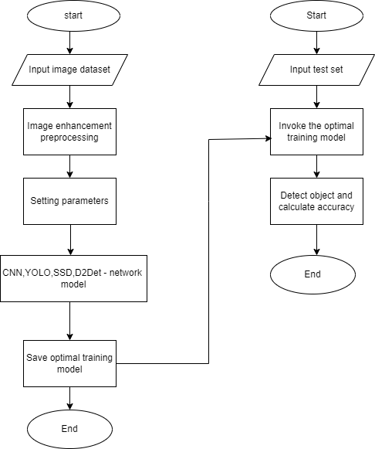

Fig:Proposed model of our project