Monitor Mode

First need to down the wlan0(wifi):

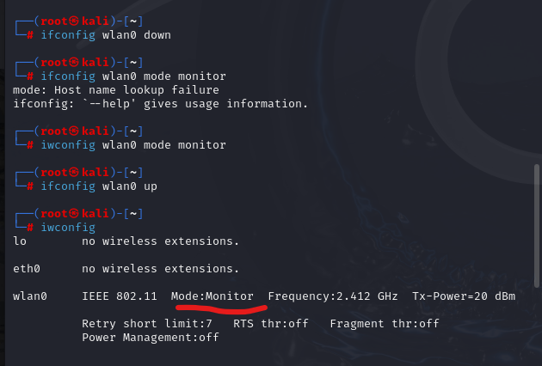

Here monitor mode is on.

Here is the different type of network around me. 