Pre Connection Att@ck

Change MAC Address: Because MAC and IP address is the way to trace you.

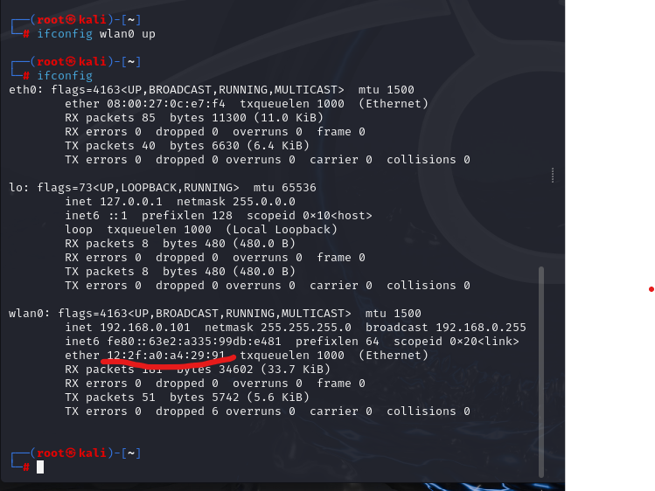

Monitor Mode

First need to down the wlan0(wifi):

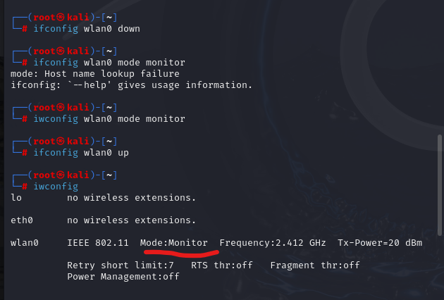

Here monitor mode is on.

Here is the different type of network around me. 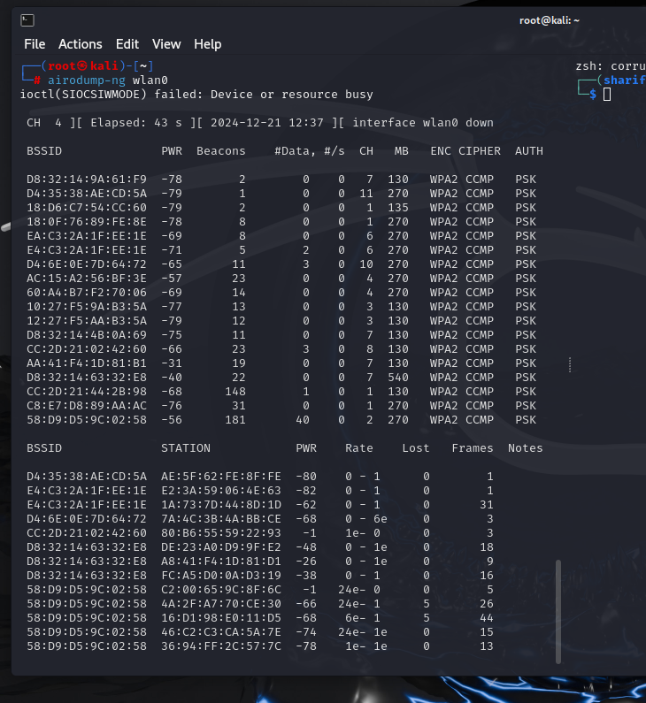

sudo chmod -R 777 /root 🡪give the read write permission

ls example-upc\* 🡪find any file

airodump-ng --channel 6 --bssid E4:C3:2A:1F:EE:1E --write example-upc wlan0 🡪here wxample-upc is the file name.

airodump-ng wlan0 🡺show the available wifi around me