Network Fundamentals

Putting it all together

**Task 1:**

No answer needed

**Task 2:**

***CDN (Content Delivery Networks)***

*A CDN can be an excellent resource for cutting down traffic to a busy website.*

***WAF (Web Application Firewall)***

*A WAF sits between your web request and the web server; its primary purpose is to protect the webserver from hacking or denial of service attacks.*

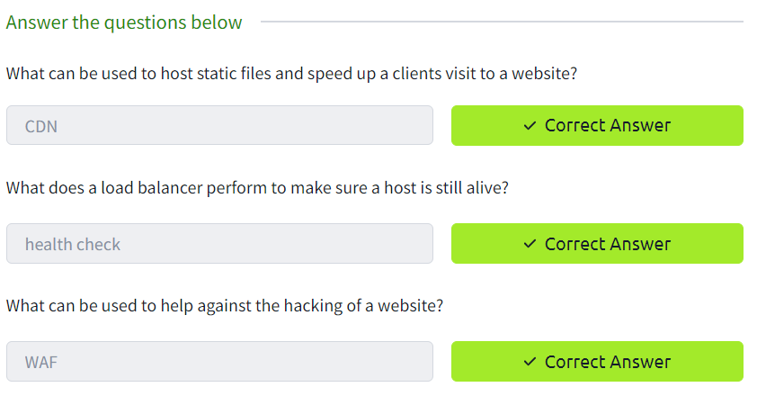

**Task 3:**

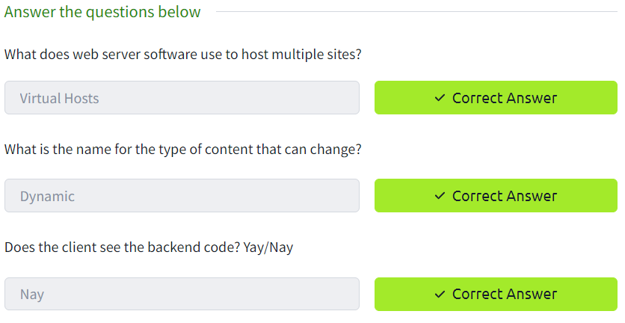

**Task 4:**

