**FitFlex: Personalized Fitness App**

**1. Introduction**

* **Project Title**:

FitFlex: Your Personal Fitness Companion - A modern, interactive web application designed to enhance fitness experiences by providing users with customized workout routines, exercise categories, and integrated video tutorials for efficient learning and engagement.

|  |
| --- |
| * **Team Leader:** Sharika Anjum F * **Email ID:** [**sharuanjum004@gmail.com**](mailto:sharuanjum004@gmail.com) * **Team Member:** Dharshini S * **Email ID:** [**priyaselv29@gmail.com**](mailto:priyaselv29@gmail.com) * **Team Member:** Harini R * **Email ID:**[**hariniravi0511@gmail.com**](mailto:hariniravi0511@gmail.com) * **Team Member:** Vijayalakshmi K * **Email ID:**[**viji1162005@gmail.com**](mailto:viji1162005@gmail.com) |

**2. Project Overview**

* **Purpose**: FitFlex is designed to offer a customized fitness experience by suggesting personalized workout routines. The app enhances user engagement by integrating exercise data and YouTube video tutorials, ensuring users can follow accurate techniques and routines.
* **Key Features**:
  + Customized workout plans based on user preferences.
  + Categories for exercises based on body parts and available equipment.
  + Embedded tutorial videos for better guidance.
  + Simple and responsive interface for seamless navigation.
  + Search functionality for quickly finding exercises.
  + Optimized routing for efficient page transitions.

**3. Architecture**

* **Component Structure**:
  + Navbar: Provides navigation links to all major sections.
  + Footer: Contains additional information and navigation links.
  + Hero: Features introductory content and promotes key app features.
  + HomeSearch: Enables users to search for specific exercises.
  + About: Offers information about the app's purpose and vision.
  + Pages: Includes main pages such as Home, Exercise, BodyPartsCategory, and EquipmentCategory.
* **State Management**:
  + Local state is handled using React's useState and useEffect hooks to ensure smooth UI interaction and data fetching.
  + For future scalability, integrating **Redux** for global state management is recommended to simplify data handling across components.
* **Routing**:
  + Utilizes react-router-dom to manage navigation between pages.
  + Routing is structured to allow easy addition of new pages as the app grows.

**4. Setup Instructions**

* **Prerequisites**:
  + Ensure Node.js and npm are installed on your system.
* **Installation Steps**:
  + Clone the project repository:

git clone [repository-url]

* + Navigate to the project directory:

cd code

* + Install necessary dependencies:

npm install

* + Run the development server:

npm start

* **Deployment Guide**:
  + To deploy on platforms like Netlify or Vercel:
    1. Build the application:

npm run build

* + 1. Upload the generated build directory to your hosting platform.

**5. Folder Structure Overview**

* components/: Houses reusable UI components like Navbar, Footer, Hero, etc.
* pages/: Contains main pages such as Home, Exercise, and various categories.
* styles/: Contains CSS files for styling individual components and pages.
* assets/: Stores static assets like images and videos.
* public/: Contains the base HTML file and publicly accessible assets.
* src/: Main source code directory where all core development happens.

**6. Running the Application**

* To start the application locally, use the following command:

npm start

**7. Component Documentation**

* **Navbar.jsx**: Manages navigation links and highlights active pages.
* **Footer.jsx**: Displays footer information and additional navigation options.
* **Hero.jsx**: Showcases introductory text and app highlights.
* **HomeSearch.jsx**: Provides search functionality for exercises.
* **About.jsx**: Explains the purpose and goals of the application.

**8. State Management Explained**

* **Local State**: Managed using useState for basic data handling and useEffect for executing side effects like data fetching.
* **Global State**: Currently not implemented, but Redux is a viable option for future enhancements to simplify state sharing across components.

**9. User Interface Design**

* The app employs a simple and intuitive interface designed with custom CSS. Key UI sections include:
  + Home page for quick navigation.
  + Detailed exercise and category pages.
  + Search functionality with intuitive filters.
* **Planned Enhancements**:
  + Integrate animations using libraries like **Framer Motion** for smoother transitions.
  + Enhance accessibility for diverse user needs.

**10. Styling and Theming**

* **Styling Framework**: Utilizes plain CSS, ensuring a clean and organized styling approach.
* **Custom Theming**: Current design includes custom color schemes. Future improvements may involve dynamic theming for personalized user experiences.

**11. Testing Strategy**

* **Current Approach**:
  + Basic component testing using Jest.
  + Future plan to implement integration tests using **React Testing Library**.
* **Example Test Case**:

|  |
| --- |
| import { render, screen } from '@testing-library/react';  import Navbar from '../components/Navbar';  test('renders navbar', () => {  render(<Navbar />);  expect(screen.getByText(/home/i)).toBeInTheDocument();  }); |

* **Code Coverage**: Minimal at present but will be expanded for key components and functionalities.

**12. Screenshots or Demo**

* **Demo Videos**: https://drive.google.com/file/d/1Dj4Amu30xYRH_9zCU6bMyxv9LpF8HdWo/view?usp=sharing
* **Screenshots**:

Home page

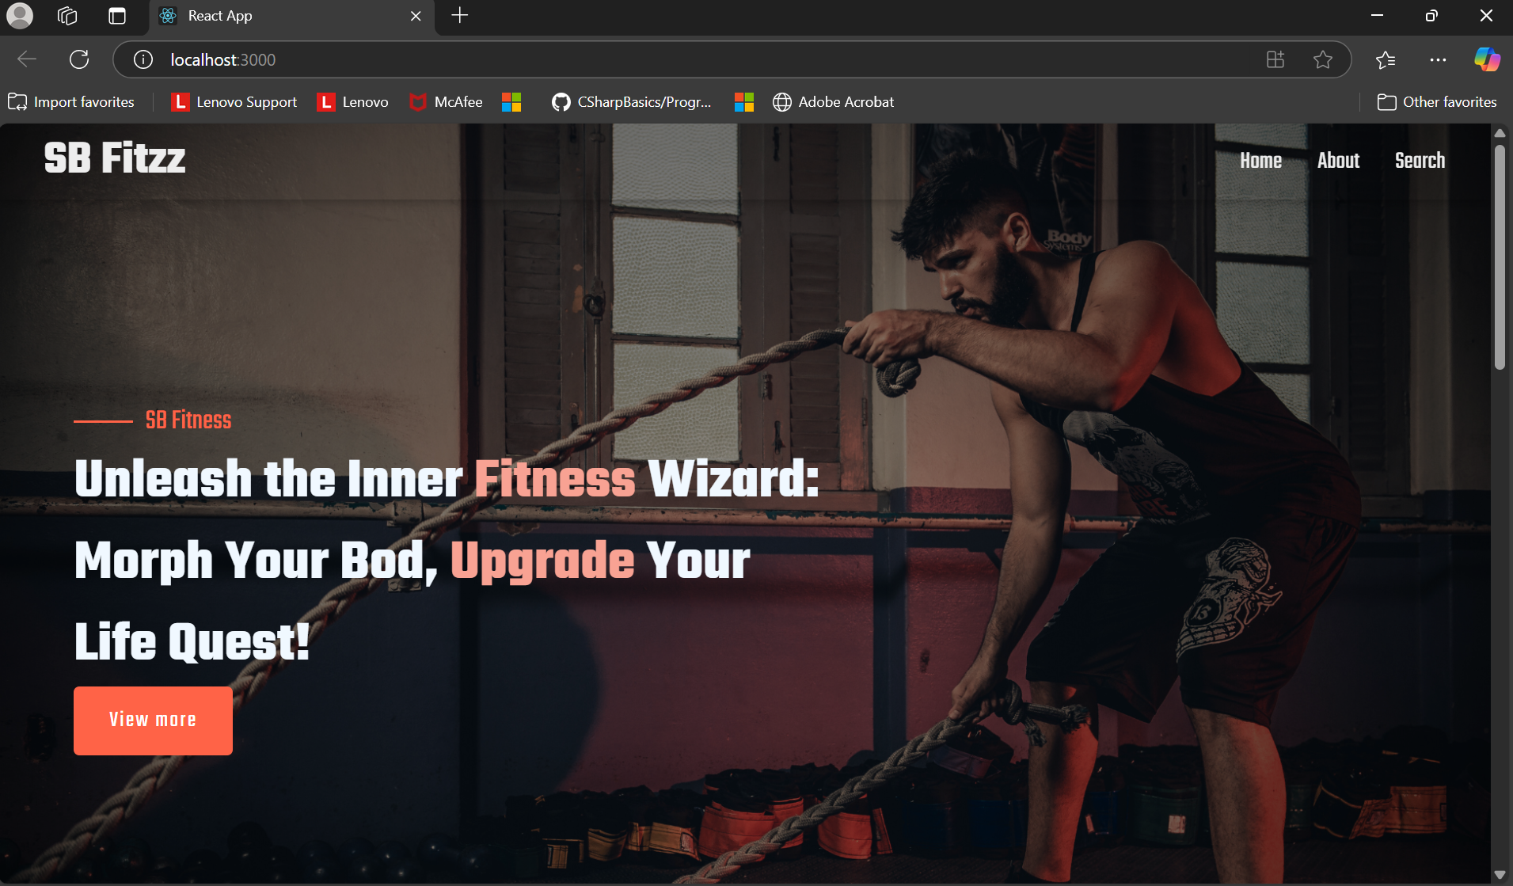

About page

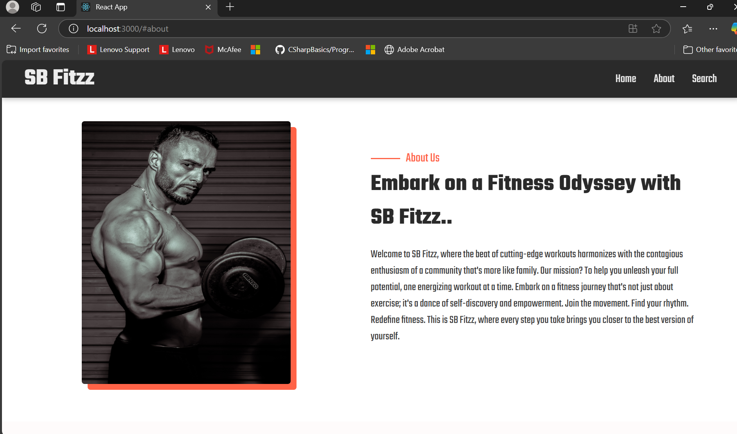

Search results

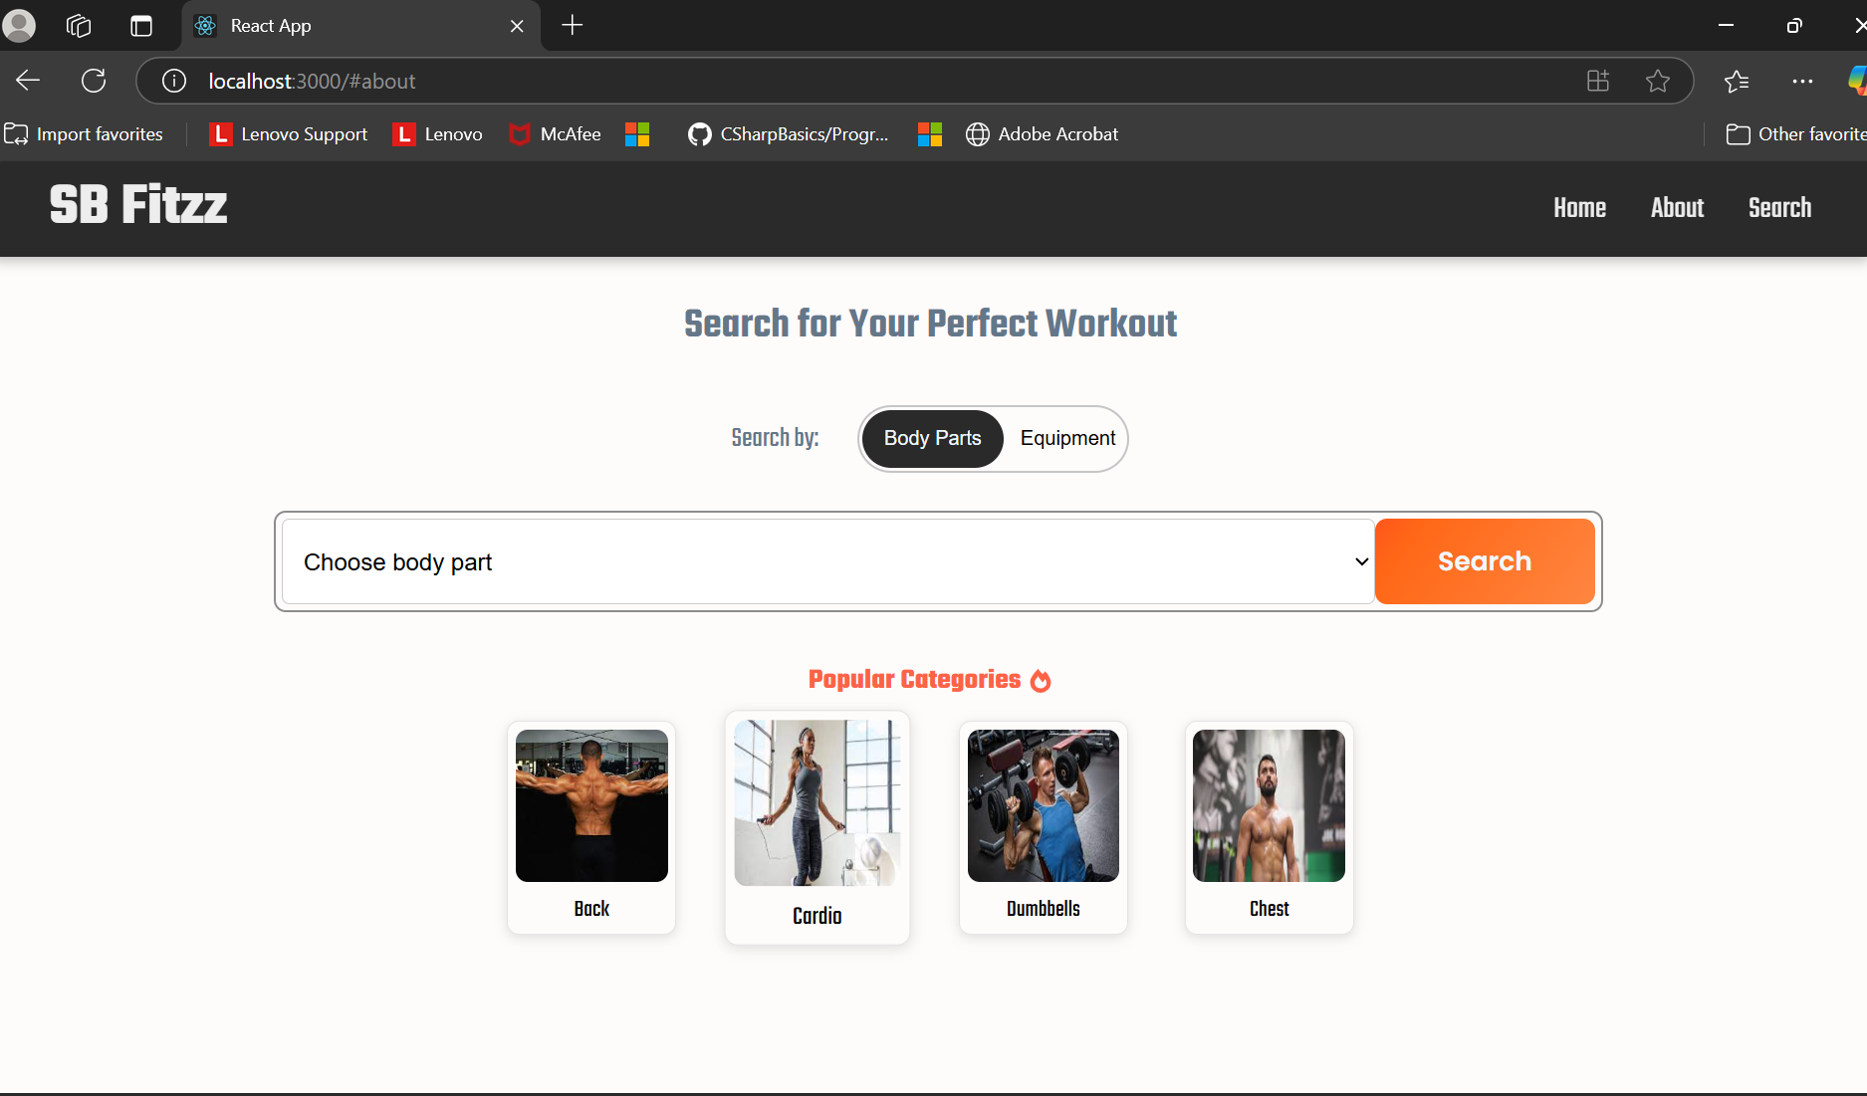

Exercise details

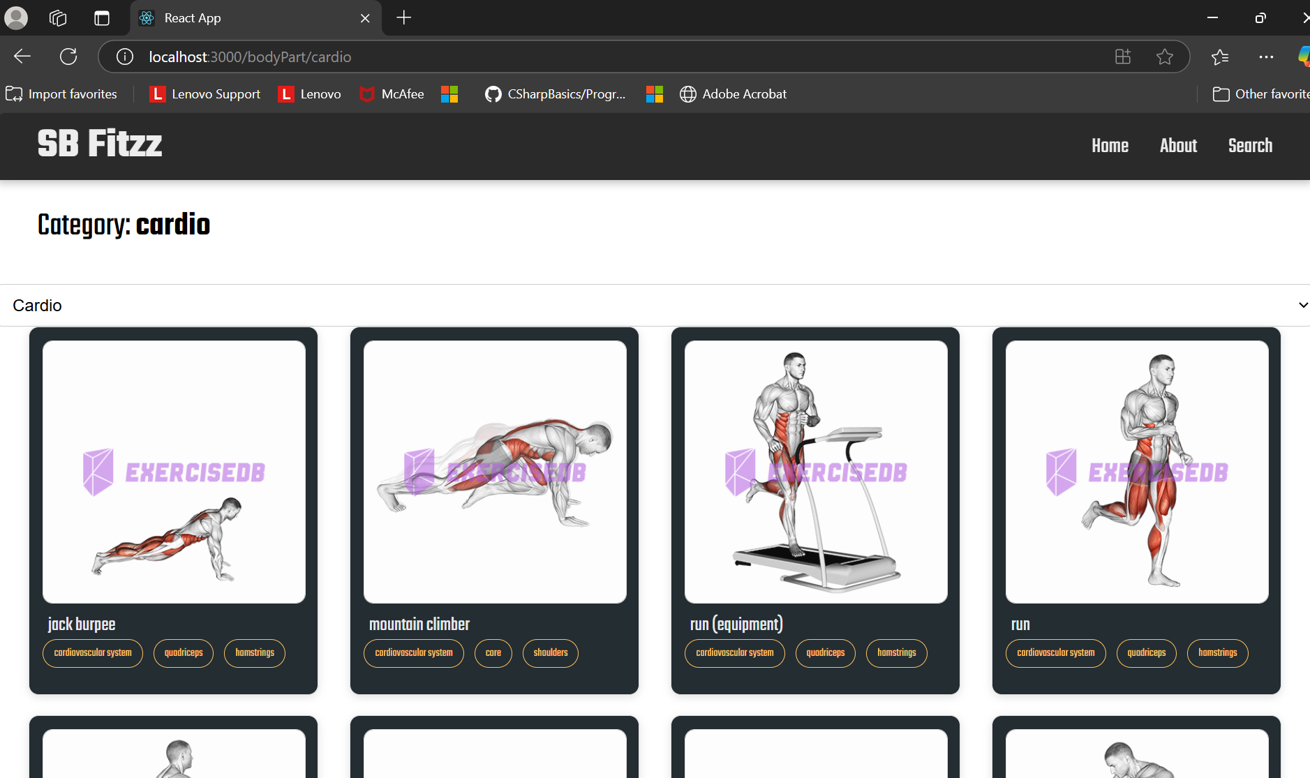

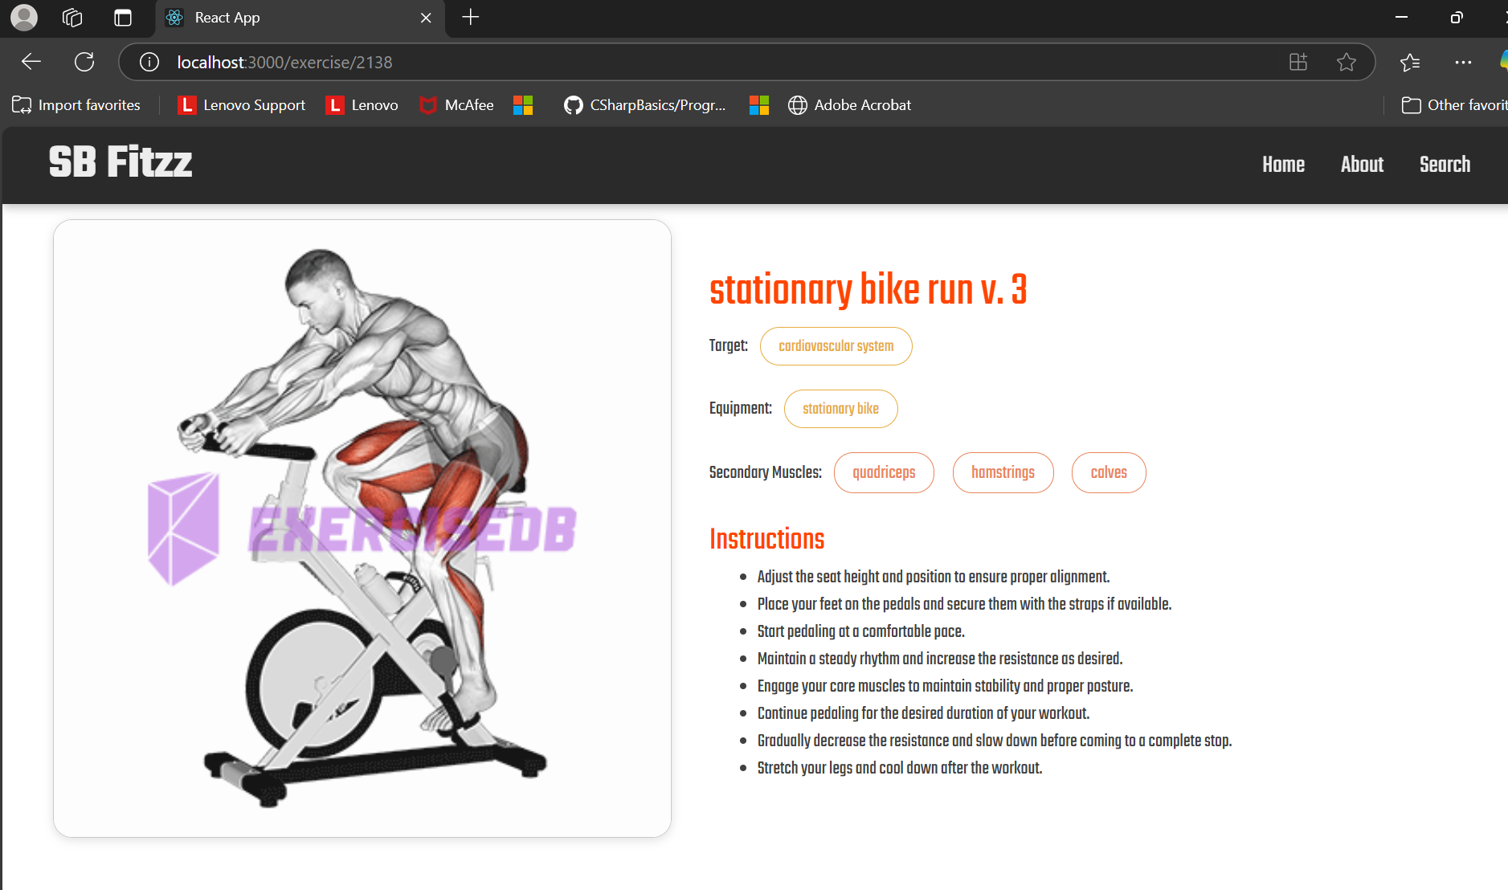

**13. Known Issues**

* Minor UI optimizations are needed for smaller screen sizes.
* No critical bugs are currently identified, but continuous testing is recommended for quality assurance.

**14. Future Enhancements**

* **Redux Integration**: To enable scalable and efficient global state management.
* **Enhanced UI/UX**: Include animations for smoother transitions and interactive elements.
* **Comprehensive Testing**: Expand test coverage to include integration and end-to-end tests.
* **Dynamic Theming**: Allow users to customize their theme preferences.
* **Mobile Optimization**: Ensure seamless experience across devices with responsive design improvements.
* **Feature Expansion**: Add more categories and personalized suggestions for exercises.