Tumor-Associated Brain Frailty and Perioperative Brain Injury in Neuro-Oncologic Surgery: A Scoping Review of Concepts, Domains, Neuroinflammatory Mechanisms, and Biomarkers
Khairunnisai Tarimah^{1,2,*} and Elvan Wiyarta³
¹ Doctoral Study Program in Medical Science, Faculty of Medicine, Universitas Padjadjaran, Bandung 45363, Indonesia
² Department of Anesthesia and Intensive Care, Faculty of Medicine, Universitas Islam Al Azhar Mataram, Mataram 83237, Indonesia
³ Department of Neurology, Faculty of Medicine, Universitas Indonesia, Kota Depok 16424, Indonesia
* Correspondence: Khairunnisai Tarimah (corresponding author, e-mail to be added)
Abstract
Background/Objectives. No instrument describes the vulnerable brain of a patient with a brain tumor. We mapped the literature to propose a working concept of tumor-associated brain frailty, chart its candidate domains, and ask whether neuroinflammation and perioperative brain injury are shared mechanisms in malignant and benign tumors.
Methods. We followed JBI guidance and PRISMA-ScR. Six sources were searched to March 2026, and citation searching and client-supplied sources on the Indonesian MoCA and NANO instruments were added. Studies were classified by design (OCEBM 2011) and synthesized by evidence mapping and direction-of-effect tallies without pooling.
Results. From 2,476 records, 76 studies were included, 70 in a core evidence base and 6 in an instrument-focused stratum. No core study defined brain frailty. Frailty indices appeared in 7 core studies, cognitive testing in 30, neurological outcomes in 16, and imaging in 32. Cognition was impaired before surgery in all 8 studies that tested it, and new diffusion-weighted lesions followed 19% to 46% of resections, including 35% of meningioma operations. S100B, GFAP, and NfL rose after surgery, but no core study reported meningioma-specific cytokine data. None used MoCA-INA or NANO-Ina.
Conclusions. Tumor-associated brain frailty is best framed as a four-domain construct (systemic, cognitive, neurological, imaging) with a two-hit course, the tumor as the first hit and perioperative brain injury as the second. The evidence is observational and the interaction between the hits is untested. Prospective cohorts that pair preoperative profiling with postoperative injury markers are the next step.
Keywords. brain frailty, brain tumor, perioperative brain injury, neuroinflammation, biomarkers, MoCA-INA, NANO-Ina, scoping review

1. Introduction
Brain tumors are a common cause of neurological and cognitive morbidity^{1,2}, and many patients with them undergo craniotomy. Cognitive deficits are present at diagnosis, before any treatment has been given³. The operation then adds anesthetic exposure, retraction, vascular manipulation, and a surgical inflammatory response to a brain whose reserve is unknown to the team in the operating room.
Frailty is the concept clinicians have borrowed to describe that reserve. In geriatrics it denotes a loss of physiological reserve that increases vulnerability to stressors⁴⁻⁶. Neurosurgical oncology has adopted general frailty indices, and a meta-analysis of the modified frailty index linked higher scores to worse perioperative outcomes in intracranial tumor surgery⁷. Two systematic reviews, however, stress what the field still lacks. The first found that studies of frailty in brain tumor surgery used different instruments and thresholds, and concluded that best practice for assessing frailty in these patients remains unclear⁸. The second reported that the literature groups all tumor types together and so overlooks differences between etiologies⁹. Neither review identified a nomenclature or an index built for the brain of a patient with a tumor.
Neurology complicates the picture because frailty is used for several different things. Imaging-defined brain frailty, built from leukoaraiosis, atrophy, and old vascular lesions, predicts outcome after acute stroke¹⁰. Cognitive frailty couples physical frailty with cognitive impairment short of dementia¹¹. A patient with a glioma or a meningioma may meet neither definition and still carry a vulnerable brain, because the tumor adds mass effect, edema, barrier disruption, and local inflammation. We use the working term tumor-associated brain frailty for this state and treat it as a concept to be mapped, not as an established entity.
Neuroinflammation is the most plausible shared mechanism. Microglia and macrophages are central components of the glioma microenvironment^{12,13}, but meningiomas, which are usually benign, also carry immune infiltrates that correlate with tumor behavior and peritumoral edema^{14,15}. Surgery and anesthesia then trigger a second inflammatory wave that is increasingly linked to perioperative neurocognitive disorders¹⁶⁻¹⁹. Studies of microglial priming show that a brain already exposed to inflammation can respond to a later systemic challenge with an exaggerated reaction^{20,21}. This suggests a two-hit sequence in which the tumor is the first hit and perioperative brain injury is the second. Circulating markers such as S100B, GFAP, and neurofilament light chain could make the second hit measurable^{22,23}.
Two instruments bear directly on the cognitive and neurological domains. The Montreal Cognitive Assessment (MoCA) detects cognitive impairment that the Mini-Mental State Examination misses in patients with brain metastases^{24,25}, and the Neurologic Assessment in Neuro-Oncology (NANO) scale was designed to give clinicians a structured measure of neurologic function²⁶. Indonesian versions of both instruments exist, but it is unclear how far they have been used in perioperative neuro-oncology.
We therefore mapped the literature on patients with intracranial tumors undergoing surgery with seven questions. How is frailty or brain frailty defined and measured in this population (RQ1)? Which domains and instruments characterize it (RQ2)? Is neuroinflammation documented in benign as well as malignant tumors (RQ3)? Which biomarkers can detect neuroinflammation and brain injury (RQ4)? What does the evidence say about perioperative brain injury as a second hit (RQ5)? Which cognitive and neurological instruments have been used, and what exists for MoCA-INA and NANO-Ina (RQ6)? Where are the gaps (RQ7)?

2. Materials and Methods

2.1. Study Design and Reporting
This was a scoping review designed to map the breadth and characteristics of evidence on tumor-associated brain frailty, its candidate domains, and the mechanisms and markers of perioperative brain injury in patients with brain tumors. We followed the JBI methodology for scoping reviews²⁷, which builds on the framework of Arksey and O'Malley and its refinement by Levac and colleagues^{28,29}. Reporting follows the PRISMA extension for scoping reviews³⁰ and the PRISMA 2020 flow diagram format³¹. The completed checklist is provided as Supplementary Table S1. A scoping approach was chosen because the literature spans designs, tumor types, outcome domains, and levels of evidence, and because the aim was to map concepts and gaps and not to estimate pooled effects³². The review was not registered in a prospective registry. The review materials, which are the search strategies, charting form, coded dataset, and analysis scripts, are deposited in a public GitHub repository (https://github.com/sharing-123/tumor-associated-brain-frailty-and-perioperative-brain-injury-scoping-review), and an archived version is deposited on Zenodo (ZENODO LINK TO BE INSERTED HERE).

2.2. Review Questions and Consultation
The seven review questions listed in the Introduction were set with the clinical team commissioning the review. The scoping framework includes an optional consultation stage²⁹. At that stage the team reviewed the extraction sheet and asked for evidence on the Indonesian versions of the MoCA and the NANO scale, which had not been part of the original search. This produced a post hoc amendment, an instrument-focused stratum described below. We also state in advance that a review question may end as partly answered or unanswered. In a scoping review this outcome is a finding, because mapping what is missing is part of the purpose^{32,33}.

2.3. Eligibility Framework
Eligibility was structured with the Population, Concept, and Context framework²⁷. The population comprised patients of any age with intracranial tumors, primary or metastatic and benign or malignant, who were scheduled for or had undergone surgery, or whose tumor tissue was obtained at surgery. The concept covered frailty or vulnerability of the brain and body, assessed through systemic frailty indices, cognitive testing, neurological assessment, and imaging, together with neuroinflammation, brain injury biomarkers, microglial activation, perioperative brain injury, delirium, and anesthetic strategies evaluated against these outcomes. The context was perioperative neurosurgical neuro-oncology, from preoperative assessment through postoperative follow-up, in any setting and country.
Eligible designs were randomized trials, trial protocols, prospective and retrospective cohorts, registry analyses, case-control and cross-sectional studies, case series, and human mechanistic studies. We excluded studies that focused on traumatic brain injury, stroke, or non-tumor conditions. We also excluded studies of chemotherapy or radiotherapy without surgery or anesthesia and studies that reported no outcome related to cognition, neuroinflammation, microglial activation, or injury biomarkers. Case reports, letters, commentaries, narrative reviews without primary data, and conference abstracts were excluded, as were reports without an available full text or without an English version.
The instrument-focused stratum admitted primary studies of the Indonesian MoCA (MoCA-INA), the Indonesian NANO scale (NANO-Ina), or their parent instruments in neuro-oncology populations, and studies of the Indonesian MoCA in any adult population. The purpose was to document the instrument evidence available for the cognitive and neurological domains in Indonesia. The language criterion was relaxed for this stratum, which included one report written in Indonesian with an English title and abstract. These studies were reported separately and did not contribute to the tumor-specific counts.

2.4. Information Sources and Search Strategy
We searched PubMed, Scopus, ProQuest, and the Cochrane Library (CENTRAL) from inception, with medRxiv and Google Scholar as additional sources. The last searches were run on 22 March 2026. Each strategy combined three blocks. The first held tumor terms such as brain neoplasm, glioma, meningioma, and astrocytoma. The second held surgery and anesthesia terms such as craniotomy, tumor resection, awake surgery, and total intravenous or inhalational anesthesia. The third covered frailty, perioperative brain injury, neuroinflammation, microglial activation, the blood-brain barrier, S100B, neuron-specific enolase, GFAP, neurofilament, postoperative cognitive dysfunction, delirium, cerebral autoregulation, and neuroprotection. Database-specific strategies are in Supplementary Table S2. The search strategy was not peer reviewed. Citation searching of included studies added further records, and the clinical team supplied seven sources on MoCA-INA and NANO-Ina.

2.5. Selection of Sources of Evidence
Duplicate records were removed before screening. Selection then followed two stages. Two reviewers screened titles and abstracts independently against the eligibility framework, and the same two reviewers assessed the full texts of the remaining reports for final eligibility with a recorded reason for each exclusion. Every disagreement at either stage was resolved by discussion in a video meeting. Reports that could not be retrieved were counted. During data charting, ten further studies were found not to meet the framework. They were moved to the full-text exclusion counts with a reason, so the final numbers differ from the original screening tally of 80 included studies (Supplementary Table S4).

2.6. Data Charting
A structured charting form with 31 items was applied to every included study. Items covered bibliographic data, country, design, tumor type, surgical procedure, sample size, age, sex, and the mechanistic domains addressed. They also covered imaging modality, laboratory biomarkers with their source, interpretation, and timing, hemodynamic measures, frailty indices, and neuropsychological tests. Operational definitions of radiological, biomarker, neurological deficit, delirium, and cognitive outcomes were charted with their assessment methods and timing, together with key findings. Key findings were restricted to results that carried a reported statistic so that each entry could be checked against the source. An item not evaluated in a study was recorded as not assessed in this study, which keeps absent data distinct from an extraction gap. The charting form is provided as Supplementary Table S3.

2.7. Evidence Classification and Synthesis
Each study was assigned a design class and an evidence level from the Oxford Centre for Evidence-Based Medicine 2011 framework. The rule was applied to design alone. Randomized trials and prospective cohorts were graded level 2, retrospective cohorts, registry analyses, and secondary analyses of trials level 3, case-control studies, cross-sectional studies, case series, and non-randomized pilot trials level 4, mechanistic laboratory studies level 5, and trial protocols were left ungraded. The level therefore describes design and does not judge quality. Each study was also placed in one of six evidence streams according to its main question. It was coded to the four candidate frailty domains (systemic frailty, cognition, neurological function, imaging) and to mechanistic domains (neuroinflammatory or tumor-tissue markers, brain injury biomarkers, delirium or agitation, hemodynamic or cerebral physiology, tumor biology and the blood-brain barrier). A study could contribute to more than one domain and was counted once within each.
Synthesis combined four methods. We tabulated study characteristics as a descriptive numerical summary. We built an evidence map that places domains against tumor categories, in the manner of an evidence and gap map³⁴. We used framework-based content analysis, with the four domains as the a priori framework, to describe instruments and definitions. For questions about direction, we tallied the direction of effect that the authors reported at the group level. This is a form of vote counting by direction of effect, as described in the Cochrane Handbook and the SWiM guideline for synthesis without meta-analysis^{35,36}. These tallies describe agreement in direction. They do not estimate an effect, combine p values, or weight studies by size. Pooling was not attempted because outcomes, tumor types, and time points differed too widely.

2.8. Analytical Environment and Appraisal
Data management, tabulation, and figure generation were scripted in Python 3.12.10 with pandas 3.0.5 and matplotlib 3.11.1, and every count in the text was generated from the coded dataset. Formal risk-of-bias appraisal was not performed. Critical appraisal is optional in scoping reviews^{27,30}, and the design-based evidence level was used instead. We return to the consequences of this choice in the Limitations.

3. Results

3.1. Study Selection
The searches returned 2,318 records from four databases and medRxiv and 117 from Google Scholar, a total of 2,435 records. Citation searching added 34 records and the clinical team supplied 7 sources, so 2,476 records were identified. After 987 duplicates were removed from the database and preprint records, 1,331 records were screened by title and abstract and 1,062 were excluded. Of 269 reports sought, 17 could not be retrieved and 252 were assessed in full text. Of these, 215 were excluded (wrong outcome 56, wrong population 80, wrong publication type 27, wrong study design 31, wrong intervention 21) and 37 were included. From the other sources, 158 reports were sought, 13 were not retrieved, 145 were assessed, 106 were excluded (wrong outcome 29, wrong population 57, wrong study design 19, wrong publication type 1), and 39 were included.
In total 76 studies were included. They comprise a core evidence base of 70 studies and an instrument-focused stratum of 6 studies. The original screening tally was 80 included studies. Ten of these (nine from the databases and one from the other sources) were removed during data charting. One was removed for population (a spinal surgery trial) and nine for outcome, because they reported no perioperative brain injury, cognitive, or clinical outcome (for example an imaging technique comparison, cerebrospinal fluid infection markers, cyst fluid proteomics, tissue receptor characterization, and drug delivery trials). The selection process is shown in Figure 1.
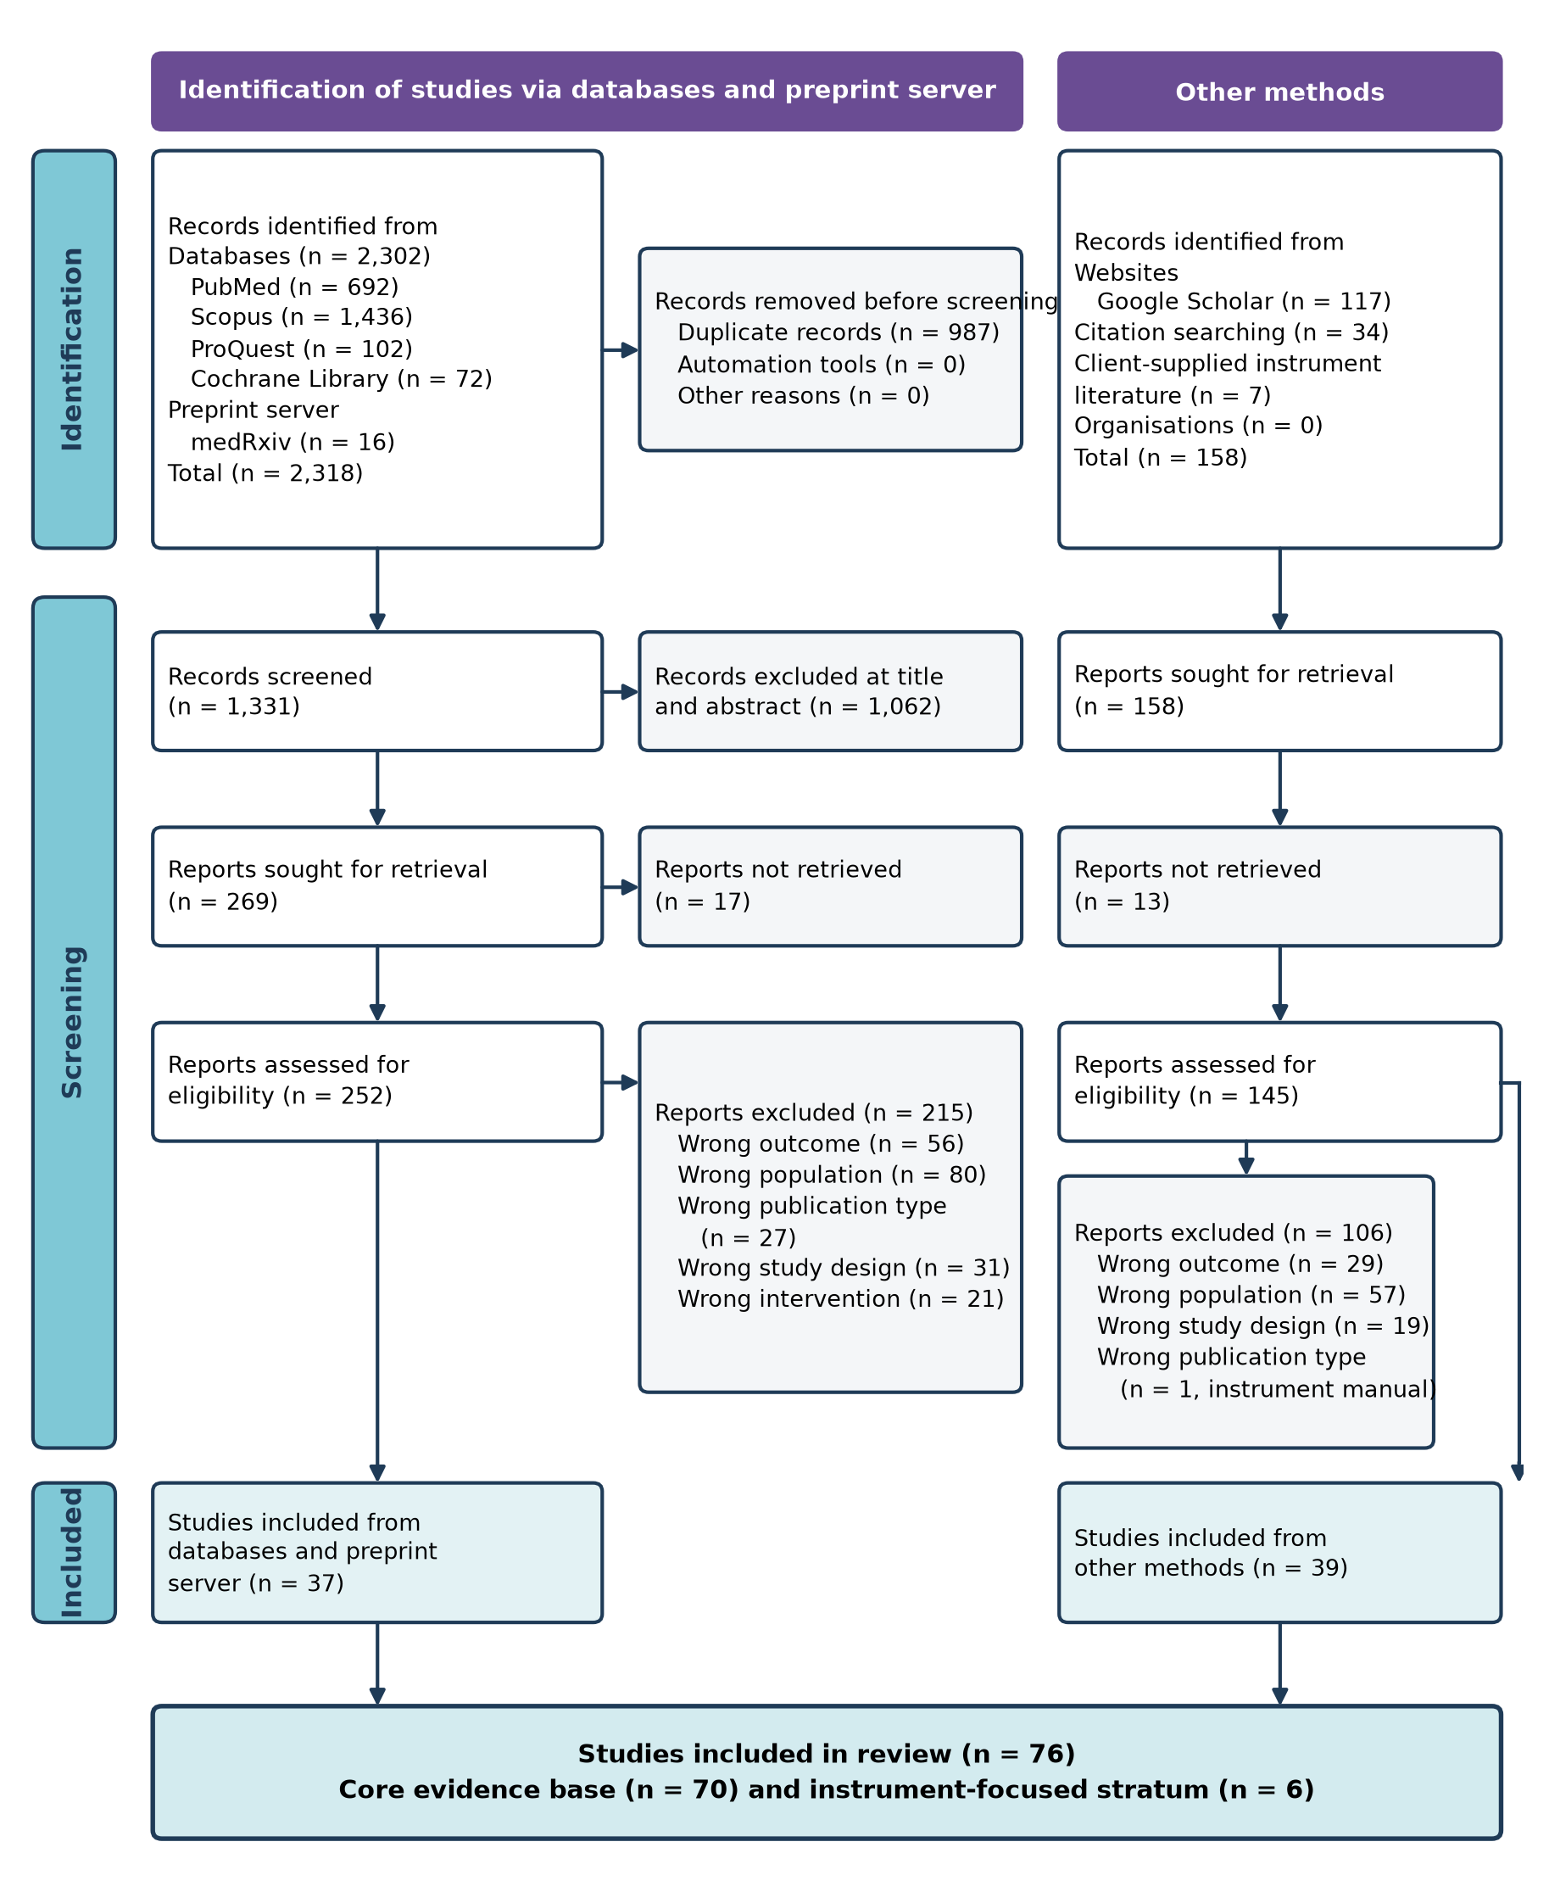
Figure 1. PRISMA 2020 flow diagram of study identification, screening, and inclusion, with databases and the preprint server on the left and other methods on the right.

3.2. Characteristics of the Core Evidence Base
The 70 core studies were published between 1987 and 2026, and 43 appeared from 2018 onward (Figure 2A). They came from 21 countries, most often the United States (13) and China (13), followed by the Netherlands (7), Germany (6), India (5), and Italy (4). One study came from Southeast Asia (Thailand) and none came from Indonesia.
Designs were prospective cohorts (28), randomized trials (17), retrospective cohorts (11), registry cohorts (3), case-control studies (2), case series (2), mechanistic laboratory studies (2), trial protocols (2), one cross-sectional study, one non-randomized pilot trial, and one secondary analysis of a trial (Figure 2B). By design, 45 studies (64%) reached level 2, 15 level 3, 6 level 4, and 2 level 5, and two protocols were ungraded. Study samples were glioma only in 25 studies, meningioma only in 10, brain metastasis only in one, and mixed tumor types in 34 (Figure 2C). Among the 68 studies that reported a sample size, the median was 60 (interquartile range 32 to 164, range 7 to 28,340), and the two protocols planned 90 and 500 participants.
Six evidence streams emerged (Figure 2D, Table 1). Eight studies addressed tumor biology, the microenvironment, and the blood-brain barrier³⁷⁻⁴⁴. Five addressed systemic frailty indices and perioperative risk⁴⁵⁻⁴⁹. Twenty-two followed cognitive trajectories after tumor surgery⁵⁰⁻⁷¹. Six described postoperative delirium or agitation⁷²⁻⁷⁷. Ten examined perioperative brain injury through imaging, biomarkers, or cerebral physiology⁷⁸⁻⁸⁷. Nineteen tested perioperative interventions or reported trial protocols⁸⁸⁻¹⁰⁶. Two studies counted operations and not patients^{85,86}.
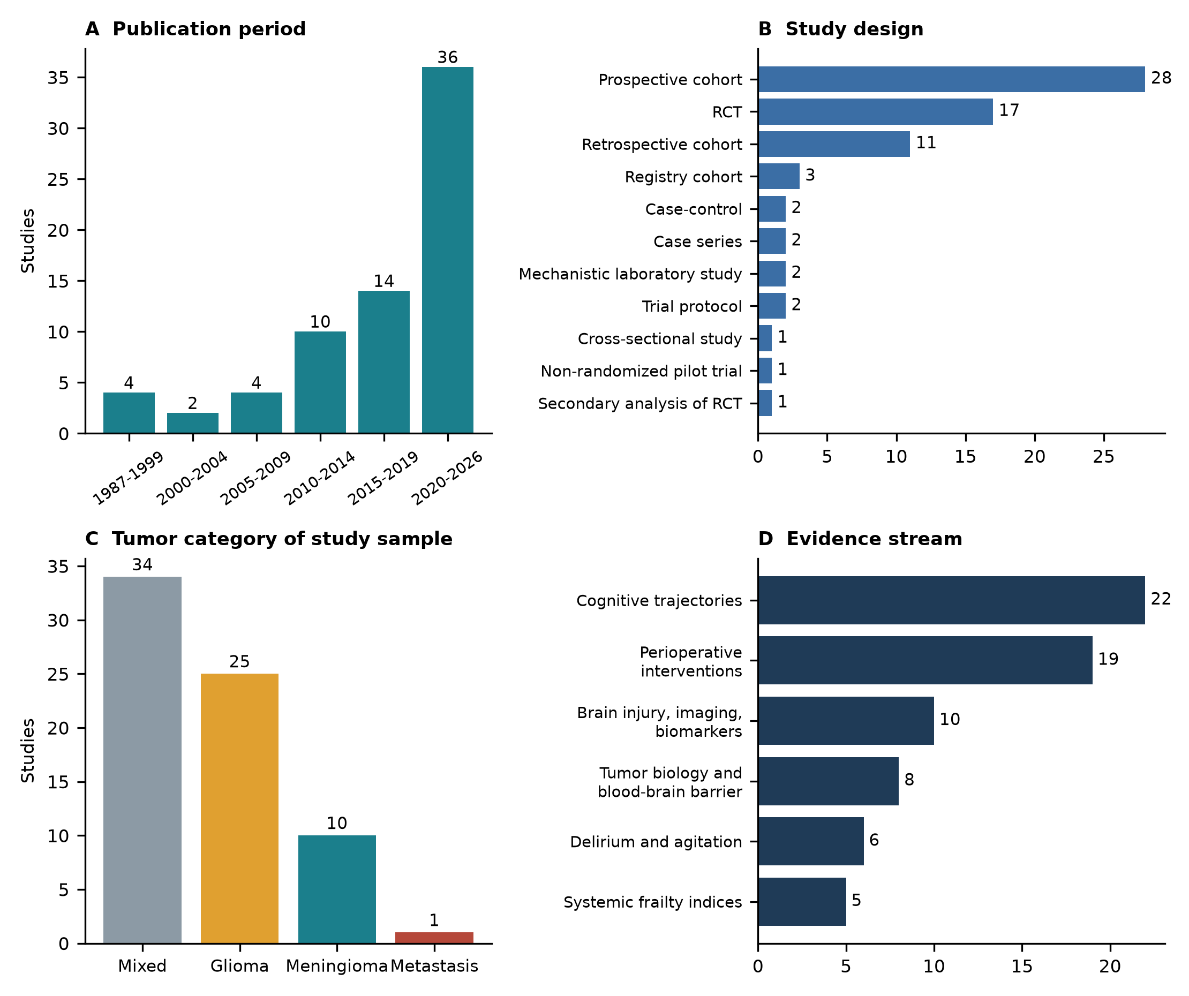
Figure 2. Characteristics of the 70 core studies. (A) Publication period. (B) Study design. (C) Tumor category of the study sample. (D) Evidence stream.

Table 1. Characteristics of the 70 studies in the core evidence base, grouped by evidence stream and ordered by year within stream.
Study | Country | Design | Population | Surgical context or intervention | Main findings | Domains | Level
Tumor biology, microenvironment, and blood-brain barrier (n = 8)
Stewart, 1987³⁷ | Canada | Mechanistic laboratory study | Glial tumors, n = 13 | Lobectomy specimens, electron microscopy | Peritumoral vessels had longer junctional clefts and more endothelial vesicles than normal vessels (p < .02 to .03), a structural barrier defect. | Tumor biology | 5
Machein, 1999³⁸ | Germany | Mechanistic laboratory study | Glial tumors n = 11, lymphoma n = 3 | Stereotactic biopsy | VEGF mRNA correlated with capillary permeability (r = 0.667, p = .015) and plasma vascular volume (r = 0.778, p = .0017) in glial tumors. | Inflammatory marker, Imaging, Tumor biology | 5
Law, 2004³⁹ | USA | Retrospective cohort | Primary glioma, n = 73 | Preoperative imaging, biopsy alone in 16 | rCBV tracked tumor grade (Spearman r = .817). Ktrans separated only grade I from grades II and III (p = .027). | Imaging, Tumor biology | 3
Cha, 2006⁴⁰ | USA | Prospective cohort | Glioma n = 20, meningioma n = 7 | Preoperative dynamic contrast MRI before resection | Ktrans from two methods separated grade IV from lower grades. The two methods agreed in gliomas (r = .95) but not in meningiomas (r = .16). | Imaging, Tumor biology | 2
Piperi, 2011⁴¹ | Greece | Retrospective cohort | Astrocytoma grade II to IV, n = 97 | Resection, archival tissue | IL-8 and IL-6 expression rose with grade and necrosis (p < .05). IL-8 correlated with VEGF (r = .475) and independently predicted survival (p = .043). | Inflammatory marker, Tumor biology | 3
Portnow, 2014⁴² | USA | Prospective cohort | Primary or metastatic brain tumors, n = 10 with dialysate | Craniotomy with peritumoral microdialysis | Most cytokines peaked within 8 h after surgery and fell over 96 h (11 of 17 with significant decline). Intracerebral levels exceeded serum levels. No temsirolimus effect. | Inflammatory marker, Tumor biology | 2
Kemmerer, 2021⁴³ | Germany | Case-control | High-grade glioma, n = 18, controls n = 14 | Resection, tissue and CSF before adjuvant therapy | CD68+ macrophages (19% to 27%) outnumbered CD45+ leukocytes (3% to 7%). CSF IL-7 was lower in glioblastoma (p = .009). CD68+ infiltration correlated negatively with several cytokines (p < .01). | Inflammatory marker, Tumor biology | 4
Grossman, 2025⁴⁴ | USA | Non-randomized pilot trial | Low-grade glioma, n = 7 | Regadenoson dose escalation, no resection | Blood-brain barrier endpoint (Ktrans > 0.04 min-1) not met at any dose. T1 subtraction signal in normal-appearing white matter rose 74.0% (p = .0163). Trial closed early. | Imaging, Tumor biology | 4
Systemic frailty indices and perioperative risk (n = 5)
Sastry, 2020⁴⁵ | USA | Registry cohort | Intracranial tumors, n = 20,333 | Elective craniotomy (ACS NSQIP) | Low and medium-to-high mFI-5 raised odds of major complication (OR 1.41, 1.61) and 30-day mortality (OR 1.87, 2.42), all p < .001. | Frailty index, Neurological or functional | 3
Harland, 2020⁴⁶ | USA | Prospective cohort | Brain tumors, n = 260 | Elective craniotomy | Frailty raised odds of non-home discharge (OR 10.36, 95% CI 3.6 to 30.1) and of any complication (OR 2.09). Slow walking speed was the most predictive item. | Frailty index, Neurological or functional | 2
Wang, 2021⁴⁷ | China | Retrospective cohort | Intracranial tumors, n = 659 | Elective craniotomy under general anesthesia | Delirium 18.8% overall, and 12.8%, 27.0%, 37.5% in non-frail, pre-frail, frail groups (mFI). Frailty independently associated with delirium (adjusted OR 1.7, p = .032). | Frailty index, Delirium | 3
Huq, 2021⁴⁸ | USA | Retrospective cohort | Brain tumors, n = 1,692 | Primary surgery | Each mFI-5 point added 0.32 ICU days and 1.38 hospital days (p = .007, p < .001) and predicted sepsis (OR 2.12) and respiratory failure (OR 1.55). | Frailty index | 3
Skandalakis, 2023⁴⁹ | USA | Registry cohort | Brain metastases, n = 11,038 | Resection (ACS NSQIP) | Thirty-day mortality rose from 1.3% (robust) to 12.6% (severely frail) by Risk Analysis Index, which outperformed mFI-5 and age (C-statistic 0.65). | Frailty index | 3
Cognitive trajectories after tumor surgery (n = 22)
Tucha, 2003⁵⁰ | Germany | Prospective cohort | Frontal meningioma, n = 54, controls n = 54 | Total removal | Patients were impaired against controls in several attentional and executive functions before surgery. No domain deteriorated, and attention improved at 4 to 9 months. | Cognition, Imaging | 2
Satoer, 2012⁵¹ | Netherlands | Prospective cohort | Glioma near eloquent areas, n = 28 | Resection | Impairment before and after surgery in language, memory, and executive domains. Postoperative decline in language (p = .027) and executive function (p = .022) at 3 to 4 months. | Cognition, Imaging | 2
van Dellen, 2013⁵² | Netherlands | Prospective cohort | Low-grade glioma, n = 10 | Resection | No group-level cognitive change. Default mode connectivity gain correlated with verbal memory (tau = .571, p = .048) and frontoparietal gain with attention (tau = .857, p = .003). | Cognition, Imaging | 2
Satoer, 2014⁵³ | Netherlands | Prospective cohort | Glioma in eloquent areas, n = 45 | Resection | Permanent decline only in category fluency (p = .030). Letter fluency and naming improved between 3 months and 1 year. Trail making normalized by 1 year. | Cognition, Imaging | 2
Meskal, 2015⁵⁴ | Netherlands | Prospective cohort | Meningioma, n = 68 | Resection | 69% impaired in at least one domain before surgery and 44% at 3 months. Five of seven domains improved. | Cognition | 2
Bommakanti, 2016⁵⁵ | India | Prospective cohort | Supratentorial meningioma, n = 57 | Resection | 73.7% impaired on at least one test before surgery. Raised intracranial pressure was linked to impairment (95.2% vs 61.1%, p = .005). Improvement at 3 months, no deterioration. | Cognition, Imaging | 2
Lang, 2017⁵⁶ | Canada | Prospective cohort | Diffuse glioma, n = 16 | Resection, mostly with cortical mapping | Frontoparietal connectivity correlated inversely with preoperative composite cognition (p = .024). Non-tumor parietal connectivity predicted one-month change (p = .009). | Cognition, Imaging | 2
Hoffermann, 2017⁵⁷ | Austria | Retrospective cohort | Mixed intracranial tumors, n = 196 | Craniotomy | No decline in any of eight computerized subtests at 3 to 4 months. Go/noGo (p = .003) and figural memory (p < .001) improved. Meningioma overall score rose from 93 to 98 (p = .001). | Cognition | 3
van Nieuwenhuizen, 2018⁵⁸ | Netherlands | Case-control | WHO grade I meningioma n = 20, controls n = 20 | Resection, assessed at mean 1.7 years | Working memory was lower than in controls and linked to lower theta-band default mode connectivity. | Cognition, Imaging | 4
Barzilai, 2019⁵⁹ | Israel | Retrospective cohort | Low-grade glioma, n = 49 | Craniotomy, awake mapping in most | Memory (p < .001) and executive function (p = .031) improved at mean 6.06 months. No link with IDH1 status or extent of resection. | Cognition | 3
Capo, 2020⁶⁰ | Italy | Retrospective cohort | Recurrent glioma, n = 40 | Awake repeat surgery | No significant change in normal-range counts after the second surgery except a small decline in oral praxis. Repeat surgery was feasible at 4 months. | Cognition | 3
Niki, 2020⁶¹ | Japan | Prospective cohort | Glioma, n = 54 | Resection with intraoperative MRI | Lesion-symptom mapping tied separate cognitive components to left temporoparietal and right frontal regions. MMSE-J stayed normal and missed these deficits. | Cognition, Imaging | 2
Noll, 2021⁶² | USA | Prospective cohort | Left perisylvian glioma, n = 15 | Awake craniotomy with language mapping | 87% declined (z <= -1.00) on at least one cognitive measure within 12 weeks. Connectomic changes correlated with cognitive change (rho -0.51 to -0.78). | Cognition, Imaging | 2
Stalnacke, 2021⁶³ | Sweden | Case series | Suspected low-grade glioma, n = 7 | Awake resection of face motor cortex | Verbal processing speed declined, with no change in fluency, memory, or working memory. Six of seven had mild facial dysfunction. | Cognition, Neurological or functional | 4
Zarino, 2021⁶⁴ | Italy | Prospective cohort | Insular glioma, n = 35 | Resection with mapping | Language fell after surgery and partly recovered by 3 months. Aphasic symptoms in 92% of left-sided patients early and 44% at 3 months. | Cognition, Neurological or functional | 2
Schei, 2022⁶⁵ | Norway | Prospective cohort | Diffuse glioma, n = 182 | Primary resection | High-grade glioma cognitive score rose from 70.9 to 85.1 at 1 month (p < .001). Low-grade glioma stayed near 80 to 81. Steroid use and tumor volume predicted improvement. | Cognition, Imaging | 2
Zangrossi, 2022⁶⁶ | Italy | Retrospective cohort | Glioma, n = 47 | Awake surgery | 85% of test scores were stable or improved at one week. Presurgical cognition was the strongest predictor of early outcome (leave-one-out r = 0.57). | Cognition, Imaging | 3
Barberis, 2022⁶⁷ | France | Case series | Right frontal IDH-mutant glioma, 20 cases in 18 patients | Awake mapping | Severe early deficits in executive function (75%) and attention (65%). Group scores stable at 4 months, but 45% of cases declined in at least one domain. | Cognition, Imaging | 4
de Sain, 2023⁶⁸ | Netherlands | Prospective cohort | Diffuse glioma, n = 37 | Awake surgery with electrostimulation | Cognition stable overall. Inhibition reaction time slowed early (p = .004) and improved later (p = .017). Mean extent of resection 83.6%. | Cognition, Imaging | 2
Schouwenaars, 2024⁶⁹ | Netherlands | Prospective cohort | Meningioma, n = 23 | Resection | Scores were below norms on three tests before and after surgery, with no improvement at 3 months. Network activity during the 2-back task was unchanged. | Cognition, Imaging | 2
Tran, 2025⁷⁰ | USA | Retrospective cohort | Glioma n = 7, meningioma n = 13 | Resection (public dataset, preprint) | Preoperative high-order resting-state features predicted the 6-month working memory group (accuracy 90%, AUC 0.95). Not peer reviewed. | Cognition, Imaging | 3
Zigiotto, 2026⁷¹ | Italy | Retrospective cohort | Glioma, n = 64 | Awake versus asleep surgery | Attention declined at 1 week and recovered by 1 month. Awake surgery was the only clinical predictor of decline. Default mode network lesions were linked to worse scores. | Cognition, Imaging | 3
Postoperative delirium and agitation (n = 6)
Huang, 2018⁷² | China | Prospective cohort | Mixed brain tumors, n = 400 | Craniotomy with ICU admission | Agitation 13.0%. Independent risks were bi-frontal pneumocephalus (OR 4.4) and delayed extubation. Agitation predicted poor mRS (OR 5.4). | Delirium, Imaging | 2
Budenas, 2018⁷³ | Lithuania | Prospective cohort | Mixed brain tumors, n = 522 | Cranial surgery | Delirium 4.2%. Predictors were age 65 or older, low education, poor function, and low hemoglobin. Delirium predicted unfavorable discharge outcome (OR 5.3). Histology was not associated. | Delirium, Inflammatory marker, Neurological or functional | 2
Chen, 2020⁷⁴ | China | Cross-sectional study | Mixed brain tumors, n = 893 | Craniotomy | Delirium 14.78%. Independent predictors were restraint, age over 50, longer operation, electrolyte disturbance, and tobacco use. Meningioma was protective (AUC 0.787). | Delirium | 4
Gu, 2022⁷⁵ | China | Retrospective cohort | Mixed brain tumors, n = 618 | Craniotomy with ICU admission | Emergence delirium 21.2%, mostly hypoactive. Later postoperative delirium occurred in 58.8% with and 4.7% without emergence delirium. | Delirium | 3
Fu, 2024⁷⁶ | USA | Registry cohort | Brain tumors, n = 28,340 | Craniotomy (National Inpatient Sample) | Delirium 4.79% by ICD codes, with 4 days longer stay, higher mortality (2.36% vs 1.28%), and more frequent three or more comorbidities. | Frailty index, Delirium | 3
Wu, 2025⁷⁷ | China | Secondary analysis of RCT | Frontotemporal tumors, n = 240 | Craniotomy, intraoperative hypotension | Delirium 35%. Mean arterial pressure below 65 mmHg was not associated with delirium. Glioma, age, and hypertension raised risk. Higher MMSE and dexmedetomidine were protective. | Delirium, Hemodynamic, Cognition | 3
Perioperative brain injury, imaging, and biomarkers (n = 10)
Stranjalis, 2005⁷⁸ | Greece | Prospective cohort | Meningioma, n = 50 | Resection | S100B above 0.4 ug/L carried a 9-fold risk of neurologic deterioration (95% CI 2.4 to 34) and an 11-fold risk of poor 6-month outcome. Early deterioration occurred in 50%. | Injury biomarker, Neurological or functional, Imaging | 2
Einav, 2006⁷⁹ | Israel | Prospective cohort | Supratentorial meningioma, n = 52 | Resection | S100B rose from 0.065 to 0.155 ug/L by 48 h (p < .0001), higher with bleeding and midline shift. MMSE deterioration correlated with S100B at all times (p = .005, .011, .036). | Injury biomarker, Cognition, Imaging | 2
Khan, 2006⁸⁰ | USA | Prospective cohort | Mixed tumors, mainly glioma and metastasis, n = 80 | Resection | Positive postoperative DWI in 19%. A new DWI lesion was the only multivariable predictor of incomplete recovery at day 7 and day 30 (both p = .005). New deficit in 30%. | Imaging, Neurological or functional | 2
Sharma, 2010⁸¹ | India, USA | Prospective cohort | Supratentorial tumors, n = 35 | Resection under isoflurane and nitrous oxide | Autoregulation impaired before surgery in 7 of 35 (20%) and stayed impaired in all 7 afterward. Larger tumor and midline shift > 5 mm were risk factors. CO2 reactivity unchanged. | Hemodynamic | 2
Gempt, 2013 (MEP)⁸² | Germany | Prospective cohort | Glioma in motor eloquent areas, n = 70 | Resection with MEP monitoring | Ischemic lesions in 46% (32 of 70), present in 76% with MEP decline > 50% versus 33% without. Permanent motor deficit in 14%. | Imaging, Neurological or functional | 2
Gempt, 2013 (recurrence)⁸³ | Germany | Prospective cohort | Glioma, n = 100 (109 operations) | Resection | New ischemic lesions in 31% of newly diagnosed and 80% of recurrent tumors (p < .01). New deficits were more frequent with lesions (p < .05). | Imaging, Neurological or functional | 2
Baumgarten, 2018⁸⁴ | Germany | Prospective cohort | Glioma n = 25, metastasis n = 7 | Resection | Serum GFAP rose after surgery in glioblastoma (p = .0172) and peaked on day 1. Baseline GFAP was higher in glioma than metastasis (0.18 vs 0.08 ug/L). No link with residual tumor. | Injury biomarker, Imaging | 2
Strand, 2021 (glioma)⁸⁵ | Norway | Prospective cohort | Diffuse glioma, 539 operations | Resection or reoperation | DWI infarction in 44.2% (238 of 539), related to tumor volume (r = .267), bleeding (r = .176), and age (r = .193). Rates differed between surgeons (32% to 72%). | Imaging | 2
Strand, 2022 (meningioma)⁸⁶ | Norway | Prospective cohort | Meningioma WHO 1 to 3, 327 operations | Resection | DWI infarction in 34.9% (114 of 327). Permanent deficit in 6.7%, 72.7% of them with infarction (p < .001). Age predicted infarction (OR 1.03 per year). | Imaging, Neurological or functional | 2
Michaelsson, 2023⁸⁷ | Sweden | Prospective cohort | Glioma, n = 34 | Resection | Plasma GFAP, tau, and NfL rose on days 1 and 3 (p < .001). NfL had a second peak at day 10 (p = .028). Day 1 GFAP and NfL were higher with new deficits (p = .048, p = .043). | Injury biomarker, Imaging, Neurological or functional | 2
Perioperative interventions and neuroprotective strategies (n = 19)
Favre, 1995⁸⁸ | Switzerland | RCT | Cerebral tumors, n = 24 | Clonidine versus placebo | No effect on intracranial pressure. Clonidine lowered mean arterial and cerebral perfusion pressure, with 8 of 12 patients below 60 mmHg versus 2 of 12. | Hemodynamic | 2
Guy, 1997⁸⁹ | USA | RCT | Supratentorial lesions, n = 63 | Remifentanil versus fentanyl | Intraoperative ICP and brain relaxation were similar. Neurologic examinations were broadly similar through day 7. | Hemodynamic, Neurological or functional | 2
Lu, 2010⁹⁰ | China | RCT | Mixed brain tumors, n = 32 | Electroacupuncture preconditioning versus none | S100B (1.16 vs 1.47 ug/L) and NSE (24.7 vs 31.4 ug/L) were lower at end of surgery (p < .05). | Injury biomarker | 2
Mousa, 2011⁹¹ | Egypt | RCT | Supratentorial tumors, n = 60 | Crystalloid, colloid, or blood | Colloid kept jugular venous oxygen saturation and flow-metabolism coupling higher than crystalloid. | Hemodynamic | 2
Mirrahimi, 2015⁹² | Iran | RCT | Supratentorial tumors, n = 60 | Magnesium versus placebo | Postoperative S100B rose less with magnesium. NSE and Barthel index did not differ between arms. | Injury biomarker, Neurological or functional | 2
Peng, 2016⁹³ | China | RCT | Supratentorial tumors, n = 80 | Lidocaine versus saline | Cognitive decline at 6 months did not differ (about 10% in each arm), although lidocaine lowered cerebral oxygen extraction. | Cognition, Hemodynamic | 2
Wu, 2017⁹⁴ | Taiwan | RCT | Supratentorial tumors, n = 80 | Goal-directed fluids, SVV threshold 10% versus 18% | New neurologic events were fewer with low SVV (17.5% vs 40%), with smaller NSE and GFAP rises. S100B did not differ. | Injury biomarker, Hemodynamic, Neurological or functional | 2
Hernandez-Palazon, 2018⁹⁵ | Spain | RCT | Supratentorial tumors, n = 60 | Hypertonic saline 3 versus 5 mL/kg | Brain relaxation score was identical (2.0 vs 2.0, p = .535). Both doses gave equal sustained rises in osmolality, with similar complications. | Hemodynamic | 2
Mahajan, 2019⁹⁶ | India | RCT | Supratentorial tumors, n = 41 | Magnesium, lignocaine, or saline | S100B was lower at 24 h with magnesium than with either other arm. Pain and fentanyl use were lower with magnesium and lignocaine. | Injury biomarker | 2
Jitsinthunun, 2022⁹⁷ | Thailand | RCT | Supratentorial meningioma, n = 76 | Magnesium sulfate versus saline | Blood loss 500 vs 510 mL. Postoperative MoCA did not differ (underpowered). No magnesium toxicity. | Cognition | 2
Wu, 2022⁹⁸ | China | RCT | Intracerebral tumors, n = 80 | Dexmedetomidine versus saline | S100B, NSE, GFAP, IL-6, and TNF-alpha were lower and CCSE and MoCA higher at day 1. Differences converged by day 3. | Injury biomarker, Inflammatory marker, Cognition, Imaging | 2
Zhao, 2022⁹⁹ | China | RCT | Supratentorial tumors, n = 60 | Lidocaine versus saline | QoR-40 was higher on days 1 and 2. S100B, NSE, IL-6, and TNF-alpha were lower at end of surgery. | Injury biomarker, Inflammatory marker | 2
Jiang, 2023¹⁰⁰ | China | RCT | Supratentorial tumors, n = 110 | Desflurane versus propofol TIVA | Satisfactory brain relaxation was similar (69% vs 73%). Desflurane gave better cognitive recovery at 15 min (16 vs 0, p = .003) but more nausea and tachycardia. | Cognition, Hemodynamic | 2
Sriganesh, 2023¹⁰¹ | India | Trial protocol | Supratentorial tumors, planned n = 500 | Fentanyl versus dexmedetomidine | No outcome data. Emergence delirium and quality of recovery are secondary outcomes. | Delirium | Not graded
Li, 2023¹⁰² | China | RCT | Frontotemporal tumors, n = 260 | Dexmedetomidine versus placebo | Delirium 22% versus 46% (RR 0.51, p < .001) with higher day 5 MMSE. Gliomas were about twice as likely to develop delirium. | Delirium, Cognition | 2
Yuan, 2023¹⁰³ | China | RCT | Mixed brain tumors, n = 291 | Frailty-originated early rehabilitation versus usual care | Delirium 15.6% versus 28.7%. Frailty at discharge 19.9% versus 30.7%. | Frailty index, Delirium, Neurological or functional | 2
Gracia, 2025¹⁰⁴ | Spain | RCT | Resective neurosurgery n = 51, tumor subgroup n = 35 | Magnesium sulfate versus saline | Primary S100B at 2 h did not differ. At 6 months the cavity was smaller (10.0 vs 26.9 cm3, p = .02) and gliosis less frequent in the tumor subgroup (43.8% vs 85.7%, p = .02). | Injury biomarker, Cognition, Imaging, Neurological or functional | 2
Ravindranath, 2025¹⁰⁵ | India | Trial protocol | Supratentorial glioma, planned n = 90 | Propofol TIVA versus sevoflurane | No outcome data. Plans NSE, IL-6, CAM-ICU, MoCA, and Glasgow Outcome Scale. | Injury biomarker, Inflammatory marker, Cognition, Delirium | Not graded
Tan, 2025¹⁰⁶ | China | RCT | Meningioma, n = 78 | Ciprofol versus propofol | S100B and NSE at 24 h were higher with ciprofol. Induction hypotension was less frequent with ciprofol (59% vs 95%). | Injury biomarker, Hemodynamic | 2
Level is the OCEBM 2011 level assigned from design alone and does not judge quality. Domains are the review team coding for each study. CSF, cerebrospinal fluid. DWI, diffusion-weighted imaging. GFAP, glial fibrillary acidic protein. MEP, motor evoked potential. mFI, modified frailty index. MoCA, Montreal Cognitive Assessment. NfL, neurofilament light chain. NSE, neuron-specific enolase. TIVA, total intravenous anesthesia.

3.3. How Frailty Is Defined and Measured (RQ1)
No core study used the terms brain frailty, cognitive frailty, or tumor-associated frailty in its full text. The label brain frailty in our charting form was a reviewer code applied to studies that used a frailty index, and it does not appear in their own reporting. Frailty was operationalized with general instruments in seven studies. The five-factor modified frailty index (mFI-5) was used in three^{45,48,49}, and the eleven-item modified frailty index⁴⁷, the Hopkins Frailty Score⁴⁶, the Risk Analysis Index⁴⁹, the Fried phenotype¹⁰³, and a comorbidity count used as a proxy⁷⁶ were each used once. Six of the seven studies sampled mixed tumor types and one sampled brain metastases, so no frailty study was restricted to glioma or meningioma. Cut-offs differed even for the same index, since one mFI-5 study grouped patients at 0, 0.2, and above 0.2⁴⁵ and another at 0, 1, and 2 or more⁴⁸.
In all seven studies, higher frailty or comorbidity burden was linked to worse outcomes, or a frailty-directed intervention improved them. Postoperative delirium rose from 12.8% in non-frail to 27.0% in pre-frail and 37.5% in frail patients⁴⁷. In a registry of 20,333 craniotomies, low and medium-to-high mFI-5 raised the odds of 30-day mortality (odds ratios 1.87 and 2.42)⁴⁵. Frail patients had higher odds of non-home discharge (odds ratio 10.36, 95% confidence interval 3.6 to 30.1)⁴⁶. Each mFI-5 point added 1.38 hospital days⁴⁸. The Risk Analysis Index separated 30-day mortality of 1.3% in robust and 12.6% in severely frail patients with brain metastases⁴⁹. A frailty-originated rehabilitation program lowered delirium from 28.7% to 15.6%¹⁰³, and delirium was more frequent in patients with three or more comorbidities⁷⁶. Brain frailty in tumor patients is therefore defined today by borrowing general indices, and the mapped literature offers no brain-specific nomenclature or index.

3.4. Candidate Domains and Instruments (RQ2)
Table 2 and Figure 3 summarize the four domains. In the systemic domain, the seven studies above supplied the only instruments. In the cognitive domain, 30 core studies reported cognitive testing and one protocol planned it. Fourteen used multidomain batteries^{50-53,55,58-63,66,67,104}, four used domain-specific tests^{64,68,70,71}, and four used computerized batteries^{54,56,57,69}. Seven used brief screeners^{77,79,93,97,98,100,102}, and one relied on a patient-reported scale⁶⁵. The MMSE appeared in five studies^{61,77,79,93,102} and the MoCA in two studies with data^{97,98} and one protocol¹⁰⁵. Timing ranged from two days before surgery⁶⁸ to a mean of 1.7 years afterward⁵⁸. One study found that the MMSE-J stayed normal while detailed testing and lesion mapping exposed specific deficits⁶¹.
Cognition was impaired before surgery in all 8 studies that compared patients with norms, controls, or cut-offs^{50,51,53-55,57,67,69}. At least one impaired test was found in 73.7% of patients with meningioma in one cohort⁵⁵ and 69% in another⁵⁴. The postoperative trajectory varied (Table 2). Across the 18 pre-post cohort studies, authors concluded the following. Improvement was reported in 6^{50,54,55,57,59,65}, no change or a persistent deficit in 3^{52,60,69}, stability at group level with individual decline in one⁶⁷, decline in 3^{51,62,63}, transient decline with recovery in 3^{64,68,71}, early decline at a single early time point in one⁶⁶, and selective persistent decline with partial recovery in one⁵³. Tumor type mattered. Of the 13 glioma-only cohorts, 8 reported an early or lasting decline^{51,53,62-64,66,68,71} and 2 reported improvement^{59,65}. Of the four meningioma-only cohorts, three reported improvement^{50,54,55} and one reported no change⁶⁹. Among trials, postoperative MoCA did not differ with magnesium in an underpowered study⁹⁷, whereas MoCA and the Cognitive Capacity Screening Examination were higher with dexmedetomidine on day 1⁹⁸.
Sixteen core studies assessed neurological or functional outcomes. Eight recorded a binary new deficit on examination^{46,64,80,83,86,87,89,94}. The others used scales such as the Barthel index^{58,73,92,94,103}, the Glasgow Outcome Scale^{73,78,104}, the Karnofsky Performance Status^{73,80}, the modified Rankin Scale^{72,73,75}, the Glasgow Coma Scale^{72,75}, the NIH Stroke Scale⁸⁰, and the House-Brackmann scale⁶³. Intraoperative motor evoked potentials served as a neurological readout in two^{63,82}. This makes nine instruments or definitions, none designed for neuro-oncology, and no core study used the NANO scale. Reported deficit rates differed with definition, from permanent deficits in 6.7% of meningioma operations⁸⁶ and 14% permanent motor deficits in glioma surgery⁸² to early deterioration in 50% of meningioma patients⁷⁸.
Imaging appeared in 32 core studies. Six used diffusion-weighted MRI to detect new ischemic lesions^{80,82,83,85-87}. Thirteen used volumetric MRI for tumor volume or extent of resection^{50-53,55,56,61,65-68,71,84}, four used perfusion or permeability imaging^{38-40,44}, seven used functional connectivity with fMRI or magnetoencephalography^{52,56,58,62,69-71}, seven reported CT findings^{38,55,72,78,79,81,89}, and one used contrast-enhanced ultrasound⁹⁸. Several studies used more than one modality. Imaging mostly described the tumor or documented injury. Two studies used preoperative connectivity to predict cognitive outcome^{56,70}. No core study derived an imaging frailty score from leukoaraiosis, atrophy, or old vascular lesions, no study measured temporal muscle thickness, and CT served to detect hematoma, edema, pneumocephalus, or midline shift and never to grade frailty^{72,78,79}.
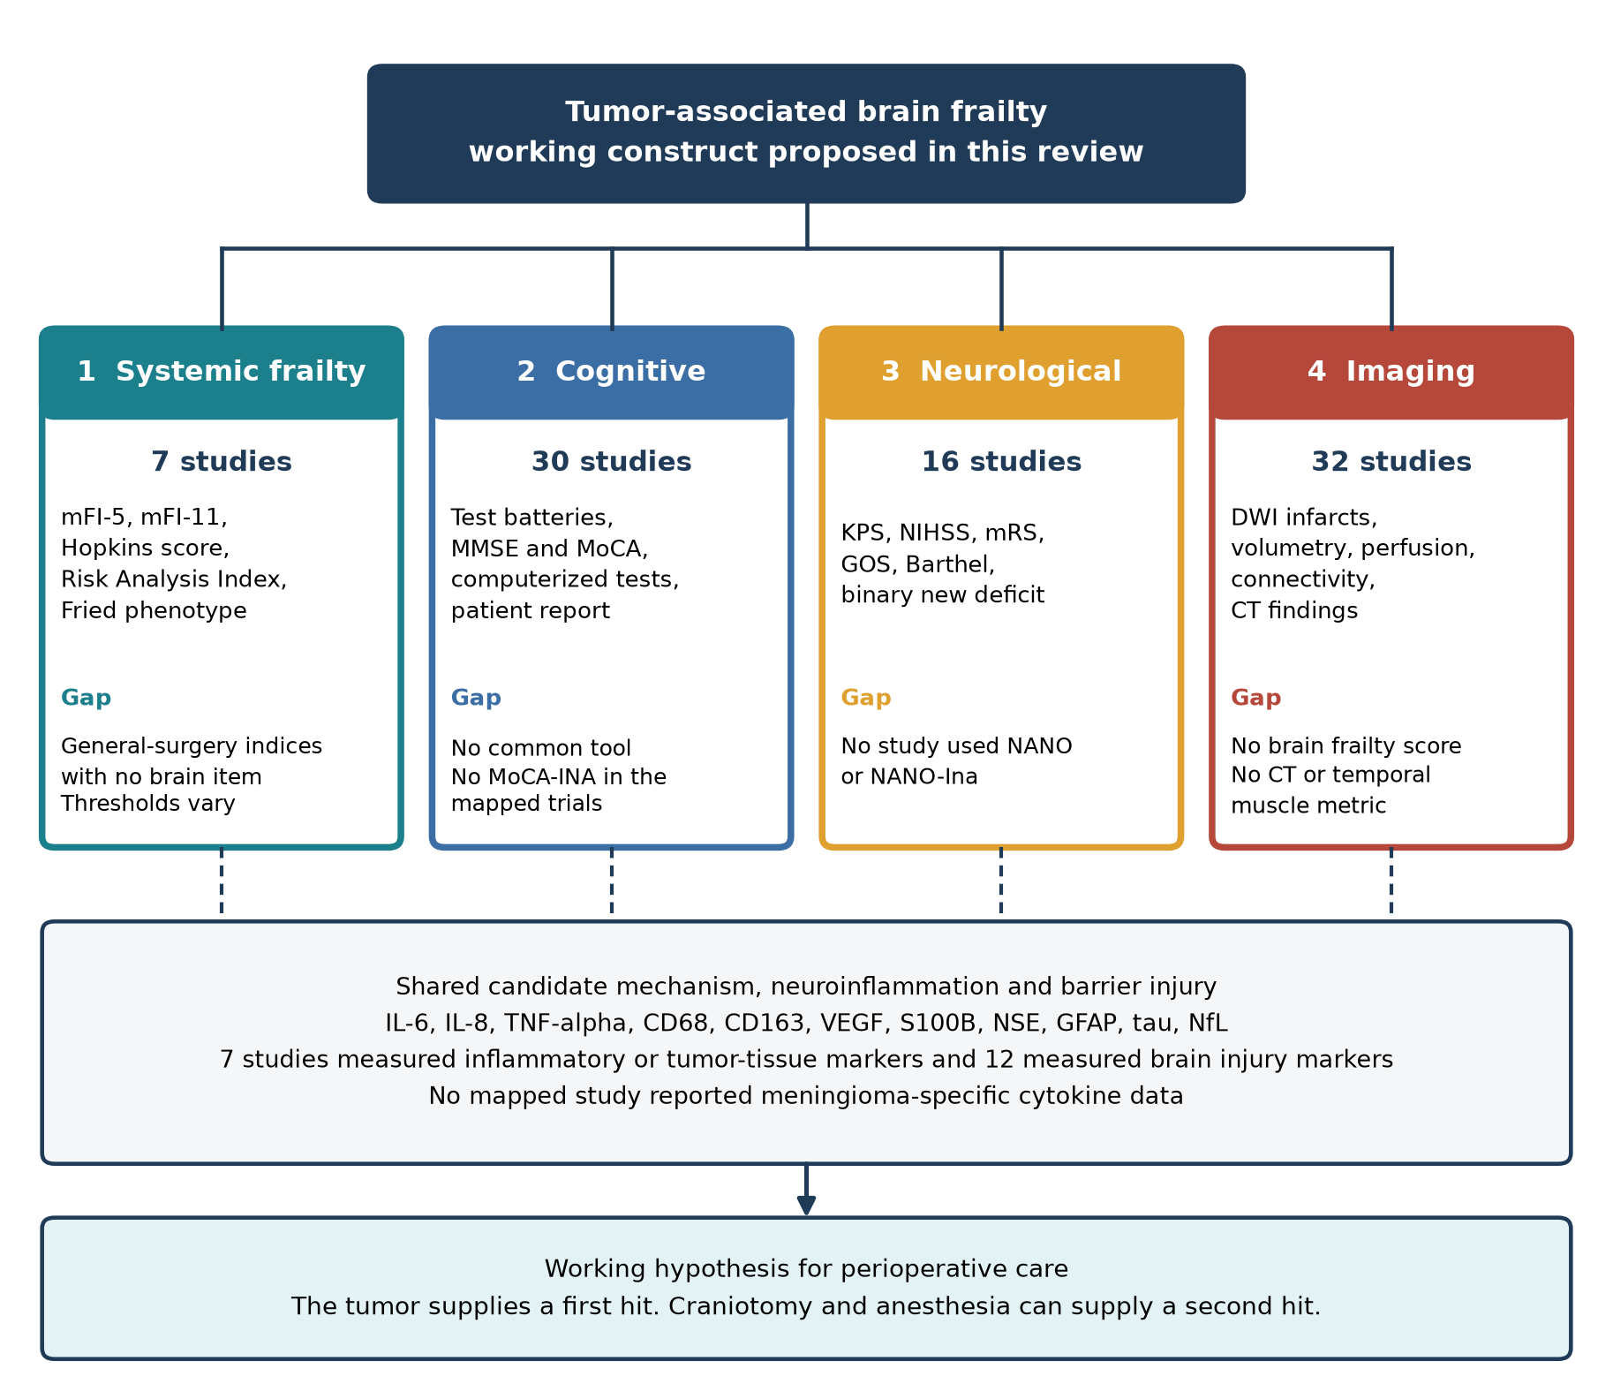
Figure 3. Four candidate domains of tumor-associated brain frailty, with the number of core studies, instruments identified, and gaps, above the shared candidate mechanism of neuroinflammation and barrier injury.
Table 2. Candidate domains of tumor-associated brain frailty, instruments identified in the core evidence base, and remaining gaps.
Domain | Studies with data (n) | Instruments or measures identified | Direction of the evidence | Main limitation
1. Systemic frailty | 7 | mFI-5 (3)^{45,48,49}, mFI-11 (1)⁴⁷, Hopkins Frailty Score (1)⁴⁶, Risk Analysis Index (1)⁴⁹, Fried phenotype (1)¹⁰³, comorbidity count (1)⁷⁶ | Higher frailty linked to worse outcome or improved by rehabilitation in 7 of 7 | General-surgery indices, no brain-specific item, thresholds differ, no glioma-only or meningioma-only sample
2. Cognitive | 30 (plus 1 protocol) | Multidomain batteries (14), domain-specific tests (4), brief screeners (7), computerized batteries (4), patient-reported scale (1). MMSE in 5, MoCA in 2 with data, no MoCA-INA | Impaired before surgery in 8 of 8 studies that tested it. After surgery, among 18 cohorts, improved 6, no change 3, decline 3, transient decline 3, others 3 | No shared tool or time point, early decline in glioma cohorts, improvement in meningioma cohorts, MMSE-J missed deficits in one study
3. Neurological | 16 | Binary new deficit (8), Barthel index (5), GOS or GOSE (3), KPS (2), mRS (3), GCS (2), NIHSS (1), House-Brackmann (1), intraoperative MEP (2). No NANO | Deficit rates 6.7% to 50% depending on definition | Nine instruments or definitions, none designed for neuro-oncology
4. Imaging | 32 | DWI for ischemic lesions (6), volumetric MRI (13), perfusion or permeability (4), functional connectivity (7), CT findings (7), contrast-enhanced ultrasound (1) | New DWI lesions after 18.8% to 45.7% of resections | Imaging describes tumor or injury, no brain frailty score, no CT-based or muscle-based metric
Counts are studies, and a study can contribute to more than one row. GCS, Glasgow Coma Scale. GOS, Glasgow Outcome Scale. GOSE, extended Glasgow Outcome Scale. KPS, Karnofsky Performance Status. mRS, modified Rankin Scale. NIHSS, National Institutes of Health Stroke Scale.

3.5. Neuroinflammation in Malignant and Benign Tumors (RQ3)
Direct inflammatory evidence came from glioma and mixed samples (Table 3). In high-grade glioma, CD68-positive macrophages (19% to 27% of cells) outnumbered CD45-positive leukocytes (3% to 7%), and cerebrospinal fluid interleukin-7 was lower than in controls⁴³. In astrocytoma, interleukin-8 and interleukin-6 expression rose with grade and necrosis, and interleukin-8 independently predicted survival⁴¹. Peritumoral microdialysis in a mixed sample showed that most cytokines peaked within 8 hours of surgery and fell over 96 hours, with intracerebral levels above serum levels⁴². A structural barrier defect³⁷ and a link between tumor VEGF expression and capillary permeability³⁸ supported a vascular route for inflammatory signaling.
The ten meningioma-only studies measured no inflammatory marker. They contributed evidence of barrier-related vulnerability and injury instead. In a sample of 20 gliomas and 7 meningiomas, permeability measured by two MRI methods agreed in gliomas but not meningiomas⁴⁰. S100B rose after meningioma surgery in two cohorts and tracked bleeding, midline shift, and deterioration^{78,79}, and 34.9% of meningioma operations produced a new diffusion-weighted lesion⁸⁶. Cognition was impaired before surgery in four meningioma cohorts^{50,54,55,69}. No core study compared inflammatory markers between meningioma and glioma. The immunological rationale for benign tumors therefore rests on external reviews of macrophage infiltration and its relation to edema^{14,15}, and the mapped studies support a shared vulnerability phenotype without testing a shared inflammatory mechanism.
Delirium risk also varied with histology. Five of the six studies that tested tumor type reported higher delirium risk with glioma or malignant tumors^{47,74,75,77,102}, and one found no association⁷³. In one cohort, meningioma was protective⁷⁴. Two trials reported that dexmedetomidine and lidocaine lowered interleukin-6 and tumor necrosis factor alpha at the end of surgery or on day 1^{98,99}, and in the dexmedetomidine trial the difference had converged with control by day 3⁹⁸.
Table 3. Neuroinflammation, injury, and vulnerability evidence by tumor category, from the 70 core studies (protocols excluded from counts of data).
Tumor category | Studies (n) | Inflammatory or tumor-tissue markers | Brain injury biomarkers | New DWI lesions after surgery | Baseline cognitive impairment | Delirium risk by histology
Glioma only | 25 | n = 2^{41,43} | n = 1⁸⁷ | n = 4^{82,83,85,87}. 44.2%, 45.7%, 31% (new) and 80% (recurrent) | n = 3^{51,53,67} | Not stratified within glioma-only samples
Meningioma only | 10 | n = 0 | n = 3^{78,79,106} | n = 1⁸⁶. 34.9% | n = 4^{50,54,55,69} | Meningioma protective in 1 mixed sample⁷⁴
Mixed tumor types | 34 | n = 5^{38,42,73,98,99} | n = 8^{84,90,92,94,96,98,99,104} | n = 1⁸⁰. 18.8% | n = 1⁵⁷ | Higher risk with glioma or malignant tumor in 5 of 6^{47,73-75,77,102}
Brain metastasis only | 1 | n = 0 | n = 0 | n = 0 | n = 0 | Not applicable
Cells show the number of studies with data and, where relevant, the reported incidence. No core study compared inflammatory markers between meningioma and glioma.

3.6. Biomarkers of Neuroinflammation and Brain Injury (RQ4)
Table 4 lists the markers. S100B was the most frequent, with data in 10 studies, followed by neuron-specific enolase (7 studies with data), GFAP (4), tau (1), neurofilament light chain (1), interleukin-6 (5), interleukin-8 (2), tumor necrosis factor alpha (2), and VEGF (3), and one study scored tissue immune cell markers⁴³. Four observational studies followed injury markers after surgery and all four found a postoperative rise^{78,79,84,87}. Three of the four linked the rise to clinical or radiological injury. Plasma GFAP, tau, and neurofilament light chain rose on days 1 and 3, neurofilament light chain showed a second peak at day 10 in keeping with continuing axonal degeneration, and day 1 GFAP and neurofilament light chain were higher in patients with new deficits⁸⁷. S100B above 0.4 ug/L carried a nine-fold risk of neurologic deterioration⁷⁸, and its rise correlated with bleeding, midline shift, and MMSE decline⁷⁹. GFAP rose after glioma surgery but did not track residual tumor, which is consistent with release from tumor cells⁸⁴.
Eight randomized trials used S100B, neuron-specific enolase, or GFAP as endpoints^{90,92,94,96,98,99,104,106}. The intervention lowered at least one marker in six trials (electroacupuncture, magnesium in two, goal-directed fluid therapy, dexmedetomidine, and lidocaine)^{90,92,94,96,98,99}. The primary S100B endpoint did not differ with magnesium in one trial¹⁰⁴, and S100B and neuron-specific enolase were higher with ciprofol than propofol in another¹⁰⁶. Sampling was almost always peripheral, from baseline to 24 or 48 hours. Cerebrospinal fluid or microdialysis sampling appeared only in mechanistic studies^{42,43}, and no perioperative trial measured a cytokine in cerebrospinal fluid. Injury markers therefore indicate that injury occurred, whereas the cytokine evidence needed to show neuroinflammation as such is compartment-specific and sparse.
Table 4. Biomarkers measured in the core evidence base, with source, interpretation, sampling, and main findings.
Marker | Source and interpretation | Typical sampling | Studies with data (n) | Main findings
S100B | Astrocytic calcium-binding protein with a serum half-life of about 30 minutes. Rise marks astrocytic injury or barrier permeability | Baseline, end of surgery, 24 to 48 h, daily to day 7 in one study | 10 | Rose after meningioma surgery^{78,79}. Lower with magnesium^{92,96}, electroacupuncture⁹⁰, dexmedetomidine⁹⁸, lidocaine⁹⁹. No primary difference with magnesium¹⁰⁴. Higher with ciprofol¹⁰⁶
Neuron-specific enolase | Neuronal glycolytic enzyme. Rise reflects neuronal injury | Same schedule as S100B | 7 (plus 1 protocol) | Lower with electroacupuncture, dexmedetomidine, lidocaine, and goal-directed fluids^{90,94,98,99}. No difference with magnesium⁹². Higher with ciprofol¹⁰⁶
GFAP | Astrocytic intermediate filament. Also released by glioma cells through a leaky barrier | Baseline, day 1, 3, 5, 7, 10 | 4 | Rose after surgery and higher with new deficits⁸⁷. No link with residual tumor⁸⁴. Lower with fluid strategy and dexmedetomidine^{94,98}
Tau | Axonal and cortical interneuron protein | Baseline to day 10 | 1 | Rose on days 1 and 3⁸⁷
Neurofilament light chain | Large-caliber axon filament. Late peak suggests continuing axonal degeneration | Baseline to day 10 | 1 | Rose on days 1 and 3 with a second peak at day 10⁸⁷
IL-6, IL-8, TNF-alpha | Cytokines from tumor cells, immune cells, endothelium, injured neurons and astrocytes, and surgical trauma | Microdialysis every 6 h for 96 h, single tissue samples, or end of surgery and day 1 in trials | IL-6 5, IL-8 2, TNF-alpha 2 (plus 1 protocol) | Rose with grade and necrosis⁴¹, peaked early after surgery⁴², and were lower with dexmedetomidine and lidocaine^{98,99}
VEGF | Endothelial mitogen and permeability inducer from tumor cells | Single tissue or CSF sample | 3 | Correlated with capillary permeability³⁸ and with IL-8⁴¹
CD45, CD68, CD163 | Tissue markers of leukocytes, macrophages and microglia, and M2 macrophages | Single sample at resection | 1 | Macrophage-dominated infiltrate in glioblastoma⁴³
IL, interleukin. TNF, tumor necrosis factor. VEGF, vascular endothelial growth factor. Marker interpretation follows the source studies.

3.7. Perioperative Brain Injury as a Second Hit (RQ5)
New diffusion-weighted lesions followed resection in 34.9% of meningioma operations⁸⁶, 44.2% of glioma operations⁸⁵, 45.7% of glioma operations with motor monitoring⁸², and 18.8% of a mixed sample⁸⁰. In one series, lesions occurred after 31% of operations for newly diagnosed and 80% for recurrent glioma⁸³. The lesions mattered clinically. Among patients with a permanent deficit after meningioma surgery, 72.7% had an infarction⁸⁶, a new lesion was the only multivariable predictor of incomplete recovery at day 7 and day 30⁸⁰, and deficits were more frequent with lesions⁸³. Table 5 summarizes this and the other second-hit evidence.
Delirium and agitation occurred in 4.2% to 35% of patients in observational cohorts and in 28.7% to 46% of control arms, depending on instrument and definition^{47,72-77,102,103}. Later postoperative delirium occurred in 58.8% of patients with emergence delirium and in 4.7% of those without⁷⁵. Hemodynamic findings were mixed. Impaired autoregulation before surgery persisted after resection in all affected patients⁸¹, intraoperative mean arterial pressure below 65 mmHg was not associated with delirium⁷⁷, and a lower stroke volume variation threshold was linked to fewer new neurologic events (17.5% against 40%)⁹⁴. Dexmedetomidine lowered delirium from 46% to 22%¹⁰².
Preoperative state predicted postoperative outcome in several designs. Presurgical cognition was the strongest predictor of early postsurgical cognition⁶⁶, frailty strata predicted delirium⁴⁷, raised intracranial pressure was linked to impairment before surgery⁵⁵, and presurgical connectivity predicted later working memory⁷⁰. Four trials tested magnesium as a protective agent^{92,96,97,104}. Two found lower S100B^{92,96}, one found no primary difference but smaller cavities and less gliosis at six months in the tumor subgroup¹⁰⁴, and one found no difference in MoCA⁹⁷. No core study examined the interaction between a preoperative vulnerability measure and a postoperative injury marker in the same patients.
Table 5. Evidence on perioperative brain injury as a second hit after tumor-related vulnerability.
Evidence type | Studies | Quantitative range or finding | Interpretation
New diffusion-weighted lesions after resection | ^{80,82,83,85-87} | 18.8% to 45.7% of operations or patients. 31% newly diagnosed versus 80% recurrent glioma | Linked to permanent deficit, incomplete recovery, and larger tumor, bleeding, and age
Postoperative release of injury markers | ^{78,79,84,87} | S100B, GFAP, tau, and NfL rose in 4 of 4 studies | Related to deficits, bleeding, midline shift, and MMSE decline in 3 of 4
Delirium or agitation | ^{47,72-77} | 4.2% to 35% in observational cohorts. 28.7% to 46% in control arms | Higher with frailty, age, malignant histology, frontal approach, longer surgery
Cerebral perfusion and autoregulation | ^{77,81,94} | Autoregulation impaired before surgery in 20% and persisting after. New neurologic events 17.5% versus 40% by fluid strategy | Mean arterial pressure below 65 mmHg not associated with delirium
Preoperative state predicting postoperative course | ^{47,55,66,70} | Frailty strata, raised intracranial pressure, presurgical cognition, and connectivity each predicted outcome | Fits a two-hit sequence, interaction untested
Interventions aimed at the second hit | ^{92-94,96-99,102-104,106} | Delirium 46% to 22% with dexmedetomidine. 28.7% to 15.6% with frailty-directed rehabilitation. Four magnesium trials with mixed results | Mostly small single-center trials with surrogate endpoints
Ranges are the lowest and highest values reported by the cited studies and are not pooled estimates.

3.8. Instrument-Focused Stratum (RQ6)
None of the 70 core studies used MoCA-INA or NANO-Ina, and none evaluated these instruments before and after surgery. The instrument-focused stratum (Table 6) added six studies. The NANO scale covers nine neurologic domains, showed more than 90% inter-observer agreement (kappa 0.35 to 0.83), and took a median of 4 minutes to administer²⁶. Its Indonesian version was tested in 30 patients with brain tumors by two physicians and reached kappa values from 0.629 for sensation to 0.935 for facial strength. Most patients (77%) were untreated, and the work came from a single center¹⁰⁷.
For cognition, a feasibility study in 71 patients with primary central nervous system tumors found a median MoCA of 27, with 32% abnormal at a cut-off of 25 or lower. Lower scores accompanied lower Karnofsky status, older age, and greater self-reported cognitive symptom burden¹⁰⁸. In 33 Indonesian patients with brain tumors assessed at diagnosis, mean scores were 21.79 on the MoCA-Ina and 23.76 on the MMSE. Impairment clustered at 7 to 9 years of education. Attention and calculation were impaired in 90.9% on the MMSE, and delayed recall was impaired in 90.9% on the MoCA-Ina¹⁰⁹. In 83 older adults without a tumor, MoCA-INA scores averaged 21.06 against 24.96 for the MMSE (correlation 0.71)¹¹⁰. In 31 anesthesiology residents, mean MoCA-INA fell from 26.84 to 25.00 after a 24-hour on-call period¹¹¹. The Indonesian scoring sheet sets a maximum of 30, treats 26 or more as normal, and adds one point for 12 or fewer years of formal education when the total is below 30. Together these studies show that both instruments can be administered in Indonesian clinical settings, that NANO-Ina agrees well between raters, and that MoCA-INA detects impairment and short-term change. None of them tested responsiveness to craniotomy.
Table 6. Instrument-focused stratum, studies of MoCA-INA, NANO-Ina, and their parent instruments.
Study | Country | Design | Population | Instrument | Main findings
Nayak, 2017²⁶ | Multinational | Multicenter reliability study | Brain tumor (RANO setting) | NANO scale, 9 neurologic domains, clinician-rated | Inter-observer agreement above 90% (kappa 0.35 to 0.83), median administration time 4 min (IQR 3 to 5).
Angelita, 2026¹⁰⁷ | Indonesia | Cross-sectional validation | Brain tumors n = 30 (glioblastoma 7, meningioma 7, metastasis 9, other 7) | NANO-Ina | Weighted kappa 0.629 (sensation) to 0.935 (facial strength) across reported domains. Most patients (77%) were untreated at assessment, and the work came from a single center.
Jammula, 2022¹⁰⁸ | USA | Cross-sectional feasibility study | Primary CNS tumors n = 71 (47 in person, 24 telehealth) | MoCA, abnormal at 25 or lower | Median 27 (range 6 to 30), 32% abnormal. Lower MoCA tracked KPS (r = 0.35), age (r = 0.27), and MDASI-BT cognitive burden (r = -0.27). Providers found it feasible.
Bangun, 2018¹⁰⁹ | Indonesia | Cross-sectional study | Brain tumors at diagnosis, n = 33 | MoCA-Ina, MMSE | Mean MoCA-Ina 21.79 (SD 4.93), MMSE 23.76 (SD 4.08). Abnormal scores clustered at 7 to 9 years of education. Attention and calculation impaired in 90.9% (MMSE) and delayed recall in 90.9% (MoCA-Ina).
Rambe, 2017¹¹⁰ | Indonesia | Cross-sectional study | Elderly adults (65 years or older), n = 83, no tumor | MoCA-INA, MMSE | MoCA-INA mean 21.06 (SD 4.56) against MMSE 24.96 (SD 3.38), Pearson r = 0.71. MoCA-INA below 26 in 85.5%.
Wonggo, 2025¹¹¹ | Indonesia | Cross-sectional before-after study | Anesthesiology residents, n = 31, no tumor | MoCA-INA | Mean score fell from 26.84 to 25.00 (Wilcoxon Z = -3.778, p < .001), mainly in visuospatial, attention, and memory domains.
These six studies were reported separately from the core evidence base. Two included no patients with tumors and are included as evidence on the Indonesian MoCA. IQR, interquartile range. MDASI-BT, MD Anderson Symptom Inventory for brain tumor. RANO, Response Assessment in Neuro-Oncology.

3.9. Integrated Evidence Map and Conceptual Synthesis
Figure 4 places each domain against tumor category and shades each cell by the share of graded studies at level 2. Cognitive testing and imaging carried the most evidence and were concentrated in glioma and meningioma cohorts. Systemic frailty indices, delirium, and hemodynamic studies came almost entirely from mixed samples. Inflammatory and tumor-tissue markers and tumor biology came from glioma and mixed samples, and none came from meningioma-only samples. Among the mechanistic domains, only brain injury biomarkers (three studies^{78,79,106}) and hemodynamics (one study¹⁰⁶) had data in meningioma-only samples.
The synthesis supports a four-domain construct with a two-hit course (Figure 5). The tumor produces mass effect, edema, barrier disruption, and local inflammation, and these are visible in the mapped evidence as impaired cognition, frailty-linked risk, and preoperative neurological and imaging abnormalities. Surgery and anesthesia then add ischemic injury, marker release, and delirium. The mapped studies describe each hit and show that preoperative state predicts postoperative course, but none tested the interaction.
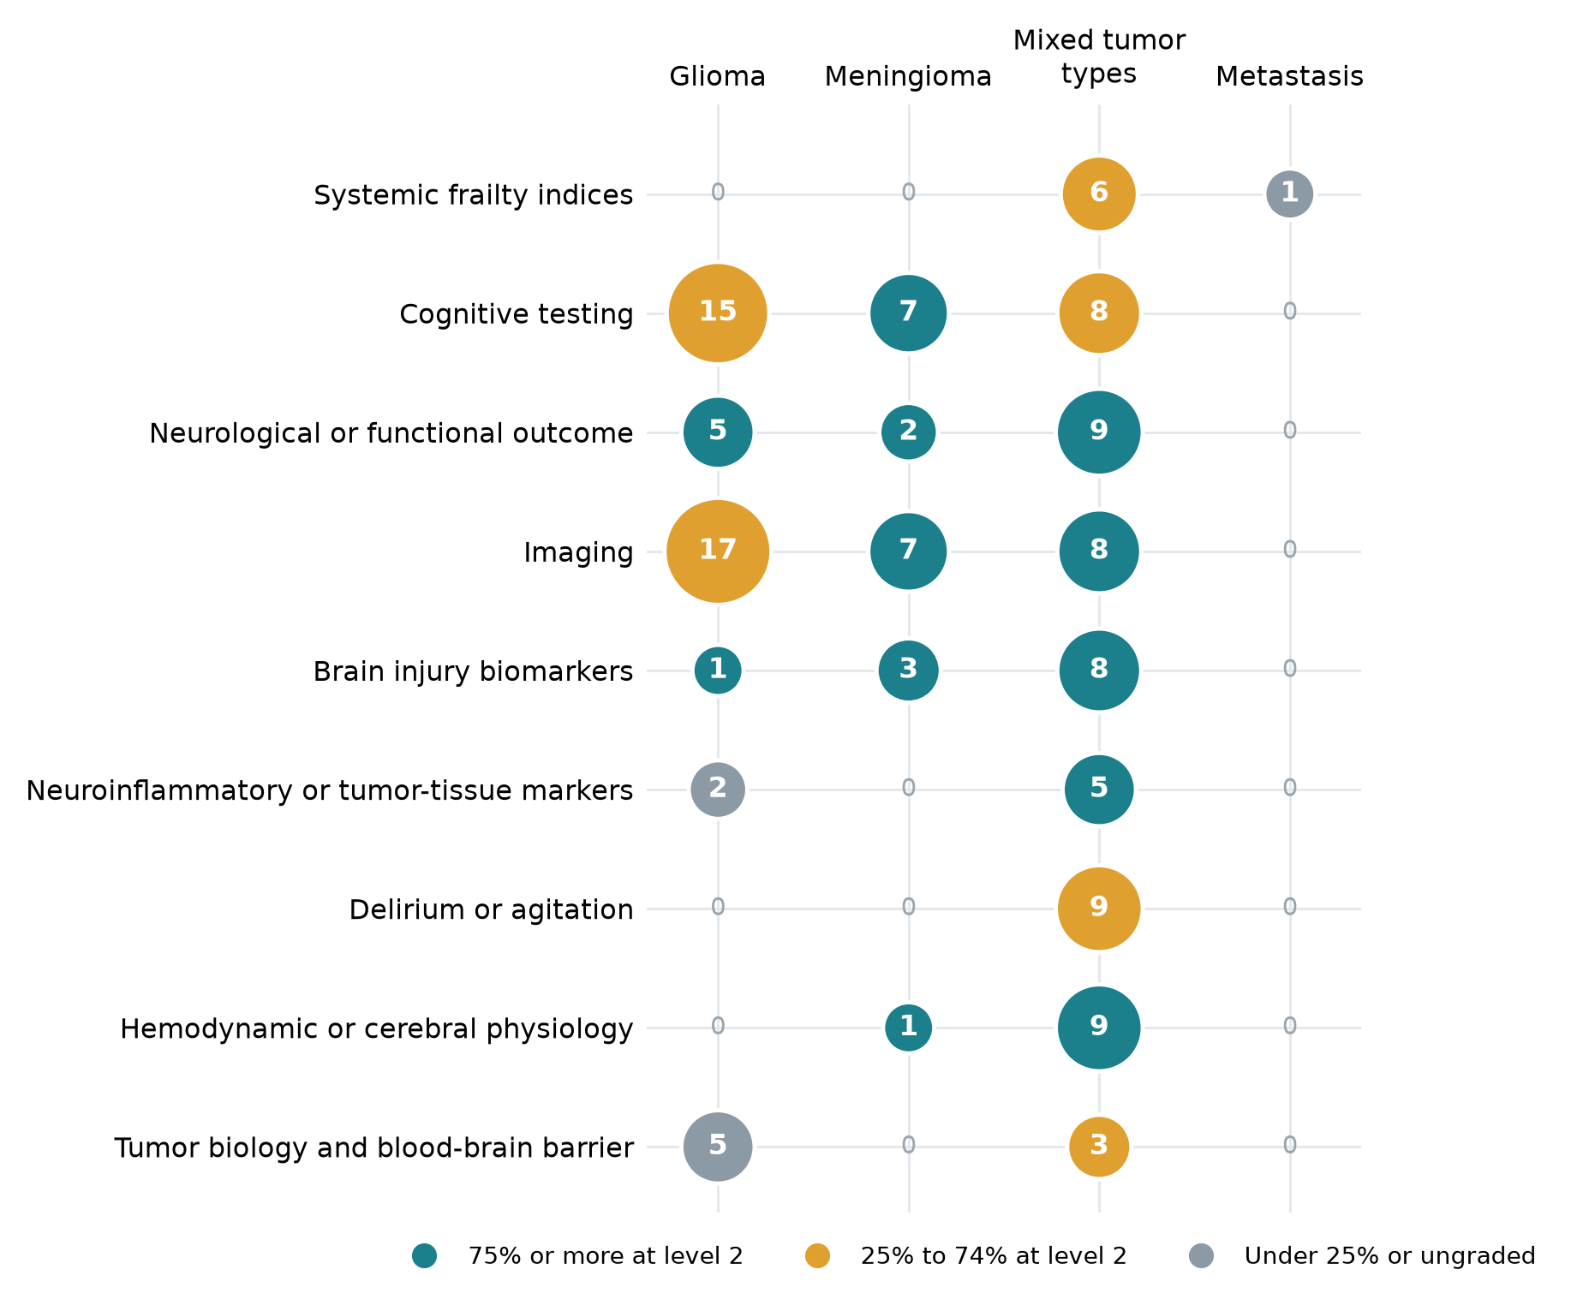
Figure 4. Evidence map of domains against tumor category. Bubble size is the number of core studies and shading is the share of graded studies at OCEBM level 2. Trial protocols are excluded.
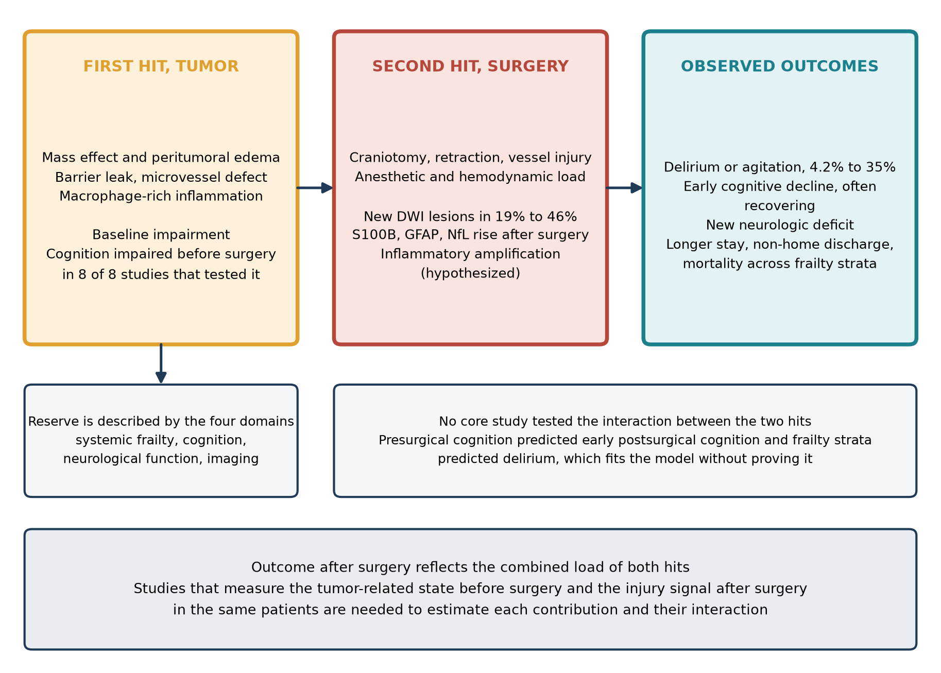
Figure 5. Conceptual two-hit model. The tumor supplies the first hit and perioperative brain injury the second. The interaction between the hits was not tested in any core study.

4. Discussion
This review mapped 76 studies to ask what is known about the vulnerable brain of a patient with a brain tumor who faces surgery. The main finding is an absence. No study defined tumor-associated brain frailty, and the seven studies that used frailty at all borrowed indices built for older adults or general surgical patients. Around that absence sits a substantial body of work on the four domains we propose as its components, on candidate mechanisms, and on perioperative injury. These can be assembled into a coherent working construct but not yet into a validated one (Table 7).
Table 7. Answers to the seven review questions and the status of the mapped evidence.
Question | Answer from the mapped evidence | Basis | Status
RQ1. How is frailty or brain frailty defined and measured? | No brain-specific definition. Frailty is borrowed through seven general indices, in mixed tumor samples, with differing thresholds | 7 core studies | Answered, and the answer is a gap
RQ2. Which domains and instruments characterize it? | Four domains map onto existing studies (systemic, cognitive, neurological, imaging). Each has several instruments and no shared standard | 7, 30, 16, and 32 core studies | Answered descriptively
RQ3. Is neuroinflammation present in benign as well as malignant tumors? | Documented in glioma tissue, cerebrospinal fluid, and microdialysate. Benign tumor evidence rests on external reviews, and meningioma-only studies show injury and vulnerability but no cytokines | 3 glioma or mixed studies, 0 meningioma | Partly answered
RQ4. Which biomarkers can detect neuroinflammation and injury? | S100B, NSE, GFAP, tau, and NfL track injury. Cytokines require tissue, cerebrospinal fluid, or microdialysis. No validated neuroinflammation panel | 12 injury and 7 inflammatory studies | Partly answered
RQ5. What supports perioperative brain injury as a second hit? | New DWI lesions after 18.8% to 45.7% of resections, marker rise in 4 of 4 studies, delirium in 4.2% to 35%. Interaction with preoperative state untested | Table 5 | Partly answered
RQ6. Which instruments exist, including MoCA-INA and NANO-Ina? | None of the core studies used either. Six supplementary studies document both, without perioperative testing | 0 core, 6 supplementary | Answered, with a gap
RQ7. Where are the gaps? | No definition, no brain-specific index, no CT or muscle metric, no meningioma cytokine data, no interaction test, no perioperative validation of the Indonesian instruments | All of the above | Answered
Status describes how fully the mapped evidence answers the question. Partly answered and gap findings are reported as results of a scoping review.
We propose tumor-associated brain frailty as a reduced capacity of the brain and body of a patient with an intracranial tumor to tolerate surgical and anesthetic stress. It is expressed in systemic, cognitive, neurological, and imaging domains and is driven at least in part by tumor-related inflammation and barrier injury. The definition differs from imaging-defined brain frailty and from cognitive frailty in three ways^{10,11}. It is tied to a lesion and its mechanisms, so mass effect, edema, and barrier leak belong to it. It may be partly reversible, because improvement after resection was the commonest conclusion in meningioma cohorts and appeared in some glioma cohorts. And it is defined against a specific coming challenge, the operation. These features justify a separate term, but the term stays a hypothesis. A construct earns its place only when its components can be measured and shown to predict outcome beyond what age and tumor grade already tell the surgeon, and none of the mapped studies did that.
Each domain has instruments and no shared standard. The systemic indices reflect comorbidity and function more than brain reserve, and none of the frailty cohorts was restricted to glioma or meningioma, so tumor-specific thresholds cannot be derived from them. This extends the conclusions of earlier systematic reviews on heterogeneous thresholds and pooled etiologies^{8,9}. Cognition is the best-studied domain and also the least standardized. Impairment before surgery was universal among studies that looked for it, but the direction after surgery depended on tumor type and timing. Declines clustered in glioma cohorts and often resolved, whereas meningioma cohorts mostly improved, which suggests that part of the preoperative deficit is a reversible tumor effect. The choice of instrument matters, because one study found normal screening scores in patients whose detailed testing and lesion mapping showed specific deficits⁶¹. Neurological outcome was recorded with nine different instruments or definitions, and the NANO scale, which offers a structured alternative, appeared only in the supplementary stratum²⁶. Imaging was abundant but never converted into a frailty metric. Markers that are well established in stroke, such as leukoaraiosis and atrophy¹⁰, were absent from the mapped set. So was temporal muscle thickness, a muscle-based measure linked to survival in glioblastoma¹¹². Both are candidates for a CT or MRI component.
Whether neuroinflammation reaches beyond malignant tumors can be answered only in part. External reviews describe macrophage-rich immune infiltrates in meningioma that track edema^{14,15}, and the mapped meningioma studies show injury and vulnerability in the form of S100B release, new diffusion-weighted lesions, and cognitive deficits before surgery. None of them measured a cytokine, and no core study compared inflammatory markers between meningioma and glioma. The cytokine data that exist, from glioma tissue, cerebrospinal fluid, and microdialysate, relate to tumor grade and early postoperative kinetics and not to frailty. The similar vulnerability phenotype in benign and malignant tumors is therefore a reason to test a shared mechanism. It is not evidence that one exists. Delirium risk was higher with glioma or malignant tumors in five of six studies, which suggests that the shared phenotype may differ in size between tumor types.
The biomarker evidence needs careful reading. S100B, neuron-specific enolase, GFAP, tau, and neurofilament light chain show that injury occurred, and their kinetics differ, with S100B acting early and neurofilament light chain showing a late second peak^{79,87}. GFAP is complicated in glioma by release from tumor cells⁸⁴. Serial sampling to day 10 and a panel that pairs an early astrocytic marker with a late axonal marker therefore look more informative than a single sample, as reviews of serial sampling and of neurofilament biomarkers also suggest^{22,23}. Trials used these markers as surrogates for neuroprotection, and in the mapped studies the link to clinical benefit was weak. Lower S100B with magnesium was not accompanied by a functional difference⁹², and lidocaine reduced cerebral oxygen extraction without a cognitive benefit at six months⁹³. Lower marker levels do not by themselves show protection.
The two-hit model organizes these findings, with the tumor as the first hit and perioperative brain injury as the second (Figure 5). New diffusion-weighted lesions followed 18.8% to 45.7% of resections, including about a third of meningioma operations, injury markers rose in every study that followed them, and delirium affected 4.2% to 35% of patients. Preoperative state predicted the postoperative course in several designs. The model borrows biological plausibility from studies of microglial priming, in which a brain already exposed to inflammation responds more strongly to a later systemic challenge^{20,21}. That literature concerns neurodegeneration and not tumors, and we do not claim it applies. What the mapped evidence cannot yet show is the interaction, meaning whether the same perioperative injury does more harm in a brain that is already vulnerable. A direct test would enroll patients with a defined tumor type and profile the four domains before surgery. It would sample injury and inflammatory markers serially, obtain early diffusion-weighted imaging, and follow cognition. The interaction between preoperative profile and injury would be the primary analysis. Modifiable second-hit factors such as anesthetic technique, hemodynamic management, and frailty-directed rehabilitation showed favorable signals in small trials, mostly with surrogate endpoints, and these should be studied inside that design.
The instrument-focused stratum matters for Indonesia in particular. No core study came from Indonesia, and none used MoCA-INA or NANO-Ina. The Indonesian studies we found were cross-sectional, with 30 to 83 participants each, and measured agreement, score distributions, and sensitivity to short-term change^{107,109-111}. MoCA-INA scores fell after a 24-hour on-call period¹¹¹, which suggests that the instrument can register brief changes in cognition. Its mean scores were lower than MMSE scores in older adults¹¹⁰ and in patients with brain tumors¹⁰⁹, as the greater sensitivity reported for the parent MoCA would predict^{24,25}. Different cut-offs prevent a direct comparison of impairment rates. Responsiveness to craniotomy and the ability of either instrument to separate the first hit from the second remain untested, and a perioperative validation of both in Indonesian neuro-oncology cohorts is a concrete next step.
A scoping review maps evidence. It does not appraise quality, estimate effects, or replace a systematic review or a narrative review written to a fixed argument. Readers who need effect estimates for frailty indices should turn to the existing meta-analyses⁷. The structure we offer here, with explicit domains, tumor strata, and counts that can be traced to a charting form, is meant to make a fuller later review easier. Three of the seven review questions ended partly answered. This is an acceptable and informative scoping result, because a question that the literature cannot answer is a finding that directs future work, and reporting it plainly is more defensible than stretching weak evidence to fit^{32,33}.
Several limitations apply. We did not appraise risk of bias, and the evidence level reflects design only, so a level 2 study may still be at high risk of bias. The direction-of-effect tallies rest on the authors' own group-level conclusions and on our coding, and other reviewers might classify borderline studies differently, which the supplementary charting form allows them to check. More than half of the core studies sampled mixed tumor types without stratified results, which limits conclusions by tumor type. We retained two trial protocols and one preprint, which add to the map of ongoing work but not to outcome counts. Screening was limited to English-language reports, the last search was run on 22 March 2026, and Google Scholar searches are difficult to reproduce. The instrument-focused stratum was added after charting began, and two of its studies enrolled participants without tumors. Finally, we did not search for studies of general brain frailty outside neuro-oncology, so the contrast we draw with imaging-defined brain frailty rests on external sources.
Studies should define and test a brain-specific vulnerability profile in single-tumor cohorts, starting with glioma and meningioma. A core outcome set should replace the nine neurological definitions and the many cognitive tests, with MoCA-based screening, a domain-specific test, and NANO as obvious candidates. Biomarker work should add cytokine measurement to injury markers and should compare meningioma with glioma. Imaging studies should test brain frailty markers and muscle measures on routine preoperative scans. And the interaction between the two hits should be the primary question of at least one prospective cohort.

5. Conclusions
The mapped literature does not define tumor-associated brain frailty, but it supplies the parts of a definition. Systemic frailty, cognition, neurological function, and imaging each carry evidence of vulnerability before surgery, and perioperative brain injury, seen as new ischemic lesions, marker release, and delirium, adds a second hit in a large share of operations. Neuroinflammation is documented in glioma and is a plausible but untested shared mechanism in meningioma. None of the 70 core studies used MoCA-INA or NANO-Ina, which have only cross-sectional Indonesian data. The evidence is observational and heterogeneous, and the interaction between the two hits is untested. Prospective cohorts that pair preoperative domain profiling with serial injury and inflammatory markers are needed to turn this working construct into a measurable and testable one.

Supplementary Materials
Supplementary Table S1 is the PRISMA-ScR checklist. Supplementary Table S2 gives the database-specific search strategies and record counts. Supplementary Table S3 is the 31-item charting form for all 76 studies. Supplementary Table S4 reconciles the original screening tally of 80 studies with the final 70 and lists the six instrument-focused studies. Supplementary Table S5 is the reference verification log with DOI, PMID, and journal data for every cited source. Supplementary Table S6 is the coding of studies by stream, design, tumor category, and domain.

Author Contributions
To be completed by the authors.

Funding
This research received no external funding.

Institutional Review Board Statement
Not applicable, because this review used published data only.

Informed Consent Statement
Not applicable.

Data Availability Statement
All data analyzed in this review are contained in the article and its Supplementary Tables. The search strategies, charting form, coded dataset, and analysis scripts are available in the public GitHub repository (https://github.com/sharing-123/tumor-associated-brain-frailty-and-perioperative-brain-injury-scoping-review), and an archived version is deposited on Zenodo (ZENODO LINK TO BE INSERTED HERE). Further inquiries can be directed to the corresponding author.

Use of Generative Artificial Intelligence
To be completed by the authors in line with the target journal policy.

Conflicts of Interest
The authors declare no conflicts of interest.

References
1. Ostrom QT, Price M, Neff C, Cioffi G, Waite KA, Kruchko C, et al. CBTRUS statistical report: primary brain and other central nervous system tumors diagnosed in the United States in 2016-2020. Neuro Oncol. 2023;25(Suppl 4):iv1-iv99. doi:10.1093/neuonc/noad149
2. Taphoorn MJ, Klein M. Cognitive deficits in adult patients with brain tumours. Lancet Neurol. 2004;3(3):159-68. doi:10.1016/s1474-4422(04)00680-5
3. Tucha O, Smely C, Preier M, Lange KW. Cognitive deficits before treatment among patients with brain tumors. Neurosurgery. 2000;47(2):324-34. doi:10.1097/00006123-200008000-00011
4. Fried LP, Tangen CM, Walston J, Newman AB, Hirsch C, Gottdiener J, et al. Frailty in older adults: evidence for a phenotype. J Gerontol A Biol Sci Med Sci. 2001;56(3):M146-M157. doi:10.1093/gerona/56.3.m146
5. Clegg A, Young J, Iliffe S, Rikkert MO, Rockwood K. Frailty in elderly people. Lancet. 2013;381(9868):752-62. doi:10.1016/s0140-6736(12)62167-9
6. Rockwood K. A global clinical measure of fitness and frailty in elderly people. CMAJ. 2005;173(5):489-95. doi:10.1503/cmaj.050051
7. Aghajanian S, Shafiee A, Ahmadi A, Elsamadicy AA. Assessment of the impact of frailty on adverse surgical outcomes in patients undergoing surgery for intracranial tumors using modified frailty index: a systematic review and meta-analysis. J Clin Neurosci. 2023;114:120-8. doi:10.1016/j.jocn.2023.06.013
8. Huq S, Liu J, Romano R, Seal S, Khalafallah AM, Walston JD, et al. Frailty in patients undergoing surgery for brain tumors: a systematic review of the literature. World Neurosurg. 2022;166:268-278.e8. doi:10.1016/j.wneu.2022.07.039
9. Qureshi HM, Tabor JK, Pickens K, Lei H, Vasandani S, Jalal MI, et al. Frailty and postoperative outcomes in brain tumor patients: a systematic review subdivided by tumor etiology. J Neurooncol. 2023;164(2):299-308. doi:10.1007/s11060-023-04416-1
10. Appleton JP, Woodhouse LJ, Adami A, Becker JL, Berge E, Cala LA, et al. Imaging markers of small vessel disease and brain frailty, and outcomes in acute stroke. Neurology. 2020;94(5):e439-e452. doi:10.1212/wnl.0000000000008881
11. Kelaiditi E, Cesari M, Canevelli M, Abellan van Kan G, Ousset PJ, Gillette-Guyonnet S, et al. Cognitive frailty: rational and definition from an (I.A.N.A./I.A.G.G.) international consensus group. J Nutr Health Aging. 2013;17(9):726-34. doi:10.1007/s12603-013-0367-2
12. Quail DF, Joyce JA. The microenvironmental landscape of brain tumors. Cancer Cell. 2017;31(3):326-41. doi:10.1016/j.ccell.2017.02.009
13. Hambardzumyan D, Gutmann DH, Kettenmann H. The role of microglia and macrophages in glioma maintenance and progression. Nat Neurosci. 2016;19(1):20-7. doi:10.1038/nn.4185
14. Domingues P, González-Tablas M, Otero Á, Pascual D, Miranda D, Ruiz L, et al. Tumor infiltrating immune cells in gliomas and meningiomas. Brain Behav Immun. 2016;53:1-15. doi:10.1016/j.bbi.2015.07.019
15. Haslund-Vinding J, Møller JR, Ziebell M, Vilhardt F, Mathiesen T. The role of systemic inflammatory cells in meningiomas. Neurosurg Rev. 2022;45(2):1205-15. doi:10.1007/s10143-021-01642-x
16. Evered L, Silbert B, Knopman DS, Scott DA, DeKosky ST, Rasmussen LS, et al. Recommendations for the nomenclature of cognitive change associated with anaesthesia and surgery-2018. Anesthesiology. 2018;129(5):872-9. doi:10.1097/aln.0000000000002334
17. Alam A, Hana Z, Jin Z, Suen KC, Ma D. Surgery, neuroinflammation and cognitive impairment. EBioMedicine. 2018;37:547-56. doi:10.1016/j.ebiom.2018.10.021
18. Subramaniyan S, Terrando N. Neuroinflammation and perioperative neurocognitive disorders. Anesth Analg. 2019;128(4):781-8. doi:10.1213/ane.0000000000004053
19. Safavynia SA, Goldstein PA. The role of neuroinflammation in postoperative cognitive dysfunction: moving from hypothesis to treatment. Front Psychiatry. 2019;9:752. doi:10.3389/fpsyt.2018.00752
20. Cunningham C. Microglia and neurodegeneration: the role of systemic inflammation. Glia. 2013;61(1):71-90. doi:10.1002/glia.22350
21. Perry VH, Holmes C. Microglial priming in neurodegenerative disease. Nat Rev Neurol. 2014;10(4):217-24. doi:10.1038/nrneurol.2014.38
22. Thelin EP, Zeiler FA, Ercole A, Mondello S, Büki A, Bellander BM, et al. Serial sampling of serum protein biomarkers for monitoring human traumatic brain injury dynamics: a systematic review. Front Neurol. 2017;8:300. doi:10.3389/fneur.2017.00300
23. Khalil M, Teunissen CE, Otto M, Piehl F, Sormani MP, Gattringer T, et al. Neurofilaments as biomarkers in neurological disorders. Nat Rev Neurol. 2018;14(10):577-89. doi:10.1038/s41582-018-0058-z
24. Nasreddine ZS, Phillips NA, Bédirian V, Charbonneau S, Whitehead V, Collin I, et al. The Montreal Cognitive Assessment, MoCA: a brief screening tool for mild cognitive impairment. J Am Geriatr Soc. 2005;53(4):695-9. doi:10.1111/j.1532-5415.2005.53221.x
25. Olson RA, Chhanabhai T, McKenzie M. Feasibility study of the Montreal Cognitive Assessment (MoCA) in patients with brain metastases. Support Care Cancer. 2008;16(11):1273-8. doi:10.1007/s00520-008-0431-3
26. Nayak L, DeAngelis LM, Brandes AA, Peereboom DM, Galanis E, Lin NU, et al. The Neurologic Assessment in Neuro-Oncology (NANO) scale: a tool to assess neurologic function for integration into the Response Assessment in Neuro-Oncology (RANO) criteria. Neuro Oncol. 2017;19(5):625-35. doi:10.1093/neuonc/nox029
27. Peters MDJ, Marnie C, Tricco AC, Pollock D, Munn Z, Alexander L, et al. Updated methodological guidance for the conduct of scoping reviews. JBI Evid Synth. 2020;18(10):2119-26. doi:10.11124/jbies-20-00167
28. Arksey H, O'Malley L. Scoping studies: towards a methodological framework. Int J Soc Res Methodol. 2005;8(1):19-32. doi:10.1080/1364557032000119616
29. Levac D, Colquhoun H, O'Brien KK. Scoping studies: advancing the methodology. Implement Sci. 2010;5(1):69. doi:10.1186/1748-5908-5-69
30. Tricco AC, Lillie E, Zarin W, O'Brien KK, Colquhoun H, Levac D, et al. PRISMA extension for scoping reviews (PRISMA-ScR): checklist and explanation. Ann Intern Med. 2018;169(7):467-73. doi:10.7326/m18-0850
31. Page MJ, McKenzie JE, Bossuyt PM, Boutron I, Hoffmann TC, Mulrow CD, et al. The PRISMA 2020 statement: an updated guideline for reporting systematic reviews. BMJ. 2021;372:n71. doi:10.1136/bmj.n71
32. Munn Z, Peters MDJ, Stern C, Tufanaru C, McArthur A, Aromataris E. Systematic review or scoping review? Guidance for authors when choosing between a systematic or scoping review approach. BMC Med Res Methodol. 2018;18(1):143. doi:10.1186/s12874-018-0611-x
33. Pollock D, Peters MDJ, Khalil H, McInerney P, Alexander L, Tricco AC, et al. Recommendations for the extraction, analysis, and presentation of results in scoping reviews. JBI Evid Synth. 2022;21(3):520-32. doi:10.11124/jbies-22-00123
34. Miake-Lye IM, Hempel S, Shanman R, Shekelle PG. What is an evidence map? A systematic review of published evidence maps and their definitions, methods, and products. Syst Rev. 2016;5(1):28. doi:10.1186/s13643-016-0204-x
35. McKenzie JE, Brennan SE. Synthesizing and presenting findings using other methods. In: Higgins JPT, Thomas J, Chandler J, Cumpston M, Li T, Page MJ, et al., editors. Cochrane Handbook for Systematic Reviews of Interventions. 2nd ed. Chichester: Wiley; 2019. p. 321-47. doi:10.1002/9781119536604.ch12
36. Campbell M, McKenzie JE, Sowden A, Katikireddi SV, Brennan SE, Ellis S, et al. Synthesis without meta-analysis (SWiM) in systematic reviews: reporting guideline. BMJ. 2020;368:l6890. doi:10.1136/bmj.l6890
37. Stewart PA, Hayakawa K, Farrell CL, Del Maestro RF. Quantitative study of microvessel ultrastructure in human peritumoral brain tissue. J Neurosurg. 1987;67(5):697-705. doi:10.3171/jns.1987.67.5.0697
38. Machein MR, Kullmer J, Fiebich BL, Plate KH, Warnke PC. Vascular endothelial growth factor expression, vascular volume, and capillary permeability in human brain tumors. Neurosurgery. 1999;44(4):732-40. doi:10.1097/00006123-199904000-00022
39. Law M, Yang S, Babb JS, Knopp EA, Golfinos JG, Zagzag D, et al. Comparison of cerebral blood volume and vascular permeability from dynamic susceptibility contrast-enhanced perfusion MR imaging with glioma grade. AJNR Am J Neuroradiol. 2004;25(5):746-55.
40. Cha S, Yang L, Johnson G, Lai A, Chen MH, Tihan T, et al. Comparison of microvascular permeability measurements, K(trans), determined with conventional steady-state T1-weighted and first-pass T2*-weighted MR imaging methods in gliomas and meningiomas. AJNR Am J Neuroradiol. 2006;27(2):409-17.
41. Piperi C, Samaras V, Levidou G, Kavantzas N, Boviatsis E, Petraki K, et al. Prognostic significance of IL-8-STAT-3 pathway in astrocytomas: correlation with IL-6, VEGF and microvessel morphometry. Cytokine. 2011;55(3):387-95. doi:10.1016/j.cyto.2011.05.012
42. Portnow J, Badie B, Liu X, Frankel P, Mi S, Chen M, et al. A pilot microdialysis study in brain tumor patients to assess changes in intracerebral cytokine levels after craniotomy and in response to treatment with a targeted anti-cancer agent. J Neurooncol. 2014;118(1):169-77. doi:10.1007/s11060-014-1415-4
43. Kemmerer CL, Schittenhelm J, Dubois E, Neumann L, Häsler LM, Lambert M, et al. Cerebrospinal fluid cytokine levels are associated with macrophage infiltration into tumor tissues of glioma patients. BMC Cancer. 2021;21(1):1108. doi:10.1186/s12885-021-08825-1
44. Grossman SA, Romo CG, Ye X, Kral B, Strowd RE, Lesser G, et al. Assessing the dose of regadenoson required to transiently alter blood-brain barrier integrity in patients with infiltrating gliomas. Neurooncol Adv. 2025;7(1):vdaf041. doi:10.1093/noajnl/vdaf041
45. Sastry RA, Pertsch NJ, Tang O, Shao B, Toms SA, Weil RJ. Frailty and outcomes after craniotomy for brain tumor. J Clin Neurosci. 2020;81:95-100. doi:10.1016/j.jocn.2020.09.002
46. Harland TA, Wang M, Gunaydin D, Fringuello A, Freeman J, Hosokawa PW, et al. Frailty as a predictor of neurosurgical outcomes in brain tumor patients. World Neurosurg. 2020;133:e813-e818. doi:10.1016/j.wneu.2019.10.010
47. Wang CM, Ma YL, Yang XY, Ji RQ, Gu WJ, Zhou JX. Association of preoperative frailty with postoperative delirium after elective brain tumor resection: retrospective analysis of a prospective cohort. Surgery. 2021;170(6):1763-9. doi:10.1016/j.surg.2021.05.048
48. Huq S, Khalafallah AM, Jimenez AE, Gami A, Lam S, Ruiz-Cardozo MA, et al. Predicting postoperative outcomes in brain tumor patients with a 5-factor modified frailty index. Neurosurgery. 2021;88(1):147-54. doi:10.1093/neuros/nyaa335
49. Skandalakis GP, Medani K, Rumalla K, Roy JM, Segura A, Zohdy YM, et al. Preoperative frailty and 30-day mortality after resection of brain metastases: a multicenter surgical registry analysis of 11,038 patients. Neurosurg Focus. 2023;55(2):E8. doi:10.3171/2023.5.focus23198
50. Tucha O, Smely C, Preier M, Becker G, Paul GM, Lange KW. Preoperative and postoperative cognitive functioning in patients with frontal meningiomas. J Neurosurg. 2003;98(1):21-31. doi:10.3171/jns.2003.98.1.0021
51. Satoer D, Vork J, Visch-Brink E, Smits M, Dirven C, Vincent A. Cognitive functioning early after surgery of gliomas in eloquent areas. J Neurosurg. 2012;117(5):831-8. doi:10.3171/2012.7.jns12263
52. van Dellen E, de Witt Hamer PC, Douw L, Klein M, Heimans JJ, Stam CJ, et al. Connectivity in MEG resting-state networks increases after resective surgery for low-grade glioma and correlates with improved cognitive performance. Neuroimage Clin. 2013;2:1-7. doi:10.1016/j.nicl.2012.10.007
53. Satoer D, Visch-Brink E, Smits M, Kloet A, Looman C, Dirven C, et al. Long-term evaluation of cognition after glioma surgery in eloquent areas. J Neurooncol. 2014;116(1):153-60. doi:10.1007/s11060-013-1275-3
54. Meskal I, Gehring K, van der Linden SD, Rutten GJM, Sitskoorn MM. Cognitive improvement in meningioma patients after surgery: clinical relevance of computerized testing. J Neurooncol. 2015;121(3):617-25. doi:10.1007/s11060-014-1679-8
55. Bommakanti K, Somayajula S, Suvarna A, Purohit AK, Mekala S, Chadalawadi SK, et al. Pre-operative and post-operative cognitive deficits in patients with supratentorial meningiomas. Clin Neurol Neurosurg. 2016;143:150-8. doi:10.1016/j.clineuro.2016.02.033
56. Lang S, Gaxiola-Valdez I, Opoku-Darko M, Partlo LA, Goodyear BG, Kelly JJP, et al. Functional connectivity in frontoparietal network: indicator of preoperative cognitive function and cognitive outcome following surgery in patients with glioma. World Neurosurg. 2017;105:913-922.e2. doi:10.1016/j.wneu.2017.05.149
57. Hoffermann M, Bruckmann L, Mahdy Ali K, Zaar K, Avian A, von Campe G. Pre- and postoperative neurocognitive deficits in brain tumor patients assessed by a computer based screening test. J Clin Neurosci. 2017;36:31-6. doi:10.1016/j.jocn.2016.10.030
58. van Nieuwenhuizen D, Douw L, Klein M, Peerdeman SM, Heimans JJ, Reijneveld JC, et al. Cognitive functioning and functional brain networks in postoperative WHO grade I meningioma patients. J Neurooncol. 2018;140(3):605-13. doi:10.1007/s11060-018-2987-1
59. Barzilai O, Ben Moshe S, Sitt R, Sela G, Shofty B, Ram Z. Improvement in cognitive function after surgery for low-grade glioma. J Neurosurg. 2019;130(2):426-34. doi:10.3171/2017.9.jns17658
60. Capo G, Skrap M, Guarracino I, Isola M, Battistella C, Ius T, et al. Cognitive functions in repeated glioma surgery. Cancers (Basel). 2020;12(5):1077. doi:10.3390/cancers12051077
61. Niki C, Kumada T, Maruyama T, Tamura M, Kawamata T, Muragaki Y. Primary cognitive factors impaired after glioma surgery and associated brain regions. Behav Neurol. 2020;2020:7941689. doi:10.1155/2020/7941689
62. Noll KR, Chen HS, Wefel JS, Kumar VA, Hou P, Ferguson SD, et al. Alterations in functional connectomics associated with neurocognitive changes following glioma resection. Neurosurgery. 2021;88(3):544-51. doi:10.1093/neuros/nyaa453
63. Stålnacke M, Bergenheim T, Sjöberg RL. Neuropsychological function and quality of life after resection of suspected lower-grade glioma in the face primary motor area. J Clin Med. 2021;10(4):580. doi:10.3390/jcm10040580
64. Zarino B, Sirtori MA, Meschini T, Bertani GA, Caroli M, Bana C, et al. Insular lobe surgery and cognitive impairment in gliomas operated with intraoperative neurophysiological monitoring. Acta Neurochir (Wien). 2021;163(5):1279-89. doi:10.1007/s00701-020-04643-9
65. Schei S, Solheim O, Salvesen Ø, Hansen TI, Sagberg LM. Patient-reported cognitive function before and after glioma surgery. Acta Neurochir (Wien). 2022;164(8):2009-19. doi:10.1007/s00701-022-05261-3
66. Zangrossi A, Silvestri E, Bisio M, Bertoldo A, De Pellegrin S, Vallesi A, et al. Presurgical predictors of early cognitive outcome after brain tumor resection in glioma patients. Neuroimage Clin. 2022;36:103219. doi:10.1016/j.nicl.2022.103219
67. Barberis M, Poisson I, Facque V, Letrange S, Prevost-Tarabon C, Houdart E, et al. Group-level stability but individual variability of neurocognitive status after awake resections of right frontal IDH-mutated glioma. Sci Rep. 2022;12(1):6126. doi:10.1038/s41598-022-08702-2
68. de Sain AM, Mantione MHM, Wajer IMCH, van Zandvoort MJE, Willems PWA, Robe PA, et al. A timeline of cognitive functioning in glioma patients who undergo awake brain tumor surgery. Acta Neurochir (Wien). 2023;165(6):1645-53. doi:10.1007/s00701-023-05588-5
69. Schouwenaars IT, de Dreu MJ, Rutten GM, Ramsey NF, Jansma JM. Cognitive brain activity before and after surgery in meningioma patients. Eur J Neurosci. 2024;60(1):3759-71. doi:10.1111/ejn.16378
70. Tran TM, Khanmohammadi S. Presurgical neural energy landscapes predict postoperative working memory outcome after brain tumor resection. arXiv. 2025. doi:10.48550/arXiv.2507.23057
71. Zigiotto L, Venturini R, Coletta L, Venturini M, Dal Monte D, Vavassori L, et al. Maximizing tumor resection and managing cognitive attentional outcomes: measures of impact of awake surgery in glioma treatment. Neurosurgery. 2026;98(2):365-75. doi:10.1227/neu.0000000000003591
72. Huang HW, Yan LM, Yang YL, He X, Sun XM, Wang YM, et al. Bi-frontal pneumocephalus is an independent risk factor for early postoperative agitation in adult patients admitted to intensive care unit after elective craniotomy for brain tumor: a prospective cohort study. PLoS One. 2018;13(7):e0201064. doi:10.1371/journal.pone.0201064
73. Budėnas A, Tamašauskas Š, Šliaužys A, Navickaitė I, Sidaraitė M, Pranckevičienė A, et al. Incidence and clinical significance of postoperative delirium after brain tumor surgery. Acta Neurochir (Wien). 2018;160(12):2327-37. doi:10.1007/s00701-018-3718-2
74. Chen H, Jiang H, Chen B, Fan L, Shi W, Jin Y, et al. The incidence and predictors of postoperative delirium after brain tumor resection in adults: a cross-sectional survey. World Neurosurg. 2020;140:e129-e139. doi:10.1016/j.wneu.2020.04.195
75. Gu WJ, Zhou JX, Ji RQ, Zhou LY, Wang CM. Incidence, risk factors, and consequences of emergence delirium after elective brain tumor resection. Surgeon. 2022;20(5):e214-e220. doi:10.1016/j.surge.2021.09.005
76. Fu W, Li Y, Liu R, Li J. Incidence and risk factors of delirium following brain tumor resection: a retrospective national inpatient sample database study. World Neurosurg. 2024;189:e533-e543. doi:10.1016/j.wneu.2024.06.108
77. Wu Y, Ren Y, Li S, Zeng M, Wang J, Li M, et al. Association between intraoperative hypotension during brain tumor resection and postoperative delirium: a secondary analysis of a randomized controlled trial. PLoS One. 2025;20(10):e0334094. doi:10.1371/journal.pone.0334094
78. Stranjalis G, Korfias S, Psachoulia C, Boviatsis E, Kouyialis A, Protopappa D, et al. Serum S-100B as an indicator of early postoperative deterioration after meningioma surgery. Clin Chem. 2005;51(1):202-7. doi:10.1373/clinchem.2004.039719
79. Einav S, Shoshan Y, Ovadia H, Matot I, Hersch M, Itshayek E. Early postoperative serum S100β levels predict ongoing brain damage after meningioma surgery: a prospective observational study. Crit Care. 2006;10(5):R141. doi:10.1186/cc5058
80. Khan RB, Gutin PH, Rai SN, Zhang L, Krol G, DeAngelis LM. Use of diffusion weighted MRI in predicting early postoperative outcome of new neurological deficits after brain tumor resection. Neurosurgery. 2006;59(1):60-6. doi:10.1227/01.neu.0000219218.43128.fc
81. Sharma D, Bithal PK, Dash HH, Chouhan RS, Sookplung P, Vavilala MS. Cerebral autoregulation and CO2 reactivity before and after elective supratentorial tumor resection. J Neurosurg Anesthesiol. 2010;22(2):132-7. doi:10.1097/ana.0b013e3181c9fbf1
82. Gempt J, Krieg SM, Hüttinger S, Buchmann N, Ryang YM, Shiban E, et al. Postoperative ischemic changes after glioma resection identified by diffusion-weighted magnetic resonance imaging and their association with intraoperative motor evoked potentials. J Neurosurg. 2013;119(4):829-36. doi:10.3171/2013.5.jns121981
83. Gempt J, Förschler A, Buchmann N, Pape H, Ryang YM, Krieg SM, et al. Postoperative ischemic changes following resection of newly diagnosed and recurrent gliomas and their clinical relevance. J Neurosurg. 2013;118(4):801-8. doi:10.3171/2012.12.jns12125
84. Baumgarten P, Quick-Weller J, Gessler F, Wagner M, Tichy J, Forster MT, et al. Pre- and early postoperative GFAP serum levels in glioma and brain metastases. J Neurooncol. 2018;139(3):541-6. doi:10.1007/s11060-018-2898-1
85. Strand PS, Berntsen EM, Fyllingen EH, Sagberg LM, Reinertsen I, Gulati S, et al. Brain infarctions after glioma surgery: prevalence, radiological characteristics and risk factors. Acta Neurochir (Wien). 2021;163(11):3097-108. doi:10.1007/s00701-021-04914-z
86. Strand PS, Sagberg LM, Gulati S, Solheim O. Brain infarction following meningioma surgery-incidence, risk factors, and impact on function, seizure risk, and patient-reported quality of life. Neurosurg Rev. 2022;45(5):3237-44. doi:10.1007/s10143-022-01840-1
87. Michaëlsson I, Hallén T, Carstam L, Laesser M, Björkman-Burtscher IM, Sörbo A, et al. Circulating brain injury biomarkers: a novel method for quantification of the impact on the brain after tumor surgery. Neurosurgery. 2023;93(4):847-56. doi:10.1227/neu.0000000000002510
88. Favre JB, Gardaz JP, Ravussin P. Effect of clonidine on ICP and on the hemodynamic responses to nociceptive stimuli in patients with brain tumors. J Neurosurg Anesthesiol. 1995;7(3):159-67. doi:10.1097/00008506-199507000-00001
89. Guy J, Hindman BJ, Baker KZ, Borel CO, Maktabi M, Ostapkovich N, et al. Comparison of remifentanil and fentanyl in patients undergoing craniotomy for supratentorial space-occupying lesions. Anesthesiology. 1997;86(3):514-24. doi:10.1097/00000542-199703000-00002
90. Lu ZH, Bai XG, Xiong LZ, Wang YH, Wang Y, Wang Q. Effect of electroacupuncture preconditioning on serum S100β and NSE in patients undergoing craniocerebral tumor resection. Chin J Integr Med. 2010;16(3):229-33. doi:10.1007/s11655-010-0229-6
91. Mousa SA, Elmaged NAEA, Ramadan TH, Alghareeb NA, Daif AA. Cerebral hemodynamics and oxygenation during brain tumor resection: a comparative study between different types of infusates. Egypt J Anaesth. 2011;27(2):67-76. doi:10.1016/j.egja.2011.01.005
92. Mirrahimi B, Mortazavi A, Nouri M, Ketabchi E, Amirjamshidi A, Ashouri A, et al. Effect of magnesium on functional outcome and paraclinical parameters of patients undergoing supratentorial craniotomy for brain tumors: a randomized controlled trial. Acta Neurochir (Wien). 2015;157(6):985-91. doi:10.1007/s00701-015-2376-x
93. Peng Y, Zhang W, Zhou X, Ji Y, Kass IS, Han R. Lidocaine did not reduce neuropsychological-cognitive decline in patients 6 months after supratentorial tumor surgery. J Neurosurg Anesthesiol. 2016;28(1):6-13. doi:10.1097/ana.0000000000000171
94. Wu CY, Lin YS, Tseng HM, Cheng HL, Lee TS, Lin PL, et al. Comparison of two stroke volume variation-based goal-directed fluid therapies for supratentorial brain tumour resection: a randomized controlled trial. Br J Anaesth. 2017;119(5):934-42. doi:10.1093/bja/aex189
95. Hernández-Palazón J, Fuentes-García D, Doménech-Asensi P, Burguillos-López S, García-Ferreira J, Falcón-Araña L, et al. A dose-response relationship study of hypertonic saline on brain relaxation during supratentorial brain tumour craniotomy. Br J Neurosurg. 2018;32(6):619-27. doi:10.1080/02688697.2018.1508640
96. Mahajan C, Mishra RK, Jena BR, Kapoor I, Prabhakar H, Rath GP, et al. Effect of magnesium and lignocaine on post-craniotomy pain: a comparative, randomized, double blind, placebo-controlled study. Saudi J Anaesth. 2019;13(4):299-305. doi:10.4103/sja.sja_837_18
97. Jitsinthunun T, Raksakietisak M, Pantubtim C, Mahatnirunkul P. Effects of magnesium sulfate on intraoperative blood loss and anesthetic requirement in meningioma patients undergoing craniotomy with tumor removal: a prospective randomized study. J Neuroanaesth Crit Care. 2022;9(3):168-76. doi:10.1055/s-0042-1750692
98. Wu Z, Sun X, Wu Y, Zhang H. Curve fitting algorithm-based contrast-enhanced ultrasound image for evaluating the effect of dexmedetomidine on neurological function in patients undergoing brain tumor surgery. Sci Program. 2022;2022:7717075. doi:10.1155/2022/7717075
99. Zhao K, Dong Y, Su G, Wang Y, Ji T, Wu N, et al. Effect of systemic lidocaine on postoperative early recovery quality in patients undergoing supratentorial tumor resection. Drug Des Devel Ther. 2022;16:1171-81. doi:10.2147/dddt.s359755
100. Jiang Z, Wu Y, Liang F, Jian M, Liu H, Mei H, et al. Brain relaxation using desflurane anesthesia and total intravenous anesthesia in patients undergoing craniotomy for supratentorial tumors: a randomized controlled study. BMC Anesthesiol. 2023;23(1):15. doi:10.1186/s12871-023-01970-z
101. Sriganesh K, Singh G, Bidkar PU, Sethuraman M, Moningi S. Non-opioid versus Opioid Peri-operative Analgesia In Neurosurgery (NOPAIN): study protocol for a multi-centric randomised controlled trial. Indian J Anaesth. 2023;67(10):920-6. doi:10.4103/ija.ija_610_23
102. Li S, Li R, Li M, Cui Q, Zhang X, Ma T, et al. Dexmedetomidine administration during brain tumour resection for prevention of postoperative delirium: a randomised trial. Br J Anaesth. 2023;130(2):e307-e316. doi:10.1016/j.bja.2022.10.041
103. Yuan Y, Gu Q, Zhu M, Zhang Y, Lan M. Reducing postoperative delirium in brain tumor patients through frailty-originated early rehabilitation: findings from a prospective randomized study. Asia Pac J Oncol Nurs. 2023;10(8):100263. doi:10.1016/j.apjon.2023.100263
104. Gracia I, Fàbregas N, Hurtado P, De riva N, Boget T, Casanovas G, et al. Effect of perioperative magnesium sulfate on neurological outcome in neurosurgical patients: a randomized double-blind controlled trial. Minerva Anestesiol. 2025;91(1-2):45-57. doi:10.23736/s0375-9393.24.18401-5
105. Ravindranath S, Hrishi AP, Praveen R, Sethuraman M, Keshavapisharady K, Madhusoodanan U. The effect of total intravenous anesthesia and inhalational anesthesia on the markers of neuronal and systemic inflammation in patients undergoing resection of supratentorial gliomas (TINSI trial): study protocol for a randomized controlled trial. Neurol India. 2025;73(4):764-9. doi:10.4103/neurol-india.neurol-india-d-24-00488
106. Tan C, Li M. Effects of ciprofol on hemodynamics and cerebral protection in patients undergoing meningioma resection. Medicine (Baltimore). 2025;104(33):e43386. doi:10.1097/md.0000000000043386
107. Angelita M, Andini P, Andriani R, Sofyan H, Savitri I, Aninditha T. Translation and validation of the Neurologic Assessment in Neuro-Oncology scale into Indonesian (NANO-Ina). Asian Pac J Cancer Prev. 2026;27(3):941-6. doi:10.31557/apjcp.2026.27.3.941
108. Jammula V, Rogers JL, Vera E, Christ A, Leeper HE, Acquaye A, et al. The Montreal Cognitive Assessment (MoCA) in neuro-oncology: a pilot study of feasibility and utility in telehealth and in-person clinical assessments. Neurooncol Pract. 2022;9(5):429-40. doi:10.1093/nop/npac038
109. Bangun S, Sjahrir H, Fitri FI. The difference of MMSE and MoCA-Ina scores in brain tumors. In: Stem Cell Oncology. London: CRC Press; 2018. p. 119-23. doi:10.1201/9781351190152-26
110. Rambe AS, Fitri FI. Correlation between the Montreal Cognitive Assessment-Indonesian Version (MoCA-INA) and the Mini-Mental State Examination (MMSE) in elderly. Open Access Maced J Med Sci. 2017;5(7):915-9. doi:10.3889/oamjms.2017.202
111. Wonggo T, Kambey BI, Lalenoh DC. Cognitive function MoCA-INA scale of anaesthesiology and intensive therapy residents: a comparison of before and after on-call duty. Med Scope J. 2025;7(1):183-8. doi:10.35790/msj.v7i1.56407
112. Furtner J, Genbrugge E, Gorlia T, Bendszus M, Nowosielski M, Golfinopoulos V, et al. Temporal muscle thickness is an independent prognostic marker in patients with progressive glioblastoma: translational imaging analysis of the EORTC 26101 trial. Neuro Oncol. 2019;21(12):1587-94. doi:10.1093/neuonc/noz131

