Citizens Bank MDEM - Okta SSO Integration Design Document
1. Objective
2. Proposed Okta Integration Flow
3. Identity Provider Details
4. Frontend: Angular >=18.x
5. Backend: Spring Boot (pass-mdem-build)
6. Token Summary
7. Sequence Flow
8. Redirect URI Behavior
9. Final Architecture Summary

1. Objective
Market Data Enterprise Management (MDEM) – SSO Integration with Okta
Enable secure user authentication via Okta using the Authorization Code (with PKCE) grant flow. The Angular frontend will authenticate users through Okta and securely interact with a Spring Boot backend by passing validated tokens.

2. Proposed Okta Integration Flow
- User visits Angular app → Redirects to Okta login
- Okta authenticates → Redirects back with auth code
- Angular exchanges code for tokens via SDK
- Access token is used in Authorization header to call backend
- Spring Boot validates JWT with Okta public keys
- Backend responds with protected data
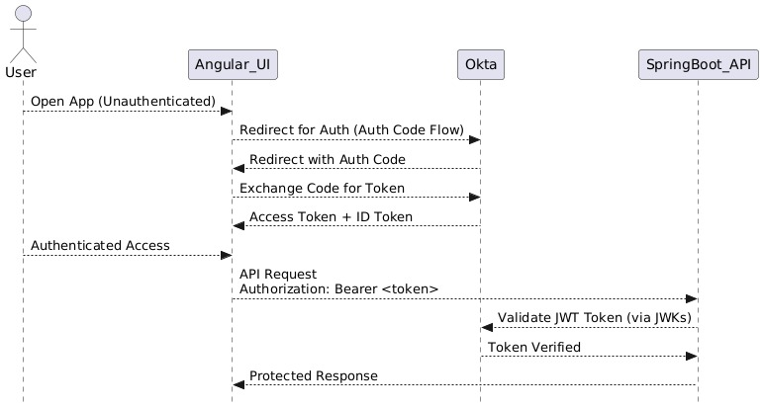

3. Identity Provider Details
- Provider: Okta
- Grant Type: Authorization Code with PKCE
- Scopes: openid, profile, email
- Issuer: https://citizensbankdev.oktapreview.com
- JWKS URI: https://citizensbankdev.oktapreview.com/oauth2/v1/keys
- User Info Endpoint: https://citizensbankdev.oktapreview.com/oauth2/v1/userinfo
- Registration endpoint: https://citizensbankdev.oktapreview.com/oauth2/v1/clients
- Redirect URI (Angular): https://mdem-dev.p2.ocp.citizensbank.com/dashboard
- Client ID: 0oa2j814v0b8wXauR0h8

Reference of details: https://citizensbankdev.oktapreview.com/well-known/openid-configuration

4. Frontend: Angular >=18.x
Package.json Setup (partial):
"@okta/okta-angular": "^6.3.0",
"@okta/okta-auth-js": "^6.8.0"

Environment Config:
oktaConfig: {
issuer: 'https://citizensbankdev.okta.com/oauth2/default',
clientId: '0oa2j814v0b8wXauR0h8',
redirectUri: window.location.origin + '/login/callback',
scopes: ['openid', 'profile', 'email'],
pkce: true
}

Implementation Auth Flow of Angular:
1. Angular checks for Okta session
2. If unauthenticated, redirects to Okta login page
3. User logs in, Okta redirects back to /login/callback
4. Angular exchanges code for access + ID tokens
5. Token stored in memory/session storage
6. API requests include Authorization: Bearer <access_token> header

5. Backend: Spring Boot (pass-mdem-build)
pom.xml Dependencies:
<dependency>
<groupId>org.springframework.boot</groupId>
<artifactId>spring-boot-starter-oauth2-resource-server</artifactId>
</dependency>

application.yml:
spring:
security:
oauth2:
resourceserver:
jwt:
issuer-uri: https://citizensbankdev.oktapreview.com/oauth2/default

Security Configuration:
@EnableWebSecurity
public class SecurityConfig {

@Bean
public SecurityFilterChain securityFilterChain(HttpSecurity http) throws Exception {
http
.authorizeHttpRequests(auth -> auth
.requestMatchers("/public/**").permitAll()
.anyRequest().authenticated()
)
.oauth2ResourceServer(oauth2 -> oauth2
.jwt()
);
return http.build();
}
}

Authorization:
- Use @PreAuthorize("hasAuthority('SCOPE_read')") where needed
- Group claims can be mapped from Okta if configured

6. Token Summary
Token Type | Purpose | Sent to Backend?
ID Token | UI Display/Profile | No
Access Token | API Authentication | Yes
Refresh Token | Optional (not used) | No

7. Sequence Flow
1. User opens Angular app
2. Redirected to Okta login if not logged in
3. Okta authenticates and redirects back with code
4. Angular exchanges code for tokens
5. Angular sends API request with access token
6. Spring Boot validates token with Okta JWKS URI
7. Returns secure response

8. Redirect URI Behavior
Only one redirect URI is used for both sign-in and sign-out: https://mdem-dev.p2.ocp.citizensbank.com/dashboard

9. Final Architecture Summary
User
↓
Angular (okta-angular) — [redirectUri, scopes]
↓ [Auth Code + PKCE]
Okta Auth Server — [Token Endpoint, User Info]
↓ [Access Token]
Angular → Spring Boot — [Bearer Token]
Spring Boot — [Validate via /.well-known/openid-configuration]
↓
Respond with Secure API Data

