Qwen3.5:9B Thinking-Control Behavior Under LM Studio
A 28-case probe of prompt handles and OpenAI-compatible API parameters

Abstract
This short report summarizes a controlled diagnostic probe of Qwen3.5:9B served through LM Studio at an OpenAI-compatible endpoint. The experiment tested whether system-prompt handles and request-body parameters could programmatically suppress or enable model reasoning. Across 28 runs using a fixed Sydney one-day itinerary prompt, every accepted response exposed reasoning_content and no case emitted visible <think> markers. Most cases consumed almost the full 300-token output cap in reasoning and produced no visible answer. Only four cases generated substantive visible response text, suggesting that the tested controls were accepted by the server but did not reliably disable reasoning.

Objective
The objective was to determine whether Qwen3.5:9B thinking behavior can be controlled programmatically in the current LM Studio setup. The target behavior for no-thinking mode was low or absent reasoning_content, no visible <think> markers, and adequate visible response tokens for a tourist itinerary answer.

Methodology
The probe used a standalone Python utility against http://127.0.0.1:1234/v1 with model qwen/qwen3.5-9b. The user prompt was fixed as: "what is the best way to explore Sydney in one day?" The system prompt framed the model as a tourist guide and trip planning expert for famous world cities. Four system-prompt handle variants were crossed with seven API-body variants, producing 28 total cases. Streaming output was recorded to separate reasoning_content timing from visible response timing. The run used max_tokens=300, so reasoning and visible response tokens competed for the same output budget.
System handles: baseline, /no_think, /no think, and /think. API variants: baseline body, enable_thinking false/true, thinking_budget 0/128, and chat_template_kwargs.enable_thinking false/true. For each case, the utility recorded total latency, reasoning tokens, visible response tokens, reasoning duration, visible response duration, whether visible <think> markers appeared, and whether reasoning_content was detected.
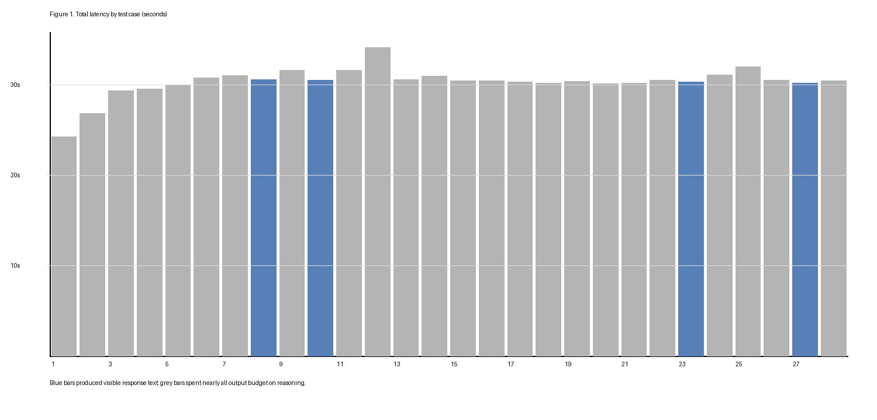
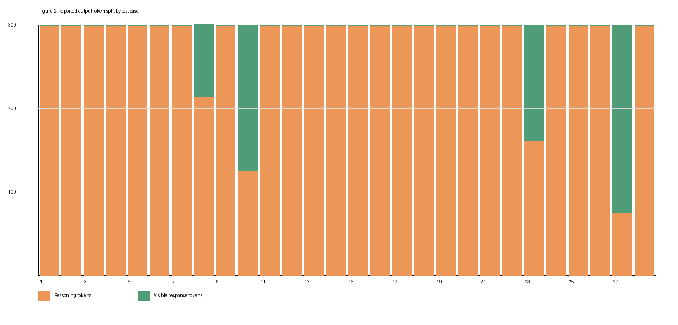

Results
Table 1 reports all 28 cases. "Answered" means the visible response token count was greater than one and a response preview was produced. All cases were accepted by the endpoint and all exposed reasoning_content.
Case | System handle | API body | Total s | Reason tokens | Reason s | Resp tokens | Resp s | Answered
1 | baseline system prompt | baseline API body | 24.25 | 299 | 24.25 | 1 | n/a | no
2 | baseline system prompt | enable_thinking=false | 26.79 | 299 | 26.79 | 1 | n/a | no
3 | baseline system prompt | enable_thinking=true | 29.30 | 299 | 29.30 | 1 | n/a | no
4 | baseline system prompt | thinking_budget=0 | 29.53 | 299 | 29.53 | 1 | n/a | no
5 | baseline system prompt | thinking_budget=128 | 29.96 | 299 | 29.96 | 1 | n/a | no
6 | baseline system prompt | chat_template_kwargs.enable_thinking=false | 30.73 | 299 | 30.73 | 1 | n/a | no
7 | baseline system prompt | chat_template_kwargs.enable_thinking=true | 31.03 | 299 | 31.03 | 1 | n/a | no
8 | /no_think in system prompt | baseline API body | 30.57 | 214 | 22.19 | 86 | 7.87 | yes
9 | /no_think in system prompt | enable_thinking=false | 31.56 | 299 | 31.56 | 1 | n/a | no
10 | /no_think in system prompt | enable_thinking=true | 30.51 | 125 | 13.28 | 175 | 16.49 | yes
11 | /no_think in system prompt | thinking_budget=0 | 31.56 | 299 | 31.56 | 1 | n/a | no
12 | /no_think in system prompt | thinking_budget=128 | 34.11 | 299 | 34.11 | 1 | n/a | no
13 | /no_think in system prompt | chat_template_kwargs.enable_thinking=false | 30.54 | 299 | 30.54 | 1 | n/a | no
14 | /no_think in system prompt | chat_template_kwargs.enable_thinking=true | 30.96 | 299 | 30.96 | 1 | n/a | no
15 | /no think in system prompt | baseline API body | 30.40 | 299 | 30.40 | 1 | n/a | no
16 | /no think in system prompt | enable_thinking=false | 30.45 | 299 | 30.45 | 1 | n/a | no
17 | /no think in system prompt | enable_thinking=true | 30.31 | 299 | 30.31 | 1 | n/a | no
18 | /no think in system prompt | thinking_budget=0 | 30.16 | 299 | 30.16 | 1 | n/a | no
19 | /no think in system prompt | thinking_budget=128 | 30.35 | 299 | 30.35 | 1 | n/a | no
20 | /no think in system prompt | chat_template_kwargs.enable_thinking=false | 30.10 | 299 | 30.10 | 1 | n/a | no
21 | /no think in system prompt | chat_template_kwargs.enable_thinking=true | 30.19 | 299 | 30.19 | 1 | n/a | no
22 | /think in system prompt | baseline API body | 30.46 | 299 | 30.46 | 1 | n/a | no
23 | /think in system prompt | enable_thinking=false | 30.31 | 161 | 16.66 | 139 | 13.15 | yes
24 | /think in system prompt | enable_thinking=true | 31.08 | 299 | 31.08 | 1 | n/a | no
25 | /think in system prompt | thinking_budget=0 | 31.96 | 299 | 31.96 | 1 | n/a | no
26 | /think in system prompt | thinking_budget=128 | 30.51 | 299 | 30.51 | 1 | n/a | no
27 | /think in system prompt | chat_template_kwargs.enable_thinking=false | 30.16 | 75 | 8.15 | 225 | 21.60 | yes
28 | /think in system prompt | chat_template_kwargs.enable_thinking=true | 30.44 | 299 | 30.44 | 1 | n/a | no

Discussion
The dominant result is that reasoning_content appeared in every case, including cases intended to disable thinking through enable_thinking=false, thinking_budget=0, and chat_template_kwargs.enable_thinking=false. The absence of visible <think> markers is therefore not evidence that thinking was disabled; LM Studio exposed reasoning through a separate response field. The 300-token cap also shaped the results: in 24 of 28 cases, reasoning consumed 299 tokens and the visible answer received only one reported token. This indicates that max_tokens constrained total completion output, including reasoning, rather than reserving space for the final answer.
The only cases that produced meaningful visible answers were cases 8, 10, 23, and 27. These showed lower reasoning-token use and measurable visible response time, but the pattern was inconsistent. For example, /no_think with enable_thinking=true produced more visible output than /no_think with enable_thinking=false, and /think with chat_template_kwargs.enable_thinking=false produced the best visible-response token share. This inconsistency argues against interpreting any single tested control as a reliable switch.

Conclusion
Under this LM Studio OpenAI-compatible configuration, Qwen3.5:9B did not demonstrate reliable programmatic thinking/no-thinking control using the tested request-body fields or system-prompt handles. The endpoint accepted the parameters, but accepted does not mean honored. The practical behavior observed was persistent hidden reasoning, no visible <think> tags, and frequent exhaustion of the output budget before a visible answer could be produced. For this runtime, downstream applications should treat reasoning_content tokens and visible response availability as the primary signals. A follow-up experiment should rerun a smaller subset with a larger output cap, such as 900 tokens, to distinguish true control effects from budget starvation.

Limitations
The report uses one prompt, one local runtime, and one max_tokens setting. Results may differ with another LM Studio build, chat template, model quantization, or serving backend. Because the 300-token cap caused many cases to saturate reasoning output, the findings are strongest for control reliability and budget behavior, not for final itinerary quality.

