Trilateration is a method of calculating the position of an object by leveraging the distance between the known positions of three anchor points and the object itself. The principle behind trilateration positioning is to trace out a circle using a line represented by the distance between the anchor point and the object, and a center point represented by the anchor point.

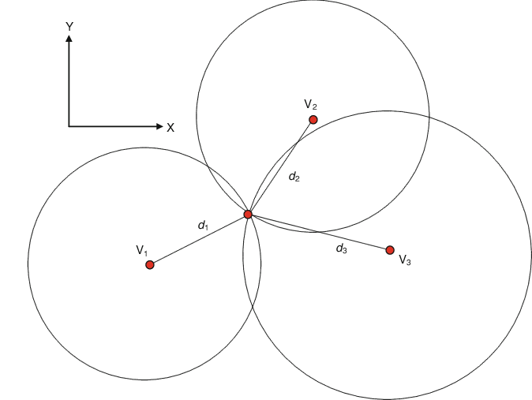

The circumference of the circle represents the pseudo-range of the equivalent signal strength of a certain anchor point. The object is located at any point on the circumference of the circle. In general, these two distance circles are intercrossed at two points, producing two solutions to the location estimate of the object. To resolve the ambiguity of the two solutions, a third distance circle, resulting from the distance measurement at the third anchor point, is required. This results in the following equations

$$\left\{\begin{aligned}\sqrt{{\left(x-x_{1}\right)}^{2}+{\left(y-y_{1}\right)}^{2}}=d_{1} \\ \sqrt{{\left(x-x_{2}\right)}^{2}+{\left(y-y_{2}\right)}^{2}}=d_{2} \\ \sqrt{{\left(x-x_{3}\right)}^{2}+{\left(y-y_{3}\right)}^{2}}=d_{3}\end{aligned}\right.$$

To get the current location of the object, we solve the equations above to obtain

$${\left[\begin{matrix}x \\ y\end{matrix}\right]=\left[\begin{matrix}{2(x}_{1}-x_{2}) & {2(y}_{1}-y_{2}) \\ {2(x}_{1}-x_{3}) & {2(y}_{1}-y_{3})\end{matrix}\right]}^{-1}*\left[\begin{matrix}x_{1}^{2}-x_{2}^{2}+y_{1}^{2}-y_{2}^{2}+d_{2}^{2}-d_{1}^{2} \\ x_{1}^{2}-x_{3}^{2}+y_{1}^{2}-y_{3}^{2}+d_{3}^{2}-d_{1}^{2}\end{matrix}\right]$$

However, we can run into the two cases depicted below where there is no solution.

Generally, the idea then is to consider the equations in the matrix form

$$HX=B$$

where

$$H=\left[\begin{matrix}x_{2}-x_{1} & y_{2}-y_{1} \\ x_{3}-x_{1} & y_{3}-y_{1}\end{matrix}\right]$$

$$B=\frac{1}{2}\left[\begin{matrix}\left(d_{1}^{2}-d_{2}^{2}\right)+\left(x_{2}^{2}+y_{2}^{2}\right)-(x_{1}^{2}+y_{1}^{2}) \\ \left(d_{1}^{2}-d_{3}^{2}\right)+\left(x_{3}^{2}+y_{3}^{2}\right)-(x_{1}^{2}+y_{1}^{2})\end{matrix}\right]$$

The solution can then be obtained by the least square method

$$X={\left(H^{T}H\right)}^{-1}H^{T}B$$

One key thing to note is that in such cases, the position of more circles and the number of their intersections are not completely considered.

Our proposed approach is to have multiple tags in the system as well as more than three anchor points. This methodology will not only limit such cases by considering the position of more circles and their intersections, but it will also increase the accuracy due to the newly introduced redundancy in the system.

Related Works:

An Algebraic Solution to the Multilateration Problem

**Abstract**:

In this paper, an approach for solving nonlinear problems on the example of multilateration is presented in both cases with and without over determination. Thereby neither approximation, nor iterative solutions are used. In the proposed method, the nonlinear elements of the equations system are treated as additional unknowns, which represent simultaneously a constraint. Thus, a new equations system is created, which is solved by mean of linear algebra methods with low computational complexity. The algorithm was implemented and tested in conjunction with a developed UWB indoor positioning system.

An improved geometric algorithm for indoor localization

**Abstract**:

Indoor localization system using receive signal strength indicator from wireless access point has attracted lots of attention recently. Geometric method is one of the most widely used spatial graph algorithms to locate object in an indoor environment, but it does not achieve good results when it is applied to a limited amount of valid data, especially when using the trilateration method. On the other hand, localization based on fingerprint can achieve high accuracy but need to pay heavy manual labor for fingerprint database establishment. In this article, we propose a bilateral greed iteration localization method based on greedy algorithm in order to use all of the effective anchor points.

Trilateration in Indoor Positioning with an Uncertain Reference Point

**Abstract**:

Triangulation is one of the most frequently used techniques which can be categorized into two techniques: lateration and angulation. Lateration technique uses distance information in the estimation of location while the angulation technique uses angles besides distances. The lateration technique is called as trilateration when it is applied in two-dimensional space. In this paper, trilateration technique is analyzed where one of the reference points resides of an uncertain location. The location of an object is estimated as an area by using two certain reference points.

Indoor localization approach based on received signal strength (RSS) and trilateration technique

**Abstract**:

Four Wi-Fi APs have been placed on grid in obstacle-free environment to send the signal to the receiver for determining the position by using trilateration technique. The receiver has been placed on the predefined locations in order to investigate the accuracy of the proposed method.

Indoor Localization Method Based on Wi-Fi Trilateration Technique

**Abstract**:

This paper describes a Wi-Fi trilateration method for indoor localization using Android-based mobile device. Approaches based on signal propagation model and received signal strength measurement collection are considered. The indoor signal propagation problem is resolved by received signal strength measurement collection that improves localization accuracy. Indoor positioning technique opens possibilities for development various intelligent systems that provide the user location-based information inside buildings. These systems include positioning functionality based on such technologies as Wi-Fi, Bluetooth, and GSM.