TITLE AND DATE
Document name: Project#2 Task Management: Cyclic Executive Lab Report
Document reference: kiddKid.cmpe311.fall25.project#2
Date of publication: November 6, 2025
GITHUB REPO LINK: LINK
VIDEO LINK (GOOGLE DRIVE VIDEO): VIDEO LINK

LEAD ENGINEER: Shariq Moghees, UMBC

STAKEHOLDERS:
Prof Kidd, Instructor, University of Maryland Baltimore County, Baltimore, Maryland, USA
MD Safwan Zaman, TA, University of Maryland Baltimore County, Baltimore, Maryland, USA

HIGH-LEVEL DESCRIPTION: This document is the project document for Project#2 of the CMPE311 class. It contains customer, technical, and testing requirements as well as the design and results of the validation testing.

DESCRIPTION: This design implements a system on the Arduino Uno R3 that reproduces the behavior of Project 1 using a Cyclic Executive task management approach. Each activity, including blinking the two LEDs and processing user input from the Serial Monitor, is defined as a separate task function. These tasks are executed sequentially in a round-robin cycle through a function pointer array that acts as the Cyclic Executive scheduler. The user can independently specify an LED number and its blink interval, and both LEDs continue blinking asynchronously while input is being processed. This document includes the customer and high-level requirements, the updated educational requirements, the design and testing procedures, and the results of system validation. The Arduino source code and supporting test video are provided in the appendices.

RESULT SUMMARY: The project was a success, the embedded system design meeting all testing and high-level requirements.

REFERENCES AND GLOSSARY
<to eliminate any ambiguity, include any specific terms or entities, any unique words, any clarification, and any abbreviations>

REFERENCES:
- ProjectTaskMngmt_draft – The definition of the project this document addresses
- CMPE310 Project #5 – A similar project assigned in CMPE310 in Spring 2025
- Arduino UNO R3 Product Reference Manual SKU A000066, 12/03/2024
- Async Programming in Arduino: Unleashing the Power of Non-Blocking Code, Mahdi Valizadeh, medium.com, 4/8/2024

DEFINITIONS:
“The User” – The person operating (not programming) the embedded system
“The System” – The embedded system being operated by The User
“The Customer” – The person(s) paying for the embedded system being designed and built
“The Developer” – The person(s) designing and building the System
“The Evaluator” – The person(s) that determine whether or not The System satisfies The Customer-requirements.
“The Customer-requirements” – The requirements defined by The Customer as satisfying The Contract.
“The Requirements” – The System’s high-level technical requirements derived from The Customer-requirements.
“The Educational-constraints” – Requirements imposed by the instructor unrelated to the embedded system that allow The System to be evaluated.
“The Company” – The organization The Customer has contracted with to build The System.
“The Contract” – The business document that legally binds The Company to provide some service or product to The Customer.
“serial-monitor” – The serial port used by the Arduino IDE to communicate with The User.
“The Reference-platform” – The configuration of The System used by The Developer to test and validate The System. For this class, The System is the Arduino compatible ELEGOO Uno R3 development board.

ACRONYMS AND ABBREVIATIONS:
Arduino – an Italian open-source hardware and software company; also refers to a development board created by the company
arduino.h – header for a library of convenience functions specific to the Arduino development platform
AVR – A family of microcontrollers, originally developed by Atmel, and currently owned by Microchip Technology
ELEGOO – A Chinese company that develops and markets 3D printers and accessories
IDE – Integrated Development Environment
gcc – front end for the GNU Compiler Collection
Github – A widely used distributed SVC (Software Version Control) system
LED – Light Emitting Diode

REQUIREMENTS
<customer, high-level and testing requirements>

CONVENTIONS:
Must, shall or will – your design must satisfy the requirement
May – your design may satisfy the requirement but doesn’t have to
Informative – the intent of the following description is to make the requirement more understandable
All customer requirements are started with “C.#”.
All high-level requirements are started with “HL.#”.
All testing/validation requirements ar5e started with “T.#”

CUSTOMER REQUIREMENTS: <list the customer requirements which I gave you>

C1. The User must be able to set the blink rate of two different LEDs.
C2. The User must be able to update the blink rate of each of the LEDs independently.
C3. The LED must blink at the set rate until The User tells the LED to blink at a different
rate.
C4. The System must run upon an Arduino Uno R3 compatible development board.
C5. The blink rate of an LED must be expressed in terms of milliseconds

HIGH-LEVEL TECHNICAL REQUIREMENTS: <list the derived high-level technical requirements>

HL.1. The system must execute multiple functional tasks, including LED control and serial input handling, through a Cyclic Executive structure. (From requirement C1)
HL.1.1. The blink rate of each LED must be able to be set independent of the other LED. (From requirement C2)
HL.1.2. The Cyclic Executive must schedule all task functions in a non-blocking, round-robin sequence that maintains asynchronous LED operation. (From requirements C2 and C3)
HL.2. The user must be able to set or modify the blink interval for each LED in milliseconds through the Serial Monitor interface. (From requirement C5)
HL.3. The System must run upon an Arduino Uno R3 compatible development board. (From requirement C4)
HL.4. the system must demonstrate deterministic task execution order within each major cycle of the Cyclic Executive. (From ER1)

DESIGN:
The system design uses two LEDs connected to digital pins 2 and 3 on the Arduino Uno R3, each with a current-limiting resistor in series to ground. The Arduino sketch implements task scheduling through a Cyclic Executive that dispatches multiple functions in a round-robin sequence. Each LED’s blinking logic and the Serial Monitor handler are defined as separate task functions, each maintaining its own state variable, last-toggled timestamp, and interval using millis() for non-blocking timing.

When the program starts, both LEDs blink at their default intervals while the Cyclic Executive continuously cycles through all task functions. The Serial Monitor task checks for user input and updates the blink interval of the specified LED without affecting the other. This ensures that both LEDs operate asynchronously under structured task management.

The design fulfills all the following high-level requirements:
- Independent LED control (HL.1.1).
- Non-blocking, asynchronous execution (HL.1.2).
- Serial Monitor-based interface (HL.2).
- Runs on Arduino Uno R3 platform (HL.3).
- Task Management via Cyclic Executive (ER.1)

DESIGN PRE-REQUISITES: <include any equipment or other things you are required to build your design upon such as the configuration of the development platform>
- ELEGOO Arduino Uno R3 clone
- Arduino IDE 2.3.3 or better
- Two external LEDs
- Two 220 Ohm or 330 Ohm resistors
- One breadboard
- Jumper wires for creating connections from Arduino board pins 2 & 3, to the resistor. and finally LED.

DEVELOPMENT PLATFORM: <include any equipment, SW, etc necessary to reproduce your design environment>
- See DESIGN PRE-REQUISITES above

ANY ADDITIONAL DESIGN CONSIDERATIONS: <include anything else needed for someone to understand and reproduce your design>
- None

See Appendix A for the logical flow of the project program.
See Appendix B for the code executing on the Arduino Uno R3.

TESTING AND VALIDATION

The testbed setup is shown in Figure 1, with two LEDs connected to pins 2 and 3. The system was tested by entering commands into the Serial Monitor. Each test involved setting a new interval for one LED while observing that the other LED’s blink rate remained unaffected.

The required dialog was reproduced successfully (Table 1), and repeated trials were used to verify stability (Table 2). Validation confirmed that inputs in milliseconds were accepted, intervals updated correctly, and LEDs blinked asynchronously.

DESCRIPTION: The tests that have to be performed and validated are shown in Table xxx. These tests were performed on the testbed shown Figure 1. Table 1 shows a dialog that must be successfully performed by the embedded system. The results of testing are shown in Table 3. When necessary, a video of the test is provided along with this report.

Figure 1. Testbed Setup. LEDs connected to digital pins 2 & 3.
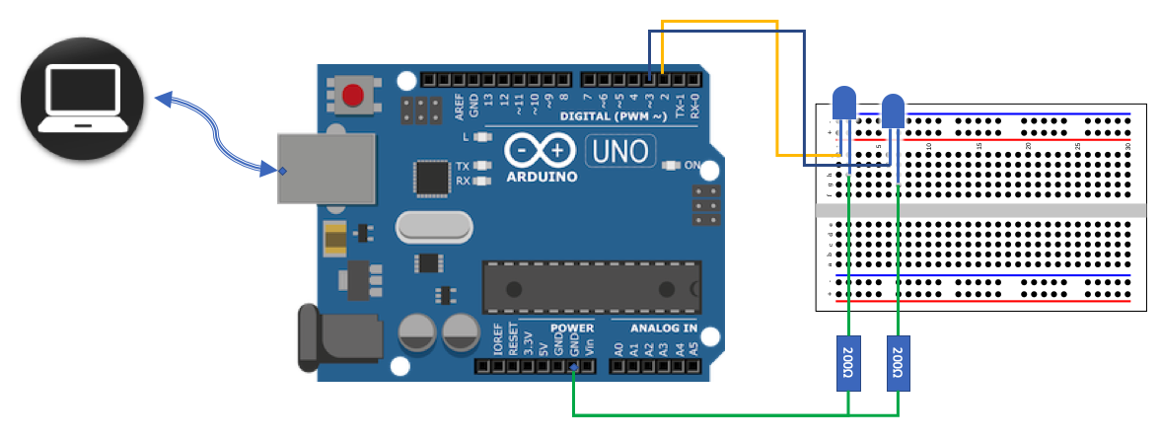

TESTING PLATFORM: <include any equipment, SW, etc necessary to reproduce your design environment>
- ELEGOO Arduino Uno R3 clone
- Arduino IDE 2.3.3 or better
- Power: Testing platform powered through USB cable, LEDs connected directly through Digital Outputs
- Two external LEDs
- Two 330 Ohm resistors
- Jumper wires for connections

Table 1. Required Test Dialog (blue are the user inputs).
Serial port I/O | Notes
"Select LED and set interval (Format: <LED#> <interval_ms>): "2 300 | LED2 starts blinking at an interval of 300ms on and 300ms off. LED1 is unaffected.
"Select LED and set interval (Format: <LED#> <interval_ms>): "1 1600 | LED1 starts blinking at an interval of 1600ms on and 1600ms off. LED2 is unaffected.
"Select LED and set interval (Format: <LED#> <interval_ms>): " | Waiting for next LED# interval pair

TESTING AND VALIDATION REQUIREMENTS: <include all tests using appropriate language, e.g. must, so that there is no ambiguity>

Table 2. Testing and Validation Requirements
T.0 All testing and validation must be done on the testbed illustrated in Figure 1.

T.1 The dialog above (or similar) must work as shown
T.1A The blink rate of an LED must be able to be set without interfering with the blinking of the other LED
T.1.1 Setting of the blink rate (and LED#) must be through the IDE serial monitor
T.2 The blink rate of the LED being set must not change until the input is complete
T.3 The user must specify the blink rate in milliseconds per blink
T.4 The blink rate specified by the user must be correctly reflected on the testbed LEDs.
T.4.1 The blink rate specified by the user must be reflected on the LED specified by the user
T.5. The setting of an LED’s blink rate must be able to be repeated at least 5 times
T.5.1. Successively for the same LED
T.5.2. Alternately between the different LEDs

TESTING RESULTS: <include any relevant tests, data, videos, etc that are used to confirm the tests>
All tests in Table 2 were executed on the ELEGOO Uno R3 clone. Observations confirmed that the blink rates matched user input, changes were isolated to the correct LED, and no blocking occurred when handling Serial input. Videos of select tests were recorded for documentation. Results are summarized in Table 3, all marked as satisfied.

Table 3. Results of tests
Test performed | Results
T.1.1 | Satisfied. See video of test.
T.1 | Satisfied
T.2 | Satisfied. See video of test.
T.3 | Satisfied
T.4 | Satisfied
T.4.1 | Satisfied. See video of test.
T.5.1 | Satisfied. See video of test.
T.5.2 | Satisfied. See video of test.

Appendix A. Logic Flow Chart

Figure 2. Logic flow for program.
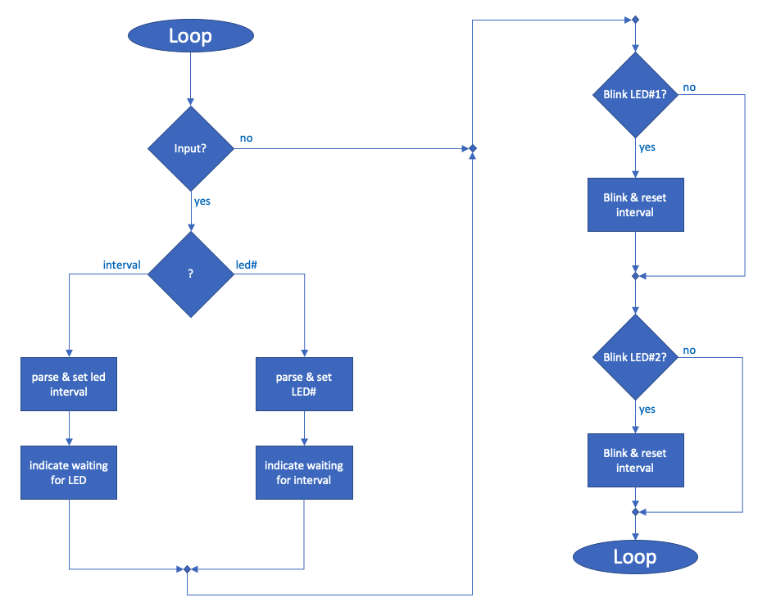

APPENDIX B. DESIGN CODE

//********************************************************************
//Author: Shariq Moghees
//Date: 11/5/2025
//Course: CMPE 311, Prof. Kidd, Fall 2025
//Filename: 311_project_2
//********************************************************************

#define TRUE 1
#define FALSE 0
#define PIN_LED1 2 // LED 1 connected to digital pin 2
#define PIN_LED2 3 // LED 2 connected to digital pin 3

unsigned long delayStart1, delayStart2;
int ledOn1, ledOn2;
unsigned long intervalLed[3] = {0, 1000, 500}; // index 1 is LED1 and index 2 is LED2
int waiting4led = FALSE, waiting4interval = FALSE;
int interval;
int setLedNum = 1;

//tasks declaration
void taskLED1(void);
void taskLED2(void);
void taskSerialHandler(void);

//tasklist for the CE
void (*tasks[])(void) = {taskLED1, taskLED2, taskSerialHandler};
const int NUM_TASKS = sizeof(tasks) / sizeof(tasks[0]);

void setup() {
// put your setup code here, to run once:
Serial.begin(9600);
pinMode(PIN_LED1, OUTPUT);
pinMode(PIN_LED2, OUTPUT);

ledOn1 = FALSE;
ledOn2 = FALSE;
digitalWrite(PIN_LED1, LOW);
digitalWrite(PIN_LED2, LOW);

delayStart1 = millis();
delayStart2 = millis();

Serial.println("Cyclic Executive Good to go");
Serial.print("Select LED and set interval (Format: <LED#> <interval_ms>): ");
waiting4led = TRUE;
waiting4interval = FALSE;
}

void loop() {
//the loop will never actually call any LED logic, it just cycles through the array
//of pointers that point to different tasks that contain the subroutines
for (int i = 0; i < NUM_TASKS; i++) { // round robin
(*tasks[i])(); // dispatch the tasks once per major cycle
}
}

//TASK SUBROUTINES (this is where the actual logic is for all the different tasks in the cyclic executive)

//Blink LED #1
void taskLED1(void) {
if ((millis() - delayStart1) > intervalLed[1]) { // still using millis so we can keep LEDs blinking asynchronously
ledOn1 = !ledOn1;
digitalWrite(PIN_LED1, ledOn1);
delayStart1 = millis();
}
}

//Blink LED #2 (same type of logic as LED #1)
void taskLED2(void) {
if ((millis() - delayStart2) > intervalLed[2]) {
ledOn2 = !ledOn2;
digitalWrite(PIN_LED2, ledOn2);
delayStart2 = millis();
}
}

//Serial Input Handler
void taskSerialHandler(void) {
static String inputString = ""; // buffer to collect serial input

while (Serial.available()) {
char inChar = (char)Serial.read();
// End of line, so process full input
if (inChar == '\n') { // fixed: only trigger on newline to prevent duplicate reads
inputString.trim();
if (inputString.length() > 0) {
// Split with a space to take in LED number and interval at the same time
int spaceIndex = inputString.indexOf(' ');
if (spaceIndex > 0) {
int ledNum = inputString.substring(0, spaceIndex).toInt();
int interval = inputString.substring(spaceIndex + 1).toInt();

if (ledNum >= 1 && ledNum <= 2 && interval > 0) {
intervalLed[ledNum] = interval;
Serial.print("LED");
Serial.print(ledNum);
Serial.print(" interval set to ");
Serial.print(interval);
Serial.println(" ms"); //newline
} else {
Serial.println("Invalid entry. Use: <LED#> <interval_ms>");
}
} else {
Serial.println("Format: <LED#> <interval_ms>");
}
}
Serial.print("\nSelect LED (enter a valid number): "); // added newline for clean formatting
inputString = "";
} else {
inputString += inChar; // keep collecting characters
}
}
}

END OF DOCUMENT

