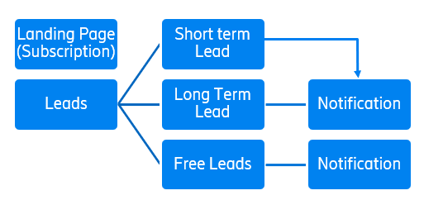

**Subscriber Page –**

User shall able to login to the application with the below information

* Username* – 100 alpha numeric character
* First Name* – 50 character
* Middle Name - 50 character
* Last Name* - 50 character
* Email ID* – email format checks with 100 character
* Address 1* –
* Address 2 -
* City* - 50 character
* State* - 50 character
* Pin* - 6 alpha numeric digit
* Pay – Button (integration with Cash app / Paypal need to be supported)

**Stock Leads Page –**

* Short Term Leads

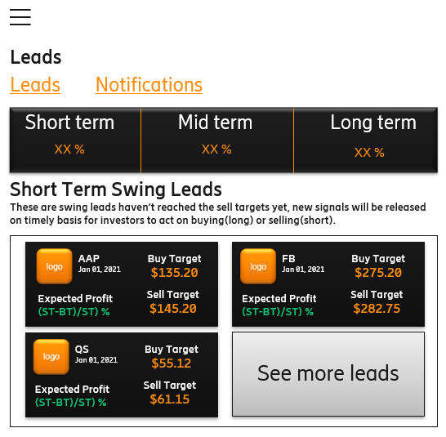

Details – Vendor shall provide a backend to enter the details mentioned as part of lead in the above figure

Backend/Admin page –

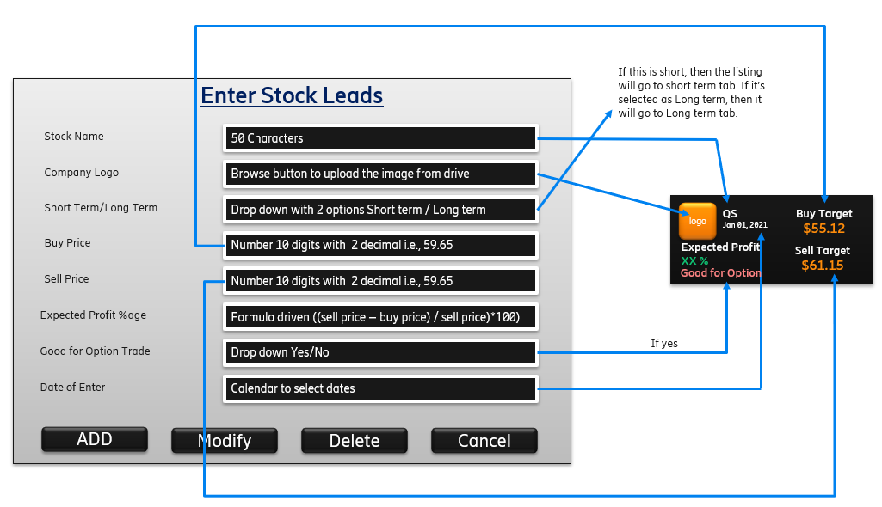

Few points to be noted –

* + In case short term is being selected then the listing will be shown in application front end in short-term tab.
  + In case long term is being selected then the listing will be shown in application front end in the long-term tab.
  + Add button will push the information to mobile application front-end.
  + Modify button will modify the details such as buy/sell price etc in the short term and long-term tab.
  + Delete button shall delete the record from frontend.
  + Cancel button can cancel the entry in case admin change mind while entering the record.
* Long Term Leads

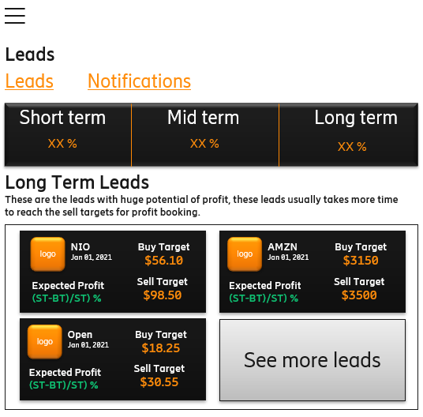

All the functionality in this tab is same. The only difference is that this tab will list the record if Admin set up the field as long term while adding the lead.

* Free Guest Leads

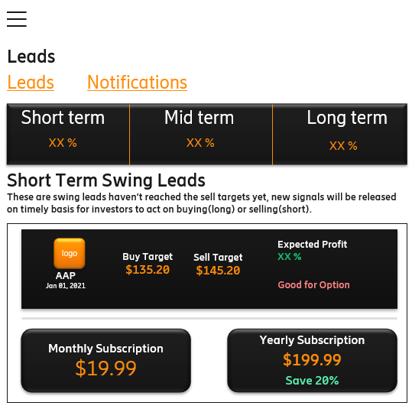

When user click to see on the lead, it shall redirect user to monthly and yearly subscription menu and when user click on these buttons then app shall redirect it to subscription page for payments.

**Notification tab**: for short- and long-term tab, single notification page will be displayed.

Look and feel in the frontend would be as mentioned below:

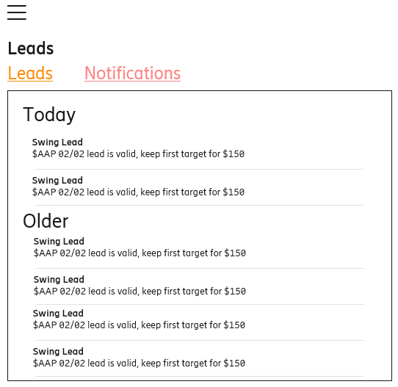

Backend for Notifications

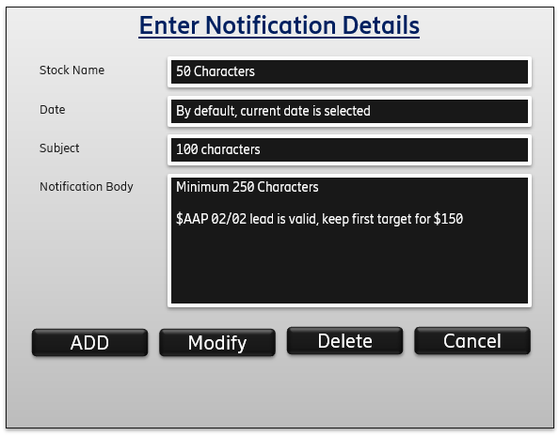

Functionality – As soon as Admin enter the notification, it shall broadcast to all the paid users.

Admin shall have provision to send 1 to 1 message to users for payment reminders.