**How to Execute program**

Save all the files in the same folder and copy the exact path of dataset folder  
and replace it here

def open_file(index):

    # set the exact path of the folder dataset

    file_name = f"C:/Users/HP/Desktop/IR assignment 1/Dataset/{index+1}.txt"

    print(file_name)

    os.startfile(file_name)

file_name = f"your path/Dataset/{index+1}.txt"

then run the main file with python main.py

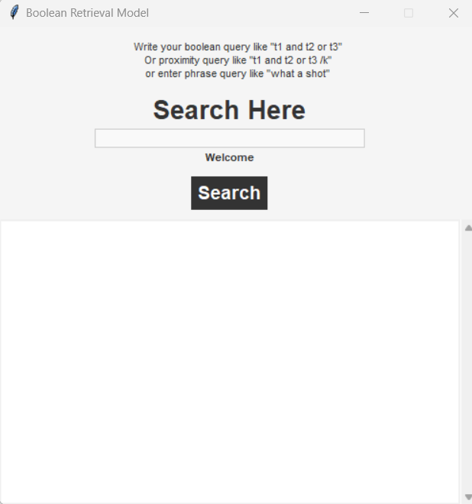

Now you can search any query Boolean phrase or proximity

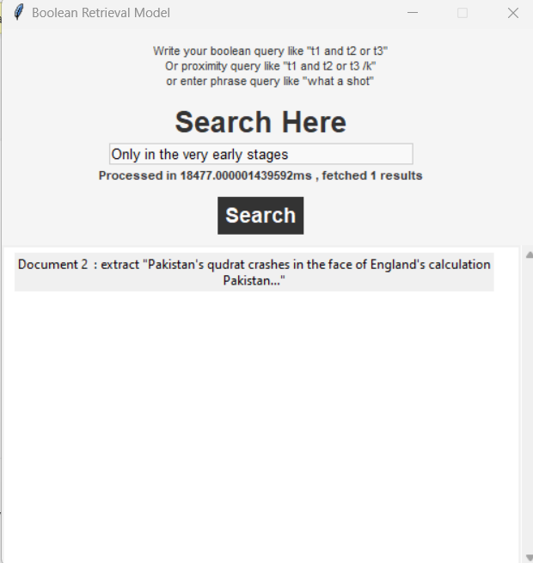

Here the query “Only in the very early stages”  
  
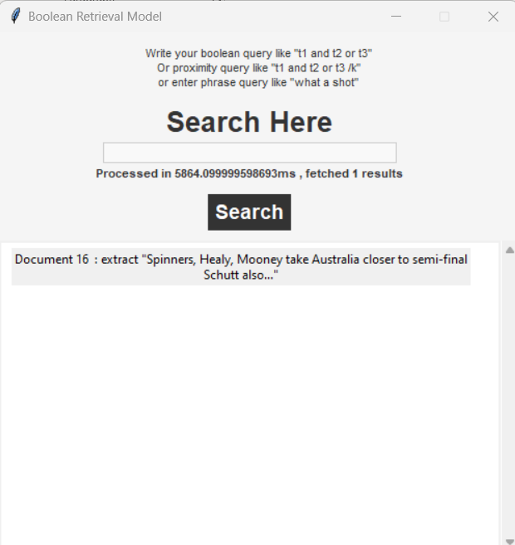  
  
and you can open results by just clicking it