ASSIGNMENT-III

(RELIABLE DATA TRANSFER)

-The **port number** to use for client-side listening is first mentioned.

-We will now specify the local **IP address** and **port number** on the client side and establish a connection to the server.

We will enter the **information** on the server side before saving it.

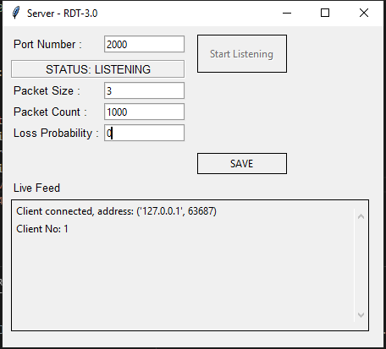

Packet size will be the same on both sides as soon as we specify the file to be transferred, add the probability of corruption to zero, and then click the transfer button for quick transfer.

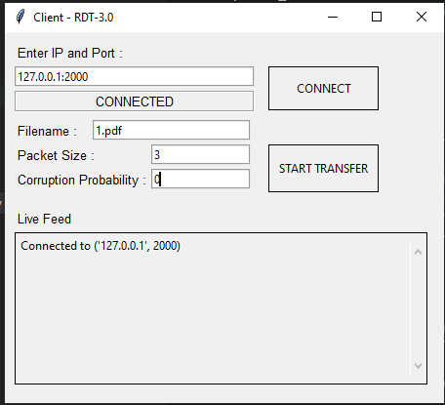

As we see the live feed, the packet is successfully transmitted to the recipient side while mentioning its Ack and Nak.

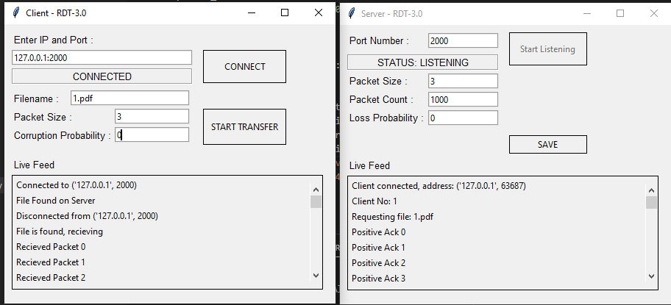

Here is the file that was successfully sent to the receiver.

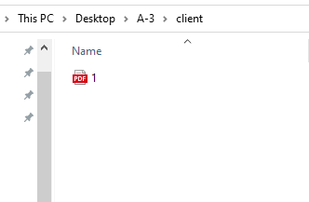

Server side code:

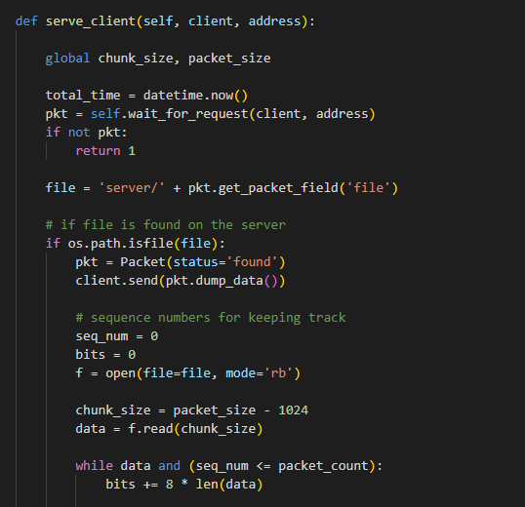

Client side code:

