**How to Execute program**

Save all the files in the same folder and copy the exact path of dataset folder  
and replace it here

def open_file(index):

    # set the exact path of the folder dataset

    file_name = f"C:/Users/HP/Desktop/IR assignment 1/Dataset/{index+1}.txt"

    print(file_name)

    os.startfile(file_name)

file_name = f"your path/Dataset/{index+1}.txt"

then run the main file with python main.py

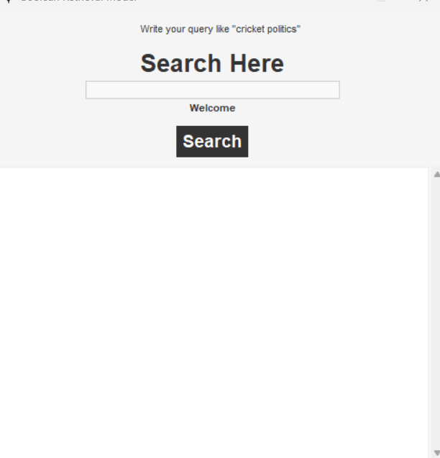

Post your query e.g “cricket Pakistan”

