Information Technology University

Manual
for
CS220: Artificial Intelligence
Course Instructor : Husnain Haider
Semester Fall 2023 : 3
Teaching Assistant : Muhammad Ahmad
Teaching Assistant : Moeed Ahmad
Teaching Assistant : Muzammil Ali
Teaching Assistant : Abdul Rehman Ameen
Teaching Assistant : Muhammad Anas

Student Name :
Student Roll No. :

Department of Computer Science ITU, Lahore, Pakistan
Lab-08

Consider the 8-puzzle problem. The 8-puzzle problem is a puzzle played on a 3-by-3 grid with 8 square blocks labeled 1 through 8 and a blank square. Your goal is to rearrange the blocks so that they are in specified order. You are permitted to slide blocks horizontally or vertically into the blank square.
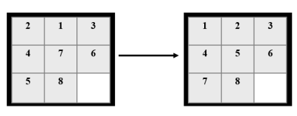 Random State Goal State
Exercise 1.
Create a State Space for 8-puzzle problem. Define it in such a way that it may act as a tree.
Exercise 2.
Use the following heuristic to create the state space:
- Heuristic h(n): Count how many tiles are misplaced compared to the goal state. Ensure that visited states are stored to avoid redundant searches.
Exercise 3.
Solve the 8-puzzle problem using the A search algorithm*, with priority given to states based on f(n)=g(n)+h(n) where:
- g(n) is the cost to reach the current state.
- h(n) is the misplaced tiles heuristic from Exercise 2.
Use a priority queue to select the state with the lowest f(n) and avoid revisiting explored states.

Husnain Haider

