

Lab # 9

Computer Networks

Course Instructor | Ms. Anam Zahid
Lab Instructor(s) | Ghulam Ruqia  Ansa Niaz
Semester | Spring 2024

Department of Computer Science ITU, Lahore Pakistan

Read the following instructions carefully:
All tasks mentioned in the lab manual are individual tasks. Copying from anyone is not allowed at all. Make sure you do not borrow answers from anyone.
Submission Guidelines:
Failure to follow the correct naming convention will result in the assignment not being marked.
- Lab (.pdf): Name: rollnumber_CNLab_lab_number.pd

*Supplement to Computer Networking: A Top-Down Approach, 8th ed., J.F. Kurose and K.W. Ross

UDP with Wireshark

In this lab, we’ll take a quick look at the UDP transport protocol. User Datagram Protocol (UDP) is a Transport Layer protocol. UDP is a part of the Internet Protocol suite, referred to as UDP/IP suite. UDP header is an 8-byte fixed and simple header, The first 8 Bytes contain all necessary header information and the remaining part consists of data. UDP port number fields are each 16 bits long, therefore the range for port numbers is defined from 0 to 65535; port number 0 is reserved.
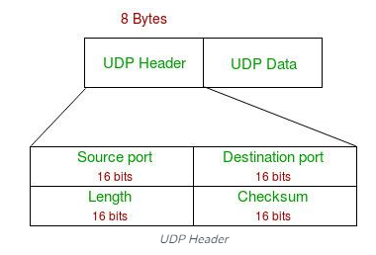

- Source Port: Source Port is a 2 Byte long field used to identify the port number of the source.
- Destination Port: It is a 2 Byte long field, used to identify the port of the destined packet.
- Length: Length is the length of UDP including the header and the data. It is a 16-bits field.
- Checksum: Checksum is 2 Bytes long field. The checksum allows the receiving device to verify the integrity of the packet header and payload.

Lab Task:
Start capturing packets in Wireshark and then wait for a while. Stop packet capturing. After stopping packet capture, set your packet filter so that Wireshark only displays the UDP packets sent and received at your host. Pick one of these UDP packets and expand the UDP fields in the details window.
Do the following (and write down the results):
1. Select one UDP packet from your trace. From this packet, determine how many fields there are in the UDP header. Name these fields.
2. By consulting the displayed information in Wireshark’s packet content field for this packet, determine the length (in bytes) of each of the UDP header fields.
3. The value in the Length field is the length of what?
4. What is the maximum number of bytes that can be included in a UDP payload?
5. What is the largest possible source port number?
6. What is the protocol number for UDP? Give your answer in decimal notation.
7. Examine a pair of UDP packets in which your host sends the first UDP packet and the second UDP packet is a reply to this first UDP packet. (Hint: for a second packet to be sent in response to a first packet, the sender of the first packet should be the destination of the second packet). Describe the relationship between the port numbers in the two packets.

