Computer Science Department - ITU
Computer Networks Lab

Course Instructor: Anam Zahid | Dated: 25/01/2024
Lab Engineer: Ansa Niaz & Ghulam Ruqia | Semester: Spring 2024
Session: 2023-2027 | Batch: BSCS2023 & BSAI2023

Lab 4a. Introduction of Wireshark and HTTP Protocol

Name | Roll number | Report Marks(10) | Viva Marks(5) | Total Marks  (15)

Checked on: ____________________________

Signature: ____________________________

Objective
The objective of this lab is to do some networking commands to help us better understand networking and, in its troubleshooting, as well as its administration.

Equipment and Component
Component Description | Value | Quantity
Computer | Available in lab | 1

Conduct of Lab
- Students have to perform this experiment on Wireshark.
- Students are required to perform this experiment individually.
- In case the lab experiment is not understood, the students are advised to seek help from the course instructor, lab engineers and assigned teaching assistants (TAs)
- At the end of the lab, every student is required to save the completed lab manual in PDF format and submit this single PDF file on Google Classroom at the submission link created for this lab..

Theory and Background
Networking commands are used at the command prompt to get network information like the IP address of the system, MAC address, network route traversed by a packet and the IP address of the server in which a website or URL is hosted.
An Internet Protocol address is a numerical label such as 192.0.2.1 that is connected to a computer network that uses the Internet Protocol for communication. They establish the framework for data exchange, with key examples including TCP/IP for internet communication and HTTP/DNS for web-related functions.
An IP address is a numerical label assigned to each device connected to a computer network, serving two main purposes: host or network interface identification and location addressing.

Lab Task
Task A
When you run the Wireshark program, you’ll get a startup screen that looks something like the screen below. Different versions of Wireshark will have different startup screens – so don’t panic if yours doesn’t look exactly like the screen below!
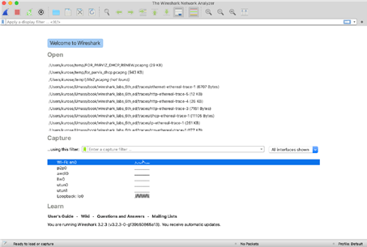
Figure 2: Initial Wireshark Screen
Note that under the Capture section, there is a list of so-called interfaces. The computer we’re taking these screenshots from has just one interface – “Wi-Fi en0,” (shaded in blue in Figure 2) which is the interface for Wi-Fi access. All packets to/from this computer will pass through the Wi-Fi interface, so it’s here where we’ll want to capture packets. On computer, double click on this interface.
If you click on one of these interfaces to start packet capture, a screen like the one below will be displayed, showing information about the packets being captured. Once you start packet capture, you can stop it by using the Capture pull down menu and selecting Stop.
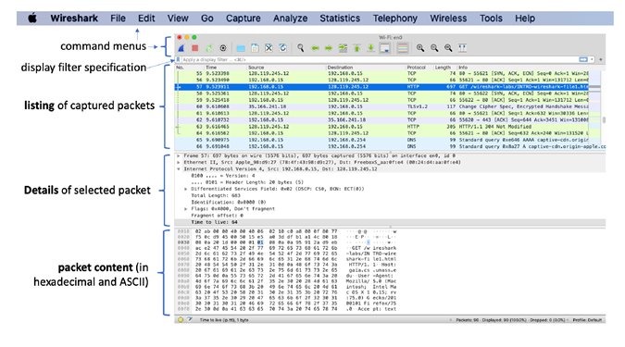Figure 3: Wireshark window, during and after capture
1. The Basic HTTP GET/response interaction
Let’s begin our exploration of HTTP by downloading a very simple HTML file - one that is very short, and contains no embedded objects. Do the following:
1. Start up your web browser.
2. Start up the Wireshark packet sniffer, as described in the Introductory lab (but don’t yet begin packet capture). Enter “http” (just the letters, not the quotation marks) in the display-filter-specification window, so that only captured HTTP messages will be displayed later in the packet-listing window. (We’re only interested in the HTTP protocol here, and don’t want to see the clutter of all captured packets).
3. Wait a bit more than one minute (we’ll see why shortly), and then begin Wireshark packet capture.
4. Enter the following to your browser http://gaia.cs.umass.edu/wireshark-labs/HTTP-wireshark-file1.html
5. Stop Wireshark packet capture.
Your Wireshark window should look similar to the window shown in Figure 1. If you are unable to run Wireshark on a live network connection, you can download a packet trace that was created when the steps above were followed.
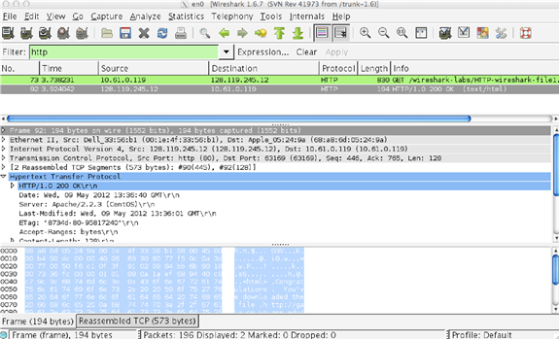
Figure 1: Wireshark Display after http://gaia.cs.umass.edu/wireshark-labs/ HTTPwireshark-file1.html has been retrieved by your browser
The example in Figure 1 shows in the packet-listing window that two HTTP messages were captured: the GET message (from your browser to the gaia.cs.umass.edu web server) and the response message from the server to your browser. The packet-contents window shows details of the selected message (in this case the HTTP OK message, which is highlighted in the packet-listing window). Recall that since the HTTP message was carried inside a TCP segment, which was carried inside an IP datagram, which was carried within an Ethernet frame, Wireshark displays the Frame, Ethernet, IP, and TCP packet information as well. We want to minimize the amount of non-HTTP data displayed (we’re interested in HTTP here, and will be investigating these other protocols is later labs), so make sure the boxes at the far left of the Frame, Ethernet, IP and TCP information have a plus sign or a right-pointing triangle (which means there is hidden, undisplayed information), and the HTTP line has a minus sign or a down-pointing triangle.
By looking at the information in the HTTP GET and response messages, answer the following questions. When answering the following questions, you should print out the GET and response messages (see the introductory Wireshark lab for an explanation of how to do this) and indicate where in the message you’ve found the information that answers the following questions. When you hand in your assignment, annotate the output so that it’s clear where in the output you’re getting the information for your answer (e.g., for our classes, we ask that students markup paper copies with a pen, or annotate electronic copies with text in a colored font).

- Is your browser running HTTP version 1.0 or 1.1? What version of HTTP is the server running?
- What languages (if any) does your browser indicate that it can accept to tht server?
- What is the IP address of your computer? Of the gaia.cs.umass.edu server?
- What is the status code returned from the server to your browser?
- When was the HTML file that you are retrieving last modified at the server?
- How many bytes of content are being returned to your browser?

In your answer to question 5 above, you might have been surprised to find that the document you just retrieved was last modified within a minute before you downloaded the document. That’s because (for this particular file), the gaia.cs.umass.edu server is setting the file’s last-modified time to be the current time, and is doing so once per minute. Thus, if you wait a minute between accesses, the file will appear to have been recently modified, and hence your browser will download a “new” copy of the document.

