

Lab # 3

Computer Networks

Course Instructor | Ms. Anam Zahid
Lab Instructor(s) | Ghulam Ruqia  Ansa Niaz
Semester | Spring 2024

Department of Computer Science ITU, Lahore Pakistan

Read the following instructions carefully:
All tasks mentioned in the lab manual are individual tasks. Copying from anyone is not allowed at all. Make sure you do not borrow answers from anyone.
Paste the screenshots of all steps done to do this lab

Objective:
To understand the basics of network diagnostics using the ping and traceroute commands in Command Prompt and to explore their differences.

Prerequisites:

Basic understanding of networking concepts.
Access to a computer with Windows operating system.

Instructions:

Opening Command Prompt:

- Press Win + R on your keyboard to open the Run dialog.
- Type cmd and press Enter to open Command Prompt.

Ping and Traceroute
Background
Two tools that are indispensable when testing network connectivity (connection between any two points on the internet) are ping and tracert.
For example, when a web browser on your computer fails to connect to a web server, the problem can be anywhere between client and the server. As we have covered in class there are many routers or core devices between a source and the destination. The number of routers in route between a source and destination are called hops. As seen in the figure below:
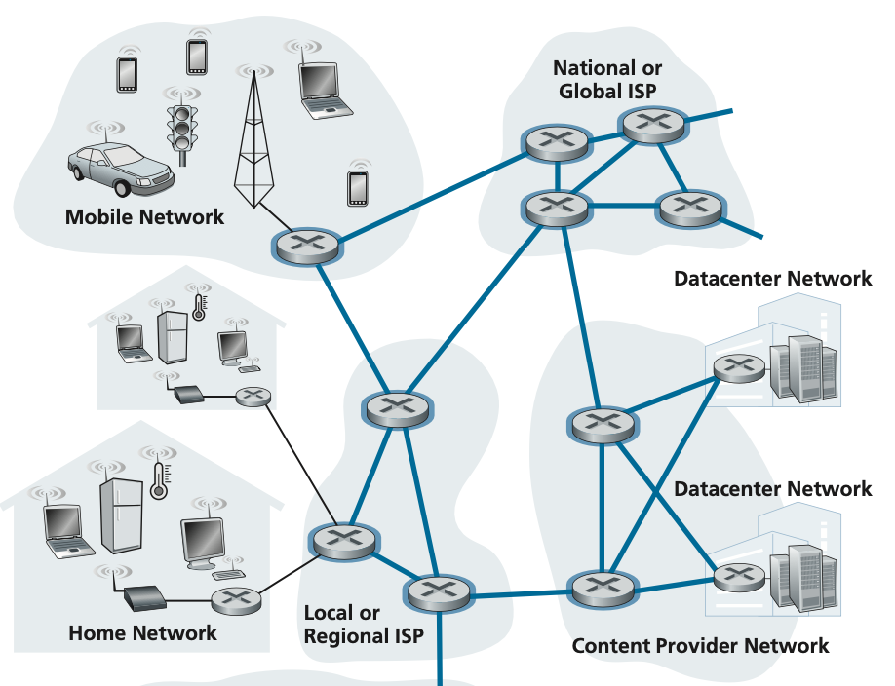
As can be seen in the diagram above there are more than one routes from one destination edge device to another edge device on the network.

Task 1:
Try ping with the following domain names
- google.com
- www.sorbonne-universite.fr // this is a domain from a university in france
- www.uni-heidelberg.de // this is a domain from a university in germany
- www.nasa.gov. // this is NASA domain so the packet will be routed to America

To invoke the ping facility you simply write ping <domain name> at the terminal prompt like:

C:\Users\Momina> ping google.com

You will receive output like
PING google.com (142.250.181.110): 56 data bytes
64 bytes from 142.250.181.110: icmp_seq=0 ttl=60 time=61.347 ms
64 bytes from 142.250.181.110: icmp_seq=1 ttl=60 time=61.509 ms
64 bytes from 142.250.181.110: icmp_seq=2 ttl=60 time=62.270 ms
64 bytes from 142.250.181.110: icmp_seq=3 ttl=60 time=62.034 ms
64 bytes from 142.250.181.110: icmp_seq=4 ttl=60 time=71.269 ms
64 bytes from 142.250.181.110: icmp_seq=5 ttl=60 time=61.191 ms
64 bytes from 142.250.181.110: icmp_seq=6 ttl=60 time=67.792 ms
64 bytes from 142.250.181.110: icmp_seq=7 ttl=60 time=68.285 ms
64 bytes from 142.250.181.110: icmp_seq=8 ttl=60 time=62.833 ms
64 bytes from 142.250.181.110: icmp_seq=9 ttl=60 time=61.695 ms
64 bytes from 142.250.181.110: icmp_seq=10 ttl=60 time=70.149 ms

Executing Ping Command:
- Type ping domain_name in the Command Prompt.
- Press Enter.
- Note: Replace domain_name with each domain from Task 1.
- Example: ping google.com
Comparing Ping Results:
- Observe the output, which includes:
  - The IP address of the domain.
  - Round-trip time (in milliseconds) for data packets.
- Discuss the differences in round-trip times for various domains.

Task 2: Traceroute with TCL Flag:
  - Execute tracert -d domain_name in the Command Prompt.
  - Press Enter.
  - Note: Replace domain_name with any domain from Task 1.
  - Example: tracert -d google.com

- Understanding Traceroute Flags:

  - -d: Disables DNS resolution, showing only IP addresses.
  - -h max_hops: Sets the maximum number of hops (routers) to search.

- Interpreting Traceroute Results:

  - Traceroute displays each router along the path to the destination.
  - It shows the round-trip time for each router.
  - Discuss how each router adds to the overall latency.

- Exiting Command Prompt:

  - Type exit and press Enter to close Command Prompt.
  - Alternatively, press Ctrl + C to interrupt the current command, then type exit and press Enter.

Task 3: Comparison: Ping vs. Traceroute

- Ping measures round-trip time between your computer and the destination.
- Traceroute shows the path data takes to reach the destination, displaying each router along the way.
- Ping provides immediate feedback on connectivity, while Traceroute helps in diagnosing network issues by revealing the route and potential bottlenecks.

Recording Results:

Note down the round-trip time for Ping.
Record the time taken by each router in Traceroute.

Exiting Command Prompt:

Type exit and press Enter to close Command Prompt.
Alternatively, press Ctrl + C to interrupt the current command and return to the prompt, then type exit and press Enter.

