

Lab # 10

Computer Networks

Course Instructor | Ms. Anam Zahid
Lab Instructor(s) | Ansa Niaz  Ghulam Ruqia
Semester | Spring 2024

Department of Computer Science ITU, Lahore Pakistan

Read the following instructions carefully:
All tasks mentioned in the lab manual are individual tasks. Copying from anyone is not allowed at all. Make sure you do not borrow answers from anyone.
Submission Guidelines:
Failure to follow the correct naming convention will result in the assignment not being marked.
- Lab (.pdf): Name: rollnumber_CNLab_lab_number.pd

*Supplement to Computer Networking: A Top-Down Approach, 8th ed., J.F. Kurose and K.W. Ross

Socket Programming
In UDP, the client does not form a connection with the server like in TCP and instead just sends a datagram. Similarly, the server need not accept a connection and just waits for datagrams to arrive. Datagrams upon arrival contain the address of sender which the server uses to send data to the correct client.
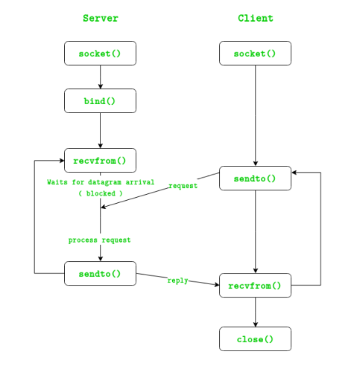
The entire process can be broken down into following steps :
UDP Server:
1. Create UDP socket.
2. Bind the socket to server address.
3. Wait until datagram packet arrives from client.
4. Process the datagram packet and send a reply to client.
5. Go back to Step 3.
UDP Client:
1. Create UDP socket.
2. Send message to server.
3. Wait until response from server is received.
4. Process reply and go back to step 2, if necessary.
5. Close socket descriptor and exit.
Necessary Functions:
 | C++ | Python
 | #include <sys/types.h>  #include <sys/socket.h>  #include <netinet/in.h>  #include <unistd.h> | from socket import *
Creates an unbound socket in the specified domain. Returns socket file descriptor. | int socket(int domain, int type, int protocol) | server_socket = socket.socket(socket.AF_INET, socket.SOCK_DGRAM)
Assigns address to the unbound socket. | int bind(int sockfd, const struct sockaddr *addr, socklen_t addrlen) | server_address = ('localhost', 12345)  server_socket.bind(server_address)
Send data to the other side | ssize_t sendto(int sockfd, const void *buf, size_t len, int flags, const struct sockaddr *dest_addr, socklen_t addrlen) | client_socket.sendto(filename.encode(), server_address)
Receive a message from the socket. | ssize_t recvfrom(int sockfd, void *buf, size_t len, int flags, struct sockaddr *src_addr, socklen_t *addrlen) | print(Receiving messeges...')  data, client_address = server_socket.recvfrom(2048)  filename = data.decode()

Lab Task:
Write a program in Python: client.py and server.py (The server listens for, and accepts, a single UDP connection; it reads all the data it can from that connection, and prints it to the screen; then it closes the connection)
Task Detail:
In this lab, you'll develop a basic banking system where the server acts as the bank and the client as the customer, utilizing UDP socket programming.
Server Side:
- Create a UDP socket on the server using Python's socket module, and bind it to a specified host and port.
- Listen for incoming datagrams from clients.
- Upon receiving a datagram, extract (by splitting the incoming string) the client's name, card number, CVC, and Amount requested by the client.
- Print these details on the screen.

Client Side:
- Create a UDP socket on the client using Python's socket module.
- Send a datagram containing client’s name, card number, CVC, and amount to withdraw to the server's host and port.
- Close the connection
Instructions:
- Both server and client scripts should utilize Python's socket module for UDP communication.
- Implement file transfer using sendto and recvfrom methods of the socket objects.
- More details can be found in chapter 02 (section 2.7) of the text book.

